Abstract.
The paper describes the general condition of the unpublished papyrological items, particularly those in the Latin language, from the excavations of Dura-Europos which are currently preserved at the Beinecke Library in New Haven (CT). It provides an edition for the less damaged of them, which seems to fit the already known typologies of Latin military papyri within the Durene group.

Unpublished Latin Papyri from Dura-Europos at the Beinecke Library

In September 2017, while re-assessing the corpus of the Latin P.Dura in New Haven at the Beinecke Library, I was able to inspect P.CtYBR. inv. DP 121 and five boxes of almost entirely unpublished material, preserved in the premises of the Library itself. The present paper offers a general description of these items, for the perusal of future scholars; and an edition for a small selection of papyri fragments which appear to contain a significant enough amount of text (even if consisting of one or two complete words).

1. A context.
In his 1979 book, Hopkins has given a full account of the excavations, jointly led between 1920 and 1936 by Yale University and the French Académie des Inscriptions et Belles-Lettres, on the site of the ancient town of Dura-Europos. The series of the Excavations at Dura Europos has brought to worldwide audience all sort of priceless findings from the ancient town. What most concerns us here is the rich papyrological collection known as P.Dura; most of all, the section of that collection which referred to the cohors XX Palmyrenorum (P.Dura 54-145), an auxiliary unit of the Roman army which was stationed in town for more than fifty years, till the very end of the town itself (AD 256). Inside the Roman garrison in Dura, i.e. in the northern section, lay the Temple of Artemis Azzanathkona: and in 1931/1932, during the 5th archaeological campaign, a great quantity of fragmentary papyri and parchments was found in room W13, a portion of the temple which bordered on the northern wall. While reinforcing the wall with ramparts in order to face the incoming Sasanian army, Romans had vacated the room, and thrown in the fill every available object, including dismissed documents which they did not feel the need of keeping; other papyri and parchments were found nearby, ‘along the fortification between the Main Gate and Tower 3 at Block E7’. They were protected from the worst effects of time and wear by the very fact that they had been covered with mud and raw materials in order to build the rampart itself. Most of the papyri and parchments found in room W13 (which constitute the greatest majority of papyri and parchments found in Dura-Europos) were in Latin language, and referred to the cohors XX Palmyrenorum; they have been subsequently almost all published, but for a handful of tiny scraps collected in a number of boxes, now preserved in the Beinecke Library at New Haven (CT), and whose content has remained only briefly described. Very little has survived on these scraps, that can be even remotely useful to modern scholarship; yet, for the sake of completeness and clarity, and in the hope that future scholars and techniques may rise that will shed light on these leftovers, I provided an editions for the least damaged of the fragments I found in the boxes. A full account of the total number and content of the boxes will be given in the final Appendix.

2. P.CtYBR. inv. DP 121.
This item consists of a box containing five to six bricks of baked mud, one of which (ca. 10x7 cm) presents layers of small papyrus fragments attached to its surface, and some writing on them. No clue is given in the box on the origin of this piece of evidence; a passage in Hopkins’ report on the excavations in Dura, however, probably reveals where these bricks came from. While describing the deplorable condition in which the first papyri were found – they immediately turned to dust if touched – Hopkins adds that ‘we had stumbled upon a room of stored documents, for there was no sign of box or bag, only documents gathered in packages. We tried to cut out small sections; the slightest movement shattered the entire segment. The immediate transformation was not even into dust – just powder. In desperation we cut out a brick-sized piece, sealed it in paraffin, and sent it back to Yale. All was futile: a dark powdery dust arrived’. Aside from the results of this operation, it seems that Hopkins and his colleagues tried, before Dave Clark was able to retrieve the papyri and parchments in a less damaging way, to cut mixed sections of papyri and other material, and send them to Yale. Not all of these sections turned to powder when they got to New Haven. C.B. Welles notes that while excavating Tower 3 and the Temple of Artemis Azzanathkona, Hopkins and his colleagues brought to light

rotted fragments of papyrus stuck together in layers so as to form little packets. Since it proved impossible to separate the layers or read anything more than an occasional letter, the excavator, Professor Clark Hopkins, had the fragments and the surrounding dirt packed in waxed cloth and returned to Yale at the end of the season. One of these packages, of about the size of an unbaked brick, was opened, but nothing could be made of the contents. The remaining three were left unexamined until this last summer, when I opened them and sorted out the papyri. […] It has continued to prove impossible to separate the layers, since the slightest pressure of a knife-blade causes the substance to crumble. Traces of writing are visible in a very few places, but actual letters can be made out only in part of one face of the largest packet. There, four layers of papyrus, receding shingle-fashion up to the left, show a neat, tiny Latin script very similar to that of P Dura 98 (ca. A.D. 218) and of P Dura 115 (A.D. 232). The original document was a roster. In one place the name,
Seleuc[
can be made out, in another the ends of names in the nominative
]us
]ianus.

The description seems perfectly to match the bricks preserved in the box. I find no trace of the Seleuc[ Welles saw, but the sequence ]us and ]ianus I think I can detect in the largest written brick, which probably coincides with the brick described by Welles in 1965 as containing four layers of papyrus.

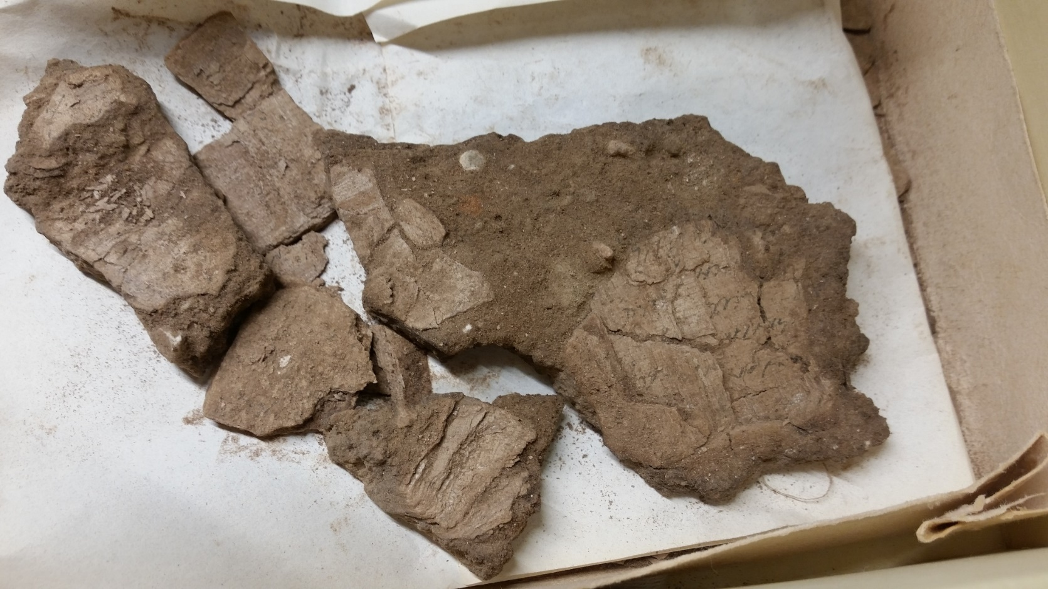
Complete view of the content of Box 1. The four layers of papyrus can be seen here
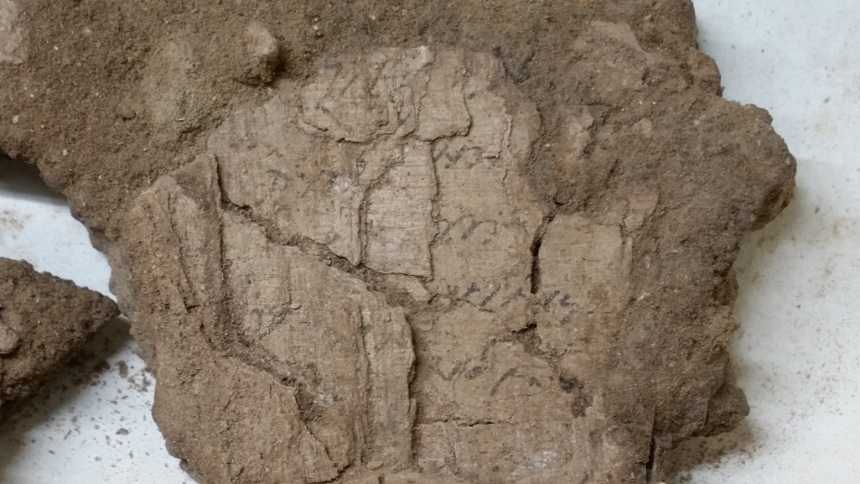
Enlarged view of the four layers. The most visible, and that described by Welles as containing ]us and ]ianus, is probably that pointed out by the arrow

All the layers appear to have been written by the same hand, a bureaucratic Roman ancient cursive, and Welles is right in pointing out parallels in P.Dura 98 and 115, as well as in thinking of a roster. One might further date the scrap(s) between AD 200 and 230 ca. The reciprocal positon of the layers – each of which probably represents a separate fragment from the original document – within the roster itself is unfathomable. The layer to the right is apparently the best preserved. What follows is an attempt at a critical edition of that layer. The ]us described by Welles is probably to be interpreted as or, and to correspond to l. 2 of the fragment.

]n ̣[
] ̣cor
] ̣ ̣iaṇus
]no coṣ

1 perhaps i || 2 before c, an oblique stroke, pointing downwards, connected to the upper portion of c, perhaps a or r | c might also be p || 3 uncertain traces, perhaps before i an u

3. Other items.
1. P.CtYBR. inv. DP 23 fr. a (11.5x23.7 cm)
Written in epistolary cursive, perhaps from a letter. Fibres are torn and ridden with holes, and ink has almost everywhere completely vanished there is no way to identify margins. The same holds for the following fragment. The word uexill(arius) (?) ‘ensign-bearer’ is probably to be seen in l. 9. So little has survived, that the possible date of composition must be roughly equivalent to the maximum chronological fork one has for Durene Latin papyri, i.e. between AD 200 and 256. The same holds for the following frr. b and h.

- - -
] ̣ ̣[ ̣ ̣] ̣[ ̣ ̣ ̣ ̣]mas [
] ̣ ̣[ ̣ ̣] ̣ạ ̣ ̣ ̣ ̣[
] ̣ ̣[ ̣ ̣ ̣ ̣] ̣ ̣[
] ̣[ ̣]mil[ ̣ ̣] ̣s[ ̣ ̣ ̣ ̣] ̣[
]e ̣ ̣di ̣[ 5
] ̣ ̣uba ̣[
] ̣[ ̣ ̣] ̣ ̣[
] ̣eb ̣ ̣ ̣[ ̣ ̣] ̣[
] uexill ̣ ̣e ̣ ̣[
- - -

1 above this line, traces in a different ink, ending with ̣ọ ̣: perhaps the remnants of an accepta-formula (… c̣ọṣ)? || 2 before a, perhaps i or l || 4 perhaps ]ẹs[ || 5 n or r | e or s | an oblique stroke, pointing upwards || 6 ] ̣ ̣ two oblique strokes, pointing upwards | an oblique stroke pointing upwards, perhaps s || 7 perhaps s | e, i or s | m or n || 8 after b, an oblique stroke pointing upwards || 9 perhaps o | perhaps s | e is in ligature with a long oblique stroke, pointing upwards: i or s | an elliptical stroke, slightly elevated from the baseline; perhaps c

2. P.CtYBR. inv. DP 23 fr. b (3x8.5 cm)

- - -
̣ ̣[
e ̣[
n[
sin[
̣ ̣ ̣[ 5

1 two oblique strokes, pointing upwards || 2 uncertain traces || 5 uncertain traces, the first a or r

3. P.CtYBR. inv. DP 23 fr. h (11.5x10.5 cm)
The fragment seems drawn up in a bureaucratic script; the word sing for singularis, a pay grade of Roman army, can be spotted; it is followed by an interpunctum. Perhaps a list of soldiers was included in the original document.

- - -
] ̣ ̣[
s]ing· ̣[ ̣ ̣ ̣ ̣ ̣ ̣ ̣ ̣]aris[
] Iul[
]l[
- - -

1 oblique strokes, pointing upwards and in ligature: a, r, s are possible || 2 perhaps i

2 fortasse s]ing(ularis) I [

Fr. a | Fr. b
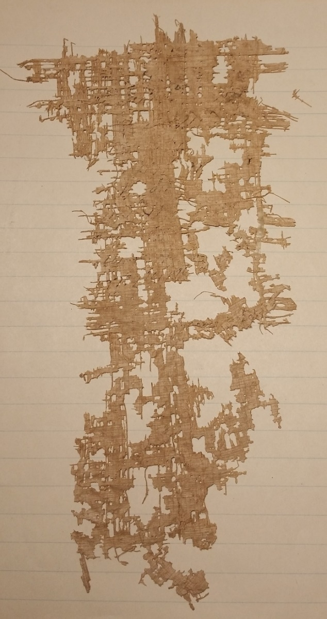 | 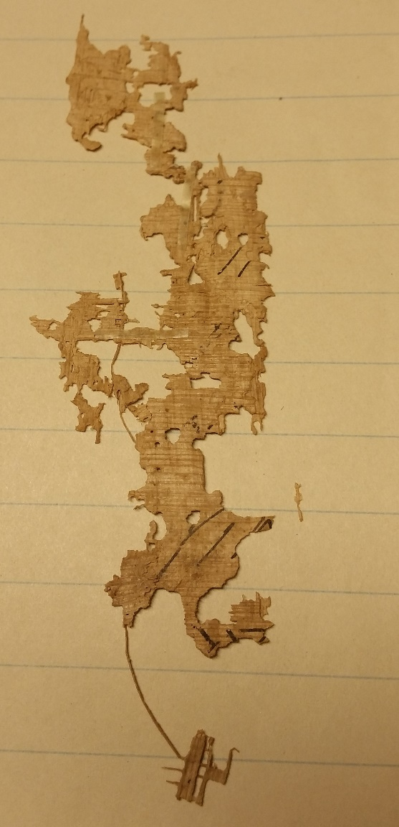
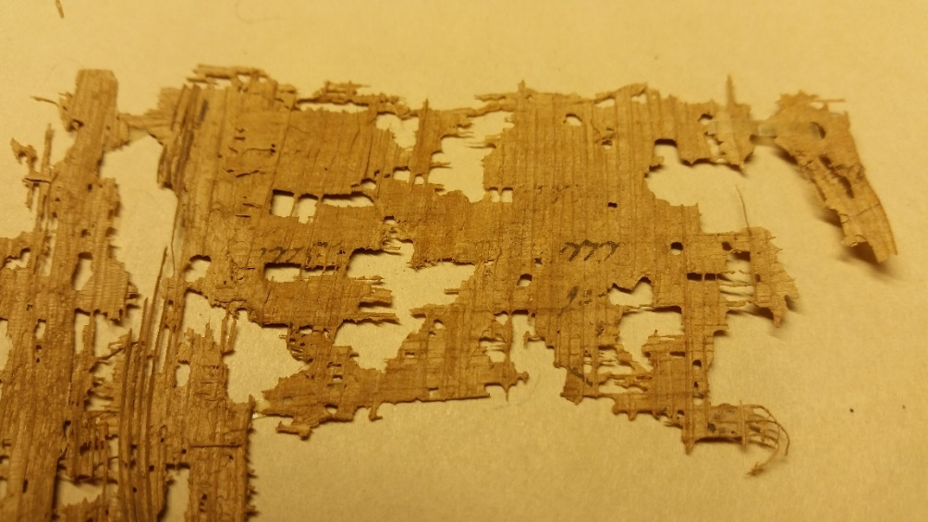
Fr. h

4. P.CtYBR. inv. DP 16 fr. 2 recto
The fragment probably comes from a roster, either partial or complete. The script can be dated between AD 200 and 230 ca. The same holds for the following two scraps. The names preserved on the three fragments from DP 16 are very common among Durene soldiers: Salmanes, Monimus, and Aurelius Antonius or Antoninus. Also a consular date (AD 212) emerges from fr. 3 recto.

- - -
] ̣ ̣[ ̣] ̣ ̣ ̣[
] Ṣalmanes M[
Mo]nimụ[s
- - -

2 ̣ ̣[ perhaps s and then a circle: b, o, or u

5. P.CtYBR. inv. DP 16 fr. 3 recto

- - -
]ẹṃ[
] ̣ ̣[ ̣] ̣
] duobus A[spris cos
] o[
] ̣ ̣[ 5
- - -

2 ] ̣ perhaps a or r

6. P.CtYBR. inv. DP 16 fr. 1 verso

- - -
Aur]el An[toni-
] ̣eus ̣ ̣ ̣[
] ̣[
- - -

2 ] ̣ a long stroke in ligature with the top of the forked e | uncertain traces

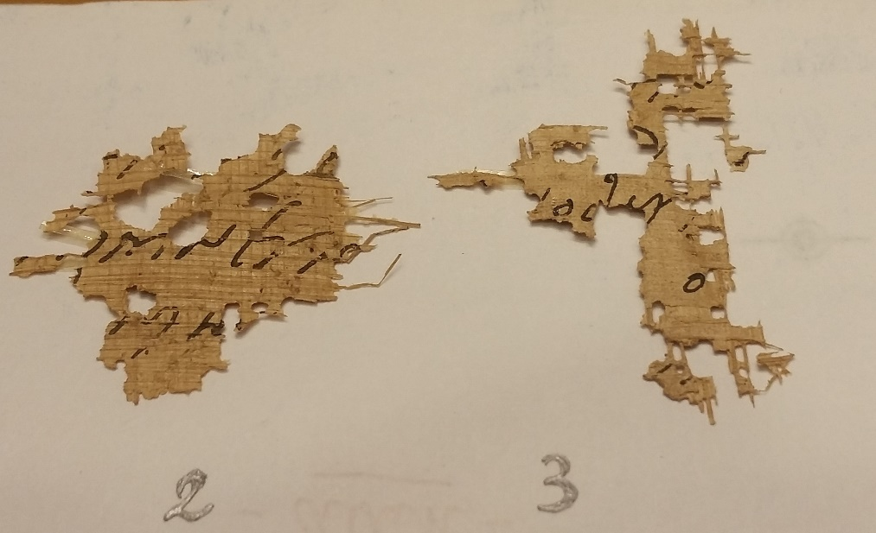 | Frr. 2 recto, 3 recto
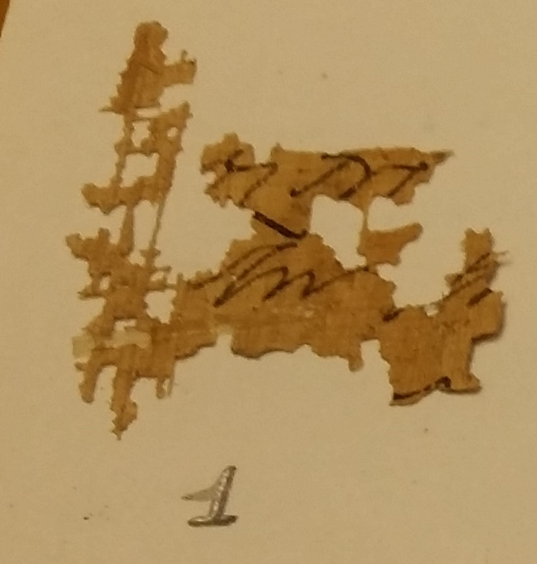 | Fr. 1 verso

7. P.CtYBR. inv. s.n. (box 3 folder 1)
A small fragment in epistolary cursive, probably mentioning Valerius Comazon; this, and similarities in the hand (particularly with c, o and r when in ligature), suggest a comparison with P.Dura 55. The scrap might well have been written by the same hand of that who wrote P.Dura 55, or come from the group of scraps pertaining to that papyrus. The script can be dated between AD 200 and 230 ca.

- - -
Val]eri Com[azontis
]pli ̣[
- - -

2 c, less likely l

2 fortasse du]plic̣[ari-

P.Dura 55
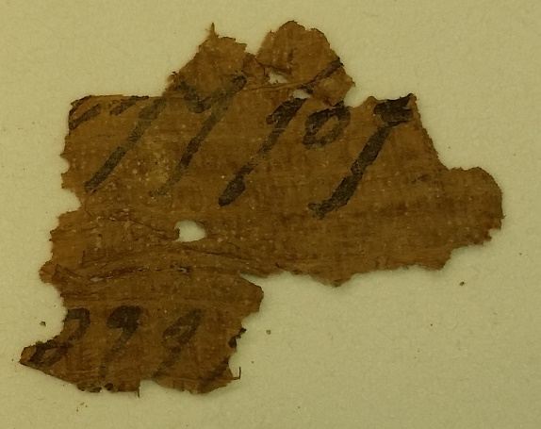
fr. b
- - -
[ ̣ ̣ ̣] ̣em Valeri C[o]mazonti[s ̣ ̣ ̣ ̣ ̣ ̣ ̣]
[a]ụctoritate sacra de ̣[ ̣ ̣ ̣ ̣ ̣ ̣ ̣]
ṭe sine mora· commiliṭ[ones in castra]
sua inducere et de cetero [curare]
ut ex disciplina ag̣ạ[nt.]

8. P.CtYBR. inv. s.n. (box 3 folder 2)
Another small fragment in epistolary cursive, which closely recalls the hand in P.Dura 60: notice the ligature um and the artificial lengthening of final m. The script can be dated between AD 200 and 230 ca.

- - -
] ̣atur
]m
- - -

1 the right portion of an oblique stroke, pointing upwards, in ligature with a

P.Dura 60
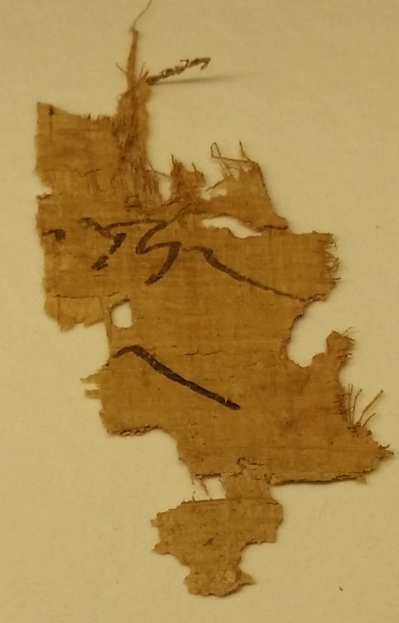
Letter A (= fr. a col. I).
- - -
]m eorum
- - -

9. P.CtYBR. inv. s.n. (box 3 folder 3)
The scrap contains a mention of duplicarii and probably comes from acta diurna. The script can be dated between AD 200 and 230 ca. It is unclear whether the figure ]VI belongs to the same line of dupl: it may also be possible that there is no actual lacuna between dupl and the figure.

- - -
] dupl [ ̣ ̣ ̣]VI [ ̣ ̣ ̣] ̣[
- - -

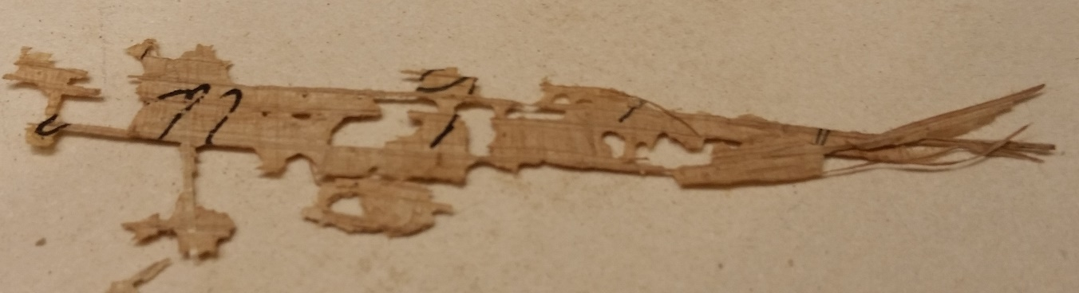
Notice the similarities with the word dupl and the figure VII in P.Dura 82, col. I l. 9

10. P.CtYBR. inv. s.n. (box 3 folder 4 fr. 1)
A small scrap containing a figure and, perhaps, the inferior margin of a document. The particularly long second stroke of l might suggests the papyrus to have been drawn up in the early 3rd AD, but there is no real certainty.

- - -  L[ ̣ ̣]XVI | 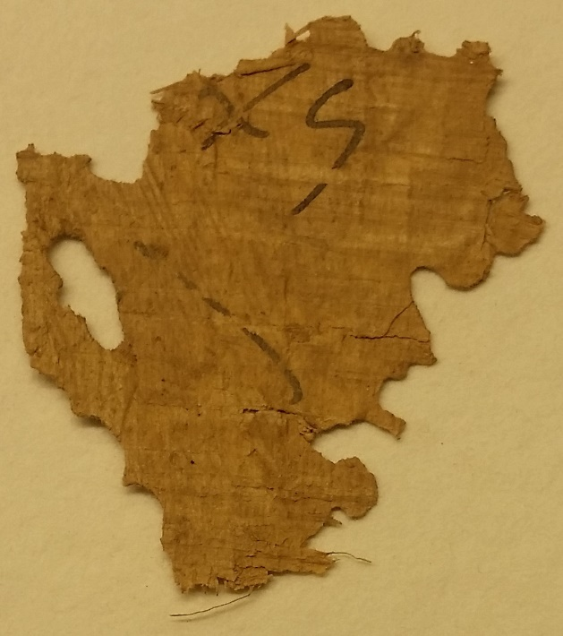

11. P.CtYBR. inv. s.n. (box 3 folder 4 fr. 2).
The scrap is written in a seemingly neat bureaucratic cursive. The script can be dated between AD 200 and 230 ca.

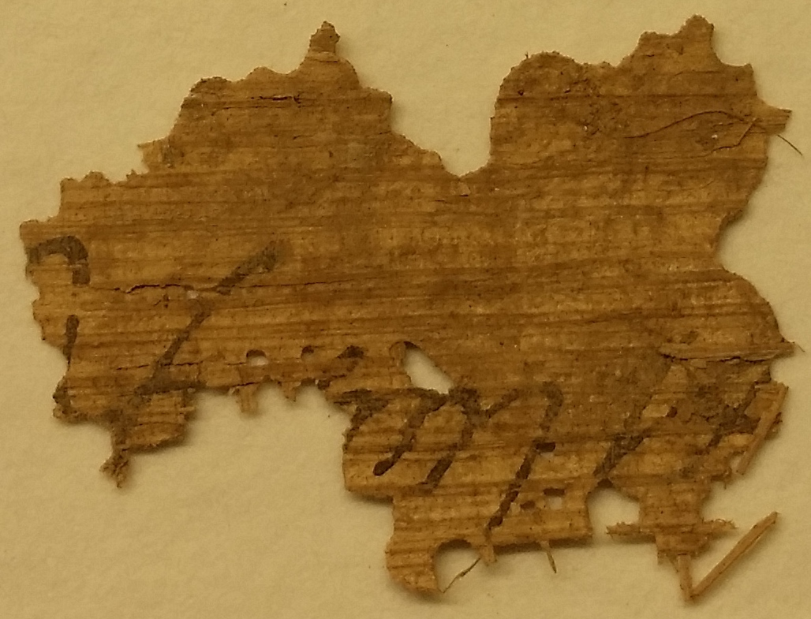
- - -
]be[ ̣]e ̣ ̣ ̣i ex[
- - -

traces after e might be of a, r, s, t

12. P.CtYBR. inv. s.n. (box 3 folder 5 fr. 4) (2.2x1.9 cm)
A small scrap in epistolary cursive, perhaps mentioning eq(uites). The script can be dated between AD 200 and 230 ca.

Fr. 4 →  - - -  ] ̣eq[  ]orum[  - - -  1 thick speck of ink | 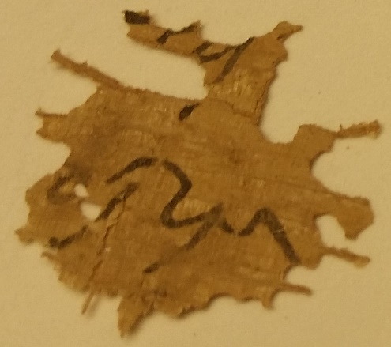

13. P.CtYBR. inv. s.n. (box 3 folder 6 fr. 3) (3.2x2.7 cm)
A small scrap in epistolary cursive; the verb retinui (l. 2) suggests that the original document might have been a letter. The n is drawn in two strokes. The script, which closely recalls the hand in P.Dura 60, particularly in the ligature ui and final m (l. 1), can be dated between AD 200 and 230 ca.

Fr. 3 →  - - -  ]ṛụm  ] ̣ retinui [  ] ̣ ̣ ̣[  - - -  2 perhaps s | after retinui, perhaps the right margin || 3 uncertain traces | 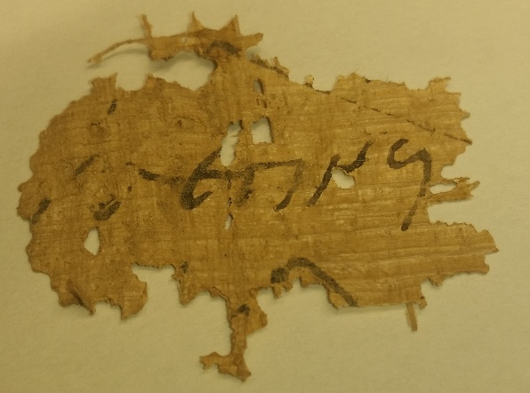

14. P.CtYBR. inv. s.n. (box 3 folder 6 fr. 4) (4.2x2.3 cm)
A small scrap, written in epistolary cursive which closely recalls the hand in P.Dura 55, particularly in the ligature as and l, which still features quite an elongated second stroke. The script can be dated between AD 200 and 230 ca. The document mentions two names, Malcus – i.e. Malchus – and perhaps Maximus. They were probably required for a specific errand, or sent for by a commanding officer. The situation might be similar to that featured in P.Dura 63, where Themarsas and Hiereus are summoned in an official letter to the tribune of the cohort (letter b, ll. 4-5).

Fr. 4 →  - - -  ] Ṃalc̣um et Ṃax[im-  ] ̣eras [  - - -  2 i or l | 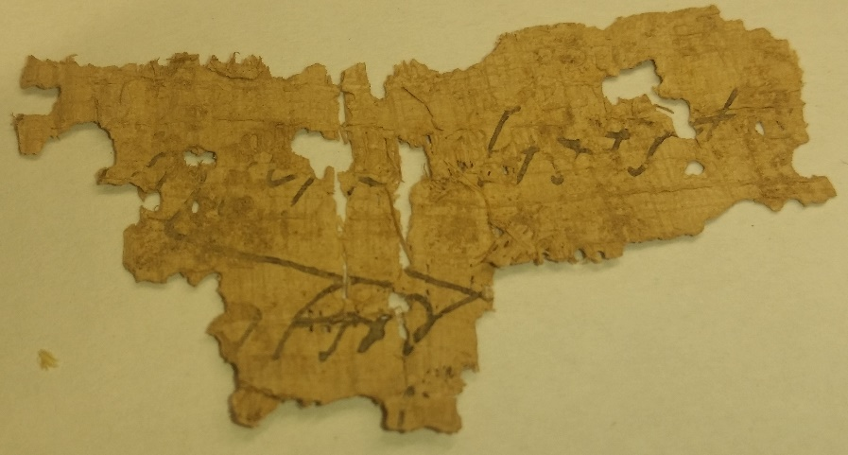

15. P.CtYBR. inv. s.n. (box 3 folder 6 fr. 10)
Three fragments, a (3x10 cm) b (3.2x5) and c (3.2x3.5 cm), all coming from the same document, most likely a roster; more specifically, from the left portion of a single column. Horizontal lines, as expected, mark all the names, none of which is extant in its entirety. Only the toponym ‘Becchufrayn’ is actually legible in fr. c, l. 1. Frr. a and b probably were a portion from the same column: the distance between them is, however, uncertain. Likewise, the color of the fibres suggests that fr. c fragment was not very far from a+b in the original roll – at what distance, one cannot gather. Little can be said of the main hand; nevertheless, the hand which drew the marginal note becchuf[ in fr. c, l. 1 can be compared to informal hands responsible for marginal annotations in other rosters, such as P.Dura 100 and 101 (see the table below).

Fr. 10 a+b →  - - -  [  [  [  A[  Si[ 5  A[  A[  Pl[  - - -  G[  Au[rel 10  - - - | 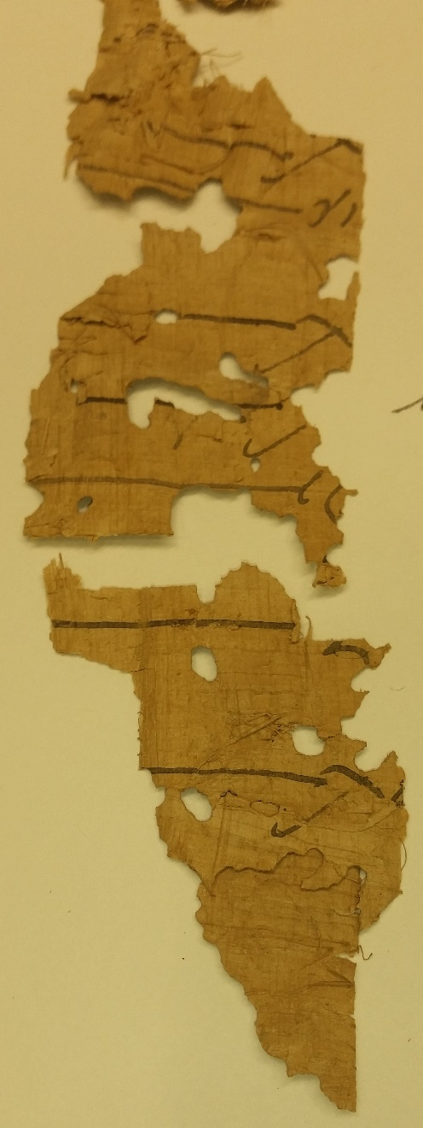
Fr. 10c →  - - -  Becchu[f  [  [  - - - | 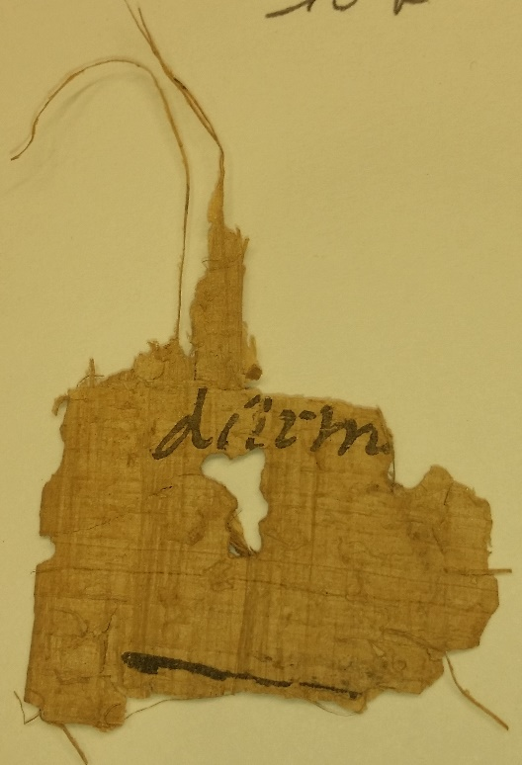

from P.Dura 100, col. XXXI l. 1. Notice the similarity between the b in fr. 10c and the b here (a small oval, then a serpentine-like stroke), the ligatures ec and hu
from P.Dura 101, col. XLI l. 19 (mistakenly written with only one c). The ligature hu is quite similar to the preceding ones; b, on the other hand, is drawn differently

16. P.CtYBR. inv. s.n. (box 3 folder 7 fr. 1) (1.8x22 cm)
The typology of the document from which fr. 1 is taken is not easy to detect. The fragment contains names of soldiers (ll. 2, with the termination ]hi of the genitive for the patronymic; 5; 8); figures associated, probably with them (ll. 3; 4); perhaps a reference to a centurion (l. 1 prior[). One finds similarities with guard rosters, such as P.Dura 106, 107 and 108, where names of soldiers are in fact associated with figures – to no fathomable purpose – and the centuries to which the soldiers belong are duly noted. Between ll. 9 and 16, one can see a large blank space. The script can be dated to a later stage of Roman presence in Dura, i.e. AD 220-256 ca.

Fr. 1 →  - - -  ] prior[  ]hi Ael[  ] ̣II ̣ ̣ ̣[  ] ̣II A ̣[  ] ̣ Iadiḅẹ[l- 5  ] ̣ḍo ̣[  ]fe ̣ ̣ ̣ ̣[  ]us Mal[ch-  ]e ̣ ̣o ̣[  10  15  ] ̣[  ]adm[  3 before II, two oblique strokes, one pointing upwards, the other downwards, as if in the right portion of k. perhaps right edge of e | faint traces of three oblique strokes, pointing upwards: the first one might be i or l || 4 same traces as in the beginning of l. 3 | b, d, less likely u || 5 small circle at the top of the writing line || 6 an oblique stroke, pointing upwards || 7 r or s | ạụṛẹ[l ? || 9 rio or tio or apo or no | bottom of an oblique stroke, pointing upwards || 10 speck of ink | 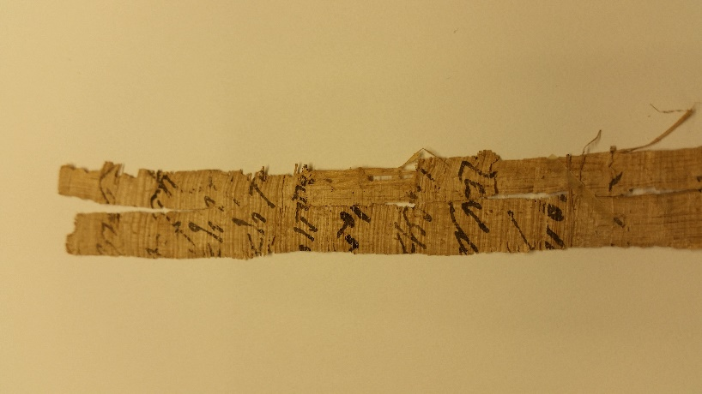
 | 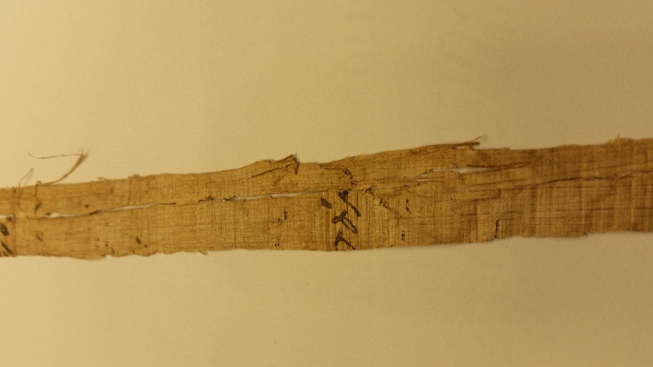

17. P.CtYBR. inv. s.n. (box 3 folder 7 fr. 8) (4.5x2.2 cm)
The writing seems here rather bureaucratic, but different from that normally found in rosters and military lists, and more coherent with acta diurna. It can be compared to hands in other morning reports, such as P.Dura 82 and 89: cfr. in particular the word a]urel in l. 1. The script can be dated roughly to AD 220-256 ca.

Fr. 8 ↓  - - -  A]urel ̣[  ] ̣eus P[  - - -  1 m or n || 2 an oblique stroke, pointing upwards | 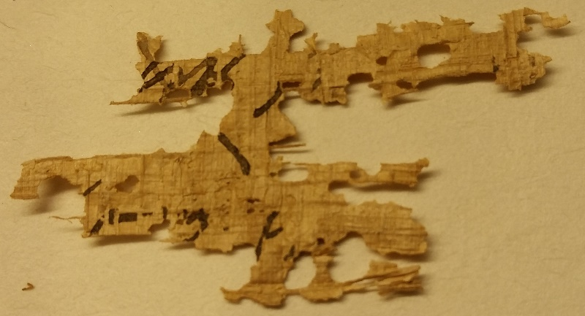

Giulio Iovine Università di Napoli ‘Federico II’
giulio.iovine@unina.it Dipartimento di Studi Umanistici
Via Porta di Massa 1 – 80133 Napoli (NA)

Appendix.

BOX 1 | This box contains several badly preserved scraps, all in Greek language, and to be linked therefore to Greek papyri among the Durene collection.
BOX 2 | This box contains eight folders, each assigned to a specific DP number, linking the scraps with other published items in the Beinecke (e.g. DP 3, 13, 58…). The scraps in the folders are remarkably small, blank for the vast majority, and yield but little information. Here and in the folders of subsequent boxes I have put numbers and letters by pencil to identify fragments, should anybody see them in the future.
 | (1) P.CtYBR. inv. DP 21 | Almost no visible traces, and the hand is not the same as that of P.Dura 74.
 | (2) P.CtYBR. inv. DP 49 | 4 small scraps: a (2x4.2 cm), b (2.7x4.3 cm), c (1x1 cm), d (1.2x1.2 cm), all presenting a few traces. The first of them, fr. a, may be Greek.
 | (3) P.CtYBR. inv. DP 100 | Several scraps, all blank.
 | (4) P.CtYBR. inv. DP 8 | Several scraps, probably not belonging to P.Dura 56; almost nothing can be read on them.
 | (5) P.CtYBR. inv. DP 3 | A single fragment where a few fragmentary lines can be read, perhaps in Greek. No clue is provided about its belonging to P.Dura 82 or 97.
 | (6) P.CtYBR. inv. DP 58 | 4 scraps with minimal traces of writing.
 | (7) P.CtYBR. inv. DP 23 | 11 scraps (a, b, c, d, e, f, g, h, i, j, k) with very faint traces of ink. No clue is given about their belonging to P.Dura 65. The most relevant (a, b, h) are published here.
 | (8) P.CtYBR. inv. DP 16 | 58 scraps, most of which are blank; those which still bear traces of writing are all written in a bureaucratic script and most likely contained a list of names with consular dates; they are written both on the recto and the verso, which most likely formed two separate documents. This all matches with the papyrus they supposedly refer to, P.Dura 67 (verso) and 102 (recto). Frr. 4, 6, 8, 10, 12, 21 on the recto clearly feature the typical apparatus of rosters, including horizontal lines, black dots and marginal notations; in fr. 20 a theta nigrum can be clearly seen. Frr. 2 recto, 3 recto and 1 verso are published here.
BOX 3 | This box contains seven folders.
 | Folder 1 | A handful of scraps in epistolary cursive. One scrap is published here.
 | Folder 2 | Likewise. One scrap is published here.
 | Folder 3 | Several scraps still attached one to another in layers, and in a number of scripts, mainly bureaucratic. Three fragments are published here.
 | Folder 4 | Divided in 4 sub-folders, only two of them offering Latin scraps. The former presents badly preserved fragments in a large epistolary cursive; the latter presents a seemingly neat bureaucratic script. Two of the scraps in this sub-folder are published here.
 | Folder 5 | Divided in 4 sub-folders; numbers 2, 3 and 4 host a few badly preserved or blank scraps; in sub-folder 1 there are scraps written in epistolary cursive. One of them (fr. 4) is published here.
 | Folder 6 | By far the richest of the box, preserving more than one hundred scraps; in fact, less than twelve provide some significant sequence of letters or recognizable layout. I have provided the most legible scraps with numbers. A selection of the most relevant is published here.
 | Folder 7 | Almost as rich as the previous one. I have divided it in two subfolders. Number 1 contains those fragments I have given a number to, two of which are published here; number 2 for blanks scraps and desperate cases.
BOX 4 | This box contains archaeological material, including a leather fragment which is, in fact, already published under the name of P.Dura 131.
BOX 5 | Like BOX 1, this box contains several small scraps in the Greek language, all unpublished.

The research leading to these results has received funding from the European Research Council (ERC) under the European Union’s Horizon 2020 research and innovation programme (Grant agreement nº 636983); ERC-PLATINUM project ‘Papyri and LAtin Texts: INsights and Updated Methodologies. Towards a philological, literary, and historical approach to Latin papyri’, University of Naples ‘Federico II’ – PI Maria Chiara Scappaticcio. My six-month stay in New Haven as a Visiting Fellow at Yale University has been funded by the Neapolitan institution COINOR, within the frame of program STAR, for which I successfully applied in 2016. My warmest gratitude goes to Ellen Doon and Mark Custer, who provided constant help and support; to Andy Hogan (Berkeley) for checking the English of this paper and for valuable suggestions.
The inspection has taken place under close monitoring and with the precious help of Ellen Doon (Beinecke Library). As no photograph is available, I have personally provided for the reader those done with my phone - with Ms. Doon’s permission.
C. Hopkins, The Discovery of Dura-Europos, London-New Haven 1979.
On the last years of Dura, see J. Baird, ‘Dura Deserta: The Death and Afterlife of Dura-Europos’, in N. Christie-A. Augenti (eds.), Vrbes Extinctae: Archaeologies of Abandoned Classical Towns, Ashgate 2012, pp. 307-329, with bibliography attached.
Hopkins 1979, pp. 75-105.
See C.B. Welles-R.O. Fink-J.F. Gilliam, The Parchments and Papyri. With an account of Three Iranian Fragments by W. B. Henning, New Haven 1959, p. 3.
The first great edition of the P.Dura is contained in the aforementioned Welles-Fink-Gilliam 1959; several documents had been published after the papyri came to Yale in the Forties and Fifties – P.Dura 54 in R.O. Fink, A.S. Hoey, W.F. Snyder, ‘The Feriale Duranum’, Yale Classical Studies 7, 1-222; P.Dura 56, 82, 97 et alii in J.F. Gilliam, ‘Some Latin Military Papyri from Dura’, Yale Classical Studies 11, 1950, 171-252, etc. – but that of Welles, Fink and Gilliam was for most of them the editio princeps. R.O. Fink re-published all documents in his Roman Military Records on Papyrus, Cleveland (Ohio) 1971; five years later (1976) R. Marichal did the same with all the Latin documents for the VI, VII, VIII and IX volumes of the Chartae Latinae Antiquiores, Dietikon-Zürich 1954–. The letters (P.Dura 55 to 81) have been published once again by P. Cugusi, Corpus Epistularum Latinarum Papyris Tabulis Ostracis servatarum (CEL). I. Textus; – II. Commentarius (Firenze 1992); III. Addenda, Corrigenda, Indices rerum, Indices verborum omnium, Firenze 2002.
The code ‘CtYBR’ is the standard way to call the papyri stored in the Beinecke Library, particularly when they are unpublished and only have an inventory number (P.CtYBR. inv.); it is not a strict acronym (it refers to Connecticut, Yale, and Beinecke Rare Book and Manuscript Library) and has been assigned to those objects by the Library of the Congress. On the other hand, the acronym ‘DP’ (Dura Papyri) is applied after ‘CtYBR’ and ‘inv.’ when the papyrus comes from the excavations in Dura-Europos.
Hopkins 1979, p. 99.
Hopkins 1979, pp. 99-101.
C.B. Welles, ‘An Additional Note on the Dura Papyri’, BASP 3, 1965, p. 28.
I refer here to the normally accepted tripartition in the palaeographical analysis of scripts in the Durene papyri (chancery and epistolary writings; bureaucratic writings; personal hands and subscriptions). Cf. R. Marichal in ChLA IX, 16-19 for an overall description.
AD 218-219, TM 44830.
AD 232, TM 44847.
Rosters were lists containing all the names of the soldiers serving in an individual unit. For practical purposes, the names were grouped in columns under their own sub-units (centuries, turmae) and, within them, according to the date of enlistment of the soldiers; a complex series of verbal and non-verbal markers was employed to signal the current status of each soldier and useful data about him, including: rank, specific duty or task, availability, non-availability, inside-outside the camp, on an errand, exempted from active service, sick, dead. The main instances of this documentary typology come from the Dura papyri: namely, P.Dura 100 (AD 219, TM 44832) and 101 (AD 222, TM 44833). Further, detailed analysis by R.O. Fink in Welles- Fink- Gilliam 1959, pp. 37-46; again Fink 1971, pp. 9-18; R. Marichal (in ChLA VIII, 3-12); K. Stauner, Das offizielle Schriftwesen des römischen Heeres von Augustus bis Gallienus (27 v.Chr. - 268 n.Chr.). Eine Untersuchung zur Struktur, Funktion und Bedeutung der offiziellen militärischen Verwaltungsdokumentation und zu deren Schreibern, Bonn 2004, pp. 21-26.
In using the syntagms ‘epistolary cursive’ or ‘bureaucratic cursive’ in order to describe particular stylistic typologies of Roman ancient cursive, I refer to two crucial works: that of R. Marichal (ChLA IX, 16-19) and that of D. Internullo (Studi Paleografici sui Papiri Latini di Dura Europos [BA Thesis], Roma 2009), particularly pp. 35-53.
He may well be Salmanes son of Maccaeus (Salmanes M[accaei), attested in P.Dura 100 and 101 col. XXXVI, from Demetrius’ turma and enrolled on the 2nd consulship of Anullinus (AD 199).
He could be Monimus son of Aufeus, Monimus or Sallumas, all attested in P.Dura 98, fr. a col. I; other Monimi were surely in the cohort.
Only one Aurelius Antonius is attested with any certainty in the P.Dura (namely, P.Dura 100 col. XII); but at least 16 Aurelii Antonini.
AD 218-220, TM 44774. The papyrus consists fragments from a Latin (55A) and a Greek (55B) letter, which were originally written in a single papyrus sheet. The blank verso, which bears no name of a recipient, suggests that the letters were copies (see R. Marichal in ChLA VI, p. 11). Both letters mention problems with the behavior of the soldiers of the 20th Palmyrene cohort, who are described as going astray (fr. a ll. 6-8) and in need of a restoration of discipline (fr. b ll. 3-5; see Welles-Fink-Gilliam 1959, 214). Among the relevant mentions pops out Valerius Comazon (fr. b l. 1), a supporter of both Elagabalus and Severus Alexander; perhaps the episode of unrest described in the letters referred to the revolt of Macrinus and his final demise, in which Comazon had a prominent role (Welles-Fink-Gilliam 1959, 213).
AD 208 ca., TM 44782. The papyrus preserves fragment from official letters, sent by the Syrian governor’s office to the commanding officers of the Palmyrene cohort and other units stationing on the Euphrates. Most of these letters are fragmentary: at least three can be identified, but yield little or no text (fr. a, col. I = letter A; frr. b+c = letter C; fr. d = letter D); then follow uncertain fragments (frr. e-p). Letter B (= fr. a, col. II), on the other hand, is entirely preserved: it contains the copy of official letter from the governor of Syria to a procurator Augustorum, forwarded to the commanding officers of military units in the neighbourhood of Dura, and concerning an embassy from Parthia.
The surviving morning reports among Dura papyri offer a number of entries, marked by the day and the month and very freely laid out in wide columns and irregular paragraphs, in which everyday activities, number and ranks of the soldiers are reported. See f. i. some of the most representative samples of acta diurna: P.Dura 82 (AD 223-232, TM 44813) and 89 (AD 239, TM 44820). Overviews will be found in R.O. Fink 1971, 179-182; R. Marichal in ChLA VII, pp. 28-29; and K. Stauner 2004, 74-90.
AD 223-232, TM TM 44813.
The name ‘Malchus’ is widespread in Dura papyri (17 Aurelii Malchi at least, and more than 27 Malchi where ‘Malchus’ is the first name); in this case, it seems the h is missing – but this is common occurrence for names in the Durene archive: Iarhaboles is often rendered as Iaraboles or Ieraboles, and so is Iarhaeus, which becomes Iareus or Ieraeus. Cf. the military prosopography of auxiliaries in Dura-Europos in G. Iovine, The Cohort of the Palmyrenes. Latin Military Papyri from Dura-Europos (P.Dura 55-145), forthcoming.
AD 211, TM 44791.
Becchufrayn (now Kifrīn) is one of the most frequent toponyms in Durene rosters, and a destination for uexillationes (detachments). See P.M. Edwell, Between Rome and Persia. The middle Euphrates, Mesopotamia and Palmyra under Roman control, London-New York 2007, pp. 68-72; T. Gnoli, ‘Some considerations about the Roman military presence along the Euphrates and the Ḫābūr’, Mediterraneo Antico 10, 2007, pp. 71-84: p. 80, with bibliography attached.
For a complete description and identification of the more than fifteen hands working on the marginal annotations of P.Dura 100 and 101, see R. Marichal in ChLA VIII, pp. 3-4.
The numbering of lines is continuous, because I cannot fathom how distant were the two fragments in the general layout of the column to which they originally belonged. The loss of lines between a and b cannot be quantified.
The adjective prior, associated in the Durene papyri to posterior, is normally employed when two centurions of the same name end up in the cohort because of a promotion or transfer. He who was already there is dubbed prior, the newcomer, posterior. Centurions Antoninus prior and posterior serve in the cohort at least between AD 222 (P.Dura 101) and 236 (P.Dura 117, TM 44849); Marinus prior and posterior are attested in P.Dura 95 (AD 250-251, TM 44827).
The guard rosters contain lists of soldiers destined to watch relevant places in town. They are not organised in columns, nor do they contain enlistment dates. Instead, they appear to be written without a precise layout, name after name, identified – as in morning reports – only by their century; and sometimes, the noun of a particular location within the fortified town of Dura – mainly its gates (portae), but also noteworthy spots within (the centre of the camp, or groma) and without the camp, like the storehouses (horrea). Further discussion in ChLA IX, pp. 35-36; K. Stauner 2004, 29-30.
AD 233-241, TM 44838.
AD 240-241, TM 44839.
AD 235-240, TM 44840.
As I was not able to take a usable photo of the scrap in its entirety, I have included two photos – one of the upper portion, one of the lower one – which overlap in the central section of the fragment.
These assignments were probably done on the excavation field – several envelopes and brief postcards and messages clearly datable to the Twenties are in the boxes – and need not to be taken as certain; that – for instance – the folder inscribed DP 16 really contains fragments to be re-assigned to P.Dura 67 or 102, is a fact far from being established.
AD 219-225, TM 44864. Probably a leather label to be associated with an individual soldier’s equipment from Zibidas’ (scil. Zebidas) turma.

