**Università degli Studi di Napoli — Federico II**

**Dipartimento di Economia, Management, Istituzioni**

**Dottorato in Management**

**XXXIV ciclo**

**Coordinatore: Chiar.ma Prof.ssa Cristina Mele**

**AUGMENTING PSYCHOLOGICAL WELL-BEING USING ARTIFICIAL INTELLIGENCE:**

**Reflections on the Workplace Productivity**

Anno Accademico 2020-2021

**Supervisor: Candidato:**

**Prof.ssa Cristina Mele Dott. Swapnil Morande**

**Preface**

We are experiencing difficult times while humanity is coping with Covid-19. The associated uncertainty of the pandemic is not only limited to the economic aspect but also increases the psychological distress of people. While we are following social distancing protocols to save ourselves from coronavirus, it is affecting us mentally. While I am confident that we will win this battle with the virus: Psychological issues in the form of stress and anxiety are part of our lives and need to be carefully looked at. Also, we must know that lack of human contact cannot be replaced with Mobile applications.

Mental health has great importance in our lives, and I would like to contribute with data-driven insights. The idea of the proposed research involves consideration of stressful situations (or stressors) and measurement of associated frequencies using a Brain-Computer Interface (BCI). This dataset was utilized to calculate attributes to develop a robust Machine Learning (ML) model for well-being practices. I believe that recommended ML-based model would be able to support health professionals and therapists offer effective treatment. I am also confident that the same would reflect on the personal and professional lives of an individual.

With this consideration, I leveraged the research foundation at University in Naples, the practical knowledge received at IBM studios, and methodology-driven support from Maastricht University to develop a presented thesis called “Augmenting Psychosomatic Health using Artificial Intelligence (A.I.): Reflections on Workplace productivity. “The research not only reflects upon the application of A.I. in Healthcare but also applies innovative research methods driven by Machine Learning (ML) modeling to enhance the performance of the organization.

**Acknowledgments**

Although most of my doctoral study period was eclipsed by Covid-19, the research I managed to develop feels me with great pride. But this pride could never only be mine as I was supported by near and dear once.

The first comes my mother (Mrs. Mangala Morande) and Vijaya for taking care of all responsibilities while I was out of the country. I was unconditionally supported by Prof. Cristina Mele, Prof. Tiziana Russo-Spena, and Dr. Marco Tregua during this period. The mentoring I received from them in terms of time and access re-enforced my learnings and experiences to the next level. I’ve had a great learning time at IBM Studios with Gianluca Meardi. At the University of Maastricht, I received fulfilling support from Gaby Odekerken-Schroder and Dominik Mahr.

My friends Francis, Maria Luisa, Erica, Andrea, Fabio, Irene, and Kanwal were also instrumental in making doctoral studies enjoyable. At the same time, my well-wishers, Miel Surya, Sushmita Mukerji, and Francisco D’souza gave me a lot of confidence when I was feeling down. Finally, Sanju mama, Vidya Mami, Mukta Aatya and Pappa (Mr. Murlidhar Morande) along with my in-laws (especially Shraddha and Prashant) were always there through thick and thin of my doctoral life.

Covid-19 times experiences of traveling, quarantines and isolation have taught me a lot, and I would have never been able to make it to the other side without constant thoughts of Sanvee and continuous support from university friends. The time I spent away from my motherland has not only made me endure the difficulties but also provided me with a silver lining to achieve a doctorate.

Cheers!

**Overview**

The doctoral thesis, with its interdisciplinary approach, focuses on the augmentation of psychosomatic health using A.I. and considers its impact on an individual to extend reflections on organizational performance. Health is an essential component of life. We take care of physical health, but mental health is usually taken for granted where it must be given the same care and importance. Psychosomatic health is nothing but a holistic reflection of both the physical and mental health of an individual. As per the pilot study, the root causes of the same are related to events relating to workplaces, finances, and relationships. As studies indicate, stress, anxiety, and depression are the signs of degrading mental health; considering service research priorities, the presented study empirically explores the impact of positive emotions on psychological well-being. Observing the complexity of neural constructs, Artificial Intelligence is deployed to be able to gain valuable insights. At the same time, keeping a managerial point of view in research reflects on co-created value in an organization achieved through a person’s well-being.

Literature suggests that seeking therapy may be the only option while dealing with psychological issues, but it could be a time-consuming, expensive process with limited access to society. We do have technologies that have advanced over the last few decades but are mainly focused on supporting physical health. The presented study offers insight into how it can be used to support psychological health in the form of Machine Learning. The study makes use of state-of-the-art Healthcare IoT and Artificial Intelligence (A.I.) to fulfill the same. It reflects on EEG retrieved in the form of brain signals. Based on the adaption of research design termed as ‘Sequential Mixed Method,’ study attempts to minimize stress levels of an individual to enhance psychological Well-being. The study extends its application from the personal to a professional arena for enhancing workplace productivity.

Research design includes experiments with predictive analytics and drives discussions using Qualitative and Quantitative data. Based on the information retrieved from the subjects - captured through a BCI and a survey questionnaire, a Machine Learning (ML) model was developed. In this study, we hypothesize that such treatment protocol can accelerate treatments by therapists for the betterment of Psychosomatic health. Not only that, but the use of the ML model can also offer greater scalability reaching out to masses of people for greater access. The well-being achieved can positively reflect on the individual. Through a comprehensive view, it would support a person in improving their personal and professional life. Ultimately given study suggests that the well-being achieved could further impact organizations, enhancing their overall performance as validated in the presented thesis.

**T**able of **C**ontents

**INTRODUCTION** 7

**REVIEW OF LITERATURE** 9

SERVICE RESEARCH 9

Service Research in Healthcare 9

Psychosomatic Health 11

TECHNOLOGY AND HEALTH 12

Artificial Intelligence (A.I.) 14

Internet of Medical Things (IoMT) 15

State-of-the-Art in Health Services 16

QUANTIFIED SELF 19

Smart Nudging 19

Impact of Self-Quantification 20

TOWARDS WELL-BEING 22

The Construct 23

Individual Well-being 25

SD-L and Interplay of Actors 27

CO-CREATING VALUE 29

Workplace Productivity 29

Organizational Performance 30

**RESEARCH OBJECTIVE** 31

Background 31

Problem Statement 31

Research Gap 32

Objectives 35

Scope of Study 36

Research Question & Hypothesis 37

**RESEARCH DESIGN** 39

Exploratory Study 39

Research Methodology 40

Study Population 40

Nature of Investigation 40

Sequential Multiple Method 41

Multivariate Analysis 42

**DATA SAMPLING** 43

Data Type 43

Data Measurement 43

Data Sampling 43

Sample Size 44

Sampling Type 48

Sample Selection 48

Ethical Considerations 49

Research Instrument 51

Emotiv Brainwear 51

Brainwaves & Frequency bands 56

Emotional States 58

Relationship between Well-being & Productivity 59

**DATA ANALYSIS** 61

Pearson correlation 61

Qualitative Content Analysis 75

Sentiment Analysis 81

Cluster Analysis 82

Co-occurrence Table 83

Linear Regression 85

Spearman Correlation 95

**PREDICTIVE MODELLING** 105

Data Pre-processing 105

Data Cleansing & Standardization 105

Data Conversion and Feeding 105

Machine Learning (ML) Modelling 106

Data Staging & Feature Extraction 107

Hyperparameter optimization 108

Feature engineering 108

Data Models 109

Supervised Modelling 110

Reliability 112

Model Development 112

Validity 113

Performance Matrix 114

**OBSERVATIONS** 115

Cognitive attributes 120

State of mind 121

Well-being with Technology 122

**FINDINGS** 123

Pervasive Health 125

Positive Emotions 126

Generating Value 127

**DISCUSSIONS** 128

**IMPLICATIONS** 132

**LIMITATIONS** 135

**FUTURE SCOPE & RECOMMENDATIONS** 136

**INFERENCE** 138

**CONTRIBUTION** 140

**APPENDICES** 141

APPENDIX A: Pilot Study 141

APPENDIX B: Survey Questionnaire 141

APPENDIX C: Codebook of Qualitative Content Analysis 141

APPENDIX D: Dataset & Code Snippets 141

APPENDIX E: GDPR Compliance Statement 141

**List of Illustrations** 142

**References** 144

**Augmenting Psychological Well-being using Artificial Intelligence: Reflections on the Workplace Productivity**

# **INTRODUCTION**

In the 21st Century, societal evolution has yielded a complex lifestyle (Dumitru & Cozman, 2012), and while we strive to accomplish our bucket list, our mental health is subjected to the anxiety and stress that may have enormous repercussions (Velten et al., 2014). Psychosomatic health is a reflection of psychological health on physical health (Vandervoort, 1995). Although we remain attentive to our physical health, psychological health stays less prioritized (Moreno et al., 2020). As a result, researchers and policymakers have encouraged research on psychosomatic health, observing the impact of service on well-being as a global research priority (Berry & Bendapudi, 2007; Ostrom et al., 2021). As well-being relates to the holistic state of health (Diener et al., 2017), it can also impact workplace productivity (Knapp et al., 2011), reflecting on organizations' overall performance (Krekel et al., 2019).

Although service research on healthcare has encompassed large-scale social and technological innovation (Mele et al., 2020), the focus needs to be diverted to the patient (McColl-Kennedy et al., 2012). Emerging cognitive technologies (such as A.I.) look relevant in healthcare (Čaić et al., 2018; Kraus et al., 2021); however, decisions making remains in the hands of health professionals (McColl-Kennedy et al., 2012), leaving minimal control to the patients (Berry, 2019). Illuminating the impact of lifestyle on Well-being (Velten et al., 2018) and limitations of existing therapies (Cook et al., 2017) and its consequences in both personal and professional lives (Weziak-Bialowolska et al., 2020), research moves along with the direction provided by Service Research Priorities (Field et al., 2021; Ostrom et al., 2021) for the betterment of psychosomatic health extending it to workplace productivity. The research question about this study, therefore, asks: ‘*Can* the *Psychological health of an individual be augmented to reflect on organizational performance?’*  There exists an undeniable connection between the state of mind and the physical health of the human being. Psychological issues such as depression may adversely affect physical health and go out of hand unless appropriate intervention is made. According to Rienzo et al. (2005), technology can enable continuous ambulatory monitoring of vital human signs; hence the presented thesis is an outcome of the intersection of healthcare and technology represented in management domain. Research also provides the extensive academic underpinning of the relationships between individual’s Well-being, Workplace Productivity, and Organizational Performance.

Conforming to Spena & Mele (2018), a network of entities made up of humans and non-human (technological) actors can offer new solutions. In line with the same, research attempts to observe the enhancement of individuals’ well-being via technological advancements. The approach includes systematic data collection of electroencephalograms (EEG) & recognizing the complexity of neural signals (Hager et al., 2018); it empirically studies the correlations among individuals and their emotional states on stress levels. The research presents an avenue for the betterment of the holistic state of health, where it carefully explores the actors, identifies relationships among various emotional states, and uses AI-driven modeling to predict stress. To understand how different actors integrate and create knowledge, we must posit the role of AI that lets actors understand contextual situations (Siddike et al., 2018) and further co-create value (Čaić et al., 2018), helping in their decision-making process.

Building on studies of value co-creation (Frow et al., 2016; McColl-Kennedy et al., 2012, 2017) and smart technologies (Mele et al., 2018; Ženka et al., 2021) study considered how tech-enabled healthcare can incorporate an active role for the patient (Joiner & Lusch, 2015; S. L. Vargo & Lusch, 2011). In healthcare service research, such an approach examines how patients co-create value and improve their respective well-being (McColl-Kennedy et al., 2012). This study does it through technology-driven self-tracking (Wittkowski et al., 2020) and employing the Nudge theory (Thaler & Sunstein, 2009) for achieving psychological well-being. Based on the data feed, the A.I. engages with individuals based on their lifestyle and emotional states and allows expression of autonomy for psychological well-being, thus boosting their self-efficacy. The research follows ‘Sequential Multiple Methodology’ that includes both qualitative and quantitative stages developed using a Questionnaire, Case studies and Brain-Computer Interaction (BCI). The research findings establish the role of significant factors that helps determine the state of health. Further, data-driven models built using 1522 unique instances can augment psychosomatic health in terms of time and access. As research is based on the scientific foundation laid by Neuroscience, its input can be used for incorporating upcoming technologies and strengthening psychosomatic care while assisting healthcare professionals. Centered on key service science research priorities (Field et al., 2021; Ostrom et al., 2021), understanding value co-creation for improved well-being in services (Mele et al., 2010; Schiavone et al., 2020) supported by technologies (Barile et al., 2020) presented work contributes theoretically and practically in five important ways. First, it represents an in-depth investigation of a data-driven approach to psychosomatic care with technology’s role as a resource integrator, identifying a range of activities and interactions. Second, it identifies the role of emotions that could impact the psychological well-being of an individual. Third, it demonstrates various ways in which customers (or patients) can contribute to their value creation. Fourth, it provides an experimental protocol for health professionals for the betterment of psychological well-being. Fifth and finally, it explores the relationship between individual well-being and workplace productivity that could result in improved organizational performance.

# **REVIEW OF LITERATURE**

## SERVICE RESEARCH

According to Christophe et al. (2011), the term 'service' relates to several fields and considering the shift from the global economy (from the product) to services has generated greater curiosity in the field. In the backdrop of the ever-expanding field of services, service science has been observed as a common point of interest in interdisciplinary domains. Service research has mostly focused on practical concerns of managerial significance, such as blueprinting the service process, designing new services, and establishing a service culture, as well as tactics, throughout its evolution (Tronvoll et al., 2011).

In the context of services, Wünderlich et al. (2015) believe technology being a key factor has the potential to holistically define the service experience. Technology has been a primary driving force behind the advancement of today's service industry, allowing smart services to gain traction. Further brainstorming on the consequences of characterizing aspects of smart services is likely to stimulate future research. Hence taking direction from Zhao et al. (2007) and considering the holistic sense of services, it merges technology with an understanding of the business process to explore how the organization can be made efficient. The multidisciplinary approach to service research necessitates a diverse range of study topics, ideas, and research methodologies, as well as empirical studies (Gustafsson et al., 2015).

Providing affordable and high-quality healthcare is very challenging due to the use, costs, delivery, and accessibility of health services. Hence according to Harris-Wehling and Morris (1991), service research in healthcare may progress toward the health of the citizenry. Health service research is an interdisciplinary field consulting but not limited to basic and applied research (Steinwachs & Hughes, 2008) that knowledge can be applied to improve the quality of healthcare (Ginzberg, 1993). While healthcare evolves, the influence of organizational changes on access to quality can be investigated by services research. Thaul et al. (1994) had earlier confirmed that new diagnostic and treatment technologies are implemented based on Service research in health.

### Service Research in Healthcare

Early services research on healthcare was limited to clinicians, economists, and other social scientists who developed an interest in the field. However, now a day, health services research encompasses a vast range of fields, including clinical sciences, economics, psychology, sociology, and statistics. Other disciplines that contribute to the field include such disparate areas as decision theory, engineering, ethics, finance, marketing, medical informatics, & operations research. Thus, Service research in healthcare with a focus on psychological health identifies the importance, current state and probable deterioration of a person’s well-being. It addresses the associated issues with Psychosomatic health with the help of AI and IoMT technologies and offers an extension to provide greater access to the stakeholders.

Psychotherapy can help an individual work better, improve well-being, and recover by managing disturbing symptoms. To attain a healthy mental state, alleviating automatic thoughts by decreasing depressive moods can help foster adaptive behavior and positive emotions. Such treatments have been gaining attention recently for their effectiveness in improving psychological issues, such as depression and anxiety (Fenn & Byrne, 2013). Despite the field's methodological complexity, psychotherapy research has progressed in the recent decade. However, empirical research has only had a minor impact on training and clinical practice (Hoglend, 1999).​​ Pursuant to Clark (2020), the phenomenological experience of truth helps us see psychotherapy as real, but its actuality is determined by the individual's awareness. As of today, psychological health can be maintained using practices that are more focused on individuals. Such practices include psychotherapies that are administered to one person and take considerable time. Such healthcare considerations are far from reaching out to the masses, highlighting the need for further research and development.

The clinical utility of the treatments, that is, what happens when they are exported from controlled environments (mainly university settings) into the field, has not been thoroughly investigated. At the 8-month follow-up, almost 70% of patients who participated in comprehensive psychotherapy procedures, only 20% of primary physicians' usual care patients, were deemed recovered (Hoglend, 1999). Cook et al. (2017) think that even though there are several advantages of using evidence-based psychotherapy, its generalizability has been called into question. As psychotherapy deals with both cognitive and behavioral functions, it usually takes longer to go through this type of goal-oriented setting of therapy (Justyna, 2017; Seijts et al., 2016). Most of them are offered in a 1:1 setup and with multiple sessions that usually take a longer time (Loewenthal & Avdi, 2016). Although many countries have implemented effective protocols, people still have limited reachability as far as psychotherapies are concerned (Dryman et al., 2017). Further, Gaudiano (2008) believes that apart from the time it may consume, many people may not be able to afford it. Considering our demanding lifestyle, Eisenberg et al. (2013) suggest that many more people may need the support of Psychotherapy to gain resilience. Health practitioners should devise different treatment approaches and promote well-being (Slade, 2010). Keeping that in mind, the presented research looks forward to augmenting – by expediting and expanding – the approach toward Psychotherapy. To achieve this, it makes use of the convergence of technologies and interventions.

### Psychosomatic Health

We live in turbulent times where personal relationships, workplace pressure, and financial problems can act as a common source of stress – known as 'stressors' (Schneiderman et al., 2005). Instead of discharging this stress, we tend to hold it where its effects become cumulative. Such conditions may lead to severe health problems leading to anxiety and even depression (Mariotti, 2015). Research on mental health is disproportionate considering the number of people who experience it and this imbalance is even striking for low and middle-income countries (Ahmed & Mari, 2014).

Psychosomatic health reflects both mind and body. Our mental state can affect our physical state at any given time. Some physical illnesses and diseases are particularly prone to be made worse by mental factors such as stress and anxiety. Therefore, it is necessary to pay attention not only to physical health but also to mental health. The balance of both can result in the well-being of an individual’s health.

The prevalence of mental illnesses is increasing (Twenge et al., 2018), with a strong correlation between physical and psychological well-being (Ishihara‐Paul et al., 2008; Surtees et al., 2008). It has become a major public health issue that affects people all over the world (World Health Organization, 2017). According to a study done by WHO, 20% of teenagers globally may develop mental illness in any single year. Mental illness has a wide range of short- and long-term harmful consequences for people, their families, and society (Davies, 2014). In fact, depression is one of the most common mental illnesses that causes impairment and shortens life expectancy (Saraceno et al., 2005).

​​As reported by Slade (2010), if the goal is to promote well-being rather than simply treat sickness, mental health providers must apply novel techniques to assessment and therapy. While mental illness research is progressing at a rapid rate, genetic, genomic, psychiatric, and epidemiological investigations, among other disciplines, are advancing our understanding. These advances should continue to inform clinical practice at an exponential pace. Traditionally, in the healthcare space, patients have been viewed as passive recipients of how treatment by health professionals been carried out (Payne et al., 2008). This passive view has been prevalent in healthcare (Berry & Bendapudi, 2007; Holman & Lorig, 2000) and needs to be reconsidered. The challenge is also to integrate and apply the evidence base on well-being so that health professionals can involve their patients to generate improved outcomes.

It is impossible to separate our minds and bodies since they are inextricably linked, communicate with one another, and work in tandem. Because our bodies and minds are so closely related, if you have mental health issues, your body gets affected in multiple ways and vice versa (Ohrnberger et al., 2017a).

​​Conforming to the Australian Institute of Health and Welfare (2020), there is a connection between mental and physical health. Individuals with psychological co-morbidities are likely to develop physical ailments and suffer lower life expectancy. Evidence suggests that Mental illnesses are more likely to transform into physical illnesses due to a combination of lifestyle and socioeconomic factors.

​​In consonance with Osborn (2001), people with long-term mental problems have a higher rate of morbidity and mortality from specific medical conditions. Another study by Ohrnberger et al. (2017) discovered that one's previous mental (mental) health has a considerable direct and indirect impact on one's current physical health. Lifestyle choices and social interactions moderate the indirect effect of past mental health on physical health. Chronic stress impacts almost every system in the body and when it sustains longer, it suppresses the body's immune system, which ultimately manifests as an illness (Mariotti, 2015). In line with the same, traditional psychotherapies deal with stress as a significant indicator.

## TECHNOLOGY AND HEALTH

One of the most debated topics in today's healthcare scenario is how to employ technology to improve access to and quality of care, as well as the patient experience (Vargo & Lusch, 2010b). Technologies such as IoT have been widely deployed in a variety of industries, with healthcare being one of them (Yang et al., 2020). Blockchain is also an upcoming technology that is offering a foundational breakthrough with significant ramifications for the economy and society, including the healthcare sector. Its capabilities are expected to expedite healthcare operations, provide patients with more control over their medical data, and enhance overall healthcare outcomes (Rejeb et al., 2021).

Further, exploring the opportunities and challenges of Artificial Intelligence in healthcare Hazarika (2020) confirms that A.I. can be used to perform diagnostics and well-being assistance. It clearly indicates how technology can relinquish ubiquitous connectivity for the betterment of health services (Porter & Heppelmann, 2014). Technology drives healthcare more than any other force, and it mirrors the future in dramatic ways. While we can contemplate future trends in healthcare, we need to act proactively to ensure the best outcomes for society (Thimbleby, 2013). Although it is true that implementing cutting-edge healthcare technology can be costly, research suggests that the social worth of living longer and healthier lives must be considered more than the cost (Bughin et al., 2019).

The application of A.I. in healthcare promises significant improvements in health outcomes and several experiments with AI have given positive indicators (Ermolina & Tiberius, 2021). It does not limit itself to Physical health (Secinaro et al., 2021) and can go beyond to serve as a critical element for the improvement of mental health (Lee et al., 2021). The recent studies on Psychosomatic health reconfirm how influential AI could be while augmenting the same (Su et al., 2020).

As AI approaches are enhanced, according to Graham et al. (2019), it may be able to help mental health practitioners re-define mental issues more objectively and personalize therapies based on an individual's unique traits. She also believes that additional work is needed to close the gap between AI research and clinical care in mental health. Implementing Artificial Intelligence in healthcare, according to Ahmed et al. (2020), is a compelling concept that has the potential to lead to major advances in accomplishing real-time and tailored treatment at lower costs. Despite the fact that these systems face numerous methodological and ethical issues, they have the potential to permit large-scale data collecting far beyond the scope of typical research laboratory settings (Cannard et al., 2020). From deep learning to control of health management systems (including electronic health records) its informatics-driven techniques and active physician guidance in treatment decisions cannot be neglected (Hamet, 2017).

Despite the flaws mentioned by Chen and See (2020), AI has the potential to supplement existing human efforts, which may be overwhelmed by the enormous number of patients. Recently, scholars have recognized the need to focus on how digitization functions as a new layer of connected intelligence that augments well-being (Demirkan et al., 2015). This is where state-of-the-art technologies come into play to help medical practitioners provide the right treatment within a limited duration and with minimal costs. It is believed that technologies are reinventing the dynamics within the healthcare industry by providing greater access to patients as well as healthcare providers (Morande & Pietronudo, 2020).

In the same fashion, the therapists can leverage the interaction with patients and technology to deliver effective therapy. Technological evolution has the capability to overcome the limitations in psychological treatments. Artificial Intelligence can mimic human cognitive functions. When the data is gathered using Healthcare IoT (also known as IoMT) devices using different sensors, the arrangement can be beneficial to healthcare, powered by the increasing availability of healthcare data and rapid progress of analytical techniques. Berry (2019) reiterates that the impact of technology on healthcare must be observed in service research. Following the same studies have identified the advantages of technologies in services (Russo-Spena et al., 2019) and have analyzed how technologies such as AI can support actors to fulfill value co-creation (Mele, Spena, et al., 2021; Peine & Moors, 2015).

### Artificial Intelligence (A.I.)

Pursuant to the definition of Minsky (1961) - the father of AI - Artificial Intelligence stands for the machine that can perform intelligent tasks imitating a human being.

In this discipline, the applications fall into two categories:

*(1) Development of utilities that could carry out human actions*

*(2) Replicate the cognitive capabilities of the humans*

With its seemingly endless capability, Artificial Intelligence (A.I.) has the potential to truly revolutionize healthcare. With its increasing ability to process and analyze uncertain and complex data into actionable tasks, A.I. can alter industry-wide practices. To accomplish this, similar data obtained from therapeutic activities can be used to learn from similar groups of people and uncover relationships between them. Demographics, medical notes, electronic records from medical equipment, physical examinations and photos, among other things, are examples of clinical data (Jiang et al., 2017).

In comparison to other technologically driven sectors, AI research in healthcare faces unique challenges. In other engineering applications, physical system models quantitatively explain the underlying behavior, which may not be possible in healthcare.

The lack of such quantitative models explaining the correlations between diseases and their causes differs substantially. Also, healthcare professionals deal with the same clinical cases with different approaches. As a result, training AI-based tools on subjective replies that carry over individual biases.

AI-based research in healthcare should imbibe medical problem characteristics across various healthcare applications that could also support minorities and people with disabilities that are not carefully considered during the AI system's programming. Depending on the type and amount of data available, the target patient group, the degree of variability and relevant information in the data, and the nature of the health care decisions to be made, each application may require a tailored A.I. technique (Asan et al., 2020). Hence as suggested by Mele et al. (2021), one needs to understand not simply how AI learns but how it can support humans in their learning abilities and addresses the potential of AI to utilize learning abilities to drive different types of intelligence (Huang & Rust, 2018) to manage with a robust understanding of the context, and of the features of AI with effective embedment into the human actor’s learning process.

### Internet of Medical Things (IoMT)

The Internet of Medical Things (Also known as Healthcare IoT) shows potential when its sensors work as smart objects to measure information /data and communicate via networked or wireless capabilities. Patients and doctors alike benefit from the network of devices within the field of attention, which provides comfort and presence of mind. It is made up of a system that connects with networked systems, apps, and devices, making it easier for patients and clinicians to monitor and record vital medical information. Wearable health bands, fitness shoes, RFID-based watches, and high-end video cameras are among the devices that track positive indicators. Apps for cellphones also make it easier to keep track of cases and receive frequent alerts and emergency assistance.

The Internet of Medical Things (IoMT) is enabling the creation of solutions to address the needs of both our aging population and patients with chronic conditions, thanks to the growth of personal computing devices and advances in computational capacity in these devices. The Internet of Medical Things (IoMT) is the interconnection of a variety of personal medical devices, as well as devices and healthcare providers such as hospitals, medical researchers, and private corporations (Gatouillat et al., 2018).

The current healthcare system primarily revolves around the hospital (Polu, 2019), which suggests that Healthcare IoT devices can identify health parameters (such as EEG). As indicated within this study, the IoMT devices could allow doctors to evaluate patients from a distance and act accordingly.

From a medical standpoint, the growth of the IoMT represents an extraordinary field of prospects for a wide range of applications, ranging from early detection of chronic diseases to remote monitoring of at-risk patients and, if necessary, triggering an urgent medical response. However, numerous research difficulties must still be studied in order to enable genuine widespread healthcare applications through the IoMT (Morande & Pietronudo, 2020).

Such pervasive healthcare has various benefits for patients, including increased comfort due to remote monitoring and smaller equipment, improved self-awareness of health conditions due to real-time input, and health improvements provided by personalized suggestions based on patient history (see **Figure 1**). According to Gatouillat et al. (2018), the facilitation carried by IoMT devices offers the potential to lead to better disease management for illnesses that could offer improved health status.

Figure 1: Application of A.I. and IoMT in Healthcare

### State-of-the-Art in Health Services

#### Brain-Computer Interface (BCI)

A BCI (brain-computer interface) is a type of technological interface that allows the brain to send and receive signals from an external device. Although brain-computer interfaces are also known as brain-machine interfaces, the abbreviation BCI stands for brain-computer interface. BCI is a type of device that collects and interprets brain signals before transmitting them to a linked machine that responds with orders based on the signals received (Shih et al., 2012). According to a BCI definition, it establishes "a direct communication link between the brain and an external device," with the existence of a two-way relationship (a bidirectional interface).

A BCI delivering brain activity to a computer and the computer converting brain activity into motor commands is one direction. Biochemical and electrical signals carry out this work. Neurons are the cells that make up our brains and appear to be active whenever we think, move, feel, or recall something. Electroencephalography (EEG) technology allows us to identify these signals and evaluate what they represent. During this process, the communication can also take place in the opposite direction, with the computer sending data directly to the BCI user's brain. In contrast to passive BCI, which is non-invasive, active BCI involves a direct brain connection. Signals from the human brain can be read by EEG and sent to amplifiers. After that, a BCI computer program interprets the amplified impulses and utilizes them to operate a device.

#### Electroencephalography (EEG)

EEG refers to "electroencephalography," which is an electrophysiological method that records the electrical activity of the brain, ​​as mentioned by Emotiv's official website (2021). EEG records changes in the electrical activity produced by the brain. Ionic current within and between some brain cells called neurons causes voltage variations. The electrical activity of the brain is measured with an EEG examination. EEG scans are performed by putting EEG sensors on your scalp, which are little metal discs also known as EEG electrodes. The electrical activity in your brain is picked up and recorded by these electrodes. The gathered EEG signals are amplified, digitized, and then stored and processed on a computer or mobile device. Mobile electroencephalography (mobile EEG) is a next-generation neuroscientific tool that is relatively inexpensive, non-invasive, and portable for studying real-time brain activity. Mobile EEG makes use of cutting-edge hardware, as well as the proven benefits of classical EEG and current breakthroughs in signal processing.

EEG data analysis is a powerful tool for studying cognitive processes: it may help researchers make a diagnosis, understand the brain processes that underpin human behavior, and individuals increase their productivity and well-being. Brainwaves are formed by billions of cells in your brain, producing very few electrical signals that generate non-linear patterns. During an EEG test, an EEG machine analyzes the electrical activity in the cerebral cortex, the brain's outer layer. EEG sensors are placed on a participant's head, and the electrodes detect the subject's brainwaves non-invasively. Within a single second, EEG sensors can capture hundreds of snapshots of the electrical activity generated in the brain. The data is processed by sending the recorded brainwaves to amplifiers, then to a computer or the cloud. On a computer, the amplified signals, which resemble wavy lines, can be recorded.

#### Machine Learning (ML)

As per Orrù et al. (2020), recent controversies about the replicability of behavioral research have elicited greater interest in developing efficient techniques to conduct psychological experiments. On the same lines, the use of ML could help in achieving at least the following objectives:

*– Developing models which can generalize/replicate to a fresh set of a dataset.*

*– Developing models focused on prediction also at the single-subject level.*

Caballé et al. (2020) confirm that intelligent data analysis is the most prominent outcome of Machine Learning. Algorithms learn from historical data and can be utilized to draw value using predictive capabilities (Arpitha et al., 2018). However, the ability to draw inferences mainly depends on the quality of data rather than the processing and execution of Machine Learning models (Feldman et al. 2017). The increasing availability of massive, publicly accessible, multimodal datasets and the rapid growth in computer capacity provide new opportunities for psychology and neuroscience researchers to ask innovative questions and address old topics in creative ways (Laird, 2021). Machine learning approaches are particularly well-suited to studies of personal qualities, situation-specific elements, and sociocultural environments (Coutanche & Hallion, 2020). A data-driven Machine Learning (ML) based treatment protocol can be used to treat people (at a large scale), design applications (with lower costs), and develop interfaces (for greater access). Recent studies have been touching upon augmenting psychotherapy with AI, where clinical psychologists believe that it could improve care as well as increase access to it (Miner et al., 2020). In the recent past, to address the need for greater access to patients and increase the effectiveness of mental health treatment, internet-delivered psychotherapy programs have achieved achieve clinical outcomes comparable to face-to-face therapy (Chikersal et al., n.d.). Balcombe & De Leo (2021) has demonstrated that including a trained ‘human supporter’ in the digital mental health ecosystem can provide useful guidance and motivation to its users and lead to more effective outcomes than unsupported interventions. Within this context, we describe early research that makes use of machine learning (ML) approaches to understand better how the behaviors of these human supporters may benefit the mental health outcomes of patients; and how such effects could be maximized. In the given study, Machine Learning was used to –

1. Identify patterns of emotional states for personalized therapy
2. Conduct predictive modelling based on past trends of data

Digital health interventions have been repeatedly emphasized as one strategy to respond to increasing levels of mental health disorders. The rapid development of digital technologies (such as smartphones and wearables) has given rise to the possibility of predictive prevention. In simpler words, it can offer the personalization of preventive treatments using data (Musich et al., 2016). Digital technology's pervasiveness provides an opportunity to facilitate expanded access to mental health therapies for adolescents. As defined by Hodges et al. (2011), psychological interventions are activities or groups of activities intended at changing behaviors, feelings, and emotional states. Improving mental wellness outcomes is a protective factor against the beginning of a mental illness, supports disease recovery and chronic disease management, and is linked to improved use of health services (Slade, 2010; van Agteren et al., 2021).

## QUANTIFIED SELF

In healthcare, self-tracking - also known as 'Quantified self' is becoming a known practice (Lupton, 2016). Several people are embracing self-quantification where they can receive ‘self-knowledge via numbers' in the hope of improving their well-being (Ajana, 2017).

​​Pursuant to Yli-Kauhaluoma & Pantzar (2018), self-tracking technologies have generated high expectations, if not outright hype, for assisting people in managing their health risks and promoting optimal wellness. Due to connecting gaps between personal experiences and self-tracking data, high expectations may not always materialize. This is a concern if people are supposed to be more involved in personal data collecting and analysis for their health and well-being. People who track routinely might become more knowledgeable about their health and, as a result, adapt their health management approach based on their experiences with tracking, asking fewer questions to their clinicians (Figueiredo et al., 2017). As noted by Sharon (2017), the capability of self-tracking would translate into the management of patient health and facilitate effective clinical decision-making.

### Smart Nudging

While introducing Nudge, Thaler & Sunstein (2009) suggested that an intervention toward the cognitive boundaries could systematically modify individual-level behaviors. When Nudge appears to be people's declared self-interests, such an intervention does not have to deal with the negativity of traditional enforcement. The behavioral sciences have developed the nudge approach to behavior change that challenges the traditional use of regulation in public health policies to address modifiable individual-level behaviors. Nudging interventions are characterized as ‘a rearrangement of a decision context that softly encourages a specific choice’ (Marchiori et al., 2017), as well as ‘physical modifications in the choice architecture that predictably influence people's choices.’

Policymakers have investigated ways to employ nudges to take advantage of people's systematic cognitive biases inspired by behavioral economics. Such interventions play into cognitive biases by altering the choice architecture for humans - that is, changing how options are presented to individuals - so that people's cognitive biases drive them to act in their own best interests, the best interests of societies, or both. People who are automatically registered as organ donors with the option to opt-out are an example of a popular nudge that exploits the status quo bias. This results in a far greater giving rate than a system in which donors must actively choose to participate (Woodend et al., 2015). Li & Chapman (2013) investigate how decision-making biases can be exploited to promote individual health behavior and how simple interventions can be used to nudge people toward optimal health decisions without limiting decision-makers freedom of choice. Further, Auf et al. (2021) have also used nudging techniques for improving User Engagement in Mental Health and Individual Well-Being using technologies.

### Impact of Self-Quantification

A systematic review by Feng et al. (2021) of the self-tracking process suggested that in many use cases, the individual reaps the potential benefits of the self-tracking through a sustained engagement in the process and use of these technologies. This finding indicates that, in comparison with event-driven tracking, routine tracking might better support patients’ self-efficacy and better assist them to improve their self-management skills. Both self-efficacy and self-management skills are associated with improved health outcomes (Lorig et al., 2001; O’Leary, 1985). According to Figueiredo et al. (2017), routine self-tracking, as opposed to occasional, event-triggered tracking, is more likely to result in positive changes to health management approaches.

Lee et al. (2018) give a theoretical underpinning and empirical evidence of how people get committed to the self-monitoring mechanism, in which they are driven to track, record, and update their health information to be accurately informed about the repercussions of their actions. It could also contribute to better clinical outcomes and healthier habits. As a result, the prospective benefits push them to use the technology for extended periods. Datafication, digitization, and automation of processes in healthcare are realizing a dynamic state of data for analysis. While such available data can be used to analyze a variety of healthcare issues, there is little discussion about how such data empowers individuals and their well-being (Kraus et al., 2021). Prainsack (2020) believes that such healthcare data can be used for "nudging" to persuade patients to adopt healthier lifestyles, whereas Vlaev et al. (2016) reconfirm its possibility based on cognitive neuroscience. As experimented by Yerkes & Dodson (1908), this also aligns with the relation of strength of stimulus for habit formations. Studies have demonstrated that the feedback received prompts to improve chronic disease self-management most consistently and are among the least controversial types of nudges (Möllenkamp et al., 2019).

Self-tracking technologies - such as smartwatches or healthbands - offer people an opportunity to monitor, evaluate, and interpret personal data to achieve well-being. It also provides them a chance to not only check their personal performance but also to more properly execute relevant advice to improve their well-being. One of the main characteristics of self-tracking, according to Hancı et al. (2021), is how users respond to self-tracking data. The findings also show that mentality is a significant factor in defining the self-tracking experience. Although self-tracking favorably influences customer perceptions of personalization (Pantzar & Ruckenstein, 2015), the data-driven and quantifiable features of self-tracking can sometimes lead to excessive self-monitoring, which can increase the pressure on the user to perform to specific health standards, leading to feelings of inadequacy and inability to enjoy the exercise activities itself (Ajana, 2020). At the same time, several studies have observed the improvement of self-efficacy in relation to self-quantification (Chamorro-Koc et al., 2021; Sturts & Gupta, 2018).

Self-tracking gadgets have been observed to elicit enthusiasm, which is then predominantly translated into increased comfort. This is the point at which cognitive decisions about how to use technology fade into the background, and self-evident routines become virtually automatic (Yli-Kauhaluoma & Pantzar, 2018). Routine tracking is also more likely when electronic self-tracking tools, such as smartphone apps are used (Figueiredo et al., 2017). There is also a critical view, according to Heyen (2020), that self-tracking is the new surveillance excess. However, research with a strong empirical foundation shows that digital self-tracking is a significantly more complicated and varied phenomenon. Simultaneously, a closer examination of the literature on self-tracking behavior finds a dearth of studies on the antecedents of the drivers of fitness tracking technology use (Jin et al., 2020a).

A conceptual model in **Figure 2** investigates whether self-tracking technologies improve advice compliance (Wittkowski et al., 2020). In fact, the estimation of self-efficacy may be complicated; healthcare practitioners can utilize consumers' BMI as an easy-to-measure proxy to forecast the effectiveness of self-tracking technology, as illustrated below.

Figure 2: Effectiveness of self-tracking technologies

From both a practical and academic standpoint, self-tracking has been seen as one of the significant developments that could shape services. Based on this context, Wittkowski et al. (2020) found that service providers can use self-tracking devices to improve client compliance with expert advice and, as a result, their well-being. It also confirmed that self-tracking devices' perceived empowerment and personalization (as psychological mechanisms moderating the influence) on the usage of advice compliance.

The revolutionary emergence of smartphones, along with today's ubiquitous internet connection, has altered the face of healthcare delivery. All the new technological capabilities have created a world that offers new opportunities to learn about oneself and develop a deep, fact-based comprehension of self-related facts. Patients are progressively becoming self-reliant and empowered actors in the healthcare system.

They diligently record a variety of factors that may be important to their doctors, such as physical activities, physique, well-being, nutrition, medicine, diagnostics, symptoms, environment, addictions, and so on (Gimpel et al., 2017).

The link between fitness tracking and task motivation has been proven in prior studies, which found that fitness tracking increases users' incentive to engage in physical activity (Butryn et al., 2016; Consolvo et al., 2006; Fritz et al., 2014; Jin et al., 2020b; Randriambelonoro et al., 2017). Maitland et al. (2006) observed that Fitness tracking applications could lead to improved motivation for exercise. In line with the same prior research has confirmed the favorable impact fitness trackers have on goal-directed activities (Asimakopoulos et al., 2017; Glynn et al., 2014; Jarrahi et al., 2018; Shin, Feng, et al., 2019; Shin, Jarrahi, et al., 2019). Jin et al. (2020) have found that fitness trackers have a positive impact on perceived well-being. Some studies confirm that self-tracking devices positively affect physical health (Henning & van de Ven, 2017; Park et al., 2020; Stiglbauer et al., 2019). Routine self-monitoring, rather than rare, event-triggered tracking, is more likely to result in favorable improvements to health management techniques, as believed by Figueiredo et al. (2017).

## TOWARDS WELL-BEING

Well-being is defined as "a condition of flourishing that includes health, happiness, and prosperity" and encompasses an individual's emotions as well as their overall assessment of life satisfaction. Well-being, also known as quality of life (Anderson et al., 2013; Anderson & Ostrom, 2015), is a significant result in health research that aids in measuring the efficacy of interventions and treatments, as well as comprehending the experiences of health care customers. Well-being is one’s cognitive and affective evaluation, including physical and psychological health (Levine et al., 2021).

A review of literature by Hirschle & Gondim (2020) suggests well-being can encompass a diversity of experiences that include positive affective states, low levels of negative affective states as well as good psychosomatic health. As specified by World Health Organization (2004), well-being should not be limited to the absence of mental illness but a positive psychological state. Individuals' well-being - as healthcare customers' perceptions - is a highly sought-after outcome of interest to both researchers and practitioners (Berry & Bendapudi, 2007; Ostrom et al., 2015). This study measures psychological well-being from the perspective of healthcare customers as well as health professionals, which measures an individual's emotions such as depression and anxiety.

The psychological issues posed by the recent pandemic (Giuntella et al., 2021) call for the need to develop an intervention to improve mental well-being (Salari et al., 2020). Watson & Clark (1997) confirmed that well-being could be measured by the presence of positive emotions that are affected by external conditions known as ‘stressors’ (Wang et al., 2021). When subjected to the stressors, the ‘stress’ emphasizes the response by the heart that outweighs the individual’s perceived ability to cope with it (Cohen et al., 2016; Hirschle & Gondim, 2020).

Although well-being is a subjective notion (Bartlett & Coles, 1998), it does mirror the impact of stress, and a study conducted by Wersebe et al. (2018) confirmed that a decrease in stress results in improved well-being. As a result, the well-being of an individual can be observed from the response to adapting stressors (van Kraaij et al., 2020). As indicated by Satici et al. (2020), well-being should be made a priority to investigate the consequences of the pandemic, and to achieve the same, it becomes imperative to trace the stress levels of an individual.

### The Construct

Ruini et al. (2017)'s findings support Keyes' flourishing model, which combines psychological, emotional, and social well-being (Keyes et al., 2002) and are seen as a fundamental sign of positive human growth (Huppert & So, 2013). To maintain greater focus presented study only considered Psychological Well-being. It is nothing but the ‘Positive affect’ associated across life domains, including social, work, physical, and with the inclusion of psychological health (Pressman et al., 2019).

Diener et al. (2010) created measures of well-being to assess psychological health by considering positive feelings, negative feelings, and the difference between the two. Ceri & Cicek (2021) later utilized the Psychological Well-Being Scale as this scale indicates the level of psychological well-being. Another study carried out by Åslund et al. (2014) used a version of the General Health Questionnaire (GHQ-12) to measure psychological well-being. One such commonly used instrument is the WHO-5 Well-Being Questionnaire (Topp et al., 2015), which can be used for the same purpose (Bosle et al., 2021).

According to Trudel-Fitzgerald et al. (2019), Well-being is a complex and multifaceted construct. Its measures are sometimes divided into objective measures and subjective measures that are based on the cognitive judgments of an individual. When these measures relate to psychological aspects, they are referred to as measures of psychological well-being. The sentiments of feeling happy, joyful, cheerful and excited are often included to assess their positive impact (Trudel-Fitzgerald et al., 2019) on Psychological well-being. As adapted by Hernandez et al. (2018), psychological well-being is the subjective experience of a positive degree of feelings.

The research further states that Psychological Well-being has cognitive appraisals, including in the form of lower activation ‘affects’ (such as relaxations), as well as higher activation ‘affects’ (such as excitement). However, psychological well-being can be operationalized with indicators that represent positively valenced emotion, such as positive affect, emotional vitality, and happiness (Boehm & Kubzansky, 2012; Ryff et al., 2004).

It can also refer to neutral or negative emotions that eventually lead to the formation of pleasant sensations in the future. According to Hernandez et al. (2018), the most relevant indices of well-being are related to neutral or negative emotions that ultimately support the creation of good experiences and cognitions in the future.

Figure 3: Conception and Categorization of Psychological Well-being

As indicated in **Figure 3**, other theoretical dimensions have been proposed to characterize Psychological Well-being, such as hedonic well-being, eudaimonic well-being, and other blended constructs (Trudel-Fitzgerald et al., 2019). Well-being can be thought of as a multifaceted construct with two domains: hedonic and eudaimonic (Deci & Ryan, 2008; Ryff et al., 2004; Winefield et al., 2012). The hedonic domain is concerned with pleasure, whereas the eudaimonic domain is concerned with happiness.

**Figure 4** shows that hedonic well-being is associated with happiness and positive affect, whereas eudaimonic well-being is associated with purpose, self-actualization, and autonomy (Deci & Ryan, 2008). Although critics have questioned the meaningful partitioning between these two well-being domains (Kashdan et al., 2008), this study concentrates on hedonic well-being and its component that pertains to emotions for the fulfillment of the given study.

Feeling good and being able to operate efficiently are two aspects of psychological well-being (Ruggeri et al., 2020; Ryff, 2015). According to Huppert (2009), the mental state of a person can be jeopardized when negative emotions are intense or sustained longer and interfere with a person's ability to conduct their tasks.

A large corpus of cross-sectional studies shows that cheerful people are more productive (Proto, 2016; Salas-Vallina et al., 2020). The data from empirical studies imply that positive emotions ignite positive cognitions, behaviors, and cognitive capability and that positive cognitions, behaviors, and capacities fuel positive emotions (Fredrickson & Joiner, 2002).

A noteworthy study on the ‘neuroscience of positive emotions and well-being’ offers an integrative description of the link between positive emotions and their overall contribution to well-being (Alexander et al., 2021). It reflects that well-being is the result of the management of positive stimuli and emotions and cumulatively leads to enhanced well-being (Diener, 2009; Silton et al., 2020). According to Chilver et al. (2020), numerous psychological categories characterize the psychosocial building blocks of pleasant emotions and well-being. These blocks identify a significant link between positive affective states in the form of emotions and attributes such as well-being.

Based on Psychological Correlations of Positive Emotions that Influence Happiness and Wellbeing offers a conceptual model (Alexander et al., 2021). As this research demonstrates, happy emotions improve psychological well-being in a variety of ways.

Figure 4: A Conceptual Model of Correlations of Positive Emotions that Influence Well-being

### Individual Well-being

Chronic stress has emerged as a critical element, according to Fava et al. (2017). Co-morbidities such as physical and psychological problems represent psychosomatic health. Somatic symptoms can cause mood swings, especially when they are the direct expression of negative feelings brought on by the perception of somatic symptoms. In such circumstances, the physical symptoms are the ones that cause the emotions (Zeng et al., 2016). According to Fava & Sonino (2000), psychological well-being is one of the crucial factors influencing individual vulnerability to any disease and one can comprehend the link between chronic stress and health (Fava et al. 2017).

Well-being is a multifaceted and complex concept. While well-being measures are both subjective and objective (Diener, 2000), they are frequently referred to as measures of psychological well-being when they address psychological characteristics (e.g., happiness) (Trudel-Fitzgerald et al., 2019).

Figure 5: Terminologies addressing Well-being

As displayed in **Figure 5**, subjective experiences of happiness are referred to as "Hedonic" well-being. it consists of two parts: an affective component (high positive affect and low negative affect) and a cognitive component (high positive affect and low negative affect). Carruthers & Hood (2004) believe that a person's happiness is a result of positive affect experienced by him or her. Even if one's basic psychological well-being is consistent, daily events and experiences have an impact. If one's daily circumstances are consistently distressing, even the most resilient individual may eventually feel quite low or depressed (Schneiderman et al., 2005). As per Warr (2012), similar to the broader construct of health, well-being takes many forms and has no single index. Existing definitions of happiness, subjective well-being, and quality of life suggest conceptual overlap among these constructs (Mezick et al., 2009). The new reconceptualization of well-being is assumed to be synonymous with happiness by Diener (2006, p. 400) as:

“*An umbrella term for different valuations that people make regarding their lives, the events happening to them, their bodies and minds, and the circumstances in which they live” resulted in greater theoretical convergence between these constructs*.”

The experience of positive feelings in the form of happiness and contentment is classified as well-being (Huppert 2009). At the same time, the World Health Organization (2004) defines positive mental health as “a state of well-being in which the individual realizes his or her abilities, can cope with the normal stresses of life, can work productively and fruitfully, and can make a contribution to his or her community.”

### SD-L and Interplay of Actors

Service science is a relatively new field that investigates the interaction, evolution, and mutual co-creation of value among service systems. This is where dynamic resource configurations for other service systems are formed (Maglio et al., 2009; Maglio & Spohrer, 2008) to generate value. S-D logic represents such dynamic interaction of resource-integrating actors linked through shared institutional arrangements and mutually creating value through the exchange of services (Vargo & Lusch, 2016).

As per Vargo & Lusch (2010), SD-L focuses on intangibles as the primary interest in a transaction, which has the potential to drastically alter operations and overall strategic view to achieving mutual benefits. S-D logic involves the exchange of service (Lusch & Vargo, 2006) as well as the co-creation of customer value and satisfaction (Vargo & Lusch, 2006) throughout the encounter. SD-L argues that actors constantly integrate, apply, and trade available resources from diverse sources for value co-creation, highlighting the dynamic and complex character of value co-creation (Vargo & Lusch, 2011).

S-D logic’s metatheoretical framework not only accommodates institutional configurations; but also serves as a coordinating framework for an understanding of value co-creation processes (Vargo et al., 2020). Along the same lines given study shows how value is created at different levels where it relates to well-being on an individual level, but also has an organizational impact in the form of workplace productivity. These structural assemblages can be viewed as micro, meso, or macro assemblages for analytical purposes (Chandler & Vargo, 2011).

S-D logic is based on the interwoven fabric of actors knitted together into networks and societies (Lusch & Vargo, 2014). Interacting with multiple actors in the digital age engages in resource integration and, ultimately, fulfills value co-creation (Ehrenthal et al., 2021). One of the most significant S-D logic elaborations has been zooming out to provide a holistic portrayal of the value creation process via a broader set of actors (Vargo & Lusch, 2016). According to Vargo and Akaka (2009), value is always co-created, and the venue for value creation transcends the constraints of service systems, making it a dynamic process involving service systems (Mele & Della Corte, 2013).

Actors are the entities that constitute a system and are responsible for creating value in either a passive or active manner. When required, actors fetch their resources and seek to address resource gaps, engaging in a co-creation process that offers access to other actors’ resources.

With such shared practices, one actor can assist another by providing newer resources in improving their capabilities. As suggested by Vargo & Lusch (2011) given study employs an actor-to-actor approach that, through continuous interaction, enhances the density of resources (Normann, 2001). Through the healthcare context, recent research reveals that individuals are active participants in positive outcomes and well-being. There is mounting evidence to back up the value of a patient-centered approach to healthcare (Porter et al., 2013). Health professionals employ cutting-edge medical equipment with built-in technological prowess (such as Healthcare IoT) and process the data (using A.I.) in novel ways (Spena & Mele, 2019). By offering additional resources that align and support the behaviors of another actor, an actor can foster co-creation activities within an environment. Through shared practices, an actor can help another actor improve their own practices and conjure new activities. Such resource sharing and co-creation behaviors can influence and also alter the relationships between actors and their resources (Frow et al., 2016). Greater value in these processes’ correlates to a higher density of resources that are relevant to a combination of certain actors, time, and circumstances. The value of a resource can be ascertained in terms of the actor's objectives.

According to Normann (2001), the purpose of these practices is to gain access to resources, remedy resource deficiencies and improve resource density, and with the ideal result, they provide valuable benefits for the actors. Thus, his idea of value constellations suggests that value creation should be viewed as a dynamic constellation of activities involving consumers directly in value production and service delivery. According to Prahalad & Ramaswamy (2004), the availability of resources influences how an actor chooses to participate in the ecosystem. As actors seek solutions to their resource shortages, ecosystems respond and adapt. As suggested by Storbacka et al. (2012), the importance of timing cannot be overstated: and when a resource that is available but does not assist, the actor becomes worthless and may even devalue it.

Co-creation refers to the resource integration process that occurs through activities involving actors connected within a service ecosystem. This viewpoint on co-creation emphasizes resource integration (Vargo & Lusch, 2008), and the interconnectedness of ecosystem players (Maglio & Spohrer, 2008). The goal of these activities is to reap value benefits for the actors (Normann, 2001). These activities represent co-creation practices because they carry out interactions in a specific environment (McColl-Kennedy et al., 2012b). Mele & Russo-Spena (2019) previously addressed how technologies enable information accessibility and resourcelessness, with implications for resource integration; in healthcare service research, such an approach examines patient engagement to co-create value and improve respective well-being (McColl-Kennedy et al., 2012b). Given study considers how smart technologies (Ženka et al., 2021) and value co-creation (Frow et al., 2016a; McColl-Kennedy et al., 2012b, 2017) can be leveraged to empower patients (i.e., patients can play an active role in healthcare). To achieve maximum resource density, an actor must contribute and integrate all of the resources needed to co-create the most valuable outcome in the given context (Lusch et al. 2010). The role of A.I., and more specifically, Machine Learning (ML), can drive the betterment of psychological healthcare. According to Normann (2001), the dematerialization of resources, which takes two forms: unbundleability and liquification, is a major driver of density improvement. In the given study, Brain Computer Interface can achieve the same result.

A study by Zhang et al. (2019) confirms that the machine learning approach to drive the prediction of subjective well-being has previously identified at-risk individuals based on the data. Another study also made a robust attempt to predict mental health based on machine learning using 32 factors, with the prediction accuracy of the proposed model being 92.55% (Wang et al., 2021). A systematic review of the Human-Computer Interface reconfirms Machine Learning in mental health to support the development of effective and implementable Systems (Thieme et al., 2020). There are several studies that have made use of Machine Learning to predict Well-being to Augment and Empower Humans (Crowley et al., 2019; Nishi et al., 2021; Wilckens & Hall, 2015).

## CO-CREATING VALUE

### Workplace Productivity

The efficiency with which tasks and goals are completed at an organization is referred to as workplace productivity. Individual workplace productivity, according to Asio (2021), is an organizational asset that can be equated to advancement and success. Employees, the organization, and other stakeholders all benefit from it. According to Bui et al. (2021), there is a negative relationship between total stress and productivity, with higher stress levels being associated with lower output. This negative relationship was especially apparent when it came to job satisfaction. There were no racial differences observed in productivity or stress. The findings of this study suggested that efforts by employers to reduce workplace stress may boost employee productivity. Employers and organizations are directly impacted by psychological disorders due to increased absenteeism, a negative impact on productivity and revenues, and an increase in spending to address the problem. Furthermore, they have a negative impact on employee morale (Rajgopal, 2010). Employee burnout, according to WHO (2005), can lead to poor mental health, which has a substantial influence on their ability to contribute meaningfully to both their personal and professional lives.

According to Krekel et al. (2019), these days, several businesses are placing a high value on employee happiness, thinking that happier employees may lead to increased productivity. Recently, Gallup (2020) conducted a meta-analysis of independent studies covering well-being and productivity that identified a robust link between employee happiness, productivity, and company performance. This is in line with the human relations theory; higher employee happiness leads to improved morale, which leads to increased outcomes (Strauss, 1985). Similarly, expectancy theories of motivation believe employee productivity is based on the expectation of perks or benefits (Schwab & Cummings, 1970).

Employees' emotional states have an impact on their productivity, according to Emotions Theory (Staw et al., 1994), and it has also been observed that pleasant emotions lead to increased motivation, which leads to improved job outcomes and organizational performance (Baron, 1991).

Recently Miller (2016) claimed that a company that prioritizes well-being is likely to experience increased productivity. There are measurable costs of low employee well-being on workplace productivity, as well as measurable productivity advantages from fostering and supporting employee well-being. Furthermore, Donald et al. (2005) have added to the body of evidence supporting the link between well-being and productivity, as well as providing new insight into the link between commitment and productivity.

### 

### Organizational Performance

Evidence suggests that long-term exposure to work-related stresses negatively influences psychological well-being (Ornek & Esin, 2020; Park et al., 2020; Schneiderman et al., 2005b). A laboratory experiment found that well-being was strongly associated with increases in productivity (Oswald et al., 2015). Cotton & Hart (2003) notes that when Employee performance goes hand in hand with sick leave, profits and stress-related compensation claims. Reducing job pressures and avoiding stressful circumstances aren't the only ways to improve wellness. It's also critical to cultivate favorable work experiences and feelings.

The study additionally suggests that stress is more likely to be caused by a lack of positive experiences and morale than by specific negative experiences or 'stressors.' Another study reveals lack of well-being of the employee also affects organizational performance (Temitope et al., 2019). Interventions aimed at increasing productivity should focus on the key drivers of workplace happiness, such as social relationships, job variety, and work-life balance. Health and productivity are inextricably related to happiness.

Employees who are in good physical, mental, and emotional health are more likely than those who are not to produce optimal performance in the workplace, according to research. Employees who are healthy and happy have a higher quality of life, a lower risk of disease and injury, higher work productivity, and a higher likelihood of contributing to their communities than those who are unhappy (Hamar et al., 2015; Litwin & Stringer, 2018). Furthermore, well-being is linked to a number of beneficial outcomes in terms of physical health and longevity (Diener et al., 2017) as well as increased individual performance at work (Knapp et al., 2011), all of which have a major impact on economic performance (Deaton, 2008).

# **RESEARCH OBJECTIVE**

## Background

According to Berry (2019), the healthcare sector has not traditionally faced intense external pressure to be innovative in service delivery; however, with a growing focus on innovation, there must be a way to provide and co-create value (Guarcello & de Vargas, 2020) to delivers scalability and revolutionize future patient care (Kelly & Young, 2017). Reports have highlighted a significant rise in digital health funding due to Covid-19, where pandemic-initiated policy enabled competitive moves for eHealth startups in 2020. Some of these startups can address physical well-being (Fraiwan et al., 2017; Marouf et al., 2017; Paglialonga et al., 2018; Wei et al., 2017), while others are positioned to tackle cognitive impairments (Bennett et al., 2017; Jurkeviciute et al., 2020) to add value to patient care and provide self-management by eHealth (Cunningham et al., 2019; Rowland et al., 2020).

At the same time, a wide range of healthcare stakeholders are forging business relationships with technology-driven companies to bridge gaps in a challenging healthcare landscape and therapeutic interventions (Kummitha, 2020; Tupper et al., 2020). These relationships illustrate the expanding range of eHealth services (Marceglia et al., 2018) and focus on prevention, personalization, and prediction in healthcare (Okun & Wicks, 2018; Pravettoni, 2020). In data-intensive enterprises, personalization is increasingly being lauded as a vital competitive component for customer acquisition and retention, as well as for assuring patient satisfaction in healthcare settings (Gallan et al., 2013; Huang & Rust, 2017). By making information more relevant, personalization increases service convenience, utility, and technology adoption (Komiak & Benbasat, 2006). As a result, the research responds to contemporary calls for a greater understanding of psychological well-being through technology-enabled services, as well as insights into the situations in which their use might be truly encouraging (Ostrom et al., 2015).

## Problem Statement

We live in turbulent times where stressors become a common source of stress (Schneiderman et al., 2005). In the background of the recent Covid-19 pandemic, the majority of people have been affected (Rodríguez-Rey et al., 2020) mentally, physically, and financially giving rise to prominent stressors (Palmer et al., 2020) that have affected their Psychosomatic Health (Pedrosa et al., 2020) and negatively impacted individual well-being. Such Degradation of Well-being has resulted in a double-edged sword where on the personal front, it gave rise to stress, anxiety, and depression (Dahl et al., 2020; Mariotti, 2015) and at professional levels resulted in a significant dip in the workplace productivity (Adams, 2019; Isham et al., 2020; Krekel et al., 2019).

The cumulative effect of the deterioration of well-being results in limited organizational performance (Krekel et al., 2019; Peccei & Van De Voorde, 2019; Taris & Schaufeli, 2015; Zakaria et al., 2014). Hence the research leverages the stat of art technologies to be able to assist therapists in addressing psychological well-being. As Psychotherapy deals with both Cognitive and Behavioral functions, it usually takes longer to go through this type of goal-oriented setting (Justyna, 2017; Seijts et al., 2016). Although many countries have implemented effective protocols, people still have limited reachability as far as psychotherapies are concerned (Dryman et al., 2017). Gaudiano (2008) believes that apart from the time Psychotherapies may consume, many people may not be able to afford it. Referring to Slade (2010), health practitioners should devise different treatment approaches to promote well-being. Keeping that in mind, the presented research looks forward to augmenting – by expediting and expanding – the approach toward Psychotherapy. To achieve this, it makes use of the convergence of technologies (such as AI & IoMT) and Electroencephalograph (EEG) to depict an experimental treatment protocol driven by Machine Learning. Such an approach is in line with a need to consider the impact that smart technologies and networked devices have on the actors (Joiner & Lusch, 2015; Vargo & Lusch, 2011).

Since the industrial revolution, studies have observed that people spend a considerable amount of time at their respective workplaces. The disruption caused by Covid-19 and changes made to the workplace environment, including Work from Home (WFH), has led to careful consideration of workplace productivity. The tools used for reporting and enhancing workplace productivity are not automated and mostly depend on the means of reporting by the employee. Lack of well-being may also affect business organizations which could result in a loss of workplace productivity (Rosekind et al., 2010). Employers and organizations are directly impacted by psychological disorders that not only give rise to increased absenteeism but also have a negative impact on workplace productivity. This pushes the revenues and increases spending to address such problems. Furthermore, they can also have a negative impact on employee morale (Rajgopal, 2010).

## Research Gap

Health services research is a multidisciplinary field requiring an in-depth understanding and knowledge of social variables, organizational structures and procedures, health technologies, as well as human behaviors. It considers how the issues affect access, quality, and cost of health care, as well as individual well-being (Hughes & States, 2008). The issue of providing high-quality, low-cost health care is becoming increasingly complex. Because of the complexities of healthcare services and systems, analyzing and interpreting their use becomes a priority, and healthcare service outcomes appear to be the key to making decisions (Lohr & Steinwachs, 2002).

According to McCloughen et al. (2016), people with mental illnesses frequently have poor physical health and a shorter life expectancy. Such circumstances also contribute to the deterioration of the dimension of well-being (Ruggeri et al., 2020). Previous research has found that subjective health is strongly related to psychological well-being (Cho et al., 2011), indicating a strong link between mental and physical health (Ohrnberger et al., 2017b). Without a doubt, technology has ushered in a new era of mental health support and data collection. Mobile devices and associated data provide health professionals with new ways to assist patients, monitor progress, and promote mental well-being. The current pandemic made it more difficult for health professionals to understand and navigate this vast field that has been rapidly changing (De Witte et al., 2021). A study by Timakum et al. (2022) reveals recent trends to apply the Internet of Things (IoT) and Mobile applications (Apps) in mental healthcare services. Moreover, there exists a significant focus on AI and Machine Learning for e-healthcare.

Artificial intelligence (AI) technology has both great promise and significant hazards in terms of transforming mental healthcare, but more effort is needed to close the gap between AI in mental health research and clinical care. Wang & Siau (2019) believe it is time for analyzing the potential impact of Artificial Intelligence on Mental Well-Being. Graham et al. (2019) confirm that although AI can transform mental healthcare, the gap between AI in mental health research and clinical care is needed to be bridged. The research follows the line of inquiry where societal benefits of research come to the forefront. Successful research investigations can only assist society if the findings are turned into marketable and consumable services (Bornmann, 2013).

Given study attempt to fulfill the same with the interdisciplinary approach of Technology and Management for augmenting psychosomatic health. Service research is an interdisciplinary discipline that aims to define, predict, and control many aspects of the service experience as it affects people's behavior and well-being (Ostrom et al., 2015). However, there exist some limitations to the research on AI in services. The quintessential role AI plays has encompassed several industries and services (Lins et al., 2021). Although there is great optimism about the application of artificial intelligence (AI) in healthcare (Bohr & Memarzadeh, 2020), current literature reveals several AI applications for health services that have not fully been explored (Secinaro et al., 2021). As suggested by Moraru et al. (2020), the prominent applications are in the form of deep learning.

Although AI technologies are attracting substantial attention in medical research, real-life implementation in the form of healthcare services is still facing obstacles (Jiang et al., 2017). Hence recent inclination shows that scholars have started focusing on understanding how AI-driven solutions could affect services (Huang & Rust, 2017).

At the same time, there are considerably few studies observing the impact of A.I. on Psychological Well-being. As far as existing utilities of AI are concerned, the concentration stays on Physical health, with mental health taking a back seat (Anderson, 2019; Yigit et al., 2019). As conveyed by Woodward et al. (2020), the fulfillment of psychological well-being using AI has been mainly limited to the use of smartphone applications. Other studies in the same domain offer limited applications via Neuroscience (Van Hal et al., 2014), and similar products can be seen using bio-feedback devices for concentration (example: *Muse* ) & sleep (example: *Notion*).

When it comes to the business implication of the individual well-being on the workplace environment, the literature appears highly scarce. Considering the busy lifestyle (Dumitru & Cozman, 2012) and the health concerns (including the prevalence of the Covid-19 pandemic), mental health has taken a plunge (Rajkumar, 2020). Such a state of well-being also spills over to workplaces (Juchnowicz & Kinowska, 2021) that have constantly been adapting new means of working styles (Xiao et al., 2021). When the state of mental health and dynamism at the workplace are put in the fray, it becomes necessary to cast a reflection of well-being as well as its impact on organizational performance.

*Hence in consideration of the following Service Research Priorities & the significance of Psychological Well-being, the proposed research looks forward to augmenting the same using state-of-the-art technologies and establishing its co-relationship with workplace productivity.*

Research also considers Ostrom et al. (2021) and Field et al. (2021) service research goals and responds to their call for an engaged scholarship that assesses impact in terms of how successfully we act on societal challenges through research grounded in key societal issues and "Lived phenomena."

**Service research Priority #1,** as suggested by Ostrom et al. (2021)

*Theme A: Technology and the changing nature of work*

Innovations in technology are usually intended to enhance customers' access, responsiveness, and reliability.

*Theme B: Technology effects on employee performance and well-being.*

With technological innovation, the boundary between service providers and recipients has become increasingly porous.

Humanness (considering human worth and dignity when integrating technology into service delivery), emotional connection (avoiding the social isolation inherent in technology-mediated interactions), and well-being are all key objectives that Ostrom et al. (2021) have urged scholars to pay attention to.

**Service research priority #7** as suggested by Field et al. (2021)

*Theme C: Services for disadvantaged consumers and communities.*

According to Anderson et al. (2013), transformational service research is increasingly focusing on those who are economically disadvantaged and have chronic physical or mental health concerns. As a result, according to Fisk et al. (2018) inclusive service systems and design services that meet the needs of all consumers, including not only service access but also a choice, fair treatment (during the service experience), and services that improve overall well-being.

In response to a call to action for scholars (Ostrom et al. 2021), service research would necessitate interdisciplinary and multidisciplinary, and transdisciplinary approaches to address the identified complex problems.

## Objectives

The sheer number of people who experience symptoms ranging from anxiety to depression is enormous; it represents a significant problem for organizations. Various studies focus on depression in people suffering from chronic diseases; however, minimal studies focus on the impact of depression that may increase the intensity of diseases. Also, it is not always straightforward because it is not easy to identify and treat psychological breakdowns (Zimmerman et al., 2006). With the development of predictive analytical techniques, we may need to implement a faster (but accurate) protocol that may serve as a remedy against degrading psychosomatic health. Based on the above, the proposed study looks forward to Exploring the reach of technology to be able to suggest a protocol for the betterment of psychological well-being.

Considering the current situation with Covid-19, people would require exceptional support on the psychological front, so the research looks forward to exploring a ‘Can psychosomatic health of an individual be augmented to reflect on organizational performance?’

Considering the challenges presented by the complexities of the human mind, identifying the factors associated with the state of mental health and leveraging technology for analytical predictions presented research looks forward to fulfilling the following objectives -

1. **Explore the role of positive emotions for the betterment of Well-being using AI**

*To achieve this objective, the research identified the construct of psychological well-being and observed the relationship of ‘Stress’ as a target with emotions such as ‘Interest’, and ‘Relaxation’ using Machine Learning.*

1. **Reflect on co-created value for an organization through individual Well-being**

*To fulfill this objective study identifies the relationships between ‘Workplace Productivity’ and ‘Stress’ to gauge their impact on organizational performance.*

## Scope of Study

The exponential growth of digital technologies has induced an information revolution in the healthcare sector (Ahern, 2007). One such outcome termed ‘eHealth’ is an emerging gateway to address the burdened healthcare system (Okun & Wicks, 2018; van Empelen et al., 2016). Latest developments in eHealth indicate the feasibility of using wearable sensors (Ozella et al., 2019) for real-time data collection (Ozella et al., 2019; Yang et al., 2015) that renders expediated care and adherence monitoring (Aldeer et al., 2018) to achieve healthy lifestyle (Spanakis et al., 2016). Such technological advancement has been persuading humanity to establish a balance between physical and digital practices (Thimbleby, 2013). In healthcare, there are circumstances where one must make a difficult decision whether to visit a healthcare professional or to seek telemedicine. In some cases, the latter may not always be feasible or even useful. Also, the unprecedented spread of Coronavirus has curtailed access to doctors and therapeutic procedures (Krenzlin et al., 2020). However, the fact remains that the healthcare system can only be considered robust when most of the population is granted access.

The contemporary context of healthcare needs and disease characteristics calls for an integrative healthcare structure through the incorporation of technologies (Costa, 2016). Such pervasive healthcare offers innumerable possibilities, offering business opportunities and innovative personalization of services (Allen & Christie, 2016; Car et al., 2017). This is where the presented thesis comes in, where it revolves around the eHealth domain, looking forward to positively influencing two factors, including time and access with respect to psychosomatic health. It must be noted that the scope of given research entails exploration of the role of AI in service science with a focus on the betterment of psychological well-being that can be linked to possible improvement of workplace productivity, although it does engage itself in devising experimental treatment protocol using ML modeling does not try to recommend or replace the clinical decision of a healthcare professional. Rather it attempts to provide a tool that can complement & strengthen their judgment and decision-making.

## Research Question & Hypothesis

Considering the role of service systems as dynamic value co-creation configurations of people, technologies, and resources (Maglio & Spohrer, 2013), there is a need to consider the impact of smart technologies and networked devices (Joiner & Lusch, 2015; Vargo & Lusch, 2011).

Hence a review of literature explores the significance of technologies (Vargo & Lusch, 2010b) and their impact on healthcare services (Porter & Heppelmann, 2014). It also identifies the construct of Well-being (Alexander et al., 2021; Hernandez et al., 2018) and its relationship with positive emotions as well as stress and happiness (Boehm & Kubzansky, 2012; Ryff et al., 2004).

To further study the entanglement among Individual lifestyles (Velten et al., 2018) and emotional states (Lee et al., 2017) to reflect on Psychological Well-being (Ohrnberger et al., 2017c) Research Question 1 has been formed. In line with Service-Dominant Logic (Joiner & Lusch, 2015, 2016; Vargo & Lusch, 2011) literature reviewed the role of actors, and resource integration for co-created value (Frow et al., 2016; McColl-Kennedy et al., 2012, 2017). It also reflected how positive affect (Boehm & Kubzansky, 2012; Ryff et al., 2004) can impact Psychological well-being.

Through the SD-L lens (Vargo & Lusch, 2008) Research Question 2 provides clarity on the enactments of these elements that also co-create the value (Guarcello & de Vargas, 2020) in an organization. This RQ reflects how individual well-being and technological convergence (Mele et al., 2018; Ženka et al., 2021) translate into workplace productivity.

The presented thesis further looks forward to fulfilling service research priorities (Field et al., 2021; Ostrom et al., 2021) by addressing,

**Objective 1:**

**Explore the role of positive emotions on Psychological Well-being using AI**

**RQ1: Do Individual Lifestyle, Age and Emotional states significantly predict Stress?**

*Ho: Individual Lifestyle, Age and Emotional states do not significantly predict Stress.*

*Ha: Individual Lifestyle, Age and Emotional states significantly predict Stress.*

**Objective 2:**

**Reflect on co-created value in an organization through individual’s well-being**

**RQ2: Analyze Actors, Resource Integrators and Co-created Value using technological convergence.**

*Provide insights on the role of technology (of A.I. & IoMT) on Well-being.*

*Discuss the impact of Well-being on Workplace Productivity and Organizational performance*

# **RESEARCH DESIGN**

## Exploratory Study

The research carried out for the fulfillment of the presented study was exploratory by design (Dawadi et al., 2021). In line with Schoonenboom & Johnson (2017), the research was driven by both quantitative and qualitative data, where the research design followed a sequence to be able to generate insights. It included experimentation – with a trial-and-error approach - during the development of this study. It followed ‘Sequential Multiple Methodology’ (Berman, 2017), as shown in **Figure 6,** which examined relationships across variables.

Figure 6: Representation of Exploratory Research Design

The study dealt with primary data collected using a Survey and from the Brain Computer Interface (BCI). According to Fouad & Labib (2016), BCI includes non-invasive imaging that reads neural activity using a multi-channel electroencephalograph (EEG). The questionnaire included a mix of close-ended questions with an attitudinal scale in the form of a Likert (Ordinal) scale (Refer to **APPENDIX A & B**).

As the proposed research was focused on getting insights into Psychosomatic health, it could be a difficult topic for every type of responder to answer. Hence to maintain the quality of data, research utilized stratified random (probability) sampling that focused on data collected from individuals that belonged to academia and other scientific fields.

## Research Methodology

The design of an exploratory 'Sequential Mixed Methods' can be carried out by a qualitative data collection and analysis stage, followed by a quantitative data collection and analysis stage. According to Morse (2010), ‘Mixed mode’ methods are an approach that has been well established for merging complex designs that combine qualitative and quantitative methods.

The final stage of data integration incorporated linking from the two independent strands of data (Berman, 2017). Based on the outcomes from previous stages can be used to determine the direction and implementation of succeeding stages of research. With ‘Sequential Multiple Methodology’, the secondary data included similar academic studies done in the past along with official data available over the world wide web.

### Study Population

The research design in the study was 'cross-sectional' single contact with the population (Kalyani et al., 2017). It was utilized to observe the occurrence of a phenomenon to improve psychological well-being.

### Nature of Investigation

The study possessed an experimental nature of investigation where a set of variables were manipulated to examine the outcome.

A statistical analysis tool called ‘Intellectus Statistics’ (with similar capabilities to IBM SPSS ) was utilized tool for the multivariate analysis required to fulfill the research objective (Intellectus Statistics, 2021). The Machine Learning modelling using ‘BigML’ supported developing illustrations on essential trends and variations presented in the given study.

## Sequential Multiple Method

In this study, it was important to establish whether psychological health affects physical health. Upon confirmation, it needed to identify if the involvement of technology can enhance well-being. When the previous query was confirmed, A.I. driven analysis (using ML modeling) was done to observe how emotions get impacted and understand the impact of psychological well-being. Finally, the last stage looked at emotional states and energy levels on workplace productivity. Hence the research methodology adopted 'Sequential Multiple Methodology’ that had been divided into four (4) stages as per the recommendations made by Mafuba & Gates (2012).

**Stage 1** (Pilot study) consisted of the exploratory stage, where a survey was administered only to the healthcare professional using quota sampling (Elfil & Negida, 2017). The sample size included 40 healthcare professionals and individuals where quantitative data was collected.

***Pearson Correlation*** *was used to explore the relationship between variables to ascertain the existence of psychosomatic effect on health.*

**Stage 2** (Confirmatory study) included qualitative content analysis (QCA) based on seven relevant case studies with the help of illustrations (such as a co-occurrence Table and thematic analysis). This stage further triangulated data from the pilot study (as well as from comments, interviews, and literature).

***Qualitative Content Analysis*** *was also used to develop illustrations (that could reconfirm the insights drawn from the pilot study) to confirm the role of technology in the betterment of psychological well-being.*

**Stage 3** included an experimental study that was conducted using an EEG monitoring tool (*called Emotiv brainwear*). The sample included 1522 unique instances drawn from five cortices of the human brain (named AF3, T7, Pz, T8, AF4).

***Multiple Linear Regression*** *was used to identify the role of emotional states on the stress levels to achieve Objective 1.*

**Stage 4** was an analytical stage that relied on a questionnaire collected from a pool of 26 therapists, academicians, and scientists that responded to a set of survey questions. Their responses captured a contextual sense of the role of well-being and its impact on workplace productivity.

***Spearman correlation*** *was used to explore the relationship across variables to observe the impact of Well-being on Workplace productivity fulfilling Objective 2.* The study's first data linkage occurred at the design level, using a sequential design in which the outcomes from each stage of the research were used to construct the next stage of the research design (McCrudden & McTigue, 2019).

## Multivariate Analysis

The Brain-Computer Interface (BCI) is a fascinating field of study. BCI systems employ electroencephalographic (EEG) technology to process brain impulses using computer algorithms. EEG (recorded via BCI) has become an important technique for real-time investigation of brain activity, thanks to recent advances in neuroscience.

The usability and quality of the signals recorded with the Emotiv device (model name: INSIGHT) are investigated in this study. With the help of a questionnaire, visual stimuli were presented to the subjects, and responses were recorded using the Emotiv Insight wireless non-invasive EEG equipment (Zabcikova, 2019).

Figure 7: Overview of Research Design

The very first objective of the study that explored the role of positive emotions towards Well-being; was achieved using Regression analysis. Considering the complex nature of neuroscience A.I. based predictive analysis was carried out (Hassabis et al., 2017). The second objective that reflected co-created value via well-being was based upon Descriptive statistics. It also infused insights from secondary data - in the form of prior studies – to reinforce the findings (Snyder, 2019). The same can be observed from the overview of the research design shown in **Figure 7.**

# **DATA SAMPLING**

## Data Type

As the study was driven largely by primary data, it was collected in both Quantitative and Qualitative forms.

The secondary data used official documentation as well as academic articles on Electroencephalography (EEG) and relevant studies. It reflected upon the emotional stress experienced by the subjects. The questionnaire included both quantitative and qualitative questions.

Simultaneously, quantitative data metrics were collected from the subjects (Refer to **Appendix A & B**). The questionnaire was collected using an Online portal (Typeform) and had several close-ended questions. It reflected the emotions of the subjects during which the experiment was carried out.

## Data Measurement

Collected data followed the ‘Likert scale’ in the form of ordinal data as a most widely used technique where it also included questions with an equal attitudinal scale based on the importance of the question.

It helped reflect on data for further co-relations where the strength of relationships was established using an appropriate correlation test.

The predictions were made using regression analysis.

## Data Sampling

The study population, Sample size & Sampling Design revolved around the nature of the study. Given study deployed ‘stratified sampling’ that has put a narrow focus on similar characteristics of the research population. The study relied on a stratified random sampling of either therapists or scientists. The inclusion of these individuals with knowledge of psychosomatic health (educational attainment) could provide more reliable data via questionnaires. Given the complex nature and interactions of brain signals (Shih et al., 2012) and the limitations of data processing, only unique records were considered as samples and used in data modelling.

The sample size was calculated for Large, Medium, and Small effect sizes, considering the approach offered by Intellectus Statistics (2021). As this research was carried out during the Covid-19 pandemic research, in consideration of social distancing, it used a ‘Large effect size’ for this study.

### Sample Size

#### Sample for Pearson Correlation

***Large Effect Size***

With an alpha of 0.05, a power of 0.80, a big effect size (p =.5), and two tails, a power analysis for a Pearson correlation was conducted in G*Power to establish a sufficient sample size (Faul et al., 2009). The desired sample size is 26 based on the aforementioned assumptions.

***Medium Effect Size***

Power analysis for a Pearson correlation can be carried out considering the G*Power to determine a sufficient sample size with an alpha of 0.05, a power of 0.80, a medium effect size (p = .3), and two tails (Faul et al., 2009). Based on the aforementioned assumptions, the desired sample size is 82.

***Small Effect Size***  
With an alpha of 0.05, a power of 0.80, a small effect size (p =.1), and two tails, a power analysis for a Pearson correlation can also be conducted in G*Power to establish a sufficient sample size (Faul et al., 2009). The desired sample size is 779, based on the aforementioned assumptions.

*Considering this study was carried out during the Covid-19 times, the practical difficulty of data collection with social distancing allowed data collection possible only for a large effect size.*

#### Sample for Qualitative Content Analysis

This study analyzed multiple case studies to understand the nature of healthcare practices and reflected on their dynamics (Teegavarapu et al., 2008). The case study approach is well established in the social sciences (Yin, 2003) and capable of covering contextual conditions which might be relevant to the phenomenon being studied (Herzig et al., 2012). Such qualitative research reflected on the information drawn from the relevant case studies to understand the influence of technologies in healthcare. As per Gummesson (2017), such a method can support researchers in understanding individual and socio-cultural contexts. The sampling process adopted purposive sampling (Patton, 2002), where cases were identified based on their relevance to the healthcare sector.

Academic articles for the given study included a wide range of areas associated with healthcare (such as mental health), psychosomatic conditions (such as stress/anxiety/depression), and the role of technology (such as Healthcare IoT & A.I.).

The collection of case studies involved the role of technology for psychosomatic health - that have used the A.I. platform to customize their healthcare offerings. As there exists no ideal number of cases used for such analysis, multiple cases showed a robust outcome, especially considering the inductive theory-building process (Eisenhardt & Graebner, 2007).

Seven case studies were analyzed for presented qualitative analysis as an interpretation method.

The breadth (across various cases) and the depth were also considered during case selection, along with the availability of case studies (Darke et al., 1998; Perry, 1998).

A comprehensive data collection was done to explicate complex issues and advance existing knowledge (Dubois & Gadde, 2002; Gummesson, 2005). Multiple sources of data and participants (Pervan & Maimbo, 2005; Ponelis, 2014) are preferable to triangulate data (Yin, 2003) and allow significant insights to emerge (Myers-Scotton, 1997).

#### Sample for Linear Regression

***Large Effect Size***

A power analysis for a Pearson correlation was completed in G*Power using an alpha of 0.05, a power of 0.80, a large effect size (p =.5), and two tails to establish an adequate sample size (Faul et al., 2009). Based on the aforementioned assumptions, the ideal sample size is 26.

***Medium Effect Size***

With an alpha of 0.05, a power of 0.80, a medium effect size (p =.3), and two tails, a power analysis for a Pearson correlation can be performed using the G*Power to find a sufficient sample size (Faul et al., 2009). The desired sample size is 82, based on the aforementioned assumptions.

***Small Effect Size***  
*Small Effect Size* A power analysis for a Pearson correlation can also be done in G*Power with an alpha of 0.05, a power of 0.80, a small effect size (p =.1), and two tails to determine sufficient sample size (Faul et al., 2009). Based on the aforementioned assumptions, the needed sample size is 779.

*Considering this study was carried out during the Covid-19 times, the practical difficulty of data collection with social distancing allowed data collection possible only for a large effect size.*

For the given study, samples were collected using large effect size. The sample size calculation determined the margin of error (as 5%) and set the confidence level (of 80%) with a determination of standard deviation (0.35). The Z-score was calculated using ‘Intellectuals Statistics’ for an 'unknown' population using the formula displayed in **Figure 10** below –

Equation 1: Formula for sample size calculation

The sampling represented a specific group of the population that was being made part of the study.

1. **Pilot Study**

A pilot study included a total of 40 Health Professionals and individuals that helped confirm the significance of Psychosomatic health with the administered survey.

1. **Case study**

The case studies included a total of 7 relevant cases that were focused on the impact of technology on the psychological health of people.

1. **Questionnaire**

The main study Survey was administered and received responses from 30 therapists, academicians, and scientists that possess a good understanding of psychosomatic issues. The same is reflected in the fine points that must be considered during this kind of sensitive study.

1. **Experiment**

It had 1522 Unique emotions sampled from the dataset of millions of samples received through BCI. The study shows as the larger the sample, accurate the findings are. Data also included variations in the sample population. It also included greater uncertainty and due to which the accuracy of the model was enhanced. It captured the significant data point to be able to draw inferences that were embedded in the study.

### Sampling Type

Sampling deals with selecting a few instances (sample) from a large pool of groups (sample populations) that represent the entire population.

In this research, such a sample population is in the form of Health Professionals and Scientists.

With respect to this research,

**Sample Size:** Selected sample (n- calculated with large effect size)

**Sampling Design:** People who are knowledgeable about psychosomatic health.

**Sampling Unit:** Included instances captured from the brain frequencies in the form of EEG.

### Sample Selection

The sampling tried to make the sample larger to enhance the accuracy of the finding. At the same time, the variation in sampling provided greater uncertainty that was more useful in data modeling. Sampling followed independent sampling as a part of non-probability sampling.

Sample selection specifically used ‘Judgmental sampling’ (Frey, 2018) that placed a narrow focus on similar characteristics, understanding and experience in the field of Psychology. It is believed that these individuals could offer correct/unbiased information regarding the state of health.

## Ethical Considerations

Scientists' conduct is governed by research ethics. Research participants' dignity, rights, and welfare must be protected by following ethical principles.

* **Consent**

A conventional consent process for capable individuals had two separate phases:

***Phase 1*** *(Giving information): the individual considers the information provided; they are not under any obligation to react to the researcher right away.*

***Phase 2*** *(Obtaining consent): the researcher reaffirms the terms of the study, often in distinct bullet points or sentences; the subject agrees to each term (explicit consent) before consenting to participate in the project.*

The required consent has been acquired online before the start of every data collection instance.

* **Incentive**

Offering financial incentives to study subjects in exchange for their participation is a widespread strategy that increases recruitment but raises ethical concerns about undue inducement, exploitation, and biased enrolment (Auf et al., 2021). Hence, there were no such incentives offered to any of the subjects to participate and undertake part of this research.

* **Confidentiality**

In the given study, individual participation was kept anonymous, and it retained research data without any personal identifiers. The data was stored in the cloud without any possibility of being linked to any individual. All the necessary requirements for confidentiality protection were applied to protect personally identifiable information obtained from the subjects.

* **BCI Security Issues**

A BCI is a software application, and like any software, it sends data to an external device; the sent data might be retrieved and used for malicious reasons. Because BCI technology gathers signals directly from a subject's nervous system, security was essential for this study. While BCI can't yet be used to extract a user's intentions, private thoughts, or what they're reading or watching, its interface warehoused relevant data on the cloud.

* **BCI Privacy Issues**

As the collected brain signals might be utilized to get access to a user's private information, privacy is a major concern in BCI ethics. While storing the data on the cloud, it was anonymized while retaining privacy.

* **GDPR Compliance**

General Data Protection Regulation (GDPR) Compliance was followed for the given research and continued to comply with European regulations, and the detailed information could be found in the Privacy policy (Refer to **APPENDIX E**). The researcher ensured that they complied with the General Data Protection Regulation (GDPR) during and after the consent process, especially when they collected sensitive data or personal data during their research.

## Research Instrument

### Emotiv Brainwear

EMOTIV Insight Headset is designed for Brain Computer Interface (BCI) and boasts advanced electronics that are fully optimized to produce reliable and robust signals (LaRocco et al., 2020).

As displayed in **Figure 8,** the Emotiv device contains license-exempt radio devices that operate based on the following two conditions:

*• This device may not cause interference.*

*• This device must accept any interference, including interference that may cause undesired operation of the device.*

Figure 8: Emotiv device and its features

Emotiv products are meant for research applications, according to their official website. Emotiv's Performance Metrics were created and tested utilizing scientifically sound methodologies. This company constructed tests based on approved methodologies to elicit a variety of cognitive reactions for each parameter and collected data from many volunteers using Emotiv headsets as well as heart, breathing, and skin conductance sensors. The data was sent into our signal processing and machine learning pipeline, which generated the mathematical models that underpin each statistic. Many of Emotiv's performance measures have been evaluated by third parties in peer-reviewed journals. These were also employed to detect various emotional states in the study.

The Emotiv device has already been tested in several applications, including Brain-Computer Interfaces (BCI), neuromarketing, and language processing, with the general conclusion that it can satisfactorily record research data and meets non-clinical requirements (Wójcik et al., 2015). Modern BCI techniques have reached a point of relative maturity in comparison to previous decades of development and are increasingly being used in real-world public applications, particularly in the realm of BCI-based human-computer interfaces in mental healthcare (Yang, 2013).

Neurocomputing methods, according to López-García et al. (2019), leverage natural inspiration to build optimization and search algorithms, which are frequently used to resolve complex problems in science as well as engineering. The interaction between reality and A.I. generates new paradigms not only in computer science but also in medicine. Combining social sciences and social behaviors with neurobiology, computing, and marketing may yield novel approaches that can be applied in other scientific domains.

Electrophysiological signals, which are an objective representation of an individual's emotional state, are critical in moving toward that goal. As a result, in the field of identifying affective states, there has been a significant increase in interest in physiological variables such as electroencephalogram, electrocardiogram, and electrodermal activity, among many others.

When combined with traditional statistical hypothesis testing, Machine Learning holds tremendous promise for the development of new models and concepts in the field of neuroscience. Machine Learning algorithms, among other things, can reveal interactions, hidden patterns of abnormal activity, brain anatomy and connections, and brain and physiological behavior systems.

Devi et al. (2020) investigate stress monitoring by measuring cognitive states throughout learning and software development activities. End-users frequent use of digital tools and mediums for learning and development causes stress, which has a long-term impact on cognition outcomes. Short-term and long-term stress causes acute and chronic effects. Acquired EEG signals, which are important tools for monitoring cognitive processes, are used to assess mental stress.

A Brain Computer Interface (BCI) provides a direct connection between the brain and an external device, which is frequently used to control its activity. BCIs read brain impulses and transform them into external actions using machine learning techniques. EEG-based BCI is defined by the approach of measuring brain activity with non-invasive EEG electrodes and translating the acquired brain signals into commands (see **Figure 9**).

Figure 9: Brain Computer Interface

EEG-based brain-computer interfaces (BCIs) detect changes in brain activity that are linked to numerous emotions, behaviors, and expressions. Through BCI technologies, these signals are then exported and processed using machine learning algorithms. Machine learning algorithms have been developed based on brain activity that could be used to trigger responses to control the device. (Emotiv, 2021).

BCI research (also known as brain-machine interface research) is rapidly becoming more useful. BCI users can directly communicate with computer software using only their brain activity, according to academic researchers: An experiment with Emotiv BCI revealed that the system could perform all mental actions and that with more training data, it may improve. Researchers are also using BCI to better understand what neural networks are doing in real-time. At the level of individual neurons, the majority of brain tissue systems are either philosophized about or comprehended. The brain-computer interface (BCI) is being used to learn more about how different tissue systems respond to electrical stimulation and what this means for cognitive performance.

**Data streams from Emotiv** (Model name: Emotiv Insight)

1. **Electroencephalogram (EEG)**

Raw EEG displays the voltage fluctuations (Refer to **Figure 10**) detected from each sensor on the Emotiv headset.

Figure 10: Electroencephalograph (EEG)

1. **Motion sensors**

Motion sensors make use of a 9-axis and display data concerning your headset’s position and orientation using a combination of absolute orientation & acceleration as per **Figure 11**:

Figure 11: Motion detection

1. **Frequency analyses**

The frequency analysis view allows you to view the frequency information of a single EEG channel, as displayed in **Figure 12.**

1. *Fast Fourier Transform (FFT) graph*

The top graph shows a dB over frequency FFT analysis of the selected EEG channel (Hz). The controls on the left upper side of the display can be used to change the following parameters.

**Amax, Amin** - adjust the maximum and minimum amplitude (dB) for the y-axis

**Fmax, Fmin** - adjust the maximum and minimum frequency (Hz) for the x-axis

**Length** - adjust the transform length for the FFT analysis

**Step** - adjust the step size for the FFT analysis

Figure 12: Frequency Graphs

2. *Band power graph*

In terms of frequency power, theta (4-8Hz), alpha (8-12Hz), low beta (12-16Hz), high beta (16-25Hz), and gamma (25-45Hz) are the five main frequencies (for the selected channel) that are displayed in the bottom graph, which is a bar graph. The controls on the bottom left side of the display can be used to change the following parameters.

**Pmax and Pmin** - adjust the maximum and minimum amplitude for the y-axis.

**Autoscale** - automatically scale the data to fit the max value on the y-axis and update the y-axis appropriately.

### Brainwaves & Frequency bands

Emotiv equipment records brainwaves (EEG) and has modern electronics that are tailored to provide reliable results. It transmits data at a rate of 128 samples per second, allowing for an in-depth examination of brain activity. With 5 EEG electrodes at AF3, AF4, T7, T8, Pz sites (Refer to **Figure 13**) and two reference electrodes, it provides a minimum voltage resolution of 0.51 volts.

Figure 13 : Sensor (Electrode’s) position

**Figure 14** depicts the headset, with the five electrodes marked for reference. For quantization, the device uses 14 bits, where Two bits of instrumental noise are deleted during the 16-bit analog to digital conversion (ADC). The device can be seen placed on the left mastoid bone as reference electrodes.Diagram

**Electrodes**

Figure 14 : Electrodes marked at positions AF3, AF4, T7, T8, and Pz

There are billions of trillions of connections in the brain, and each interaction occurs at its rate. EEG observations can only be made when numerous neurons in the same location operate as part of a large-scale activity that is indicative of a specific type of attribute (such as happiness or excitement); as a result, BCI frequently detects significant activity on multiple frequency bands at the same time. The rate at which information is processed in the brain and how it interacts with other brain regions can be examined by using several frequency bands that are commonly used to explain observations of brain activity.

The frequency of interactions, as well as the precise location of the activity, can be used to identify brain function. Although Emotiv's detection suites are driven by activity in many areas of the brain, including frequency bands, as per Andrew (2018) most EEG researchers rely on the band activity described below -

* **Theta waves (4–8 Hz):**  Theta activity includes drowsiness, arousal, and meditation. There is a strong relationship between dominant Theta activity and memory recall, flow, meditative states, and creative states.
* **Alpha waves (8–12 Hz):** The brain's default ‘relaxed’ and ‘alert’ state is represented by Alpha waves. When people are closed-eyed, high Alpha values are common in the rear channels (occipital and parietal sensors), which indicates that the visual processing system may not be actively engaged but is ready to receive information.
* **Beta waves (12–25Hz):** Active attention, thinking, and activity of various types are considered to be associated with a beta, including energy, task orientation, busyness, and worry. Using Brain Computer Interface, we can access two beta sub-bands: 12-18Hz and 18-25Hz, allowing you to better understand the strength and type of processing.
* **Gamma waves (more than 25Hz):** When diverse populations of neurons collaborate to perform complex cognitive or motor tasks, Gamma rhythms emerge. During fight-or-flight reactions or when switching tasks during multitasking, Gamma waves are predominantly seen in the frontal areas. The Gamma waveform also appears when a task is archived in short-term memory and a new task is retrieved for a 'concurrent' process while switching tasks.

### Emotional States

According to cognition Tyng et al. (2017), emotional experiences are of great importance for a human. Certain emotions affect almost every other element, such as Stress, Excitement, Interest, Relaxation, Focus, and Engagement (Nijholt, 2019).

These variables interact with subjective and objective variables in complex ways that can (a) produce affective experiences of emotional valence (pleasure-displeasure) and emotional arousal (high-low activation/calming-arousing) and (b) cognitive processes such as emotionally relevant perceptual affect.

Based on the data drawn by Brain-Computer Interface following cognitive states can be observed.

* **'Stress'** as a metric represents individual comfort levels. The inability to carry out tasks, dreadful experiences and overwhelmed state of mind can ignite higher stress levels. That said, low to moderate levels of stress can be supportive for productivity, but when the stress levels exceed certain limits (for a long time), it may affect well-being.
* **'Engagement'** is nothing but the state that relates to awareness and attention towards task-related input. It is a mixture of ‘attention’ and ‘focus’ that contrasts with boredom and measures the level of involvement in a particular scenario. This state is the outcome of increased physiological arousal and beta waves, as well as reduced alpha waves.
* Also termed ‘valance’; **‘Interest'** is the degree of attraction or aversion to the current stimuli or activity. Low interest suggests a strong disdain for the task; high interest indicates a great affinity for the task, and mid-range scores indicate that you are undecided about the activity.
* **‘Excitement’ is** a positive-valued experience that is about physiological stimulation. In comparison, experiencing this state, the sympathetic nervous system is activated and results in increased heart rate and muscle tension, blood diversion, and digestion suppression. This specific state can also be classified into short-term excitement and long-term excitement based on the period.
* **'Focus'** iterates how much attention is being paid to a particular task. It measures both depths of attention as well as the frequency with which attention transitions between tasks being carried out. A high level of task switching represents a low score as a distraction.
* A very significant cognitive state called **'Relaxation'** shows the person's ability to switch off and recuperate from strong concentration levels. Practices like mediation can be used to gain exceptionally high levels of calmness and relaxation levels.

## Relationship between Well-being & Productivity

Conforming to Crosswell & Lockwood (2020), there are numerous considerations for selecting the measures related to stress. As per their advice, the selection of stress measures accounted for measurement characteristics, such as the lifestyle (as a student) during stressor exposure and the measurement assessment window (during the occurrence of a pandemic).

As suggested by Harding et al. (2014), apart from AGE, and GENDER, the Body Mass Index (BMI) was used as one of the significant variables in the study. Research also considered the students' LIFESTYLE (Early riser and Late sleeper) and STATE OF MIND (history of prior exposure to depression) to understand how they responded to stressors.

The study further included measures such as SLEEP (Kim & Dimsdale, 2007; Nollet et al., 2020) and HEART RATE (including Heart Rate Variability) in calculating STRESS INDEX (The et al., 2020). During data collection, the GENDER, STATE OF MIND, and LIFESTYLE followed nominal scales while BMI was represented as ordinal categories (including Underweight/Normal/Overweight/Obese).

**Construct [A] depicting ‘Stress’**

{Age} AGE

{Individual Lifestyle} GENDER LIFESTYLE WEIGHT HEIGHT STATE OF HEALTH

{Emotional states} EXCITEMENTINTEREST RELAXATION ENGAGEMENT FOCUS

{Psychological Well-being} STRESS

**Construct [B] depicting ‘Energy’**

{Sleep Pattern} SLEEP

{Circadian Rhythm} BODY CLOCK (Or CIRCADIAN RHYTHM)

{Energy Level} ENERGY LEVEL

**Construct [C] depicting ‘Productivity’**

{Psychological Well-being} STRESS

{Energy Level} ENERGY LEVEL

{Workplace Productivity} OBSERVED PRODUCTIVITY

The same can be seen in **Figure 15.**

Figure 15: Pictorial representation of Constructs in the study

Strizhitskaya (2019) confirms that the association between stress and psychological well-being is well established in a solid body of research. As per Malik et al. (2020), stress level negatively influences psychological well-being. The data revealed that perceived job stress and psychological well-being have a strong negative relationship. Furthermore, all sub-scales of perceived occupational stress and psychological well-being had a moderate negative connection (Suleman et al., 2018). In another study by Clemente & Hezomi (2016), it was found that an inversely significant relation exists between stress and psychological well-being and the same was re-confirmed with empirical support for decreasing stress and promoting psychological well-being (Wersebe et al., 2018).

# **DATA ANALYSIS**

## Pearson correlation

To determine the link between variables 1 and 2, a Pearson product-moment correlation was used. The Pearson correlation coefficient (p) is a metric for determining the strength of a linear relationship between two continuous variables. The Pearson correlation presupposes that the variables are related in a linear fashion (Conover & Iman, 1981). A scatterplot will be used to evaluate the linearity assumption graphically. When both input variables are continuous and linearly connected, a Pearson r correlation is the suitable bivariate statistic.

The Pearson correlation coefficient is a number that goes from one to one hundred. Positive values imply that while one variable increases, the other tends to increase as well. Inverse relationships are shown by negative values where one variable tends to decrease as the other increases.

A correlation of zero shows no relationship between the variables. Cohen (1988) provides heuristics for determining the effect size of ρ, where values within the ±.10 to ±.29 range are considered weak associations, values within the *.30 to *.49 range are considered moderate associations, and values more than *.50 are associated with strong associations.

The suggested analysis for this kind of analysis was either a Pearson correlation or a Spearman correlation. Both analyses are used to examine the relationship between two variables, but Pearson correlations require the relationship to be linear. Spearman correlations can be used when the relationship is nonlinear as long as it is monotonic (Schober & Schwarte, 2018). Hence Pearson correlation was adopted to be able to reflect on the role of technology in Well-being and to ascertain the confirmation of Psychosomatic Health.

Qualitative comments suggested that mental health impacts physical health. Insights from Qualitative Content analysis of Case studies (Refer to Table 1) accentuate the significant ‘role of technology for mental health’. As mental health impacts individual well-being, we can ascertain that technology can support individuals’ well-being (Eyre et al., 2021).

The dataset included the following variables:

* Pearson Correlation Analysis for Psychological_Issue, Role_of_Technology, Personality_Dimensions, Bio_Signatures, Subconscious_Mind, Physical_Issue, Psychosomatic_Health, Conscious_Mind, and Therapeutic_Intervention

**Pearson Correlation Analysis**

***Introduction***

A Pearson correlation analysis was conducted among Psychological_Issue, Subconscious_Mind, Bio_Signatures, Physical_Issue, Conscious_Mind, Therapeutic_Intervention, Role_of_Technology, Personality_Dimensions, and Psychosomatic_Health. The strength of the correlations was assessed using Cohen's standard, with coefficients between .10 and.29 indicating a minor impact size, coefficients between.30 and.49 indicating a moderate effect size, and coefficients above.50 indicating a big effect size (Cohen, 1988).

***Assumptions***

**Linearity.** A Pearson correlation requires that each pair of variables have a linear connection (Conover & Iman, 1981). If there is curvature among the dots on the scatterplot between any two variables, this assumption is broken. The scatterplots of the relationships are shown in Figure 1.1 and Figure 1.18. To aid interpretation, a regression line has been included.

**Figure 1.1**

*Scatterplots with the regression line added for Psychological_Issue and Subconscious_Mind (left), Psychological_Issue and Bio_Signatures (right)*

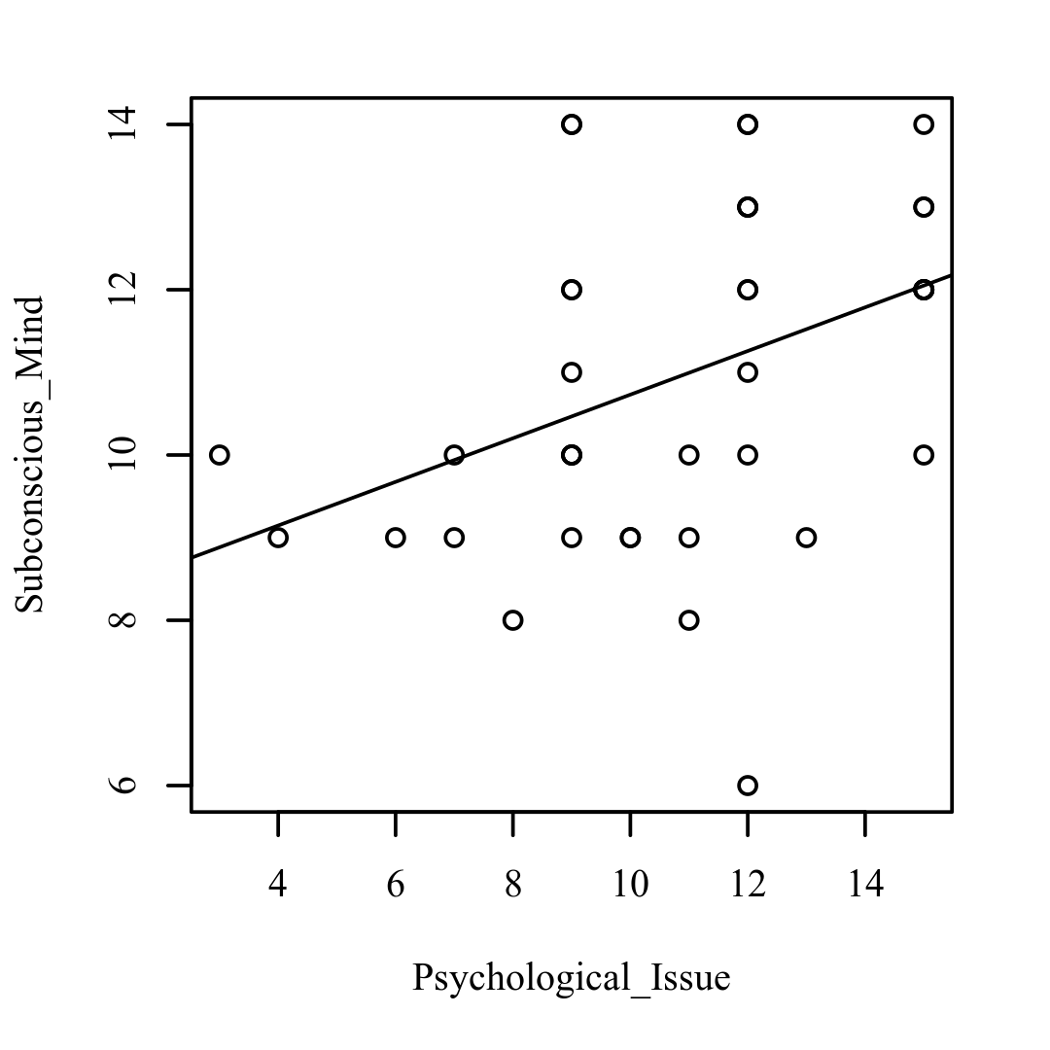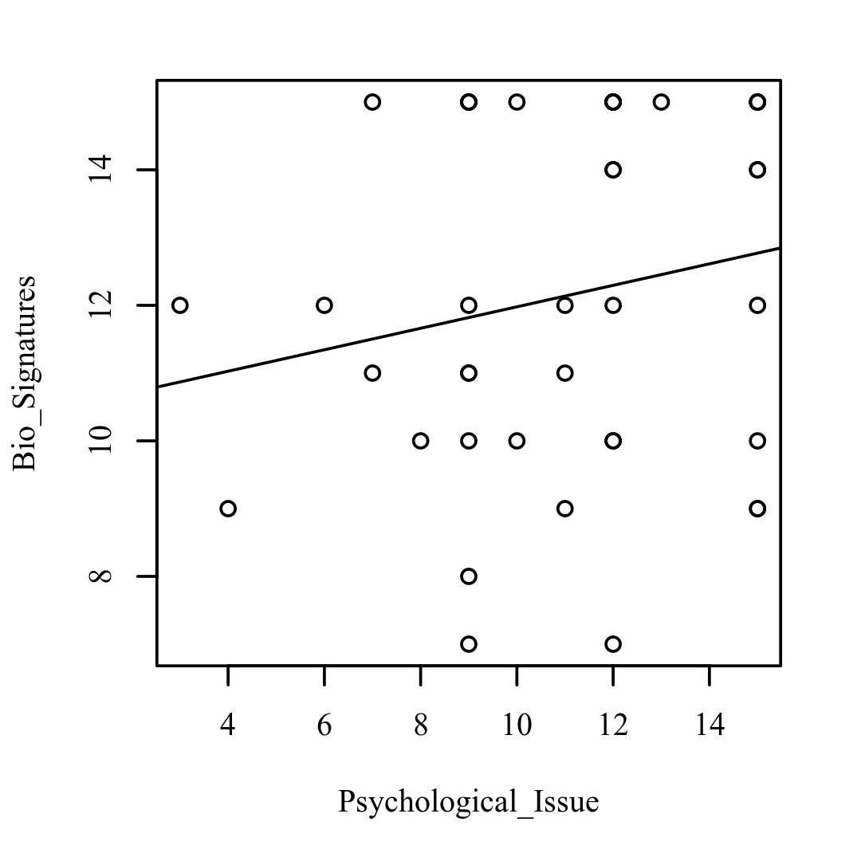

**Figure 1.2**

*Scatterplots with the regression line added for Psychological_Issue and Physical_Issue (left), Psychological_Issue and Conscious_Mind (right)*

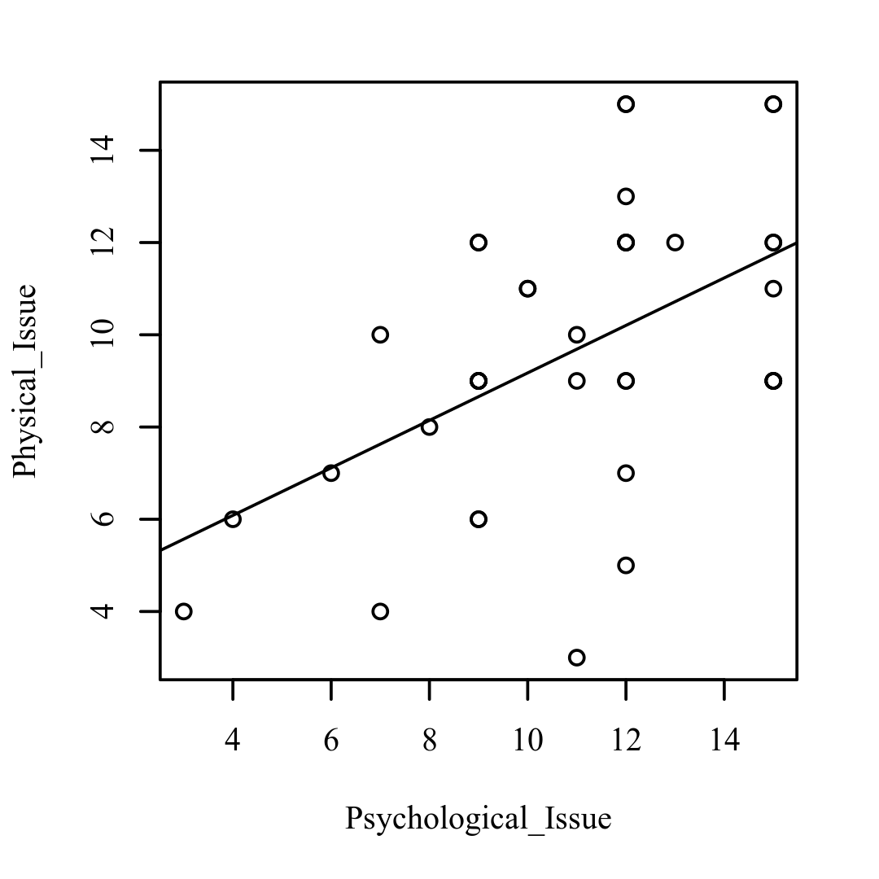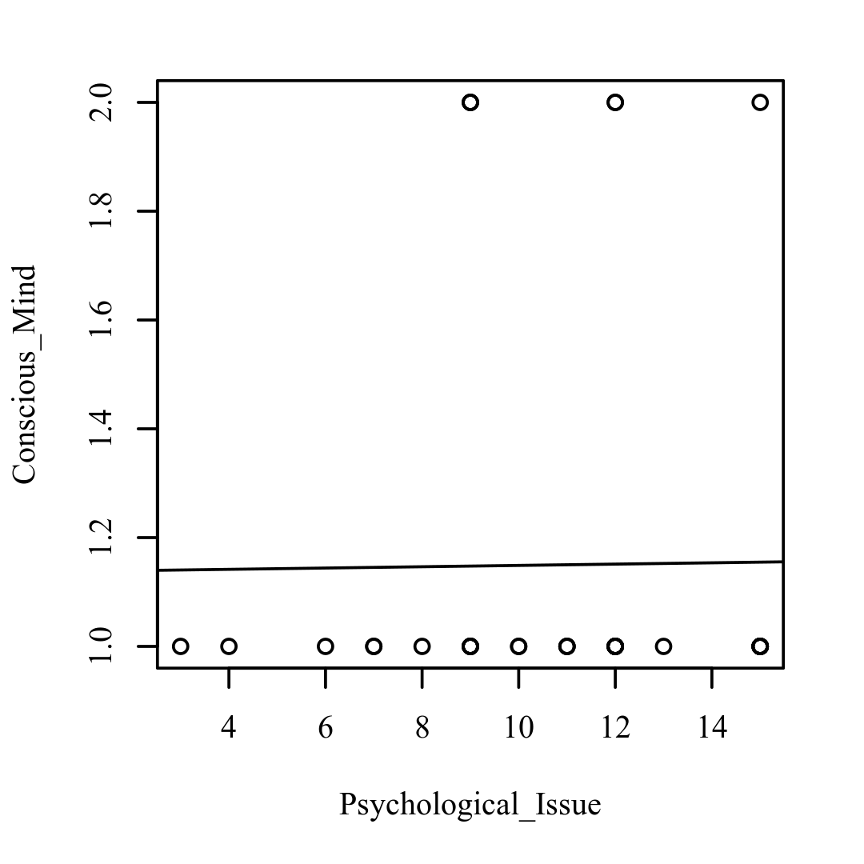

**Figure 1.3**

*Scatterplots with the regression line added for Psychological_Issue and Therapeutic_Intervention (left), Psychological_Issue and Role_of_Technology (right)*

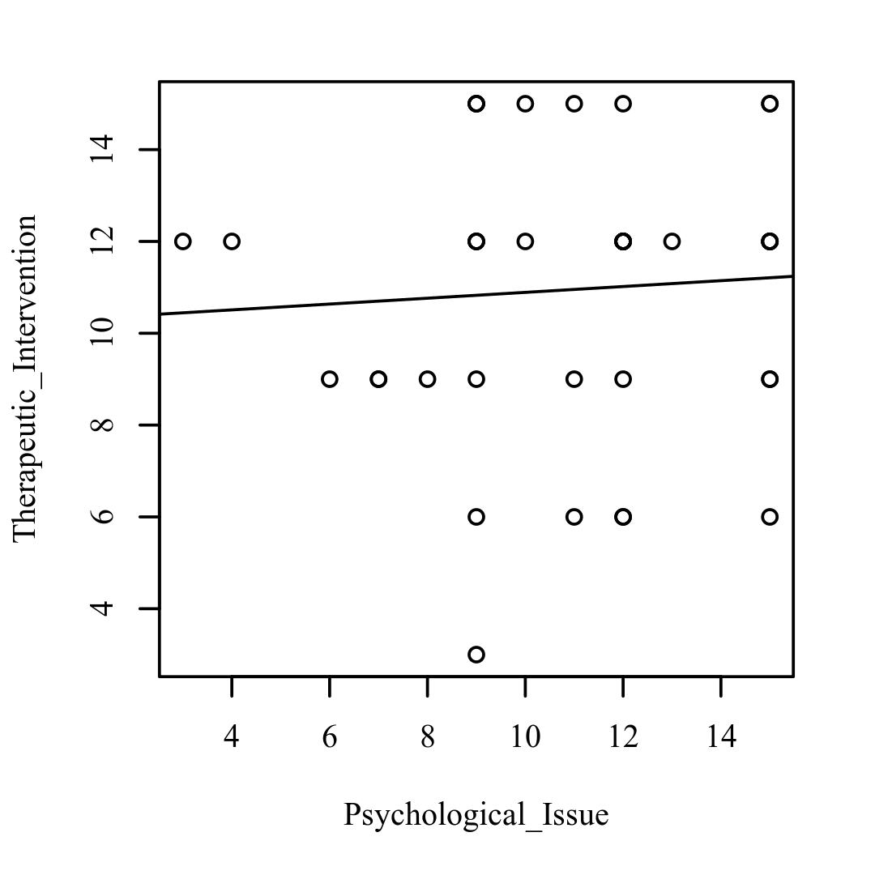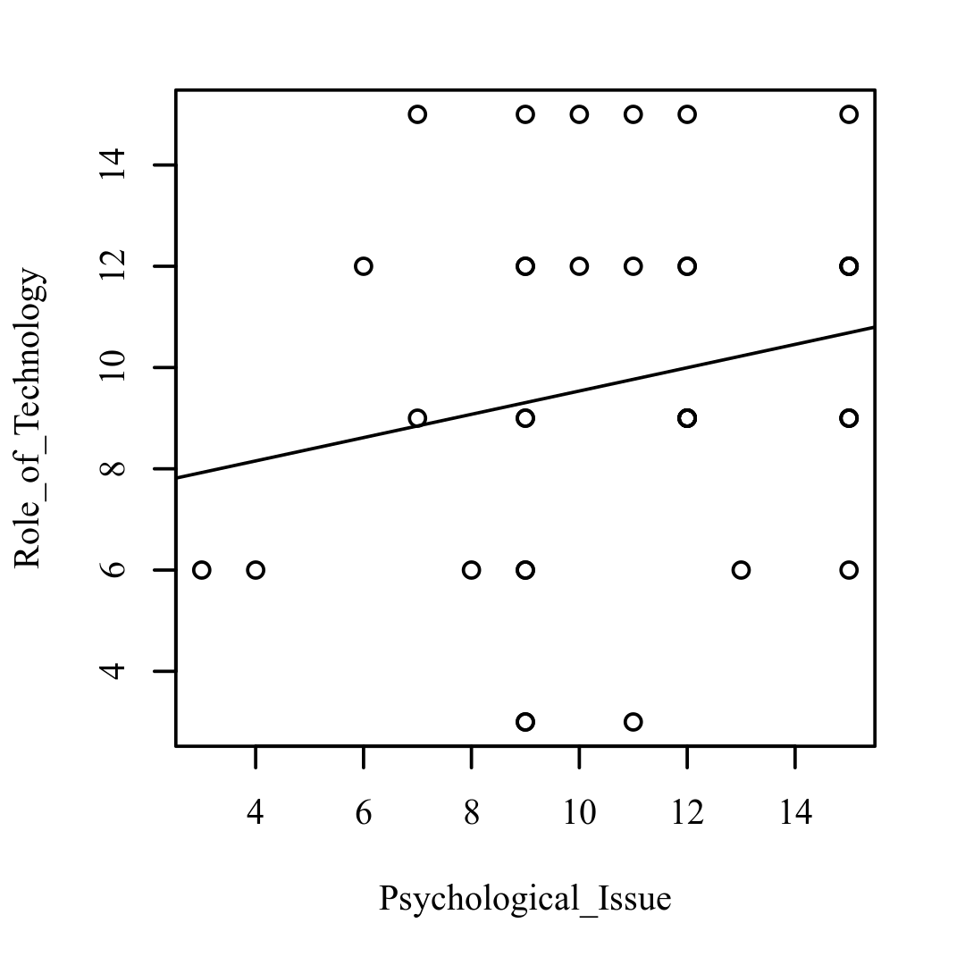

**Figure 1.4**

*Scatterplots with the regression line added for Psychological_Issue and Personality_Dimensions (left), Psychological_Issue and Psychosomatic_Health (right)*

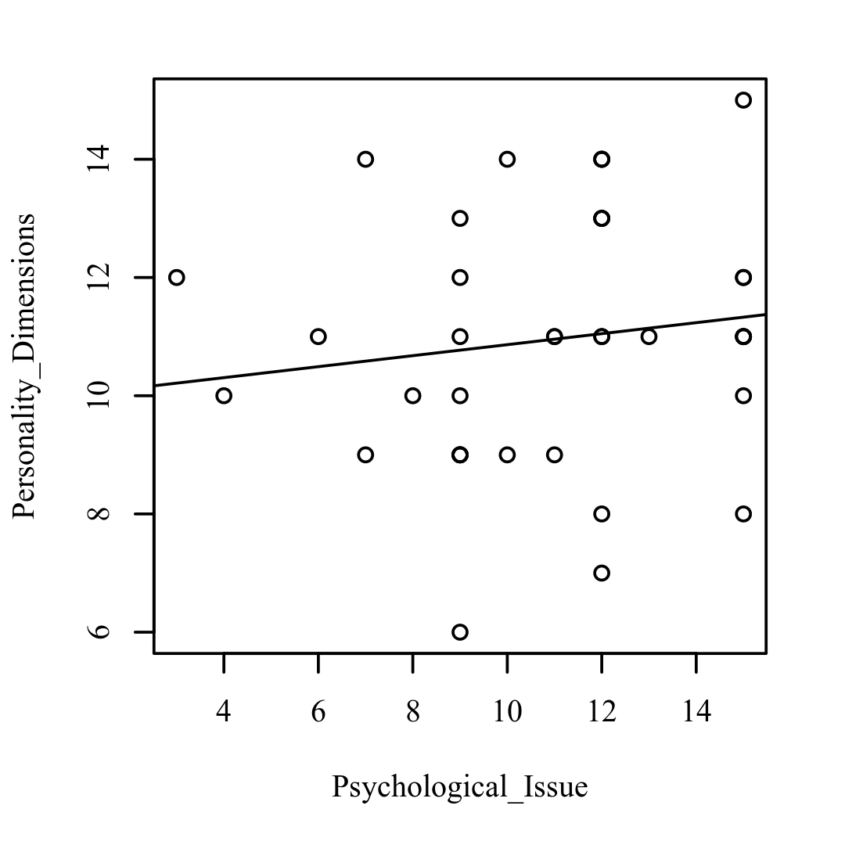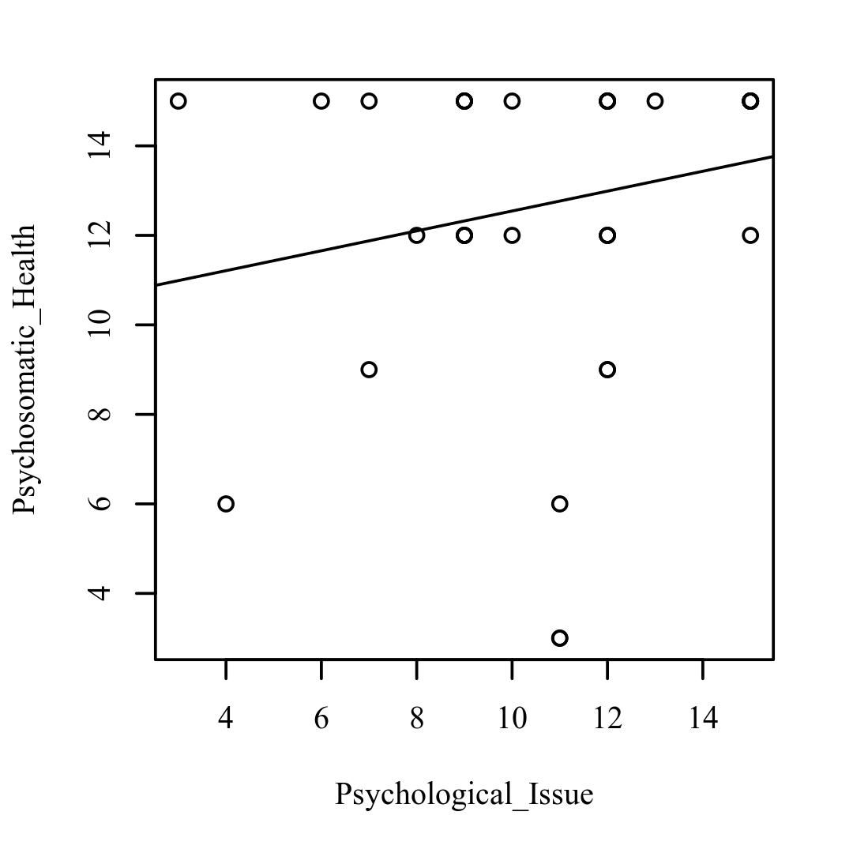

**Figure 1.5**

*Scatterplots with the regression line added for Subconscious_Mind and Bio_Signatures (left), Subconscious_Mind and Physical_Issue (right)*

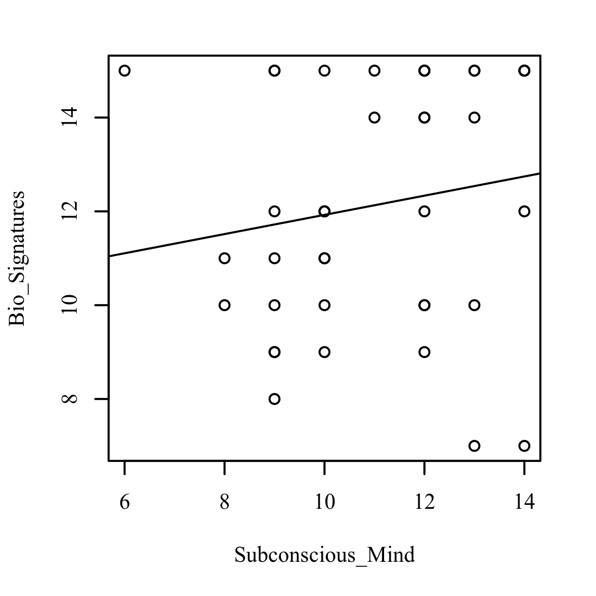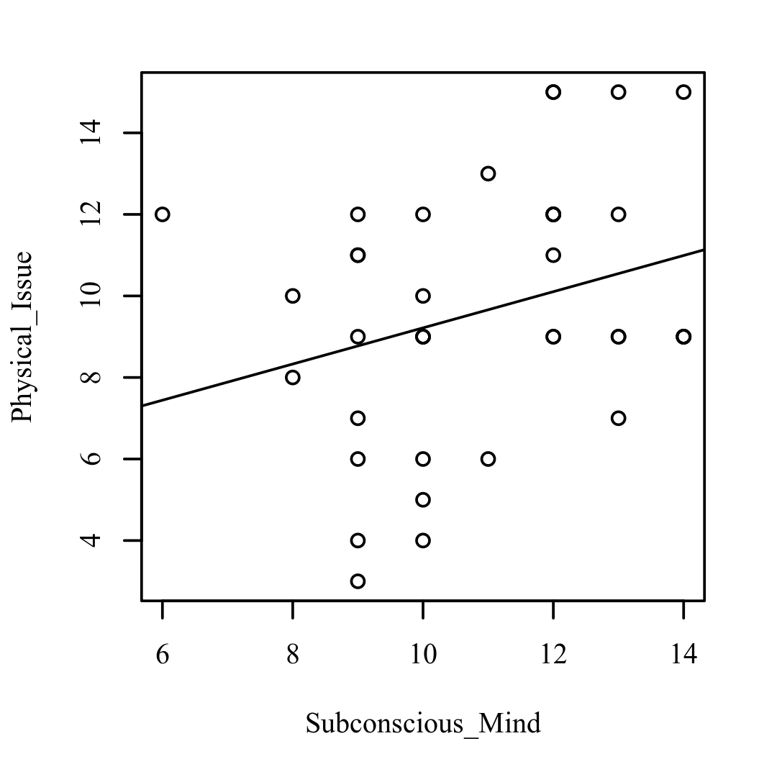

**Figure 1.6**

*Scatterplots with the regression line added for Subconscious_Mind and Conscious_Mind (left), Subconscious_Mind and Therapeutic_Intervention (right)*

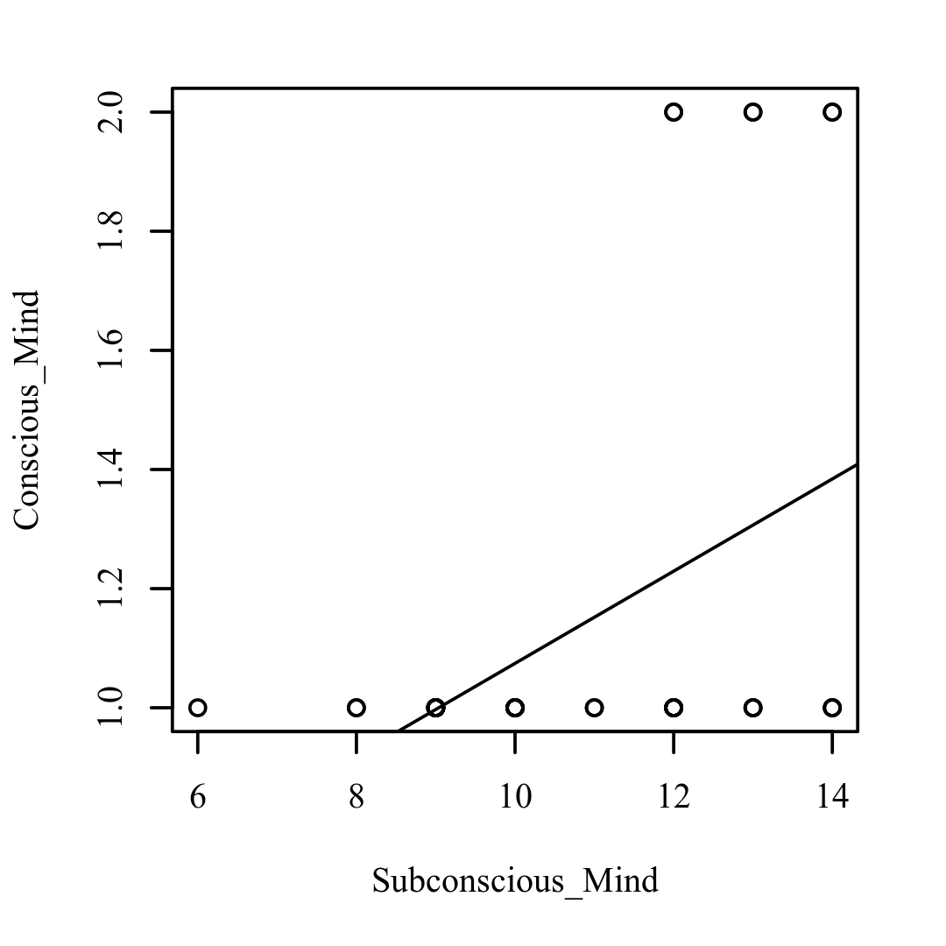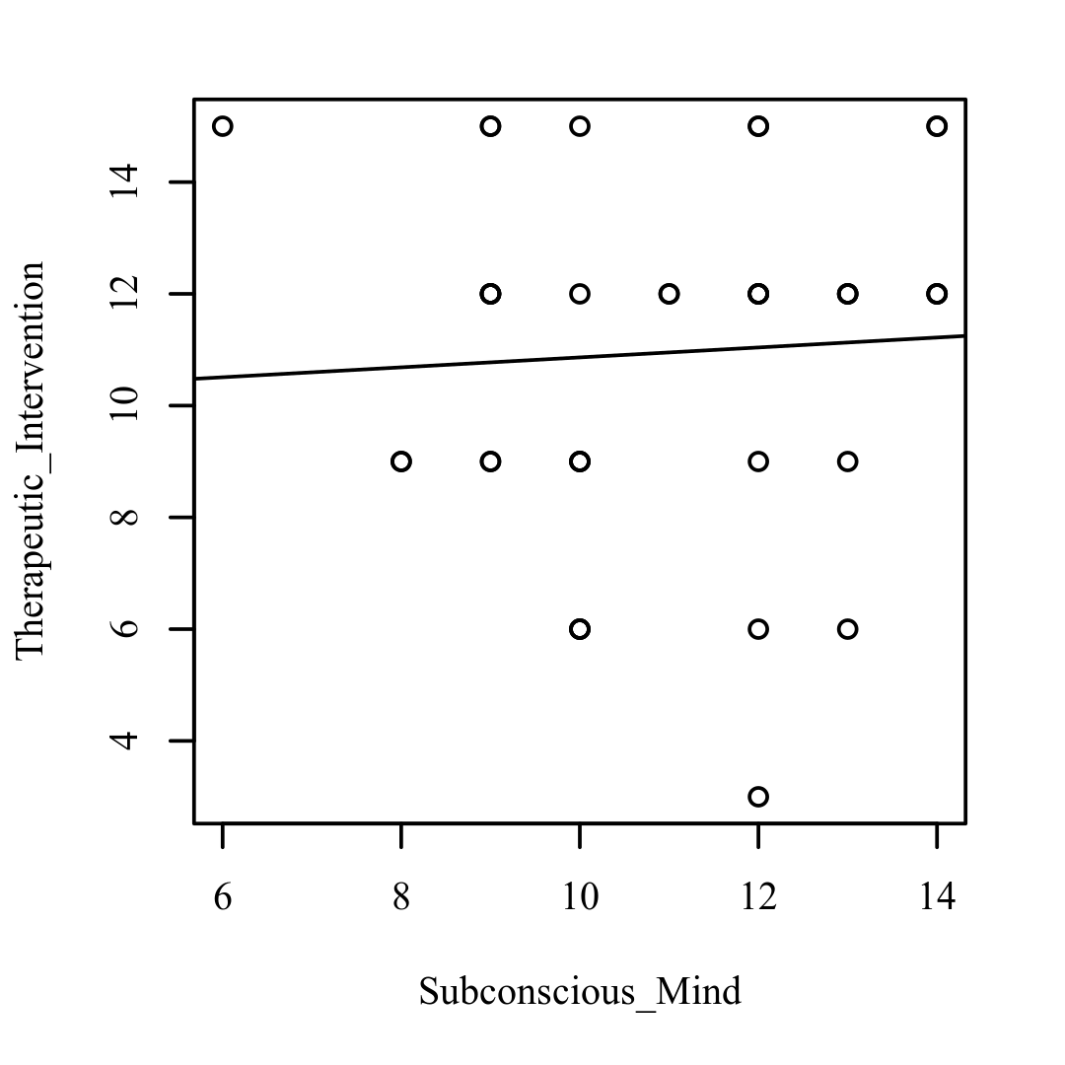

**Figure 1.7**

*Scatterplots with the regression line added for Subconscious_Mind and Role_of_Technology (left), Subconscious_Mind and Personality_Dimensions (right)*

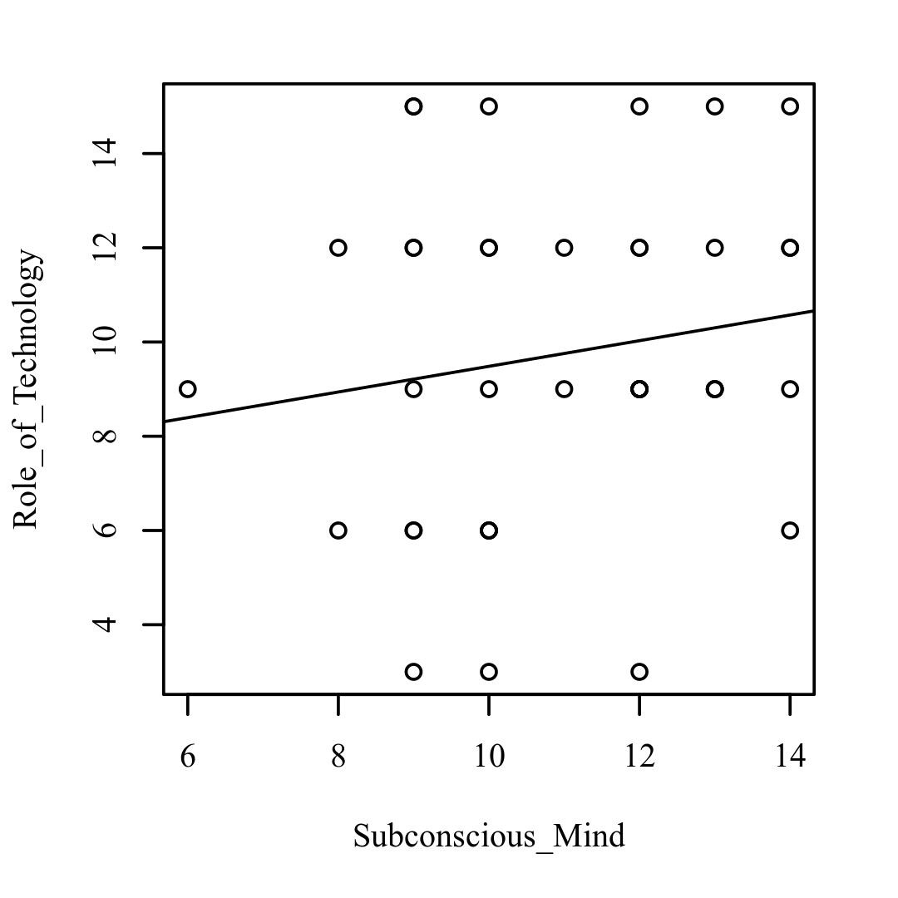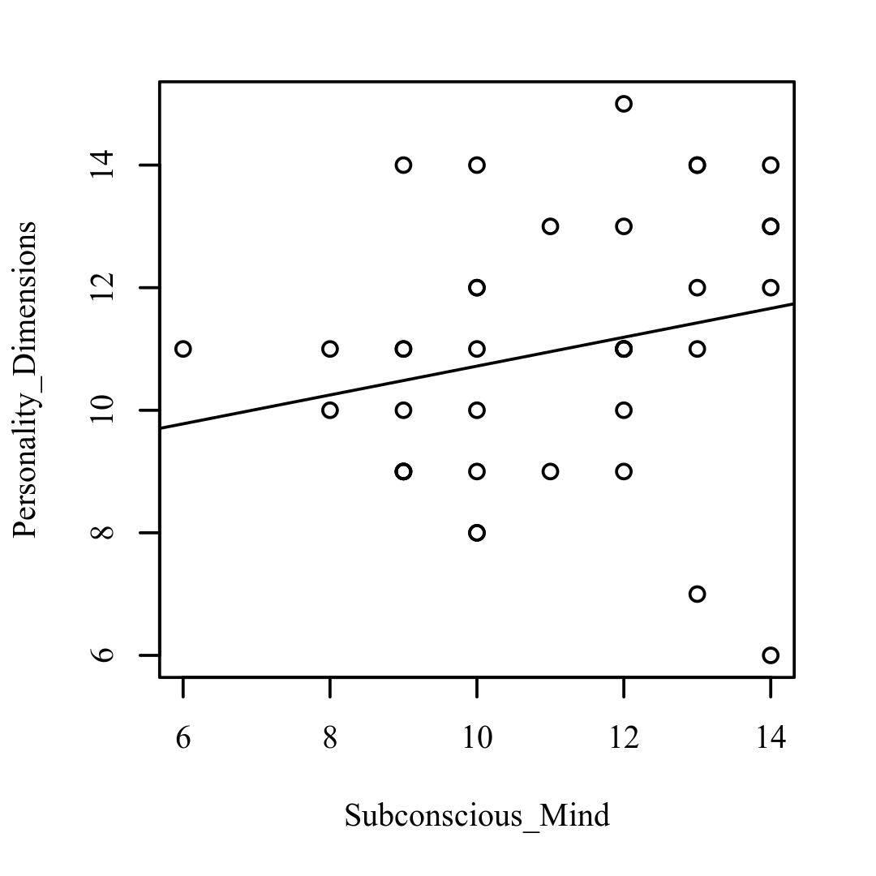

**Figure 1.8**

*Scatterplots with the regression line added for Subconscious_Mind and Psychosomatic_Health (left), Bio_Signatures and Physical_Issue (right)*

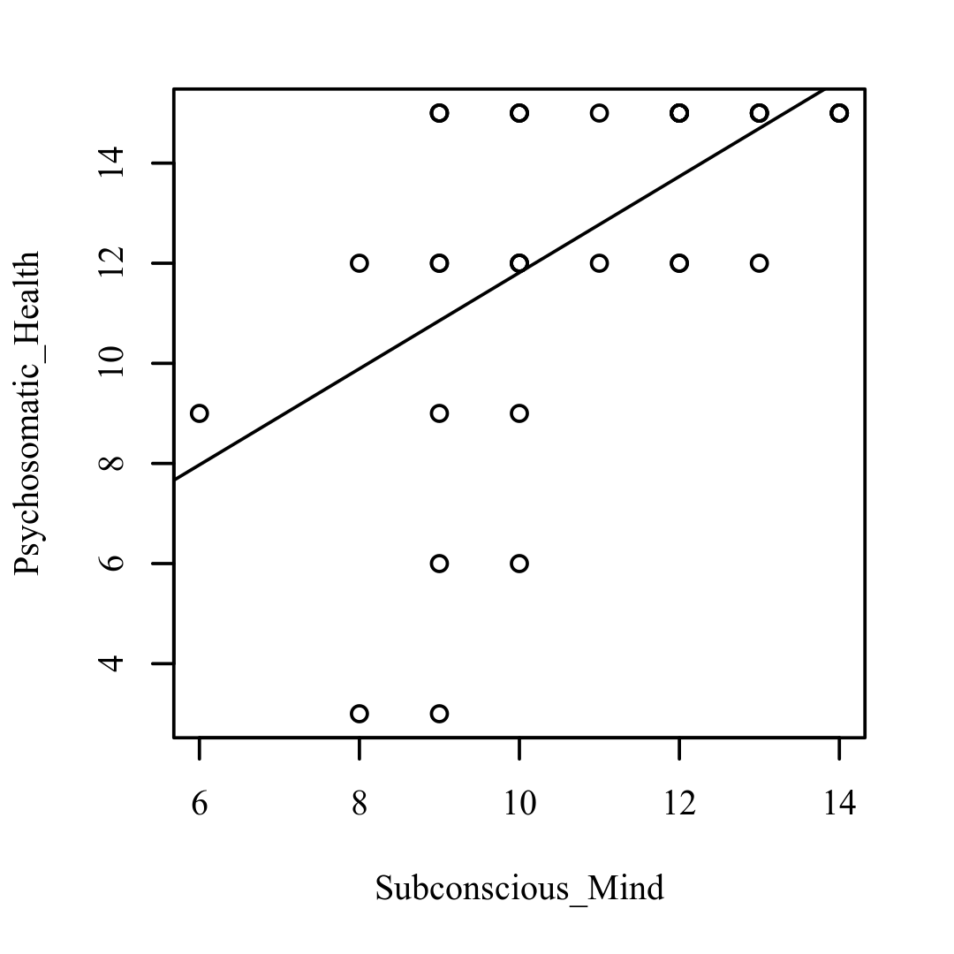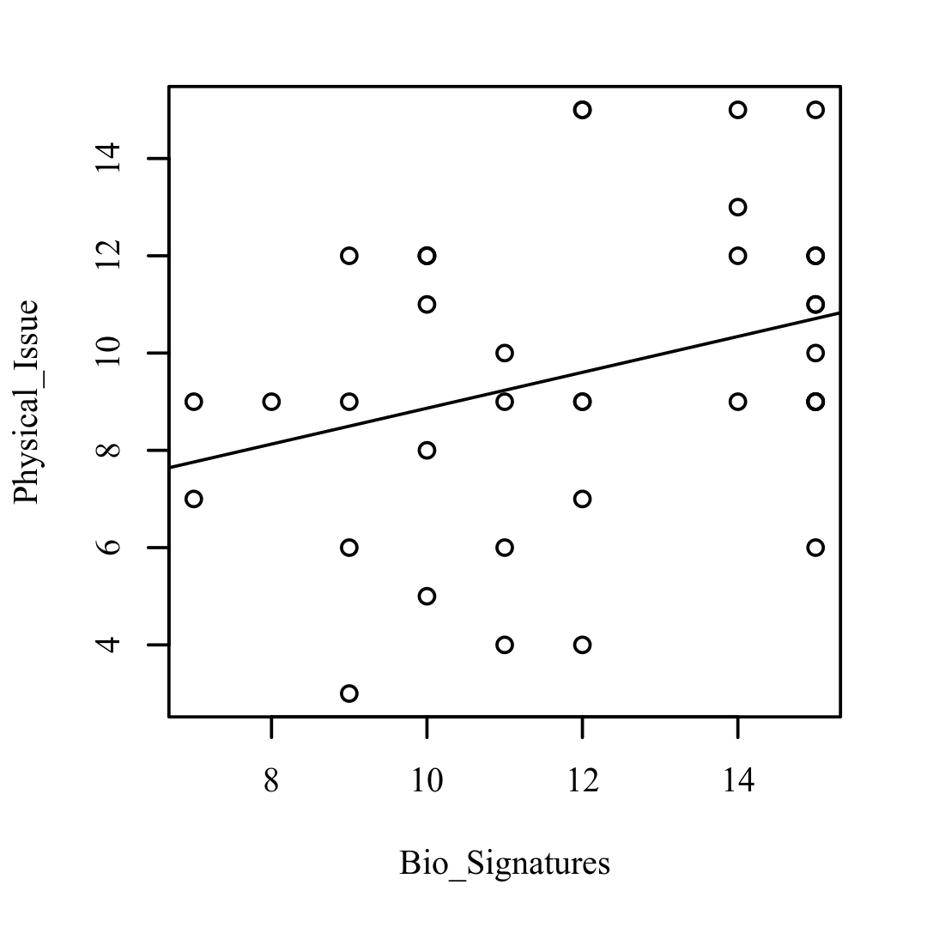

**Figure 1.9**

*Scatterplots with the regression line added for Bio_Signatures and Conscious_Mind (left), Bio_Signatures and Therapeutic_Intervention (right)*

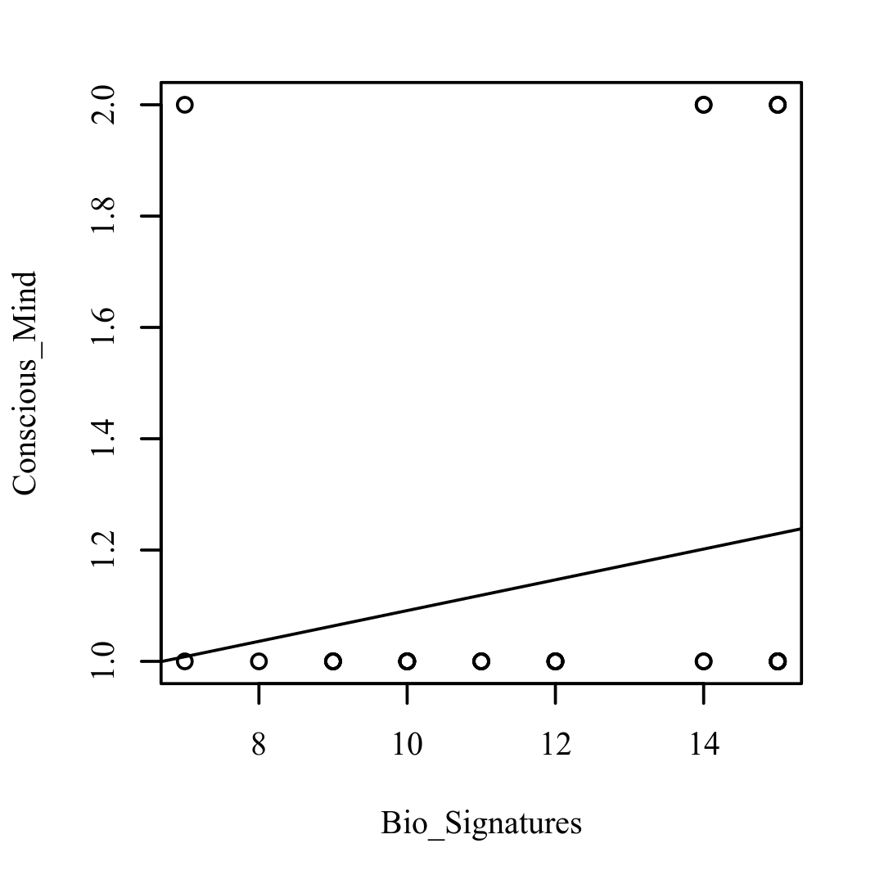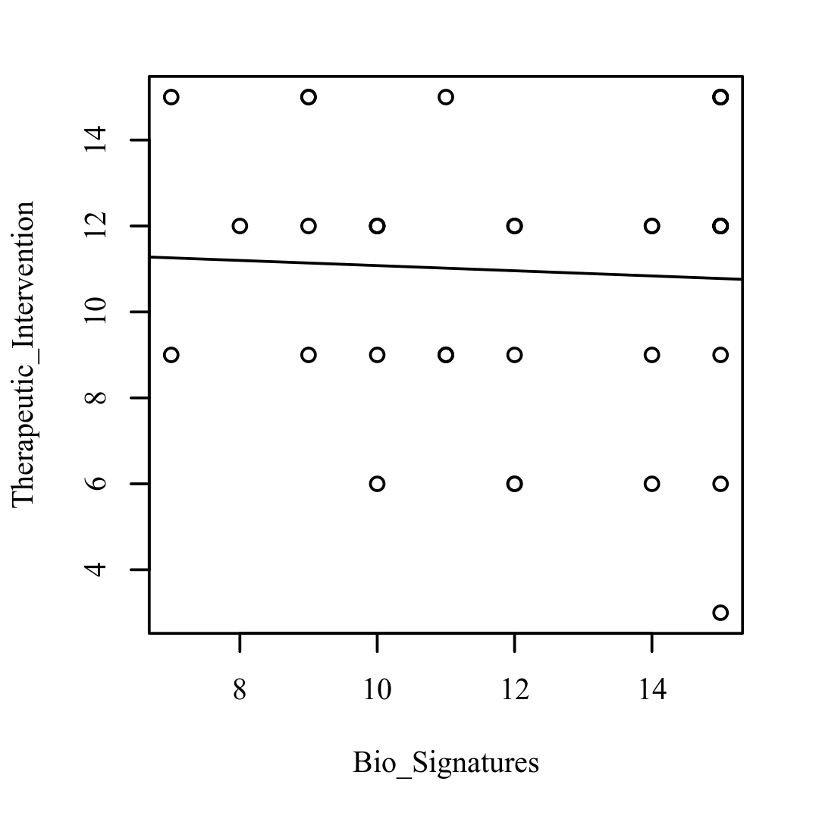

**Figure 1.10**

*Scatterplots with the regression line added for Bio_Signatures and Role_of_Technology (left), Bio_Signatures and Personality_Dimensions (right)*

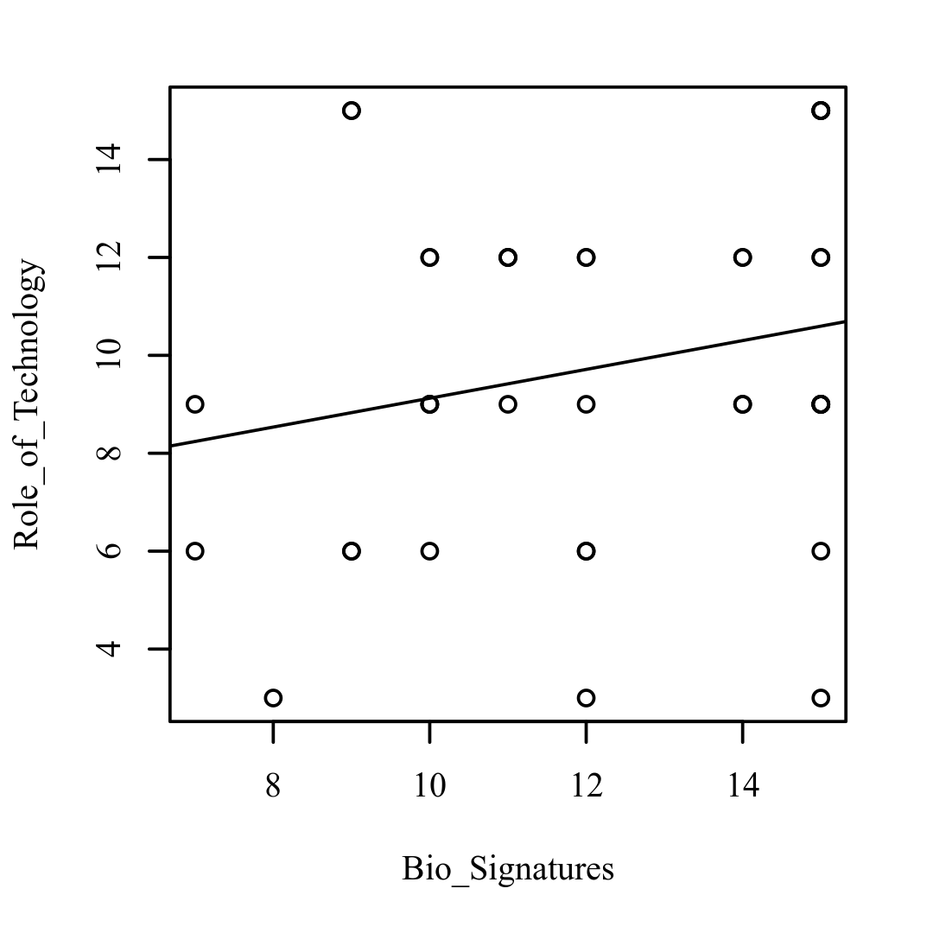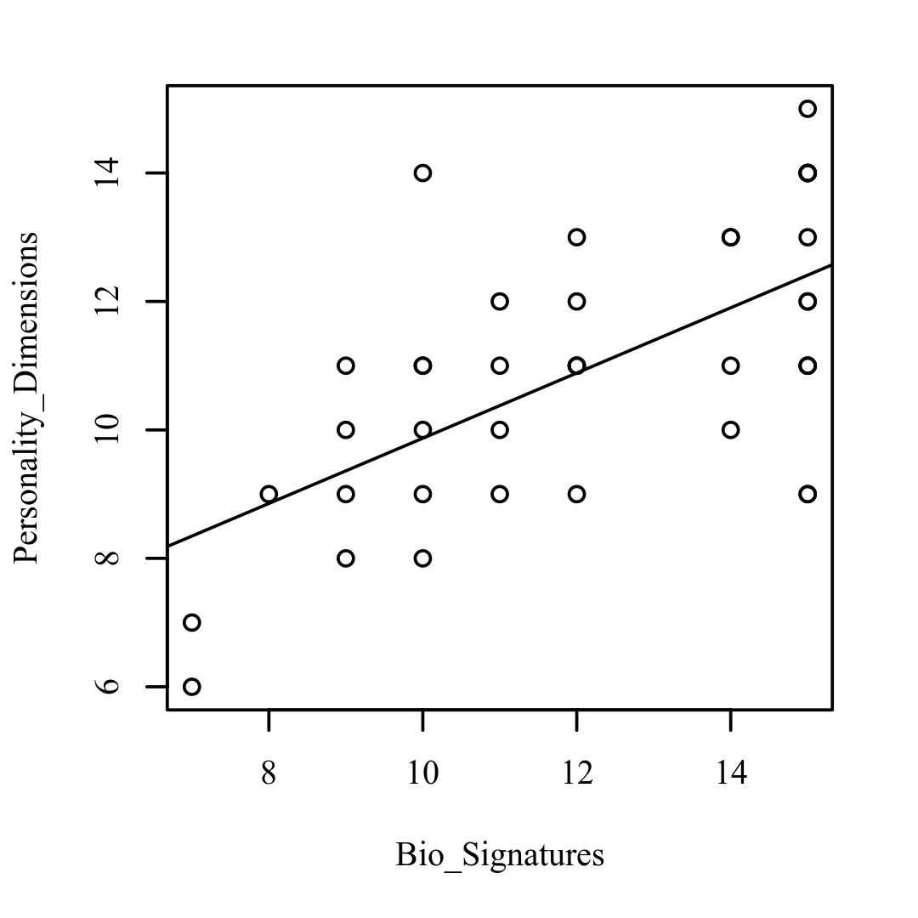

**Figure 1.11**

*Scatterplots with the regression line added for Bio_Signatures and Psychosomatic_Health (left), Physical_Issue and Conscious_Mind (right)*

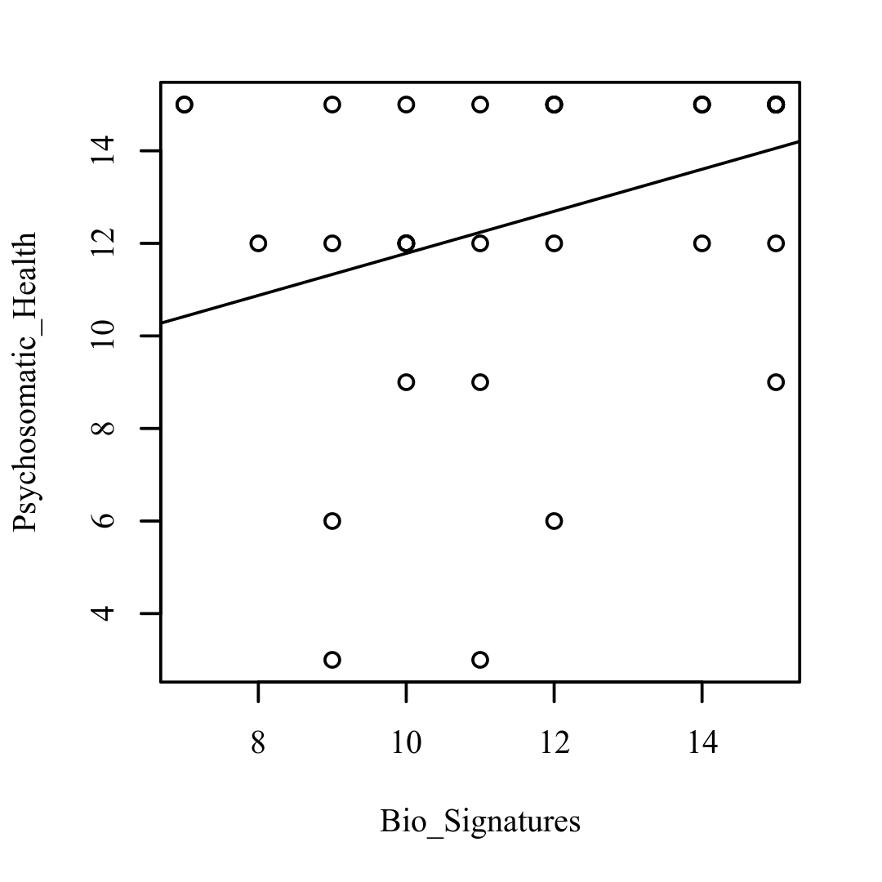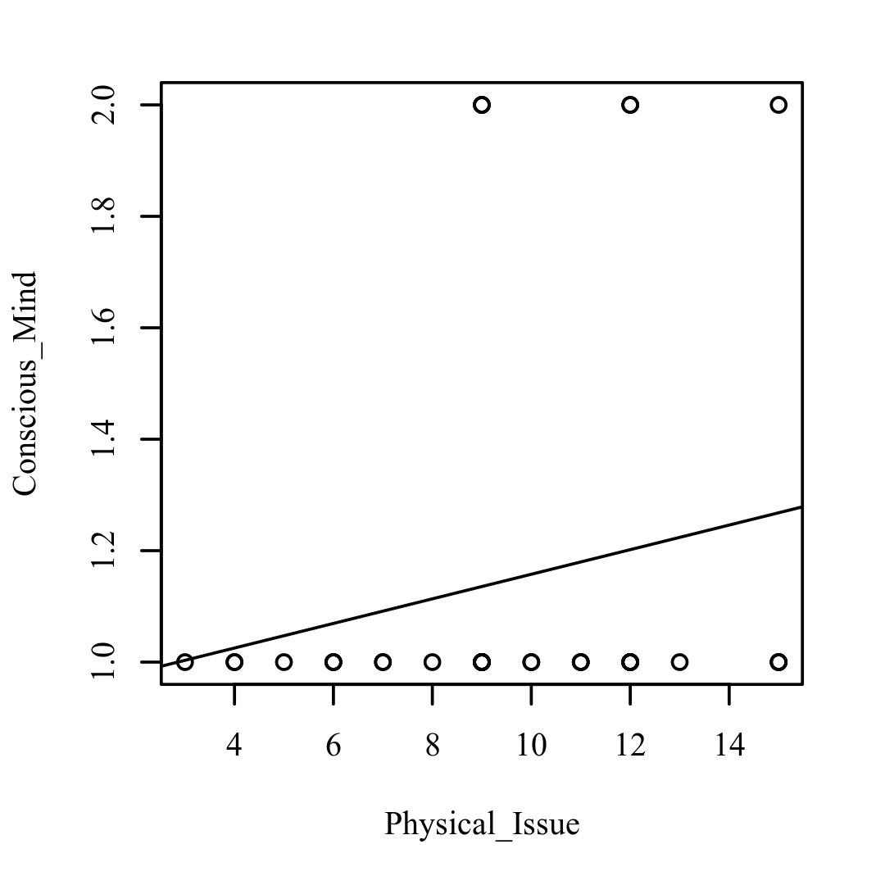

**Figure 1.12**

*Scatterplots with the regression line added for Physical_Issue and Therapeutic_Intervention (left), Physical_Issue and Role_of_Technology (right)*

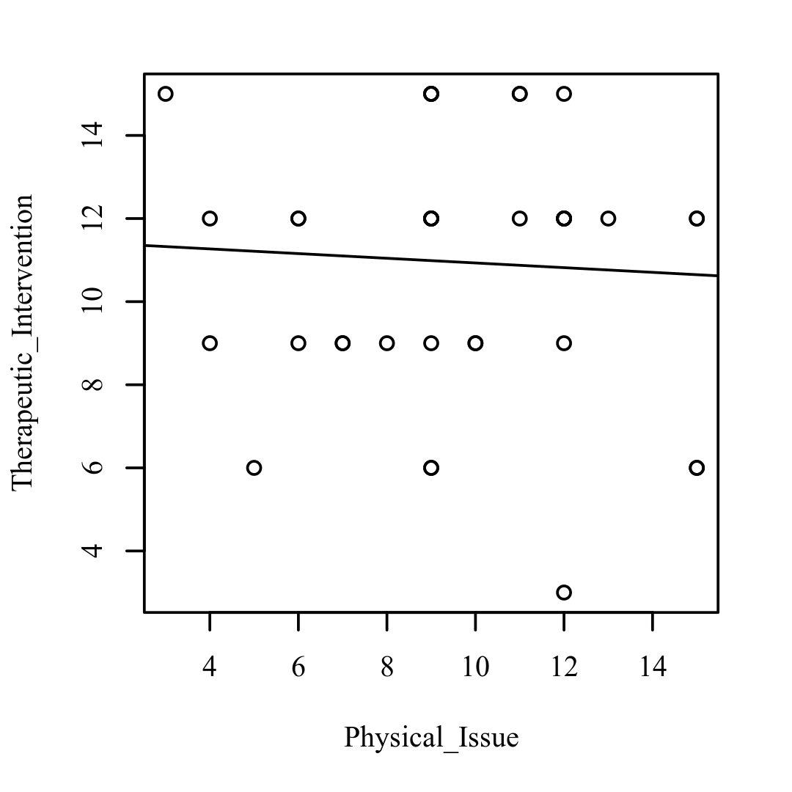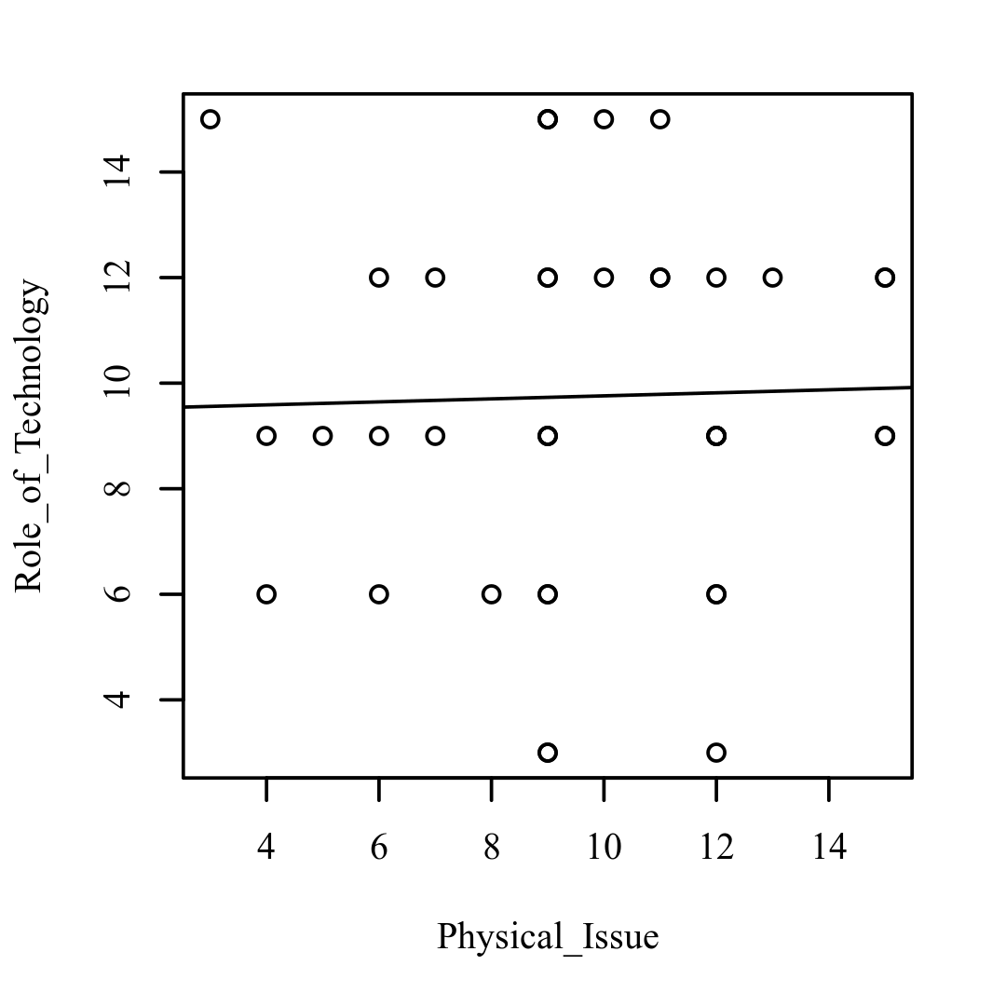

**Figure 1.13**

*Scatterplots with the regression line added for Physical_Issue and Personality_Dimensions (left), Physical_Issue and Psychosomatic_Health (right)*

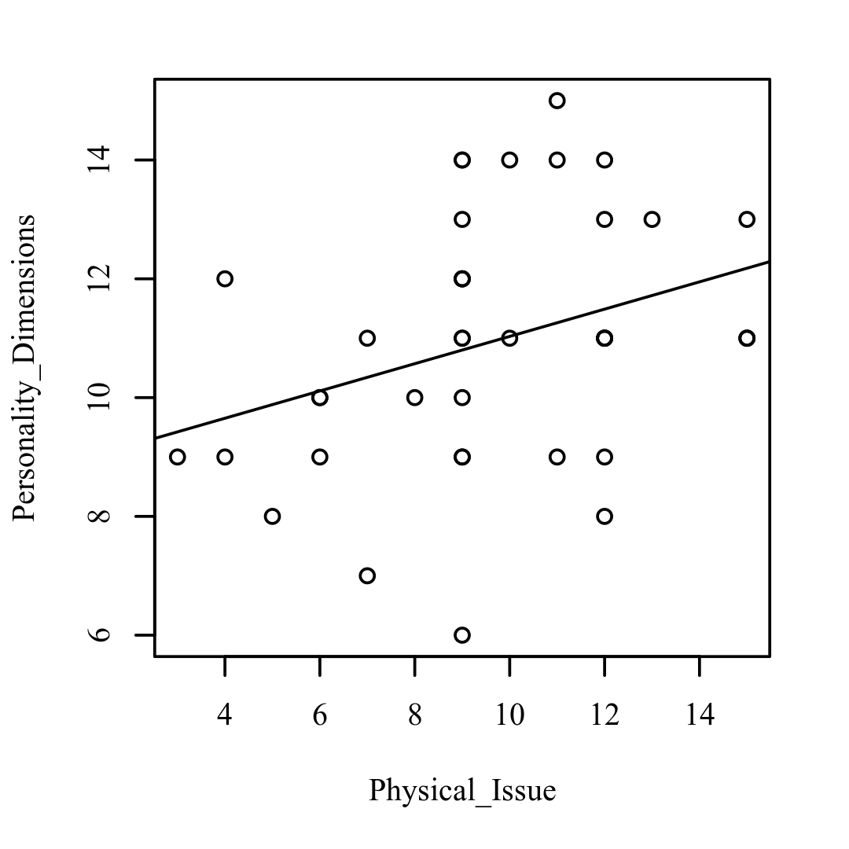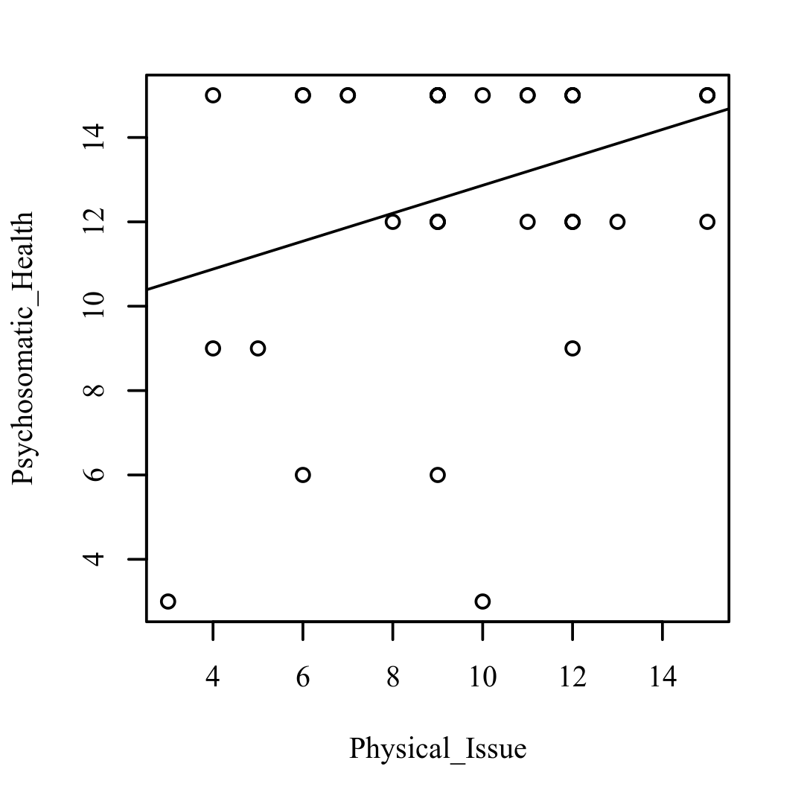

**Figure 1.14**

*Scatterplots with the regression line added for Conscious_Mind and Therapeutic_Intervention (left), Conscious_Mind and Role_of_Technology (right)*

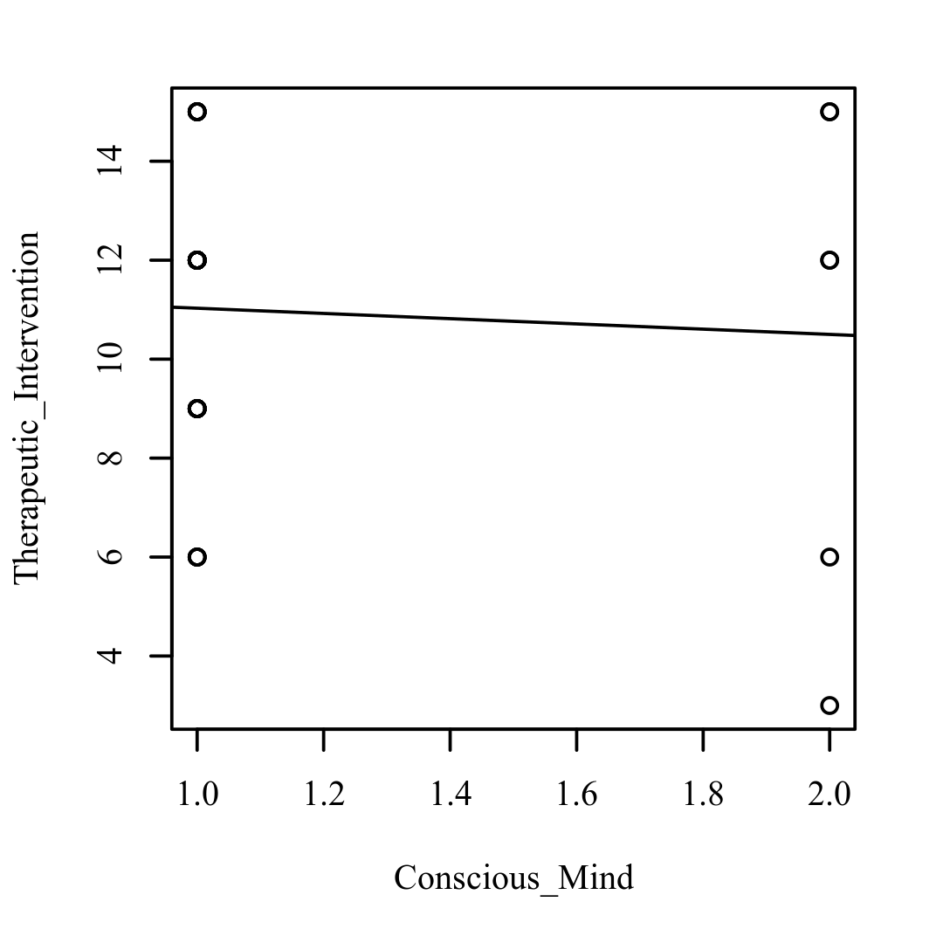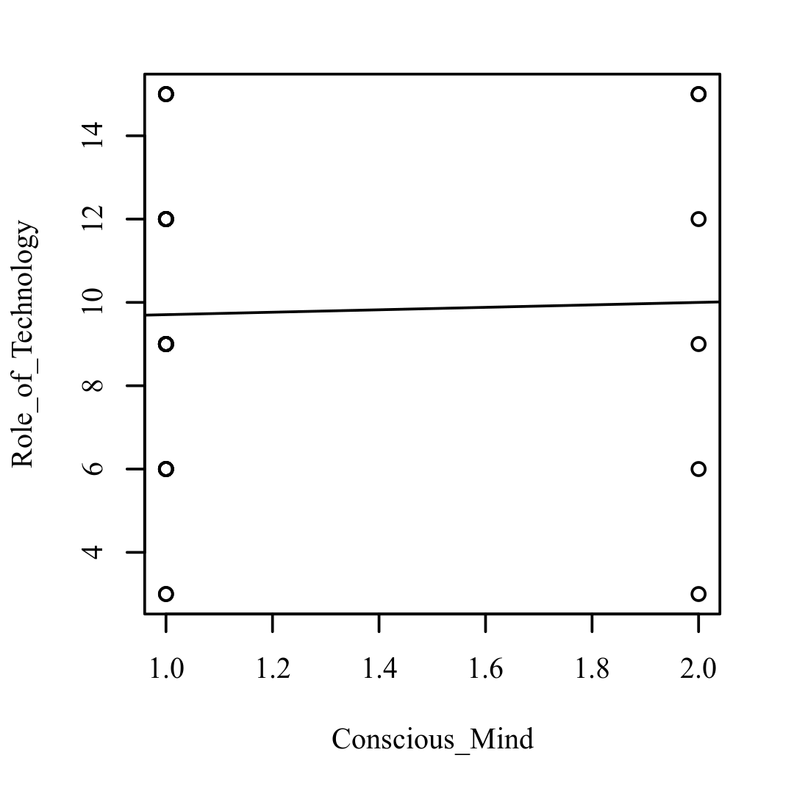

**Figure 1.15**

*Scatterplots with the regression line added for Conscious_Mind and Personality_Dimensions (left), Conscious_Mind and Psychosomatic_Health (right)*

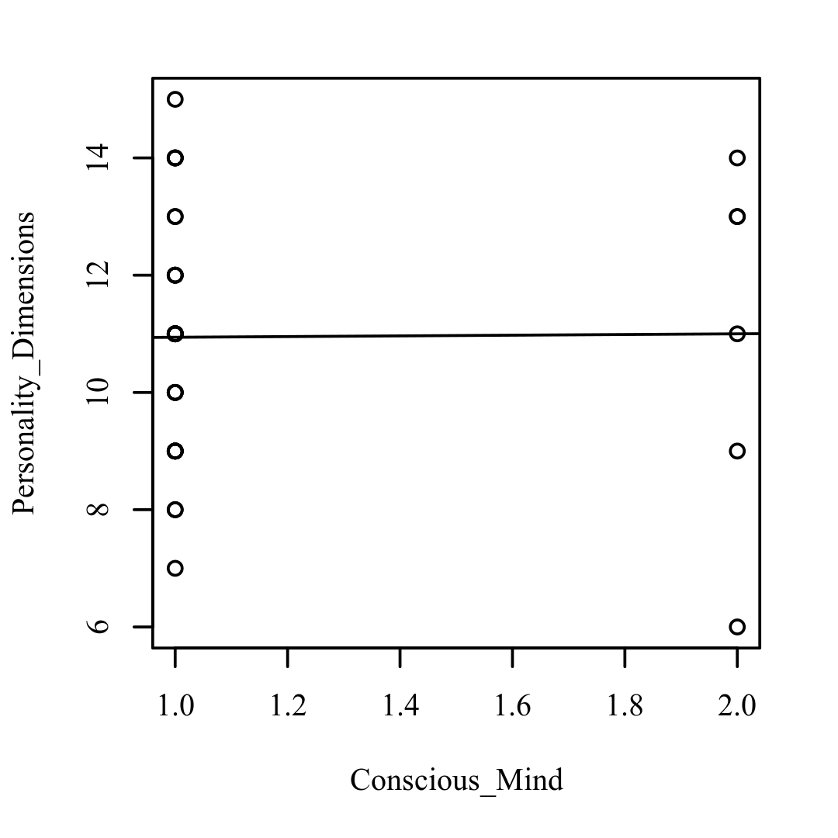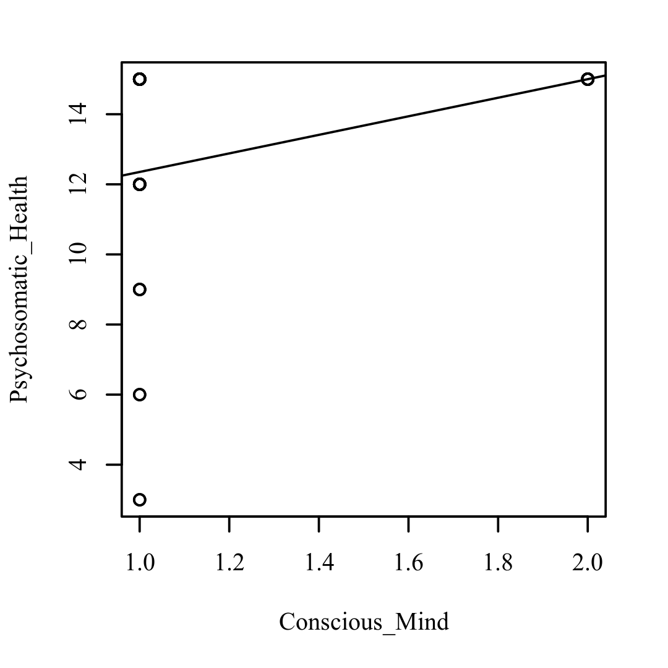

**Figure 1.16**

*Scatterplots with the regression line added for Therapeutic_Intervention and Role_of_Technology (left), Therapeutic_Intervention and Personality_Dimensions (right)*

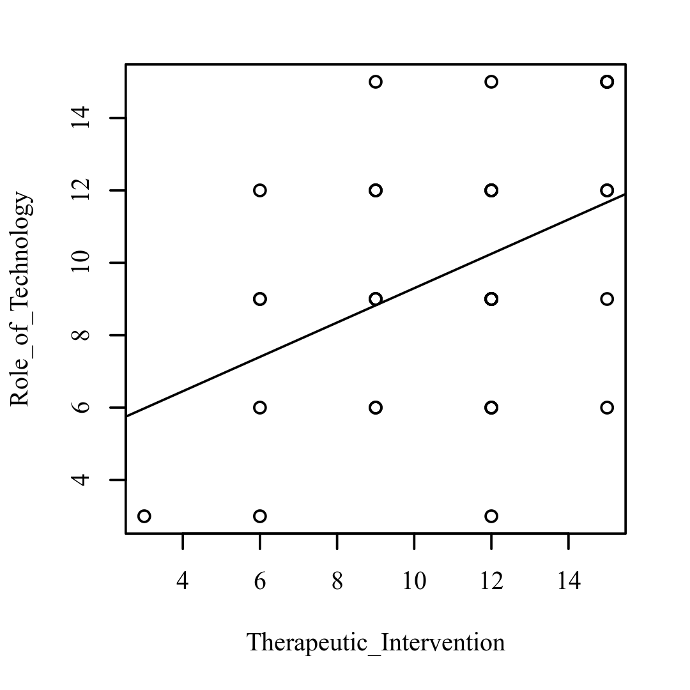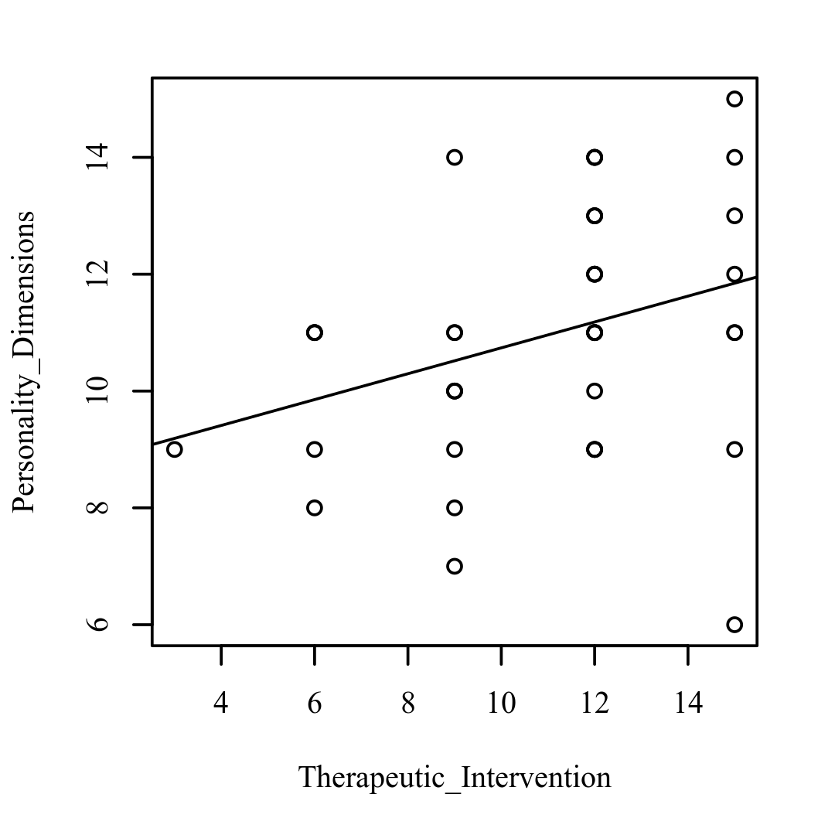

**Figure 1.17**

*Scatterplots with the regression line added for Therapeutic_Intervention and Psychosomatic_Health (left), Role_of_Technology and Personality_Dimensions (right)*

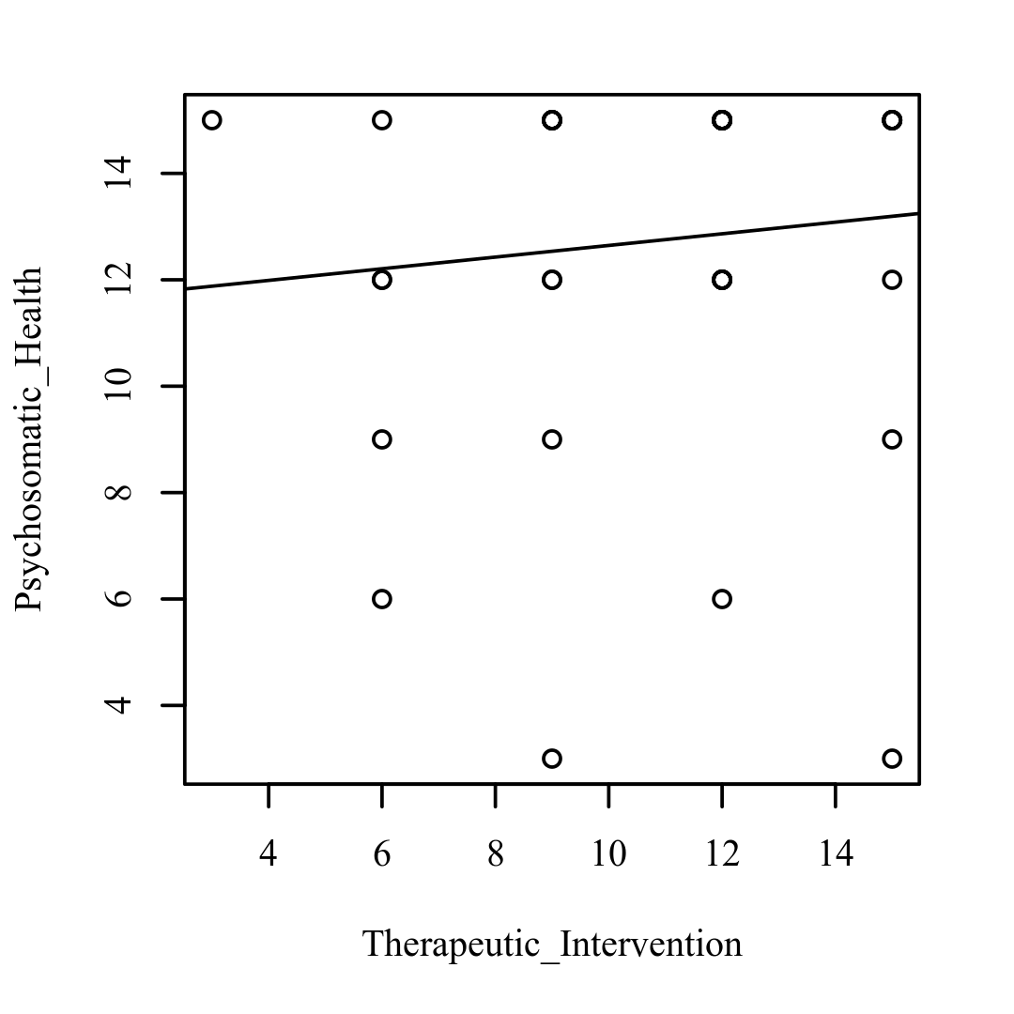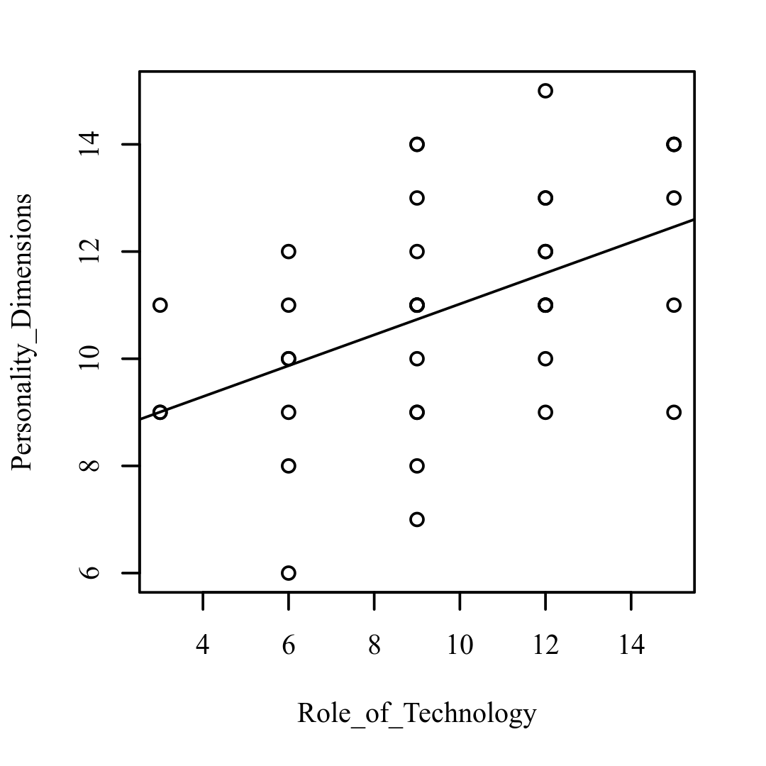

**Figure 1.18**

*Scatterplots with the regression line added for Role_of_Technology and Psychosomatic_Health (left), Personality_Dimensions and Psychosomatic_Health (right)*

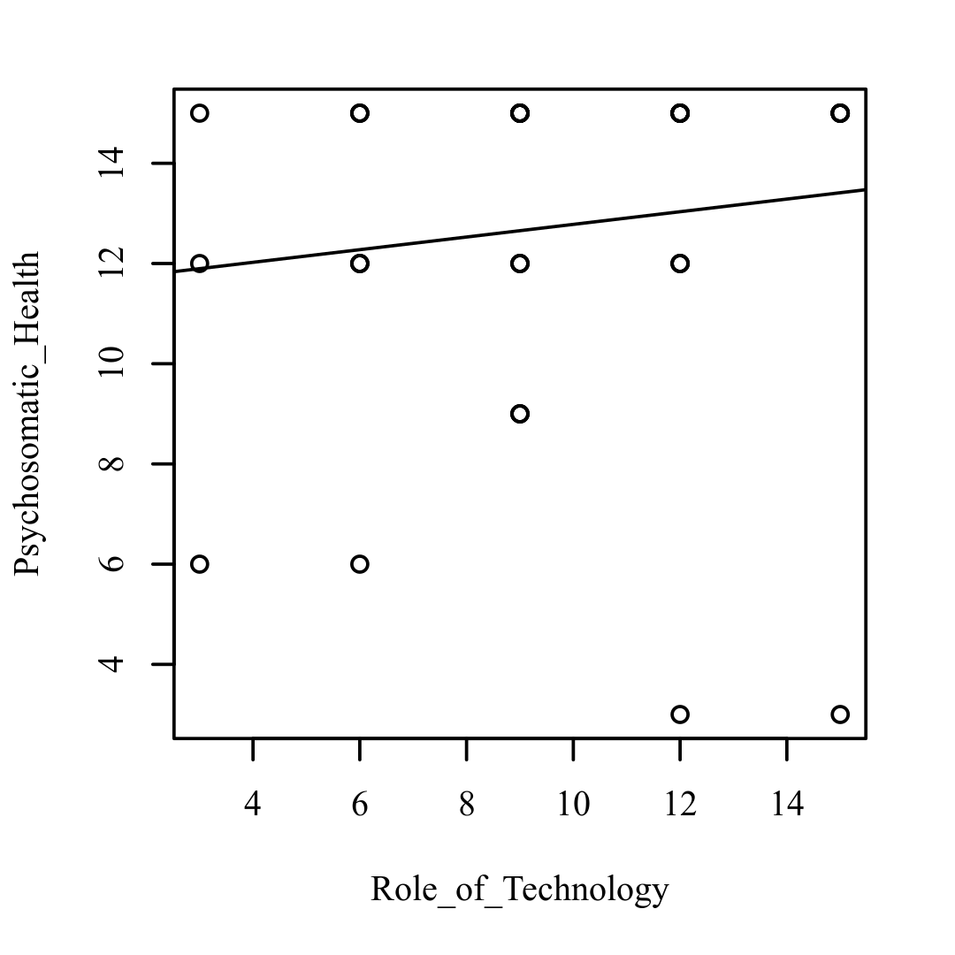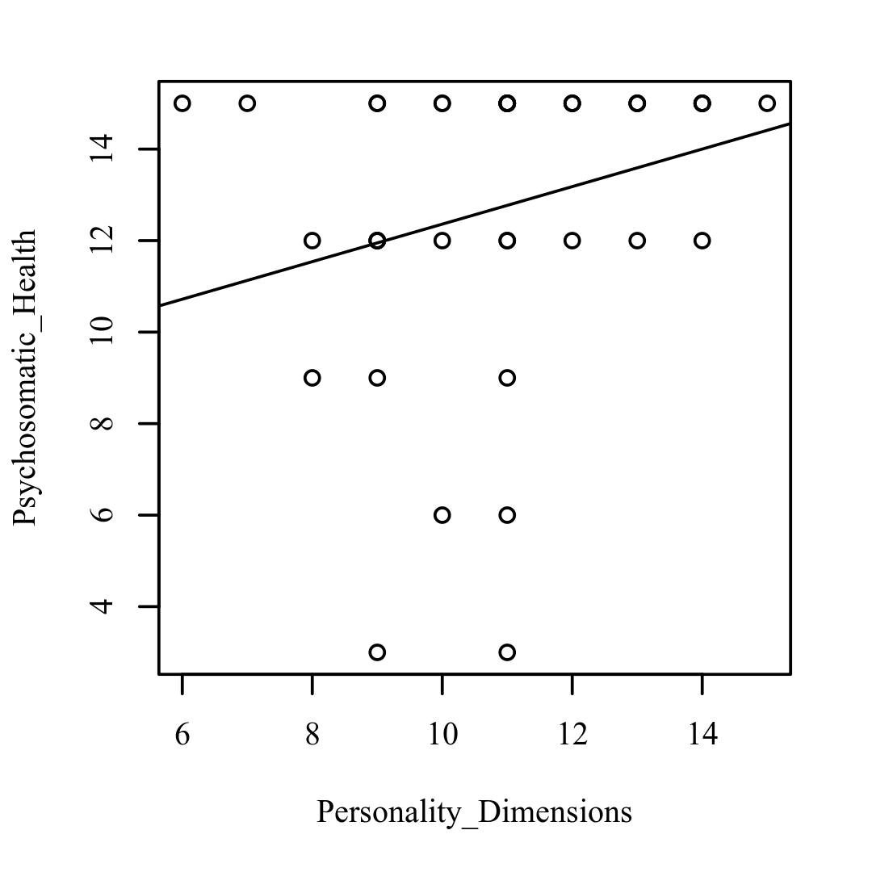

***Results***

The Holm correction, based on an alpha value of 0.05, was used to compensate for multiple comparisons in the correlations. Psychological Issue and Physical Issue had a significant positive connection (r = 0.52, p =.020, 95 percent CI = [0.25, 0.72]). Psychological Issue and Physical Issue had a correlation coefficient of 0.52, indicating a large effect size. This relationship shows that as Psychological Issue rises, Physical Issue rises as well. Subconscious Mind and Psychosomatic Health have a substantial positive connection (r = 0.57, p =.004, 95 percent CI = [0.31, 0.75]).

Subconscious Mind and Psychosomatic Health had a 0.57 correlation coefficient, indicating a large effect size. This relationship suggests that as Subconscious Mind grows, so does Psychosomatic Health. Bio Signatures and Personality Dimensions had a substantial positive connection (r = 0.63, p.001, 95 percent CI = [0.39, 0.79]). Bio Signatures and Personality Dimensions have a 0.63 correlation coefficient, indicating a large effect size. This relationship suggests that as Bio Signatures rise, Personality Dimensions rise as well. There were no additional significant relationships discovered. The correlations' results are shown in Table 1.

**Table 1.1**

*Pearson Correlation Results Among Psychological_Issue, Subconscious_Mind, Bio_Signatures, Physical_Issue, Conscious_Mind, Therapeutic_Intervention, Role_of_Technology, Personality_Dimensions, and Psychosomatic_Health*

|  |  |  |  |  |
| --- | --- | --- | --- | --- |
| Combination | *r* | 95% CI | *n* | *p* |
| Psychological_Issue-Subconscious_Mind | 0.41 | [0.11, 0.64] | 40 | .270 |
| Psychological_Issue-Bio_Signatures | 0.19 | [-0.13, 0.47] | 40 | 1.000 |
| Psychological_Issue-Physical_Issue | 0.52 | [0.25, 0.72] | 40 | .020 |
| Psychological_Issue-Conscious_Mind | 0.01 | [-0.30, 0.32] | 40 | 1.000 |
| Psychological_Issue-Therapeutic_Intervention | 0.06 | [-0.25, 0.37] | 40 | 1.000 |
| Psychological_Issue-Role_of_Technology | 0.21 | [-0.11, 0.49] | 40 | 1.000 |
| Psychological_Issue-Personality_Dimensions | 0.14 | [-0.18, 0.43] | 40 | 1.000 |
| Psychological_Issue-Psychosomatic_Health | 0.20 | [-0.12, 0.48] | 40 | 1.000 |
| Subconscious_Mind-Bio_Signatures | 0.16 | [-0.16, 0.45] | 40 | 1.000 |
| Subconscious_Mind-Physical_Issue | 0.29 | [-0.02, 0.55] | 40 | 1.000 |
| Subconscious_Mind-Conscious_Mind | 0.43 | [0.14, 0.65] | 40 | .182 |
| Subconscious_Mind-Therapeutic_Intervention | 0.06 | [-0.26, 0.36] | 40 | 1.000 |
| Subconscious_Mind-Role_of_Technology | 0.16 | [-0.16, 0.45] | 40 | 1.000 |
| Subconscious_Mind-Personality_Dimensions | 0.22 | [-0.09, 0.50] | 40 | 1.000 |
| Subconscious_Mind-Psychosomatic_Health | 0.57 | [0.31, 0.75] | 40 | .004 |
| Bio_Signatures-Physical_Issue | 0.31 | [0.00, 0.57] | 40 | 1.000 |
| Bio_Signatures-Conscious_Mind | 0.20 | [-0.12, 0.48] | 40 | 1.000 |
| Bio_Signatures-Therapeutic_Intervention | -0.05 | [-0.36, 0.27] | 40 | 1.000 |
| Bio_Signatures-Role_of_Technology | 0.22 | [-0.10, 0.50] | 40 | 1.000 |
| Bio_Signatures-Personality_Dimensions | 0.63 | [0.39, 0.79] | 40 | < .001 |
| Bio_Signatures-Psychosomatic_Health | 0.35 | [0.04, 0.60] | 40 | .794 |
| Physical_Issue-Conscious_Mind | 0.19 | [-0.13, 0.47] | 40 | 1.000 |
| Physical_Issue-Therapeutic_Intervention | -0.06 | [-0.36, 0.26] | 40 | 1.000 |
| Physical_Issue-Role_of_Technology | 0.03 | [-0.29, 0.33] | 40 | 1.000 |
| Physical_Issue-Personality_Dimensions | 0.34 | [0.03, 0.59] | 40 | .959 |
| Physical_Issue-Psychosomatic_Health | 0.30 | [-0.01, 0.56] | 40 | 1.000 |
| Conscious_Mind-Therapeutic_Intervention | -0.06 | [-0.37, 0.25] | 40 | 1.000 |
| Conscious_Mind-Role_of_Technology | 0.03 | [-0.28, 0.34] | 40 | 1.000 |
| Conscious_Mind-Personality_Dimensions | 0.01 | [-0.30, 0.32] | 40 | 1.000 |
| Conscious_Mind-Psychosomatic_Health | 0.28 | [-0.03, 0.55] | 40 | 1.000 |
| Therapeutic_Intervention-Role_of_Technology | 0.42 | [0.13, 0.65] | 40 | .199 |
| Therapeutic_Intervention-Personality_Dimensions | 0.32 | [0.01, 0.58] | 40 | 1.000 |
| Therapeutic_Intervention-Psychosomatic_Health | 0.10 | [-0.22, 0.40] | 40 | 1.000 |
| Role_of_Technology-Personality_Dimensions | 0.47 | [0.19, 0.68] | 40 | .068 |
| Role_of_Technology-Psychosomatic_Health | 0.13 | [-0.19, 0.42] | 40 | 1.000 |
| Personality_Dimensions-Psychosomatic_Health | 0.25 | [-0.06, 0.52] | 40 | 1.000 |
| *Note.* *p*-values adjusted using the Holm correction. | | | | |

#### Insights from Pearson Correlations Analysis

This ‘pilot study’ was run with the help of an online questionnaire.

The survey was used to establish the existence and significance of ‘Psychosomatic health’.

This stage of research was driven by Quantitative analysis inclusive of 40 healthcare professionals using Pearson Co-relation.

**STAGE I Confirmed that Psychosomatism exists!**

*Pearson Correlation Results Among Psychological_Issue, Subconscious_Mind, Bio_Signatures, Physical_Issue, Conscious_Mind, Therapeutic_Intervention, Role_of_Technology, Personality_Dimensions, and Psychosomatic_Health*

|  |  |  |  |  |
| --- | --- | --- | --- | --- |
| Combination | *r* | 95% CI | *n* | *p* |
| Psychological_Issue-Physical_Issue | 0.52 | [0.25, 0.72] | 40 | .020 |

A significant positive correlation was observed between Psychological_Issue and Physical_Issue (r = 0.52, p = .020, 95% CI = [0.25, 0.72]). The correlation coefficient between Psychological_Issue and Physical_Issue was 0.52, indicating a large effect size.

The data shows that Physical_Issues are co-related with Mental_Issues. At the same time, Mental_Issues reflects upon State_of_Health. Ultimately, it suggested that "Role_of_Technology" can be used for "Therapeutic_Intervention"

The same was also affirmed through qualitative content analysis of the seven case studies as demonstrated in **STAGE II**.

## Qualitative Content Analysis

Qualitative Analysis was a part of the research design that helped researchers triangulate the facts based on Qualitative quotes. As suggested by Woods et al. (2016), this stage of research used NVivo software (QSR International, 2020) to extract Qualitative data from the Case studies. The content analysis was based on subjective interpretation and followed a systematic classification process to identify patterns, making replicable and valid inferences according to the context (Ary et al., 2018). The technique followed the framework by Bengtsson (2016), which divided the text into four meta-synthesis stages: de-contextualization, re-contextualization, categorization, and compilation (Refer to **Figure 16**).

Figure 16: An overview of the process of a Qualitative Content Analysis

A deductive coding scheme was identified and compared to the original data during these four stages. It resulted in the content being condensed and the underlying meaning of the textual data being discovered. It also included 'manifest' and 'latent' analysis to back up the findings. Replicable and reliable conclusions from the data were made according to the context using qualitative data analysis techniques (Krippendorff, 2018). The content analysis helped organize the data and elicit meaning from aggregated information (case studies) to draw a realistic conclusion. The in-depth analysis of companies provided a reflection on innovative health solutions that are based on A.I. and IoMT. Data extraction further led to an understanding of the emergence of valuable insights that implied the role of technological innovation to improve patients’ self-efficacy to yield social and physical offerings.

1. **Qualitative Quotes from the Pilot study**

Query 1: Can you think of any innovative solution (using state-of-the-art technologies for medical intervention) to improve mental well-being?

*“Something that can give biofeedback in real-time so that heart rate and breath can be read As it begins to rise or fall, and simultaneously provide audio-visual input to the patient that will guide in what to do to bring the functions to normal.”*

*“Mood oriented/derived music therapy”*

*“To relief from stress, anxiety is the solution what I think is to communicate, the more u communicates the more resolution the patient gets.”*

*“Personal help or assistance in form of robot which can remind oneself about medication, create awareness regarding changing heart rate or respiratory pattern in everyday life.”*

*“Just to stay away from the newer and quest for upgradation... These itself produce anxiety.”*

*“They can help to maintain positive attitude.”*

*“Mental health counseling anywhere & anytime”*

*“Yoga, meditation, experience of cured patients with other, most important is moral support and medicine and the help of surrounding people.”*

*“Speak out!”*

Query 2: Provide any additional comments on how technology can help resolve psychological issues?

*“I believe that overuse of technology to control stress maybe counter effective as the mind is already undergoing stress & facing it can add to its effect. Technology can only support stress control functions & patterns from backend & not with opinion of the person undergoing stress directly. “*

*“Suggestions on the exercise patterns with respect to daily routine or eating habits.”*

*“Development of simple devices that could detect psychological stress, like necklaces, wristwatches etc.”*

*“Communication and learning help.”*

*“Being accessible whenever needed”*

*“While some mental health apps are designed to deliver outcomes (an improved mood, lessened anxiety), but online technology won’t be able to control humans from suicidal inclinations, burgeoning manic episodes, or depressive episodes.”*

*“I do not believe in technology resolving psychological issues.”*

*“Encourage sports and outdoor activities.”*

*“By knowing mental health of a person, his confidence that reflects his personal his and his faithfulness.”*

*“Till a good extent it can help in.”*

1. **Qualitative content analysis of the Case Studies**

**The Research tags used to identify relevant case studies were as follows:**

*“Mental Healthcare using technology” (1)*

*“Psychosomatic health therapy with technology” (1)*

*“Psychological health treatment using technology” (1)*

*"Case study mental health artificial intelligence” (1)*

*"Case study mental health Machine Learning” (1)*

The number of case studies gathered using the above tags were analyzed using the Qualitative Content Analysis tool. Content Analysis was done using NVivo based on the ten selected case studies as shown in **Table 1.**

Table 1 : Content analysis of case studies

|  |  |  |  |
| --- | --- | --- | --- |
| Number | Title of the Case study | Nomenclature | Summary |
| Case study 1 | “Using AI to provide better behavioral health care “ | *Mental health management through technology* | This real-time collection of information provides an authentic, more complete picture of the patient’s state between sessions. And therefore, withholding data that is key to treatment planning and delivery. |
| Case study 2 | “Designing with AI for Mental Health. Amygdala Case Study” | *Mental health management through technology* | Discovering new relationships between mental illnesses and latent variables relies significantly on the availability of enormous, high-quality datasets. AI alone cannot cure healthcare’s ills and those new technologies bring novel and potentially under-appreciated challenges. |
| Case study 3 | “AI can help diagnose mental health disorders where access to care lacking” | *Mental health management through technology* | Using the combination of sociodemographic information and brain imaging to assess brain age act as a measure of cognitive function and performance and apply to constructs directly related to mental health. |
| Case study 4 | “Evidence case study: Use of computer and mobile phone in the treatment of depression or anxiety” | *eHealth Technology* | The evidence retrieved using a technological backbone can be fed to develop ideas to help shape the development of new services in the periphery of mental health. |
| Case study 5 | “Digital Mental health: A Case study” | *Digital technology in Mental healthcare* | The future business direction for digital health is beginning to evolve to ensure a continued critical role, specifically with emerging digital medicines & diagnostics focused on early detection, prevention, and early intervention. |
| Case study 6 | “Case studies from Digital Clinic: Integrating digital phenotyping and clinical practice into today’s world” | *Digital Technologies in Clinical practices* | As mental healthcare strives to improve access to care, the careful application of digital technologies will progressively expand care and present opportunities for mental health treatment. The Digital Clinic framework can be a fruitful means for existing and novel technologies to translate into clinically meaningful access to care. |
| Case study 7 | “Technology‑Based Psychosocial Management for Psychological Distress Due to Stigma Associated with COVID‑19: A Case Study from North Karnataka” | *Trends in Psychosomatic Health management* | In treating psychological distress, online psychosocial management has a significant role to play. |

The software employed an Auto-coding feature to avoid any bias from the researcher's end. The software was used to code the sentences, not the paragraph. Through such coding, Case studies focused on the ‘role of technology for mental health’ focus on the following themes.

**Themes:**

Based on the case study-based analysis with Automated software following classifications were derived.

**Classification:**

* *Psychosomatic Issue:*  ***Patient***
* *Psychosomatic Health:* ***Health & Care***
* *Role of Technology:* ***Data, Technology &App***
* *Therapeutic Intervention****: Treatment***

### Sentiment Analysis

In the field of sentiment analysis, machine learning techniques are used to systematically evaluate textual content. A feature from NVivo software was utilized to capture the content of case studies to be able to identify the sentiments. It has been shown to deliver accurate and repeatable results (Rambocas & Gama, 2013).

Further, the sentiment analysis carried out presents the sentiments as marked below in **Figure 17.**

Figure 17: Case-wise Sentiments

As **Figure 17** showed, the case study selection was balanced in the selected seven case studies. The case-wise sentiment analysis also reflected the same. It indicates that the selected case and articles were balanced with positive and negative sentiments, suggesting minimal bias in the qualitative study.

### Cluster Analysis

Qualitative methods can add depth to preventive research, but even with small samples, they can generate vast volumes of complex data (Henry et al., 2015). Cluster analysis is an exploratory approach for detecting correlations in qualitative data, and it can be very useful in identifying patterns.

Figure 18: Cluster Analysis

It can be used to clarify the findings of preventative research by assisting efforts to disclose things like participants' motivations for their activities and the reasons behind surprising outcomes using coded qualitative data (Macia, 2015)**.**

As displayed in **Figure 18,** through this approach, the merging trend of the role of technology (as eHealth) can be identified and applied for the betterment of Psychosomatic Health. It further suggests that comprehensive psychological healthcare can be deployed using Ubiquitous technology. Building research on and linking it to current knowledge is an increasingly intricate building block of research activity. Literature reviews act as a crucial foundation of studies and serve as a foundation for knowledge creation and possess the potential to generate new ideas and directions for a field. As a result, a Literature Review can be inducted as a study methodology or as a foundation for future research (Snyder, 2019).

### Co-occurrence Table

As per Martyn (2021), co-occurrences are the frequencies that render elements of quantification while analyzing qualitative data. Researchers have successfully used the technique of words and phrases (or both) counts or frequency for content analysis in the analysis of content.

This provides a systematic method to analyze the content of a text (Woods et al., 2016).

Table 2: Co-occurrence Table

|  |  |  |  |  |  |  |  |
| --- | --- | --- | --- | --- | --- | --- | --- |
|  | Case study 1 | Case study 2 | Case study 3 | Case study 4 | Case study 5 | Case study 6 | Case study 7 |
| 1 : app | 0 | 3 | 0 | 0 | 2 | 6 | 0 |
| 2 : care | 6 | 2 | 0 | 0 | 3 | 9 | 0 |
| 3 : data | 2 | 3 | 6 | 0 | 0 | 11 | 0 |
| 4 : health | 4 | 10 | 3 | 1 | 8 | 12 | 2 |
| 5 : patient | 0 | 0 | 1 | 0 | 0 | 8 | 1 |
| 6 : technology | 0 | 1 | 1 | 0 | 1 | 16 | 1 |
| 7 : treatment | 5 | 4 | 0 | 1 | 1 | 10 | 5 |

The co-occurrence table (refer to **Table 2**) was reflective of the importance of healthcare in our life and how technology could transform it. It suggests that the Psychosomatic nature of health can be managed using technology. The interventions facilitated by A.I. and can be used for a) Self-tracking and b) Nudge Theory.

#### Insights from Qualitative Content Analysis

Thus, this confirmatory stage was run with the help of relevant case studies driven by specific queries and keywords that were related to the role of technology in the betterment of psychological health.

Qualitative Content Analysis (QCA) was used to explore a relationship between ‘psychosomatic health' and the 'role of technology’ to improve well-being. This stage of research triangulated findings with several illustrations such as Co-occurrence Table, Thematic Analysis and Cluster Analysis.

These illustrations helped establish linkages and analyses intervention between technology and mental health. Use of Auto-Coding (Crowston et al., 2005) and Sentiment analysis (Fondevila-gascón et al., 2016) made sure to avoid bias during coding the content from the articles (Refer **APPENDIX C**).

The study suggested that 'Stress' has a statistically significant relationship with 'Thearaputic_Intervention'. The study did reveal that Thearaputic_Intervention (as an independent variable) was statistically significant to predict stress.

**Ultimately, STAGE II suggested that "Role_of_Technology" is applicable for "Therapeutic_Intervention."**

The stress prediction was made in the next stage (Stage 3) using linear regressions.

## Linear Regression

To answer the study question, multiple linear regression will be utilized to examine assuming independent variables 1, 2, and 3 are capable of predicting the dependent variable. A multiple linear regression assesses the connection between a set of nominal, ordinal, or interval/ratio predictor variables on an interval/ratio criterion variable. The following will be utilized in the main effects model (regression equation): B1*independent variable 1 + 2*independent variable 2 + 3*independent variable 3 +... + 0, where s denotes unstandardized beta coefficients.

The residual normality, homoscedasticity, absence of multicollinearity, and absence of outlier’s assumptions will be tested. The normality of the residuals hypothesis argues that the residuals from a regression model have a normal distribution (a bell-shaped curve). The residuals will be checked for normality using a Q-Q scatterplot (Bates et al., 2014; DeCarlo, 1997; Field, 2017).

In order for homoscedasticity to be valid, residuals and fitted values must not be related. To test the assumption, a scatterplot of residuals and fitted values will be employed (Bates et al., 2014; Field, 2017; Osborne & Waters, 2002). Multicollinearity is not implied by the absence of this assumption, indicating that the factors are not too closely related, and variance inflation factors will be employed to examine them (VIF). VIF values larger than ten imply multicollinearity (Menard, 2010). Any observation with a studentized residual (Field, 2017; Pituch & Stevens, 2015) that surpasses the .999 quantile of a t-distribution with degrees of freedom of n-1, where n is the sample size, is deemed to be devoid of outliers.

Any observation with a studentized residual that exceeds the .999 quantiles of a t-distribution with degrees of freedom of n-1, where n is the sample size, is considered to be free of outliers (Field, 2017; Pituch & Stevens, 2015). Standard multiple linear regression will be performed using the enter procedure. All independent variables (predictors) are entered into the model at the same time in the traditional process. Enter is the most common method of variable entry unless the theory allows for a different approach. Variables will be evaluated based on their contribution to the prediction of the dependent variable rather than the predictability provided by the model's other predictors. The F-test will be used to determine whether the set of independent factors can predict the dependent variable as a whole. The determination R-squared multiple correlation coefficient will be presented and used to determine how much variance in the dependent variable can be explained by the set of independent variables. Each predictor's significance will be determined using the t-test, and the magnitude of prediction for each independent variable will be determined using beta coefficients. Each unit increase in the predictor for a significant predictor causes the dependent variable to expand or decrease according to its size, corresponding to its unstandardized beta coefficient.

In this part of the research, **objective 1** was to explore the role of positive emotions in the betterment of Well-being.

This objective relied on data science to be able to devise a real-time usable model that can be used by the therapists. The inputs for the same mainly included EEG data collected using Brain-Computer Interface (BCI). It applied regression using ML modeling.

The insights from this modeling confirmed that,

* Age and Gender play a significant role in predicting stress
* The stress is dependent on Engagement, Focus, Interest & Relaxation

The Independent variable in the study used for the prediction of the target includes the following -

**Included Analyses**

* Linear Regression with OBSERVED_PRODUCTIVITY predicted by LIFESTYLE, STATE_OF_HEALTH, LTE, INTEREST, ENERGY_LEVEL, AGE, WEIGHT, ENGAGEMENT, STRESS, FOCUS, SLEEP, RELAXATION, EXCITEMENT, HEIGHT, and GENDER

**Linear Regression Analysis**

***Introduction***

A linear regression analysis was conducted to assess whether AGE, WEIGHT, ENGAGEMENT, RELAXATION, GENDER, HEIGHT, EXCITEMENT, INTEREST, LIFESTYLE, STATE_OF_HEALTH, LTE, and FOCUS significantly predicted STRESS.

***Assumptions***

**Normality.** The normality assumption was tested by comparing the quantiles of the model residuals to the quantiles of a Chi-square distribution, also known as a Q-Q scatterplot (DeCarlo, 1997). The residual quantiles must not significantly differ from the theoretical quantiles to satisfy the normalcy assumption. Large variances may indicate that the parameter estimates are incorrect. Figure 2.1 depicts a Q-Q scatterplot of the model residuals.

**Figure 2.1**

*Q-Q scatterplot for normality of the residuals for the regression model.*

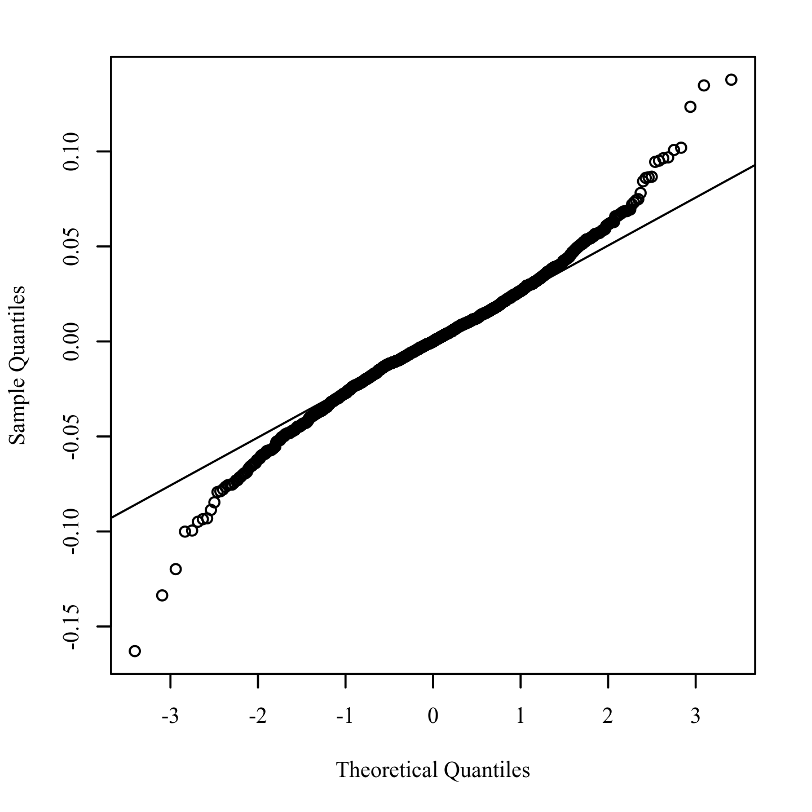

**Homoscedasticity.** The residuals were plotted against the anticipated values to determine homoscedasticity (Bates et al., 2014; Field, 2017; Osborne & Waters, 2002). A random distribution with zero mean and no visible curvature meets the homoscedasticity requirement. An analysis of the predicted values and residuals is shown in Figure 2.2.

**Figure 2.2**

*Residuals scatterplot testing homoscedasticity*

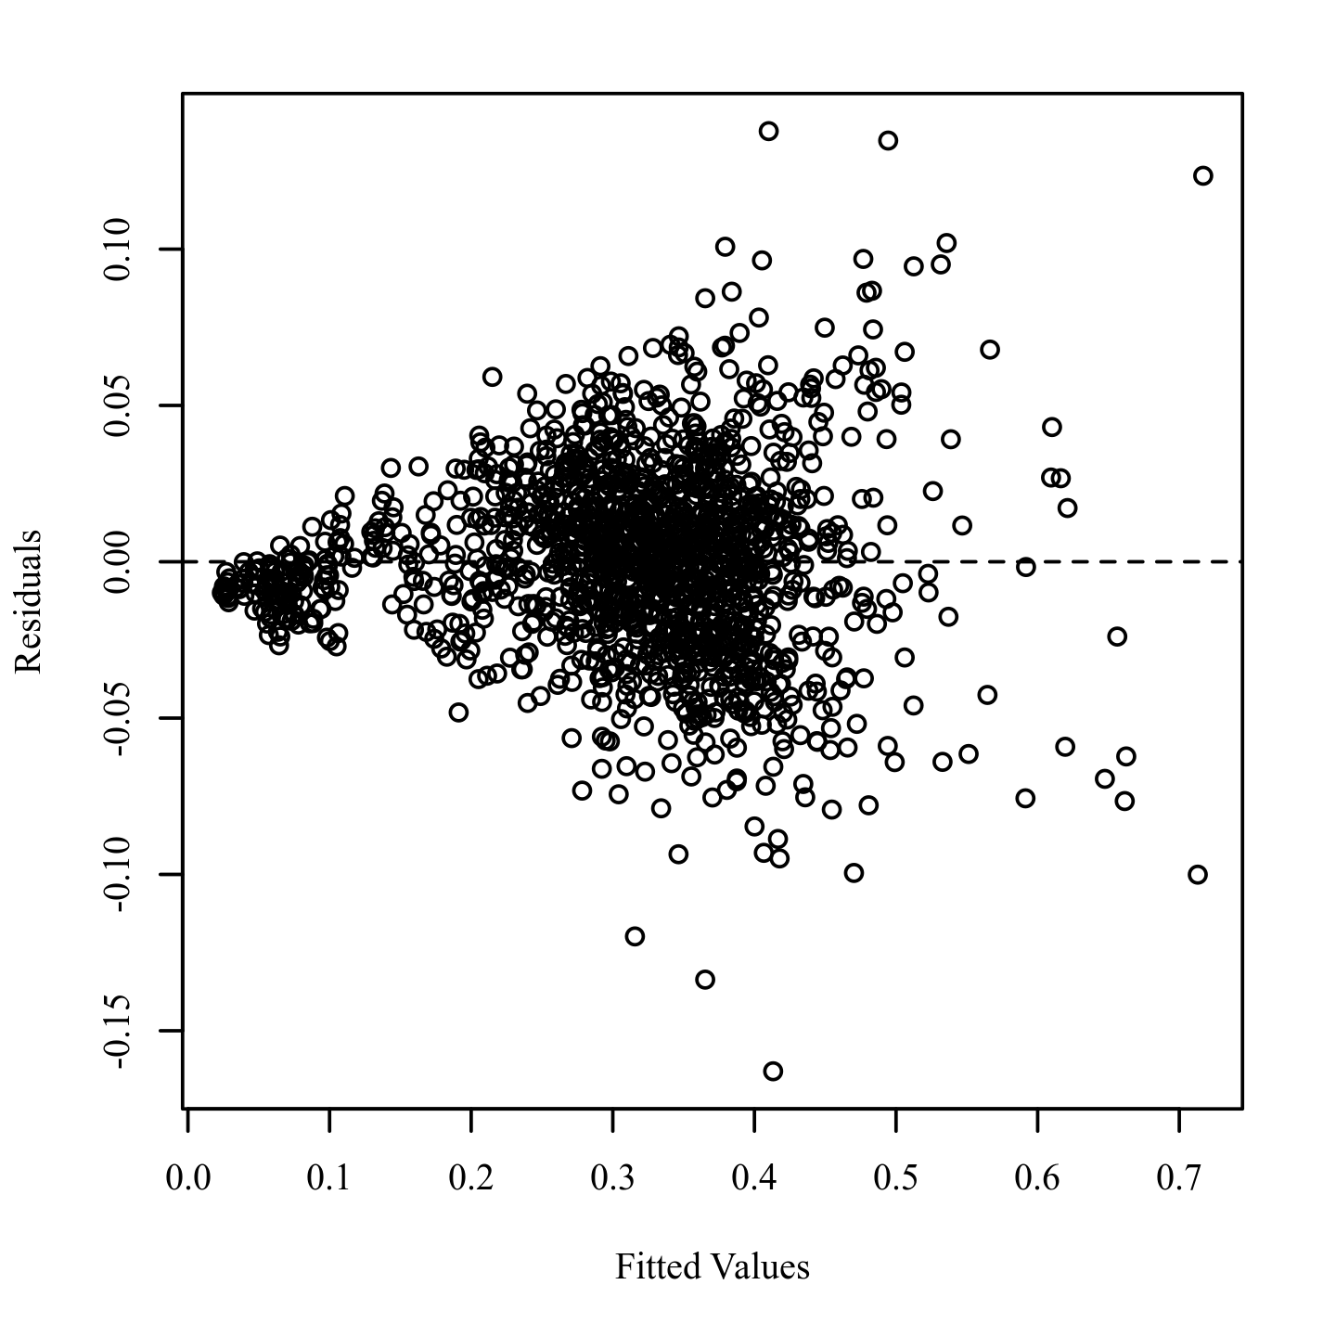

**Multicollinearity.** The presence of multicollinearity between predictors was detected using Variance Inflation Factors (VIFs). When VIF is high, the effects of multicollinearity are more evident. VIFs greater than 5 should be considered concerning, whereas VIFs greater than 10 should be considered the upper limit (Menard, 2010). The VIFs of all predictors in the regression model were less than ten. Table 1 shows the VIF for each predictor in the model.

**Table 2.1**

*Variance Inflation Factors for AGE, WEIGHT, ENGAGEMENT, RELAXATION, GENDER, HEIGHT, EXCITEMENT, INTEREST, LIFESTYLE, STATE_OF_HEALTH, LTE, and FOCUS*

|  |  |
| --- | --- |
| Variable | VIF |
| AGE | 7.62 |
| WEIGHT | 3.47 |
| ENGAGEMENT | 5.80 |
| RELAXATION | 3.23 |
| GENDER | 4.94 |
| HEIGHT | 2.20 |
| EXCITEMENT | 2.73 |
| INTEREST | 4.75 |
| LIFESTYLE | 3.03 |
| STATE_OF_HEALTH | 7.73 |
| LTE | 2.83 |
| FOCUS | 3.95 |

**Outliers.** To identify influential points, studentized residuals were generated and absolute values were plotted against observation numbers (Field, 2017; Pituch & Stevens, 2015). The studentized residuals are calculated by dividing the residual standard deviation by the model residuals. A Studentized residual with an absolute value greater than 3.10, corresponding to the 0.999 quantiles of a t distribution with 1521 degrees of freedom, was considered to have a significant influence on the model's outcomes. Figure 3 depicts the Studentized residuals plot of the observations. A number is assigned to every observation that has a Studentized residual greater than 3.10.

**Figure 2.3**

*Studentized residuals plot for outlier detection*

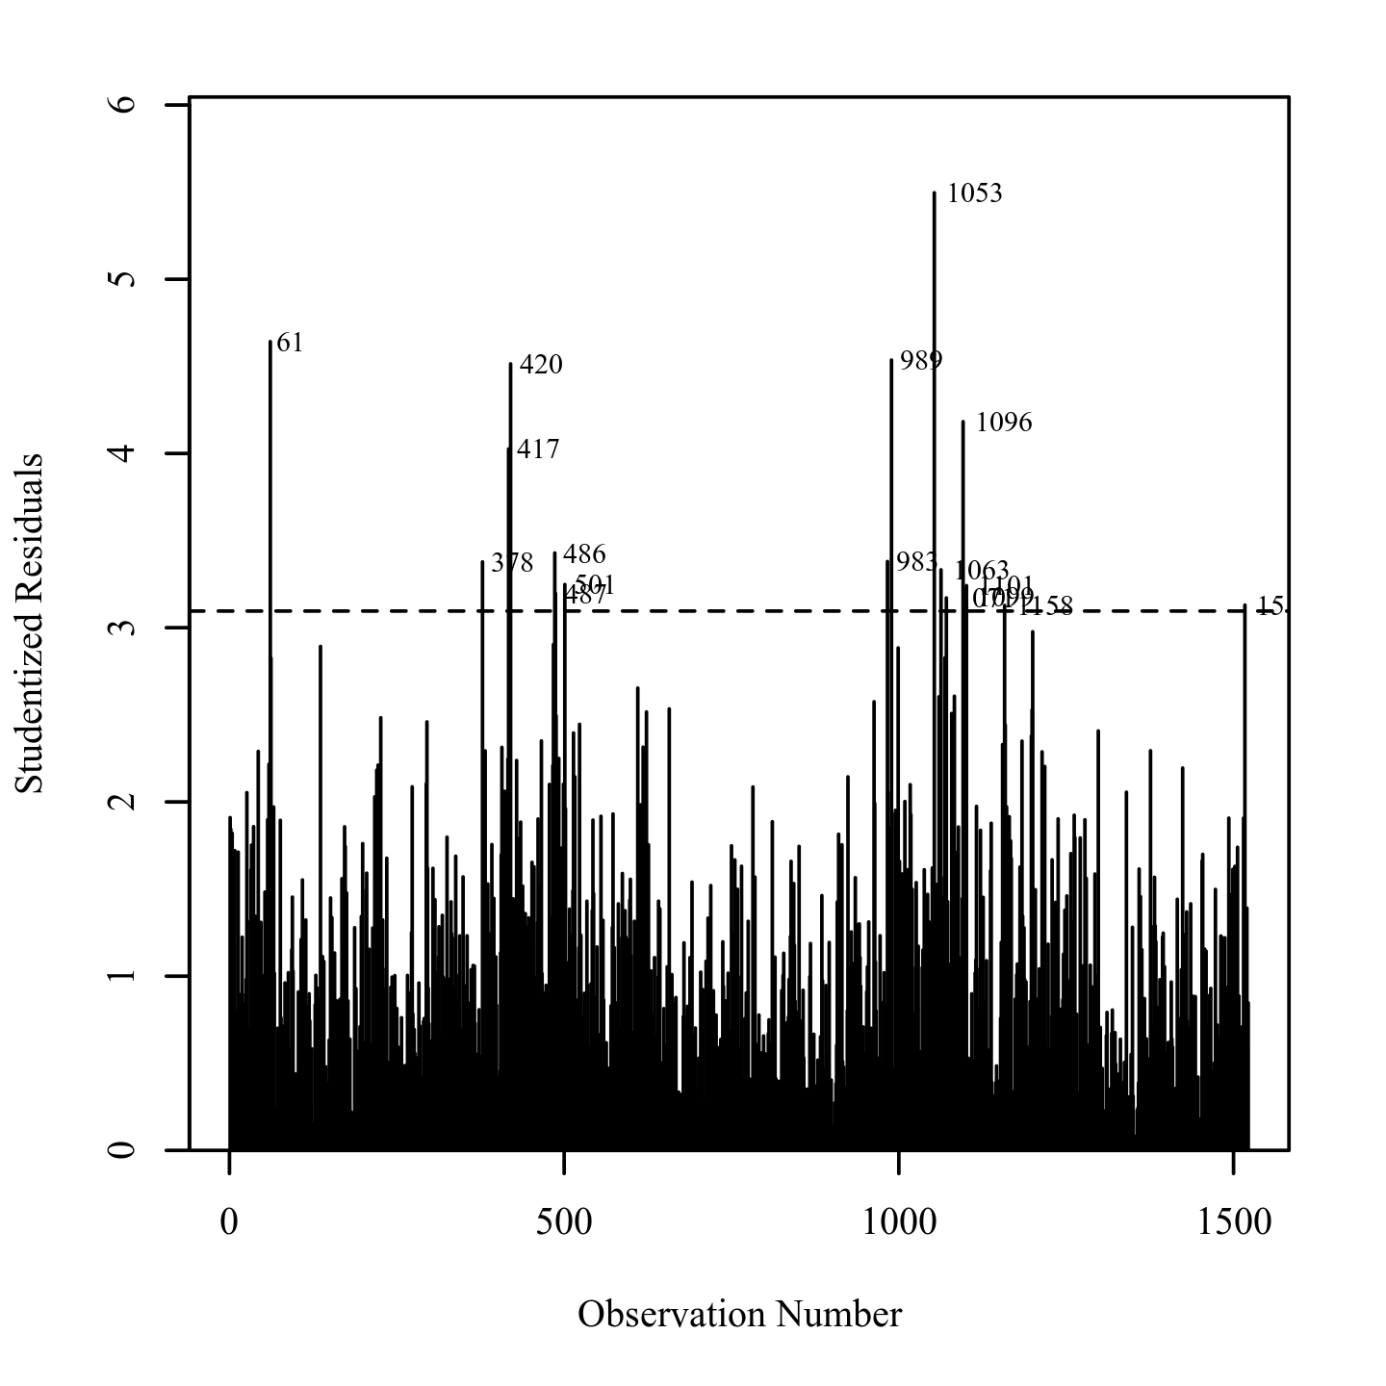

***Results***

The findings of the linear regression model were significant, F(12,1509) = 1584.37, p.001, R2 = 0.93, showing that AGE, WEIGHT, ENGAGEMENT, RELAXATION, GENDER, HEIGHT, EXCITEMENT, INTEREST, LIFESTYLE, STATE OF HEALTH, LTE, and FOCUS account for roughly 93 percent of the variance in STRESS. B = 0.00, t(1509) = 2.60, p =.010, AGE significantly predicted STRESS. This means that a one-unit rise in AGE increases the value of STRESS by 0.00 units on average. WEIGHT predicted STRESS substantially, B = -0.00, t(1509) = -2.78, p =.005. This means that a one-unit increase in WEIGHT reduces the value of STRESS by 0.00 units on average. B = -0.09, t(1509) = -9.00, p.001, ENGAGEMENT substantially predicted STRESS. This means that a one-unit increase in ENGAGEMENT reduces the value of STRESS by 0.09 units on average. B = 0.49, t(1509) = 48.41, p.001, RELAXATION substantially predicted STRESS. This means that a one-unit increase in RELAXATION increases the value of STRESS by 0.49 units on average. B = -0.01, t(1509) = -1.86, p =.063, GENDER did not significantly predict STRESS, B = -0.01, t(1509) = -1.86, p =.063.

A one-unit increase in GENDER does not have a meaningful effect on STRESS in this group. B = 0.00, t(1509) = 0.78, p =.435, HEIGHT did not significantly predict STRESS, B = 0.00, t(1509) = 0.78, p =.435. A one-unit increase in HEIGHT does not have a meaningful effect on STRESS in this group. B = -0.02, t(1509) = -2.20, p =.028. EXCITEMENT significantly predicted STRESS, B = -0.02, t(1509) = -2.20, p =.028. This means that a one-unit rise in EXCITEMENT reduces the value of STRESS by 0.02 units on average. INTEREST predicted STRESS substantially, B = 0.33, t(1509) = 26.24, p.001.

This means that a one-unit rise in INTEREST will result in a 0.33-unit increase in STRESS on average. B = 0.01, t(1509) = 2.32, p =.020, LIFESTYLE significantly predicted STRESS. This means that a one-unit increase in LIFESTYLE will result in a 0.01-unit rise in STRESS on average. STRESS was strongly predicted by STATE OF HEALTH, B = 0.02, t(1509) = 3.84, p.001. This means that a one-unit rise in STATE OF HEALTH increases the value of STRESS by 0.02 units on average. B = 0.02, t(1509) = 2.38, p =.018; LTE substantially predicted STRESS. This means that a one-unit increase in LTE will result in a 0.02 unit rise in STRESS on average. FOCUS predicted STRESS substantially, B = 0.13, t(1509) = 12.50, p.001. This means that a one-unit increase in FOCUS will result in a 0.13-unit rise in STRESS on average. The regression model's results are summarized in Table 2.2.

**Table 2.2**

*Results for Linear Regression with AGE, WEIGHT, ENGAGEMENT, RELAXATION, GENDER, HEIGHT, EXCITEMENT, INTEREST, LIFESTYLE, STATE_OF_HEALTH, LTE, and FOCUS predicting STRESS*

|  |  |  |  |  |  |  |
| --- | --- | --- | --- | --- | --- | --- |
| Variable | *B* | *SE* | 95% CI | β | *t* | *p* |
| (Intercept) | -0.00 | 0.03 | [-0.06, 0.06] | 0.00 | -0.06 | .952 |
| AGE | 0.00 | 0.00 | [0.00, 0.00] | 0.05 | 2.60 | .010 |
| WEIGHT | -0.00 | 0.00 | [-0.00, -0.00] | -0.04 | -2.78 | .005 |
| ENGAGEMENT | -0.09 | 0.01 | [-0.11, -0.07] | -0.15 | -9.00 | < .001 |
| RELAXATION | 0.49 | 0.01 | [0.47, 0.51] | 0.61 | 48.41 | < .001 |
| GENDER | -0.01 | 0.00 | [-0.02, 0.00] | -0.03 | -1.86 | .063 |
| HEIGHT | 0.00 | 0.00 | [-0.00, 0.00] | 0.01 | 0.78 | .435 |
| EXCITEMENT | -0.02 | 0.01 | [-0.03, -0.00] | -0.03 | -2.20 | .028 |
| INTEREST | 0.33 | 0.01 | [0.30, 0.35] | 0.40 | 26.24 | < .001 |
| LIFESTYLE | 0.01 | 0.00 | [0.00, 0.01] | 0.03 | 2.32 | .020 |
| STATE_OF_HEALTH | 0.02 | 0.00 | [0.01, 0.02] | 0.07 | 3.84 | < .001 |
| LTE | 0.02 | 0.01 | [0.00, 0.04] | 0.03 | 2.38 | .018 |
| FOCUS | 0.13 | 0.01 | [0.11, 0.14] | 0.17 | 12.50 | < .001 |
| *Note.* Results: *F*(12,1509) = 1584.37, *p* < .001, *R*2 = 0.93 Unstandardized Regression Equation: STRESS = -0.00 + 0.00*AGE - 0.00*WEIGHT - 0.09*ENGAGEMENT + 0.49*RELAXATION - 0.01*GENDER + 0.00*HEIGHT - 0.02*EXCITEMENT + 0.33*INTEREST + 0.01*LIFESTYLE + 0.02*STATE_OF_HEALTH + 0.02*LTE + 0.13*FOCUS | | | | | | |

#### Insights from Regression Analysis

This predictive analysis was run with the help of data retrieved from Brain Computer Interface (BCI).

The same was used to establish the existence and significance of 'Psychosomatic health'. This stage of research was driven by Quantitative analysis (inclusive of 26 individuals) of 1522 unique EEG samples collected from them. The data modeling was done using multiple linear regression analysis.

The results of this stage of research explored the impact of emotions on psychological well-being.

‘Stress’ is moderated by Emotions (including Interest, Relaxation, Focus and Engagement)

*Results for Linear Regression with AGE, WEIGHT, ENGAGEMENT, RELAXATION, GENDER, HEIGHT, EXCITEMENT, INTEREST, LIFESTYLE, STATE_OF_HEALTH, LTE, and FOCUS predicting STRESS*

|  |  |  |  |  |  |  |
| --- | --- | --- | --- | --- | --- | --- |
| Variable | *B* | *SE* | 95% CI | β | *t* | *p* |
| ENGAGEMENT | -0.09 | 0.01 | [-0.11, -0.07] | -0.15 | -9.00 | < .001 |
| RELAXATION | 0.49 | 0.01 | [0.47, 0.51] | 0.61 | 48.41 | < .001 |
| INTEREST | 0.33 | 0.01 | [0.30, 0.35] | 0.40 | 26.24 | < .001 |
| FOCUS | 0.13 | 0.01 | [0.11, 0.14] | 0.17 | 12.50 | < .001 |

The results of the linear regression model were significant, *F*(12,1509) = 1584.37, *p* < .001, *R*2 = 0.93, indicating that approximately 93% of the variance in STRESS is explainable withRegression Equation: STRESS = -0.00 + 0.00*AGE - 0.00*WEIGHT - 0.09*ENGAGEMENT + 0.49*RELAXATION - 0.01*GENDER + 0.00*HEIGHT - 0.02*EXCITEMENT + 0.33*INTEREST + 0.01*LIFESTYLE + 0.02*STATE_OF_HEALTH + 0.02*LTE + 0.13*FOCUS

**The latter part of the study was used for ML modeling using regression as a statistical technique.**

To derive real-time insights, the presented research opted for data science-driven techniques using ML-driven Modeling (Morande & Tewari, 2020). Although regression modeling provides greater depth of the impact of predictors on the dependent variable psychosomatic construct can be complex to evaluate. This is due to the fact that the brain generates relevant waves multiple times in an instance. It could even go as far as thousands of instances per second. Hence for a particular instance, the value of stress keeps on changing with interest, relaxation, excitement, focus, and engagement as mediators. Hence evaluating the state of health of an individual as a particular instance calls for a holistic approach in consideration of the signal emitted by other cortices of the human brain. Such calculations could get very complex in nature; hence in the given study, Machine Learning is used to predict the possible instance based on the historical data and patterns.

Figure 19: ML based Model Evaluation

As per the model evaluation (Refer to **Figure 19**), STAGE III concluded that Psychological Well-being is correlated with Stress and two other significant predictors (*including Interest & Relaxation*). Considering Psychosomatic health and its attributes as a human actor(s) and its interplay with technological actors (such as IoMT devices) induce Resource integration. The application of Machine Learning can leverage sleep-related data and address complexities in the system to enhance the overall resource density. The study reflected on the actors (such as stressors/interventions) that can augment psychosomatic health by resource integration (using A.I. technologies) to fulfill value co-creation (betterment of health). The ML model obtained from Brain-Computer Interaction (Refer to **APPENDIX D &** Section **PREDICTIVE MODELLING**) can be used in real-time for psychotherapy by therapists. Value Co-creation takes place in the form of optimal workplace productivity, reflecting on organizational performance and, most importantly for an individual, resulting in well-being of health. Organizations can make use of in-house therapists or telemedicine to be able to enhance their overall efficiency. The same was affirmed in Stage IV, as shown below.

## Spearman Correlation

Spearman rank correlation or Spearman's rho is another name for a Spearman correlation coefficient. It is usually represented by the Greek letter rho () or the Roman letter rs. Spearman's rho, like all correlation coefficients, measures the strength of the relationship between two variables. As a result, the Spearman correlation coefficient and the Pearson correlation coefficient are very close.

All bivariate correlation analyses give a single number between -1 and +1 to the strength of the link between two variables. The correlation coefficient is the name given to this value. A positive correlation coefficient implies that the two variables have a positive link, whereas a negative correlation value suggests that they have a negative association.

A correlation value of 0 shows that the variables have no relationship. Correlation coefficients such as Spearman's and Pearson's, on the other hand, presuppose a linear relationship between variables. A non-linear relationship may exist even if the correlation coefficient is zero.

Because it employs ranks rather than assumptions about the distributions of the two variables, the Spearman correlation coefficient does not require continuous-level data (interval or ratio) like the Pearson correlation coefficient. This enables us to investigate the relationship between variables with different ordinal measurement levels. Furthermore, the Spearman correlation makes no assumptions about the distribution of the variables. In many circumstances where the Pearson correlation assumptions (continuous-level variables, linearity, heteroscedasticity, and normality) are not met, a Spearman correlation analysis can be employed.

**Spearman Correlation Analysis**

***Introduction***

A Spearman correlation analysis was conducted among AGE, BMI, FOCUS, CIRCADIAN_RHYTHM, GENDER, STATE_OF_HEALTH, STRESS, ENERGY_LEVEL, LIFESTYLE, ENGAGEMENT, SLEEP, and OBSERVED_PRODUCTIVITY. To assess the magnitude of the relationship, Cohen's standard was used. A coefficient between .10 and .29 likely indicates a small effect, a coefficient between .30 and .49 means a moderate effect, and a coefficient above .50 means a large effect (Cohen, 1988).

***Results***

Using an alpha value of 0.05, Holm correction was used to adjust for multiple comparisons. There was a significant negative correlation between AGE and BMI (*r* = -0.21, *p* < .001, 95% CI = [-0.26, -0.16]). The correlation coefficient between AGE and BMI was -0.21, indicating a small effect size. This correlation indicates that as AGE increases, BMI tends to decrease. A significant negative correlation was observed between AGE and CIRCADIAN_RHYTHM (*r* = -0.23, *p* < .001, 95% CI = [-0.28, -0.19]). AGE and CIRCADIAN_RHYTHM had a -0.23 correlation coefficient, indicating a small effect size. This correlation indicates that as AGE increases, so does CIRCADIAN_RHYTHM. A significant positive correlation was observed between AGE and GENDER (*r* = 0.28, *p* < .001, 95% CI = [0.23, 0.32]). There was a small effect size between AGE and GENDER, based on the correlation coefficient of 0.28. According to this correlation, AGE tends to increase with GENDER. A significant negative correlation was observed between AGE and STATE_OF_HEALTH (*r* = -0.85, *p* < .001, 95% CI = [-0.87, -0.84]). STATE_OF_HEALTH and AGE were negatively correlated, suggesting a large effect. STATE_OF_HEALTH tends to decrease in relation to AGE.

A significant positive correlation was observed between AGE and ENERGY_LEVEL (*r* = 0.08, *p* = .042, 95% CI = [0.03, 0.13]). In relation to ENERGY_LEVEL, there was a small correlation coefficient of 0.08, which indicates a small effect size.

A correlation between AGE and ENERGY_LEVEL indicates that these values tend to increase together. A significant negative correlation was observed between AGE and LIFESTYLE (*r* = -0.68, *p* < .001, 95% CI = [-0.70, -0.65]). There was a large effect size between AGE and LIFESTYLE, as evidenced by the correlation coefficient of -0.68 between the two.

The correlation coefficient between AGE and ENGAGEMENT was 0.11, indicating a small effect size. This correlation indicates that as AGE increases, ENGAGEMENT tends to increase. The correlation indicates that ENGAGEMENT tends to increase with increasing AGE. The correlation indicates that ENGAGEMENT tends to increase with increasing AGE.

AGE and ENERGY LEVEL had a significant positive connection (r = 0.08, p =.042, 95 percent CI = [0.03, 0.13]). AGE and ENERGY LEVEL has a 0.08 correlation coefficient, indicating a small effect size. This relationship implies that the ENERGY LEVEL tends to rise as AGE rises. The connection between AGE and LIFESTYLE was found to be significant (r = -0.68, p.001, 95 percent CI = [-0.70, -0.65]). AGE and LIFESTYLE had a -0.68 correlation coefficient, indicating a substantial effect magnitude. This relationship implies that as one's age rises, one's LIFESTYLE tends to decline. The connection between AGE and ENGAGEMENT was found to be significant (r = 0.11, p.001, 95 percent CI = [0.06, 0.16]). AGE and ENGAGEMENT had a 0.11 correlation value, indicating a small effect size. This relationship implies that as a person's age rises, so does their level of engagement.

AGE and OBSERVED PRODUCTIVITY have a substantial positive connection (r = 0.18, p.001, 95 percent CI = [0.13, 0.23]). AGE and OBSERVED PRODUCTIVITY had a 0.18 correlation coefficient, indicating a small effect size. This relationship shows that as AGE rises, OBSERVED PRODUCTIVITY rises as well. BMI and FOCUS showed a significant negative connection (r = -0.24, p.001, 95 percent CI = [-0.28, -0.19]). BMI and FOCUS had a -0.24 correlation value, indicating a small effect size. This relationship shows that as BMI rises, FOCUS tends to fall. BMI and CIRCADIAN RHYTHM have a substantial negative connection (r = -0.67, p.001, 95 percent CI = [-0.70, -0.64]). BMI and CIRCADIAN RHYTHM had a correlation coefficient of -0.67, indicating a strong effect magnitude. CIRCADIAN RHYTHM tends to decrease as BMI rises, according to this association.

BMI and GENDER showed a substantial positive connection (r = 0.16, p.001, 95 percent CI = [0.11, 0.20]). BMI and GENDER had a 0.16 correlation value, indicating a small effect size. This relationship implies that as BMI rises, GENDER rises with it. BMI and STATE OF HEALTH showed a significant positive connection (r = 0.21, p.001, 95 percent CI = [0.16, 0.26]). BMI and STATE OF HEALTH had a 0.21 correlation value, indicating a small effect size. This relationship shows that as BMI rises, STATE OF HEALTH rises as well. BMI and ENERGY LEVEL showed a significant negative connection (r = -0.29, p.001, 95 percent CI = [-0.34, -0.24]). BMI and ENERGY LEVEL had a -0.29 correlation coefficient, indicating a small effect size. This relationship suggests that when BMI rises, ENERGY LEVEL tends to fall. BMI and LIFESTYLE were shown to have a significant positive connection (r = 0.14, p.001, 95 percent CI = [0.09, 0.19]).

BMI and LIFESTYLE had a 0.14 correlation value, indicating a small effect size. This relationship implies that as BMI rises, LIFESTYLE rises as well. BMI and ENGAGEMENT were found to have a significant negative connection (r = -0.29, p.001, 95 percent CI = [-0.34, -0.25]). BMI and ENGAGEMENT had a -0.29 correlation value, indicating a small effect size. This relationship shows that when BMI rises, ENGAGEMENT tends to fall. BMI and SLEEP were shown to have a significant negative connection (r = -0.29, p.001, 95 percent CI = [-0.34, -0.25]). BMI and SLEEP had a -0.29 correlation coefficient, indicating a minimal effect size. This relationship shows that as BMI rises, SLEEP tends to fall. BMI and OBSERVED PRODUCTIVITY have a substantial positive connection (r = 0.16, p.001, 95 percent CI = [0.11, 0.21]). BMI and OBSERVED PRODUCTIVITY had a 0.16 correlation coefficient, indicating a small effect size. This relationship shows that as BMI rises, OBSERVED PRODUCTIVITY rises as well.

FOCUS and CIRCADIAN RHYTHM have a substantial positive connection (r = 0.30, p.001, 95 percent CI = [0.25, 0.34]). FOCUS and CIRCADIAN RHYTHM have a 0.30 correlation coefficient, indicating a small effect size.

This relationship shows that as FOCUS rises, CIRCADIAN RHYTHM rises as well. FOCUS and GENDER showed a significant negative connection (r = -0.38, p.001, 95 percent CI = [-0.42, -0.34]). FOCUS and GENDER had a -0.38 correlation value, indicating a moderate effect magnitude. This relationship shows that as FOCUS rises, GENDER tends to fall. FOCUS and STRESS were found to have a substantial positive connection (r = 0.63, p.001, 95 percent CI = [0.60, 0.66]). FOCUS and STRESS had a 0.63 correlation value, indicating a substantial effect size. This relationship implies that while FOCUS rises, STRESS rises as well. FOCUS and ENERGY LEVEL have a substantial positive connection (r = 0.10, p =.002, 95 percent CI = [0.05, 0.15]). FOCUS and ENERGY LEVEL had a 0.10 correlation coefficient, indicating a small effect size. This relationship shows that as FOCUS rises, ENERGY LEVEL rises as well.

FOCUS and ENGAGEMENT were found to have a substantial positive connection (r = 0.81, p.001, 95 percent CI = [0.79, 0.82]). FOCUS and ENGAGEMENT had a 0.81 correlation value, indicating a strong effect size. This relationship shows that as FOCUS rises, ENGAGEMENT rises as well. FOCUS and OBSERVED PRODUCTIVITY have a significant negative connection (r = -0.12, p.001, 95 percent CI = [-0.17, -0.07]). FOCUS and OBSERVED PRODUCTIVITY had a -0.12 correlation value, indicating a small effect size. This relationship shows that while FOCUS rises, OBSERVED PRODUCTIVITY tends to fall.

CIRCADIAN RHYTHM and GENDER have a substantial negative connection (r = -0.34, p.001, 95 percent CI = [-0.39, -0.30]). CIRCADIAN RHYTHM and GENDER had a -0.34 correlation coefficient, indicating a moderate effect size. This relationship shows that as CIRCADIAN RHYTHM rises, GENDER tends to fall. CIRCADIAN RHYTHM and STATE OF HEALTH have a significant positive connection (r = 0.20, p.001, 95 percent CI = [0.16, 0.25]). CIRCADIAN RHYTHM and STATE OF HEALTH had a 0.20 correlation coefficient, indicating a small effect size. This relationship implies that as CIRCADIAN RHYTHM rises, so does the STATE OF HEALTH. CIRCADIAN RHYTHM and ENERGY LEVEL have a substantial positive connection (r = 0.47, p.001, 95 percent CI = [0.43, 0.51]). CIRCADIAN RHYTHM and ENERGY LEVEL had a 0.47 correlation value, indicating a moderate effect size. This relationship suggests that as CIRCADIAN RHYTHM rises, so does ENERGY LEVEL.

CIRCADIAN RHYTHM and LIFESTYLE have a substantial positive connection (r = 0.48, p.001, 95 percent CI = [0.44, 0.52]). CIRCADIAN RHYTHM and LIFESTYLE had a 0.48 correlation value, indicating a moderate effect size. This relationship implies that as CIRCADIAN RHYTHM rises, so does LIFESTYLE. CIRCADIAN RHYTHM and ENGAGEMENT had a substantial positive connection (r = 0.25, p.001, 95 percent CI = [0.21, 0.30]). CIRCADIAN RHYTHM and ENGAGEMENT have a 0.25 correlation coefficient, indicating a small effect size. This relationship implies that as CIRCADIAN RHYTHM rises, so does ENGAGEMENT.

CIRCADIAN RHYTHM and SLEEP have a substantial positive connection (r = 0.48, p.001, 95 percent CI = [0.44, 0.51]). CIRCADIAN RHYTHM and SLEEP had a 0.48 correlation value, indicating a moderate effect magnitude. This relationship implies that as CIRCADIAN RHYTHM rises, so does SLEEP. CIRCADIAN RHYTHM and OBSERVED PRODUCTIVITY have a significant negative connection (r = -0.30, p.001, 95 percent CI = [-0.34, -0.25]). CIRCADIAN RHYTHM and OBSERVED PRODUCTIVITY had a correlation coefficient of -0.30, indicating a small effect size. This relationship implies that as CIRCADIAN RHYTHM rises, OBSERVED PRODUCTIVITY falls.

GENDER and STATE OF HEALTH have a significant negative connection (r = -0.15, p.001, 95 percent CI = [-0.20, -0.10]). GENDER and STATE OF HEALTH had a -0.15 correlation value, indicating a minor effect size. STATE OF HEALTH tends to decline as GENDER increases, according to this association. GENDER and STRESS were shown to have a significant negative connection (r = -0.22, p.001, 95 percent CI = [-0.27, -0.17]). GENDER and STRESS had a -0.22 correlation value, indicating a minor effect magnitude. This relationship shows that when GENDER rises, STRESS tends to fall.

GENDER and ENERGY LEVEL have a significant negative connection (r = -0.11, p.001, 95 percent CI = [-0.16, -0.06]). GENDER and ENERGY LEVEL had a -0.11 correlation coefficient, indicating a minor effect size. This relationship shows that when GENDER increases, ENERGY LEVEL decreases. GENDER and LIFESTYLE were shown to have a significant negative connection (r = -0.29, p.001, 95 percent CI = [-0.34, -0.24]). GENDER and LIFESTYLE had a -0.29 correlation coefficient, indicating a minimal effect size. This relationship suggests that when GENDER rises, LIFESTYLE tends to fall. GENDER and ENGAGEMENT were shown to have a significant negative connection (r = -0.24, p.001, 95 percent CI = [-0.28, -0.19]). GENDER and ENGAGEMENT had a -0.24 correlation coefficient, indicating a small effect size. This relationship suggests that when GENDER rises, ENGAGEMENT tends to fall.

The variables GENDER and SLEEP had a significant positive connection (r = 0.40, p.001, 95 percent CI = [0.36, 0.44]). GENDER and SLEEP had a 0.40 correlation value, indicating a moderate effect magnitude. This relationship implies that SLEEP tends to rise as GENDER increases. GENDER and OBSERVED PRODUCTIVITY had a significant positive connection (r = 0.21, p.001, 95 percent CI = [0.17, 0.26]). GENDER and OBSERVED PRODUCTIVITY had a 0.21 correlation value, indicating a small effect size. This relationship shows that as GENDER rises, OBSERVED PRODUCTIVITY rises as well. STATE OF HEALTH and STRESS have a significant positive connection (r = 0.11, p.001, 95 percent CI = [0.06, 0.15]). STATE OF HEALTH and STRESS had a 0.11 correlation coefficient, indicating a small effect size. This relationship shows that as STATE OF HEALTH rises, STRESS rises with it.

STATE OF HEALTH and LIFESTYLE have a substantial positive connection (r = 0.75, p.001, 95 percent CI = [0.72, 0.77]). STATE OF HEALTH and LIFESTYLE had a 0.75 correlation value, indicating a large effect size. This relationship shows that as STATE OF HEALTH improves, LIFESTYLE improves as well. STATE OF HEALTH and ENGAGEMENT had a significant negative connection (r = -0.15, p.001, 95 percent CI = [-0.20, -0.10]). STATE OF HEALTH and ENGAGEMENT had a -0.15 correlation coefficient, indicating a small effect size. This relationship shows that as STATE OF HEALTH rises, ENGAGEMENT tends to fall.

STATE OF HEALTH and OBSERVED PRODUCTIVITY have a significant negative connection (r = -0.23, p.001, 95 percent CI = [-0.27, -0.18]). STATE OF HEALTH and OBSERVED PRODUCTIVITY had a correlation coefficient of -0.23, indicating a small effect size. This relationship implies that as STATE OF HEALTH rises, OBSERVED PRODUCTIVITY falls. STRESS and ENERGY LEVEL had a significant negative connection (r = -0.10, p =.002, 95 percent CI = [-0.15, -0.05]). STRESS and ENERGY LEVEL has a -0.10 correlation coefficient, indicating a minor effect magnitude. This relationship shows that when STRESS grows, ENERGY LEVEL decreases. STRESS and ENGAGEMENT were found to have a substantial positive connection (r = 0.63, p.001, 95 percent CI = [0.60, 0.66]). STRESS and ENGAGEMENT had a 0.63 correlation value, indicating a large effect size. This relationship implies that while STRESS rises, ENGAGEMENT rises as well. ENERGY LEVEL and LIFESTYLE have a substantial positive connection (r = 0.13, p.001, 95 percent CI = [0.08, 0.18]). ENERGY LEVEL and LIFESTYLE had a 0.13 correlation coefficient, indicating a small effect size. This relationship shows that as ENERGY LEVEL rises, LIFESTYLE rises with it. ENERGY LEVEL and OBSERVED PRODUCTIVITY have a significant negative connection (r = -0.81, p.001, 95 percent CI = [-0.83, -0.80]). ENERGY LEVEL and OBSERVED PRODUCTIVITY had a -0.81 correlation coefficient, indicating a strong effect size. This relationship suggests that as ENERGY LEVEL rises, OBSERVED PRODUCTIVITY tends to fall. LIFESTYLE and SLEEP have a substantial positive connection (r = 0.09, p =.017, 95 percent CI = [0.04, 0.14]). LIFESTYLE and SLEEP had a 0.09 correlation value, indicating a small effect size. This relationship implies that as LIFESTYLE improves, SLEEP improves as well. The connection between ENGAGEMENT and SLEEP was found to be significant (r = 0.14, p.001, 95 percent CI = [0.09, 0.19]). ENGAGEMENT and SLEEP had a 0.14 correlation value, indicating a small effect size. This relationship shows that while ENGAGEMENT rises, SLEEP tends to rise as well. There were no additional significant relationships discovered. The correlations' results are shown in Table 3.1.

**Table 3.1**

*Spearman Correlation Results Among AGE, BMI, FOCUS, CIRCADIAN_RHYTHM, GENDER, STATE_OF_HEALTH, STRESS, ENERGY_LEVEL, LIFESTYLE, ENGAGEMENT, SLEEP, and OBSERVED_PRODUCTIVITY*

|  |  |  |  |  |
| --- | --- | --- | --- | --- |
| Combination | *r* | 95% CI | *n* | *p* |
| AGE-BMI | -0.21 | [-0.26, -0.16] | 1522 | < .001 |
| AGE-FOCUS | 0.03 | [-0.02, 0.08] | 1522 | 1.000 |
| AGE-CIRCADIAN_RHYTHM | -0.23 | [-0.28, -0.19] | 1522 | < .001 |
| AGE-GENDER | 0.28 | [0.23, 0.32] | 1522 | < .001 |
| AGE-STATE_OF_HEALTH | -0.85 | [-0.87, -0.84] | 1522 | < .001 |
| AGE-STRESS | -0.07 | [-0.12, -0.02] | 1522 | .124 |
| AGE-ENERGY_LEVEL | 0.08 | [0.03, 0.13] | 1522 | .042 |
| AGE-LIFESTYLE | -0.68 | [-0.70, -0.65] | 1522 | < .001 |
| AGE-ENGAGEMENT | 0.11 | [0.06, 0.16] | 1522 | < .001 |
| AGE-SLEEP | -0.03 | [-0.08, 0.02] | 1522 | 1.000 |
| AGE-OBSERVED_PRODUCTIVITY | 0.18 | [0.13, 0.23] | 1522 | < .001 |
| BMI-FOCUS | -0.24 | [-0.28, -0.19] | 1522 | < .001 |
| BMI-CIRCADIAN_RHYTHM | -0.67 | [-0.70, -0.64] | 1522 | < .001 |
| BMI-GENDER | 0.16 | [0.11, 0.20] | 1522 | < .001 |
| BMI-STATE_OF_HEALTH | 0.21 | [0.16, 0.26] | 1522 | < .001 |
| BMI-STRESS | -0.01 | [-0.06, 0.04] | 1522 | 1.000 |
| BMI-ENERGY_LEVEL | -0.29 | [-0.34, -0.24] | 1522 | < .001 |
| BMI-LIFESTYLE | 0.14 | [0.09, 0.19] | 1522 | < .001 |
| BMI-ENGAGEMENT | -0.29 | [-0.34, -0.25] | 1522 | < .001 |
| BMI-SLEEP | -0.29 | [-0.34, -0.25] | 1522 | < .001 |
| BMI-OBSERVED_PRODUCTIVITY | 0.16 | [0.11, 0.21] | 1522 | < .001 |
| FOCUS-CIRCADIAN_RHYTHM | 0.30 | [0.25, 0.34] | 1522 | < .001 |
| FOCUS-GENDER | -0.38 | [-0.42, -0.34] | 1522 | < .001 |
| FOCUS-STATE_OF_HEALTH | -0.02 | [-0.07, 0.03] | 1522 | 1.000 |
| FOCUS-STRESS | 0.63 | [0.60, 0.66] | 1522 | < .001 |
| FOCUS-ENERGY_LEVEL | 0.10 | [0.05, 0.15] | 1522 | .002 |
| FOCUS-LIFESTYLE | 0.08 | [0.03, 0.13] | 1522 | .054 |
| FOCUS-ENGAGEMENT | 0.81 | [0.79, 0.82] | 1522 | < .001 |
| FOCUS-SLEEP | 0.04 | [-0.01, 0.09] | 1522 | 1.000 |
| FOCUS-OBSERVED_PRODUCTIVITY | -0.12 | [-0.17, -0.07] | 1522 | < .001 |
| CIRCADIAN_RHYTHM-GENDER | -0.34 | [-0.39, -0.30] | 1522 | < .001 |
| CIRCADIAN_RHYTHM-STATE_OF_HEALTH | 0.20 | [0.16, 0.25] | 1522 | < .001 |
| CIRCADIAN_RHYTHM-STRESS | 0.07 | [0.01, 0.11] | 1522 | .179 |
| CIRCADIAN_RHYTHM-ENERGY_LEVEL | 0.47 | [0.43, 0.51] | 1522 | < .001 |
| CIRCADIAN_RHYTHM-LIFESTYLE | 0.48 | [0.44, 0.52] | 1522 | < .001 |
| CIRCADIAN_RHYTHM-ENGAGEMENT | 0.25 | [0.21, 0.30] | 1522 | < .001 |
| CIRCADIAN_RHYTHM-SLEEP | 0.48 | [0.44, 0.51] | 1522 | < .001 |
| CIRCADIAN_RHYTHM-OBSERVED_PRODUCTIVITY | -0.30 | [-0.34, -0.25] | 1522 | < .001 |
| GENDER-STATE_OF_HEALTH | -0.15 | [-0.20, -0.10] | 1522 | < .001 |
| GENDER-STRESS | -0.22 | [-0.27, -0.17] | 1522 | < .001 |
| GENDER-ENERGY_LEVEL | -0.11 | [-0.16, -0.06] | 1522 | < .001 |
| GENDER-LIFESTYLE | -0.29 | [-0.34, -0.24] | 1522 | < .001 |
| GENDER-ENGAGEMENT | -0.24 | [-0.28, -0.19] | 1522 | < .001 |
| GENDER-SLEEP | 0.40 | [0.36, 0.44] | 1522 | < .001 |
| GENDER-OBSERVED_PRODUCTIVITY | 0.21 | [0.17, 0.26] | 1522 | < .001 |
| STATE_OF_HEALTH-STRESS | 0.11 | [0.06, 0.15] | 1522 | < .001 |
| STATE_OF_HEALTH-ENERGY_LEVEL | -0.02 | [-0.07, 0.03] | 1522 | 1.000 |
| STATE_OF_HEALTH-LIFESTYLE | 0.75 | [0.72, 0.77] | 1522 | < .001 |
| STATE_OF_HEALTH-ENGAGEMENT | -0.15 | [-0.20, -0.10] | 1522 | < .001 |
| STATE_OF_HEALTH-SLEEP | 0.04 | [-0.01, 0.09] | 1522 | 1.000 |
| STATE_OF_HEALTH-OBSERVED_PRODUCTIVITY | -0.23 | [-0.27, -0.18] | 1522 | < .001 |
| STRESS-ENERGY_LEVEL | -0.10 | [-0.15, -0.05] | 1522 | .002 |
| STRESS-LIFESTYLE | 0.07 | [0.02, 0.12] | 1522 | .119 |
| STRESS-ENGAGEMENT | 0.63 | [0.60, 0.66] | 1522 | < .001 |
| STRESS-SLEEP | 0.05 | [0.00, 0.10] | 1522 | .632 |
| STRESS-OBSERVED_PRODUCTIVITY | -0.02 | [-0.07, 0.03] | 1522 | 1.000 |
| ENERGY_LEVEL-LIFESTYLE | 0.13 | [0.08, 0.18] | 1522 | < .001 |
| ENERGY_LEVEL-ENGAGEMENT | -0.00 | [-0.05, 0.05] | 1522 | 1.000 |
| ENERGY_LEVEL-SLEEP | 0.03 | [-0.02, 0.08] | 1522 | 1.000 |
| ENERGY_LEVEL-OBSERVED_PRODUCTIVITY | -0.81 | [-0.83, -0.80] | 1522 | < .001 |
| LIFESTYLE-ENGAGEMENT | -0.06 | [-0.11, -0.01] | 1522 | .277 |
| LIFESTYLE-SLEEP | 0.09 | [0.04, 0.14] | 1522 | .017 |
| LIFESTYLE-OBSERVED_PRODUCTIVITY | -0.05 | [-0.10, 0.00] | 1522 | .777 |
| ENGAGEMENT-SLEEP | 0.14 | [0.09, 0.19] | 1522 | < .001 |
| ENGAGEMENT-OBSERVED_PRODUCTIVITY | 0.02 | [-0.03, 0.07] | 1522 | 1.000 |
| SLEEP-OBSERVED_PRODUCTIVITY | -0.01 | [-0.06, 0.04] | 1522 | 1.000 |
| *Note.* *p*-values adjusted using the Holm correction. | | | | |

#### Insights from Spearman Correlations Analysis

This final stage of the study was used data from the survey that was done during simultaneous interaction with BCI. The survey was used to establish relationships across Individual well-being and Workplace Productivity. This stage of research was driven by Quantitative analysis inclusive of 26 subjects (including academicians and scientists) with the help of spearman co-relation analysis.

*Spearman Correlation Results Among AGE, BMI, FOCUS, CIRCADIAN_RHYTHM, GENDER, STATE_OF_HEALTH, STRESS, ENERGY_LEVEL, LIFESTYLE, ENGAGEMENT, SLEEP, and OBSERVED_PRODUCTIVITY*

|  |  |  |  |  |
| --- | --- | --- | --- | --- |
| Combination | *r* | 95% CI | *n* | *p* |
| AGE-OBSERVED_PRODUCTIVITY | 0.18 | [0.13, 0.23] | 1522 | < .001 |
| BMI-OBSERVED_PRODUCTIVITY | 0.16 | [0.11, 0.21] | 1522 | < .001 |
| FOCUS-OBSERVED_PRODUCTIVITY | -0.12 | [-0.17, -0.07] | 1522 | < .001 |
| CIRCADIAN_RHYTHM-OBSERVED_PRODUCTIVITY | -0.30 | [-0.34, -0.25] | 1522 | < .001 |
| ENERGY_LEVEL-OBSERVED_PRODUCTIVITY | -0.81 | [-0.83, -0.80] | 1522 | < .001 |

A significant negative correlation was observed between FOCUS and OBSERVED_PRODUCTIVITY (r = -0.12, p < .001, 95% CI = [-0.17, -0.07]). The correlation coefficient between FOCUS and OBSERVED_PRODUCTIVITY was -0.12, indicating a small effect size. This correlation indicates that as FOCUS increases, OBSERVED_PRODUCTIVITY tends to decrease.

**STAGE IV confirmed that Psychological Well-being (driven by emotion such as Focus) impacts Workplace Productivity.**

*The same can further be extended for the improvement of organizational performance.*

# **PREDICTIVE MODELLING**

The data analysis suggested that ‘Stress’ is relative & it is also not a constant indicator when measured by EEG. It has several mediators, and their holistic consideration is necessary. With Brain Computer Interface, EEG stress needs to be simultaneously validated and confirmed with the subject (via Survey). Then the predictive model can be developed using personalized data to confirm the actual stress levels.

As EEG data has thousands of instances recorded in a second, it becomes extremely difficult for a health professional to reflect on the (tremendous) volume of available data. Hence this part of the study was dedicated to Predictive Modelling.

## Data Pre-processing

### Data Cleansing & Standardization

Frequencies captured from electrodes attached to BCI (Emotiv) were converted into the CSV format.

The level of measurements (Nominal, Ordinal and Scale) was checked. These values and related metrics were converted into scaled values for ease of measurement.

### Data Conversion and Feeding

Univariate outliers were removed outside the range of +/- 3.29 standard variation from the mean.

Multivariate outliers with extreme observations from a set of two or more scale level variables were removed. As few values were missing from the collected data, data imputation was carried out (Fichman & Cummings, 2000).

The output was then fed to ML modeler tools (BigML).

## Machine Learning (ML) Modelling

The research Method effectively used ‘Data Science’ for computational modelling as suggested in **Figure 20.** In the process,it looks for Correlation interdependence of variable quantities and Regression for predictive modeling.

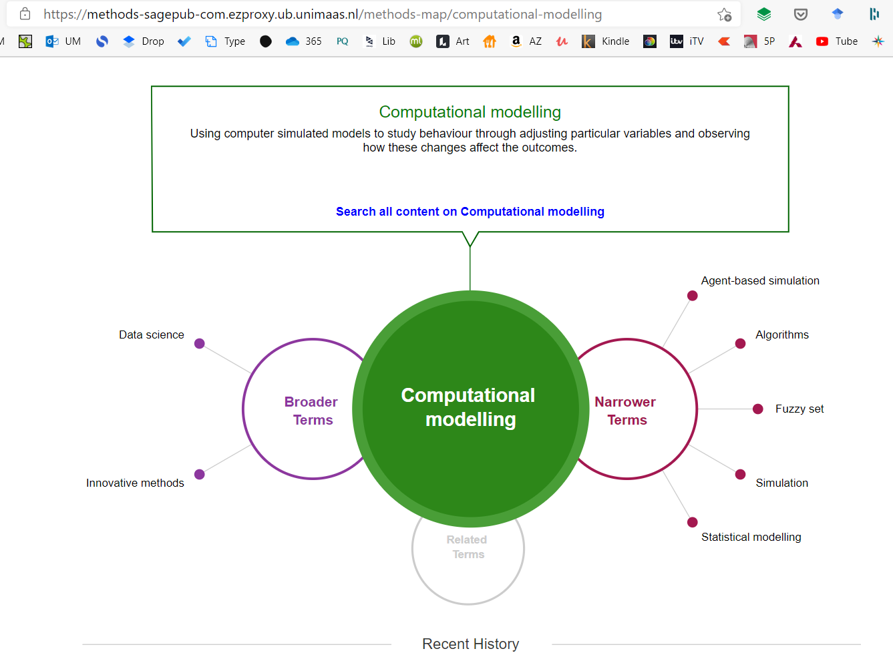

Figure 20: Landscape of Data Science in academic research

The power of prediction granted by data science can make an individual proactive towards their state of health, and the same can be used in a preventive and personalized way to attain well-being.

Based on the collected and quantified data on STRESS (Electroencephalography) & ENERGY (Sleep and Circadian Rhythm) experienced by the individual, a predictive model was created using Multiple linear regression and Decision Tree modeling.

### Data Staging & Feature Extraction

Because this data is gathered from several source systems via a distributed network, it comes in a variety of data kinds and forms. Before being transferred to the destination systems, the source data is processed and cleaned using algorithms and functions, which takes extra time (Gatimu et al., 2015).

The step of preprocessing data in any Machine Learning process involves changing, or encoding, it to make the parsing process easier for the machine. In other words, the algorithm can effectively interpret the data's features, and the final training set is the result of data pre-processing (Kotsiantis & Kanellopoulos, 2006).

Figure 21: ML Modelling pipeline

Dimensionality reduction is a key topic in machine learning and pattern recognition, and several algorithms have been presented (Refer to **Figure 21**).

As a preprocessing step for machine learning, dimensionality reduction is useful in reducing unnecessary and superfluous data, enhancing learning accuracy, and improving result comprehensibility (Khalid et al., 2014).

### Hyperparameter optimization

Hyperparameters are crucial for machine learning algorithms because they directly regulate the behavior of training algorithms and have a major impact on model performance. For some application domains, several strategies have been developed and effectively utilized. However, this work necessitates specialist expertise and experience (Wu et al., 2019).

Automated hyperparameter optimization approaches have been commonplace with the introduction of automated machine learning. However, development in autonomous analyses that provide information beyond performance-optimizing hyper-parameter settings has not kept pace (Van Rijn & Hutter, 2017).

Yang & Shami (2020) claim that hyper-parameters of a machine learning model must be modified to fit different tasks. The performance of machine learning models is directly influenced by the hyper-parameter configuration. It often requires in-depth knowledge of machine learning algorithms and the application of effective hyper-parameter optimization techniques.

### Feature engineering

Feature engineering is an important phase in the predictive modeling process. It entails the change of given feature space, usually with the aid of mathematical functions, intending to lower modeling error for a specified aim. Effective feature engineering, on the other hand, lacks a well-defined foundation. It entails topic knowledge, on-the-job training, and, most importantly, a long period of trial and error.

The amount of human attention required to manage this process has a major impact on the cost of model production (Khurana et al., 2017).

## Data Models

An experimental setup that deploys data science for predictive analysis.

*▪ Multiple Linear regression &*

*▪ Decision Tree algorithm*

There are different types of linear regression analysis, but multiple linear regressions are the most common. One continuous dependent variable is analyzed along with two or more independent variables in this kind of predictive analysis. The independent elements are combined linearly to forecast the dependent variable. The statistical value of R-Squared is used to assess the ability of a regression model to predict the dependent variable. On the other hand, the unstandardized beta (B) indicates the increase or decrease of the independent variables concerning the dependent variables.

**Creating ML Model:**

*1: Collect Both Categoric and Measurement data*

*2: Stage it for the Target value*

*3: Feature Extraction / Algorithms Selection*

*4: Make Predictions (Regression/Classification)*

*5: Holdout score (80% - 20%) & Performance Measures (such as MAE/Recall)*

*6: Model Evaluation (Accuracy, Reliability & Data path) and fit the data*

*7: Algorithm Selection & Data Evaluation for Batch predictions.*

Machine Learning consists of Supervised and Unsupervised modeling to generate the outcomes (Krawczyk, 2016; Mierswa, 2017; Rameka et al., 2019).

### Supervised Modelling

#### Sunburst Chart

A Sunburst diagram is used interactively for exploratory purposes in data-driven research. As explained by Russell (2016), its different arcs open up subfractions of data that display a common ancestry. A Sunburst is useful both as an investigation tool and a presentation tool.

Figure 22: Sunburst Chart with three dimensions

Data charts are widely used in technical science and are capable of providing an intuitive understanding of their underlying data (Araújo et al., 2020). It provides three (3) unique dimensions representing the Confidence, Accuracy, and Data path of a Machine Learning based model (Refer to **Figure 22**).

**Three (3) dimensions of the Machine Learning model:**

1. 'Error dimensions' reflect the accuracy of a model while predicting stress with 'Testing data.'
2. 'Prediction dimension' also shows confidence that indicates that the probability of input to fall in different classes is based on several instances in 'Training data'.
3. 'Split field dimension' shows the consideration data path (measures) required to predict stress.

#### Partial Dependence Plot (PDP)

Although complex machine learning models are better than the traditional interpretable models, they could be difficult to understand and trust these complex models due to the lack of intuition (Elshawi et al., 2019).

Figure 23: Partial Dependence Plot (Interest Vs. Relaxation)

Partial Dependence Plots (PDP) are model agnostic, meaning that regardless of the underlying model, they can show how changing one or two features affects the model’s output. They reflect the marginal contribution of different features to the output. They are used to display either the contribution of a single feature or two features (Molnar et al., 2020).

Partial Dependence Plow shows the marginal effect that two variables have on the predicted outcome of the ML model. It could represent a linear, monotonic, or Complex relationship between the features and the target value (Refer to **Figure 23**).

The partial dependence plot (PDP) can be used to make predictions for the set of values. Based on the same, the batch predictions can be seen in **APPENDIX D**.

## 

## Reliability

Reliability and validity are essential elements for the evaluation of measurement instruments (Mohajan, 2017). The relevance of assessing model reliability is highlighted by the current application of Machine Learning in healthcare. Given the purpose and use of Machine Learning in healthcare, comprehensive verification is required to support rational decision-making. Reliability is a measure of consistency that focuses on the re-production of results when research is done under the same set of conditions. Considering the sensitive nature of psychosomatic health, the current adoption of the ML model demands verification to support its applications (Rodr et al., 2006). According to Singh (2014), the adaption of such an approach in the ML model increases transparency and decreases researcher bias. Hence, both validity and reliability become a backbone to assure the integrity and quality of such research (Kimberlin & Winterstein, 2008).

According to Altheide & Johnson (1994), reliability is a measure of the stability of findings. It refers to a measurement that is in agreement with the results (Blumberg et al., 2005) that are a measure of consistency, precision, repeatability, and trustworthiness (Chakrabartty, 2013). As identified by Bolarinwa (2015), reliability indicates the extent of lack of error and ensures consistent measurement.

### Model Development

During the model training automation process, the following procedures were used to ensure the dependability of the ML training process in the current study -

1. Automated data extraction

2. Feature extraction

3. Model training and testing

4. Model selection and

5. Model evaluation

In ML, reliability depends on the procedure followed during model training. In the present study, quality checks were conducted during the pre-processing stage (Cearns et al., 2019) to avoid an inefficient model. The reliability was achieved using automated data staging and feature extraction (Chriskos et al., 2018; Mårtensson et al., 2020). A significant focus on the data and automated model-building process minimized the uncertainty of the ML model while improving the reliability of the process.

## Validity

Validity refers to the accuracy with which a measure confirms that the results measure what they claim to measure. Model validation is a technique for evaluating a model's anticipated performance using data that was not included in the initial construction of the model.

As stated by Blumberg et al. (2005), validity is often defined as the extent to which an instrument measures what it is asserted to measure. It relates to the extent to which the survey measures the right elements that are intended to be measured. The dependability of the exam was further tested by looking at the consistency of outcomes across different sections of the exam. The method required the creation of machine learning models as well as a performance comparison between the test and training sets of data. The data reliability was discovered after training the dataset (with 80% of the data) and testing the model with the remaining training dataset (using 20 percent data).

It was quantified using several metrics (Kailkhura et al., 2019) in a data-driven model, as reported by the following performance measures. The difference between observed values and the model's predicted values is summarized by Goodness-Of-Fit indices. A good match for a Machine Learning algorithm is when both the training data error and the test data error are modest. Based on the following characteristics in **Figure 24**, the same is visible in the presented research.

Figure 24 : Goodness-Of-Fit of Model

### Performance Matrix

**A) MEAN ABSOLUTE ERROR (MAE) - 0.03**

MAE is widely adopted in ML (Weijie Wang & Lu, 2018) for evaluation purposes. It is the standard metric to measure the accuracy of continuous variables with regression models. The MAE of a model (for a test set) is the mean of the absolute values of the individual prediction errors on overall instances in the test set.

According to Sammut & Webb (2010), the average of the absolute values of the differences between the true target and the target is predicted by the model. As MAE shows a lower value of 0.03, it grants greater accuracy to the given model.

**B) R2 VALUE - 0.88**

Regression analysis constitutes a large part of supervised ML, and R2 is known as the coefficient of determination for multiple regression that determines the performance of the model. Chicco et al. (2021) considered this metric more informative than other measures of model evaluation.

According to Hamilton et al. (2015), R2 bestowed a variable response explained by a linear model. The higher the R2, the better the model fits the data. Herein, R2 = 88 indicates that the model ascribes the variability of the response data.

# 

# **OBSERVATIONS**

During a pilot study, all the health professionals equivocally observed their patients affected by anxiety, stress, or depression during their practice. Most of their patients also experienced issues related to falling asleep, unbalanced appetite, and obesity.

**Figure 25** represents how a negative state of mind may deteriorate health or existing illnesses.

Figure 25: Analytical representation of Psychosomatic health.

However, the views were distributed when they were queried on the utility of technology to resolve psychological issues, as shown in **Figure 26.**

Figure 26: Analytical representation of the role of technology in healthcare.

In their expert opinion, 65.2% believed that technology could support the resolution of psychological issues by managing stress, while 69.6% of them agreed that “mental relaxation” or “physical exercises” can improve psychological health. A total of 91.3% of them confirmed that well-being techniques(s) could deliver therapeutic results.

During data collection, different emotional responses were elicited from the subjects. Collected data included EEG frequencies extracted from five cortices of the brain: ALPHA, BETA (H), BETA (L), GAMMA, and THETA frequencies (Romero & Molina, 2011). By identifying the significance of each frequency, scaled values were calculated for attributes such as Engagement, Focus, Excitement, Interest, Relaxation, and Stress. As Ooms & Spruit (2020) confirmed, data science can be applied in the healthcare sector. To accomplish the same, a machine learning (ML) model was trained to identify the probable effect of “Stress” as a target value for prediction.

Table 3: Model performance.

|  |  |
| --- | --- |
| Target (scaled) | Stress |
| Expected error (range) | **0.02–0.84** |

Figure 27: Sunburst chart representing an ML model.

The algorithm learned from the data and predicted the target values (Arpitha et al., 2018) with higher accuracy, as shown in **Figure 27** and **Table 3.** Thus, observations from the study primarily illuminate the existence of Psychosomatic along with the possible role of technology in the betterment of psychological health. At later stages, the study reflects on emotional states and individual well-being through data-driven analysis. For the fulfillment of this study, two constructs were used to identify Stress and predict Productivity. The construct of Stress relied on the degree of “Interest” and “Relaxation,” while the construct of Productivity was dependent on “Focus” and “Engagement” levels of an individual.

The workflow and outcome of the “Sequential Mixed Method” performed in the research are shown in **Figure 28**, indicating various phases of research.

Figure 28: Workflow of the four phases of research.

**STAGE I**

Pearson Correlation Results among Psychological_Issue, Subconscious_Mind, Bio_Signatures, Physical_Issue, Conscious_Mind, Therapeutic_Intervention, Role_of_Technology, Personality_Dimensions, and Psychosomatic_Health

A significant positive correlation was observed between Psychological_Issue and Physical_Issue (r = 0.52, p = .020, 95% CI = [0.25, 0.72]).

STAGE I Confirmed that Psychosomatism exists!

**STAGE II**

Qualitative Content Analysis (QCA) was used to establish a relationship between “Psychosomatic health” and the “role of technology” to improve well-being.

The study suggested that “Stress” has a statistically significant relationship with “Thearaputic_Intervention.”

Ultimately, STAGE II suggested that “Role_of_Technology” is applicable for “Therapeutic_Intervention.”

**STAGE III**

Results for Linear Regression with AGE, WEIGHT, ENGAGEMENT, RELAXATION, GENDER, HEIGHT, EXCITEMENT, INTEREST, LIFESTYLE, STATE_OF_HEALTH, LTE, and FOCUS predicting STRESS

The results of the linear regression model were significant, *F*(12,1509) = 1584.37, *p* < .001, and *R*2 = 0.93, indicating that approximately 93% of the variance in STRESS is explainable with Regression Equation: STRESS = –0.00 + 0.00*AGE – 0.00*WEIGHT – 0.09*ENGAGEMENT + 0.49*RELAXATION – 0.01*GENDER + 0.00*HEIGHT – 0.02*EXCITEMENT + 0.33*INTEREST + 0.01*LIFESTYLE + 0.02*STATE_OF_HEALTH + 0.02*LTE + 0.13*FOCUS

As per the model evaluation (Refer to **Figure 19**), STAGE III concluded that Psychological Well-being is correlated with Stress and other two predictors (including Interest and Relaxation).

**STAGE IV**

Spearman Correlation Results among AGE, BMI, FOCUS, CIRCADIAN_RHYTHM, GENDER, STATE_OF_HEALTH, STRESS, ENERGY_LEVEL, LIFESTYLE, ENGAGEMENT, SLEEP, and OBSERVED_PRODUCTIVITY

A significant negative correlation was observed between FOCUS and OBSERVED_PRODUCTIVITY (*r* = –0.12, *p* < .001, 95% CI = [–0.17, –0.07]).

STAGE IV confirmed that Psychological Well-being (driven by emotions such as Focus and Stress) impacts Workplace Productivity.

As research explicates, Individual Lifestyle (including Body Mass Index), Age, and Emotional states (ENGAGEMENT, EXCITEMENT, RELAXATION, INTEREST & FOCUS) determine Stress levels. As stress in an individual can potentially reflect on the Psychological Well-being, it can be managed through manipulation of RELAXATION and INTEREST.

Figure 29: Construct representing Psychological Well-being and Workplace Productivity.

( Credit: Welltory, 2022 )

Further, Stress (predicted by Age and Emotions) and Energy levels (predicted by Sleep pattern and Circadian rhythm) can provide insights into Workplace Productivity. Workplace Productivity can be reconfirmed with FOCUS and ENGAGEMENT LEVELS, as shown in **Figure 29**. That said, the above constructs could provide reflections on Psychological Well-being and Workplace Productivity.

## Cognitive attributes

Electroencephalographs (EEG) reflect neural oscillations generated by the human brain. These brainwaves can be read using a brain–computer interface (BCI) and converted into scaled values for analytical purposes. Such a setup can be used to enhance Psychosomatic health using a technology-supported data-driven model. Measures including Age, State of Health, Engagement, Relaxation, Interest, and Focus significantly affect the stress levels of a person, of which, the Relaxation and Interest levels are the most prominent ones.

In the healthcare ecosystem, actors such as brainwaves interact with applied therapeutic Interventions and integrate resources to reflect on current lifestyle and state of health. This process provides an individual with a relaxed state of mind to be able to effectively manage the stress. With such an approach, Therapists can diagnose and prognose stress levels for enhancing Psychosomatic health. Using Artificial Intelligence and managing individual attributes, it is possible to achieve optimal stress levels.

“Psychological stress” refers to the emotional and physiological response to uncontrollable and unpredictable situations. It represents acute stress brought on by demanding cognitive tasks under both time and social pressure. Based on the low *p*-value (<.05) of the indicators shown in **Table 2,** it can be confirmed that variables related to “Individual Lifestyle,” “Brainwaves, “ and “Therapeutic Intervention” affect the stress levels in an individual. As data analysis suggests, Age, Gender, and State of Health (Prior) are beyond control; however, the Intervention density can be manipulated to attain certain stress levels in an individual.

At the same time, Psychologists or Psychotherapists can manipulate the Focus, Interest, Relaxation, and Engagement levels to improve Psychosomatic health. The same can be reconfirmed by the ML model summary report shown in **Figure 30**.

Figure 30: ML-based model summary report.

## State of mind

The observation shows that every emotion (such as Relaxation and Excitement) in the study was associated with brainwaves. The holistic consideration of the state of mind could support Therapists (mold the human brain or make it more receptive) to achieve minimal stress. THETA and BETA (HIGH) frequencies were observed inversely, demonstrating a clear distinction between a meditative state and a focused state of mind. THETA and ALPHA frequencies were highly correlated, indicating that a creative thought process is supported by a relaxed state of mind.

The evidence of Anxiety and Stress could be co-related with GAMMA frequencies where an individual remains in fight or flight Mode (with minimal relaxation). It also indicates that apart from ‘Stress,’ research also needs to consider “Relaxation” as a significant factor. When the interventions were applied, associated actors worked differently for different people. An individual can utilize interventions for various forms of resource integration. It appears to be a complicated process that results in a certain degree of “Relaxation” and “Stress” to achieve peak mental performance. However, there were a few cases that have been found to have appeared (constantly) under stress. This is not because of strenuous situations but due to a lack of relaxation activities.

That said, the brain in neuroscience is a complex territory, and there are millions of brainwaves that are generated every minute; hence, it could get very much difficult to follow the Stress levels. Also, for every individual, the pattern of stress management is different. Instead, a more appraised strategy is to look at emotional states in a holistic manner (comparing Stress with Interest, or Relaxation, or Excitement levels). Psychosomatic health reflects a lucid state of mind that can be achieved by optimizing Stress levels in the body.

Figure 31: Yerkes–Dodson law bell curve.

As established in psychological theory by Yerkes & Dodson (1908), this self-tracking and nudging (refer to **Figure 31**) can support an individual in attaining the level of Stress that leads to optimal performance (Teigen, 1994). The BCI device and the ML model created in the study can make an individual understand when they are reaching unproductive territory.

## Well-being with Technology

The study focused on psychological health as a key predictor of well-being, which can include ‘positive affect' across all life domains (Pressman et al., 2019). Diener et al. (2010) created well-being measures to assess psychological health by taking into account positive and negative feelings, as well as the difference between the two. Happiness, joy, cheerfulness, and excitement are frequently included in studies to evaluate their positive impact on psychological well-being (Trudel-Fitzgerald et al., 2019). Positive affect and other psychological well-being indicators can be used to operationalize psychological well-being (Boehm & Kubzansky, 2012; Ryff et al., 2004). Based on psychological correlations of positive emotions that influence well-being, this study draws from, a conceptual framework of well-being by Alexander et al. (2021). Given the importance of psychosomatic health, the research presented here provides a transdisciplinary approach to addressing questions about psychological healthcare (Karami et al., 2018).

The observations made in the study suggest that an individual can achieve an optimal level of Stress by maintaining a predicted level of Interest and Relaxation using an ML-driven model. When used in real-time, the insights generated by an ML model can significantly support Therapists to understand and treat the Psychosomatic condition. A Therapist may be able to use the relationship between Interest and Relaxation to drive positive outcomes. The ML model derived from BCI can be used in real-time and can reduce the time required for Psychosomatic treatment by Therapists. Further use of the validated model can also be scaled beyond and can be used by the patient for the betterment of their individual health, reducing the associated costs. Such a model can be extended in the form of a “Web portal” to enhance access to the healthcare ecosystem.

The ML model expedites and optimizes the process of augmenting Psychosomatic health. In the process, the value is created by the interaction of Actors in Healthcare, where such type of Psychotherapy can be performed with minimal time with the application of the proposed experimental ML model. Additionally, for the people, greater access can be granted to the Healthcare Ecosystem by scaling the model in the form of an App and Web portals.

Well-being experienced by an individual can also support their respective organizations, allowing long-term growth. In line with self-tracking, people would be able to reach a desired mental state (with or without help from Therapists). The approach mentioned in the given study would help people attain greater self-control of their brain and stay in the productive zone. This entire study would offer higher productivity to the individual and, in turn, affect organizational performance.

# **FINDINGS**

The “Sequential Multiple Methodology” in this research shows that mental health affects physical health (Stage I), confirming the existence of the “Psychosomatic” nature of health issues.

A significant positive correlation was observed between Psychological_Issue and Physical_Issue (*r* = 0.52, *p* = .020, 95% CI = [0.25, 0.72]).

It calls for maintaining the well-being of an individual, which could be achieved with an active role of technology (Stage II). The same was confirmed with qualitative comments from the health professionals and relevant case studies analyzed using content analysis (Cluster analysis and Co-occurrence table).

Stage III of the research design observes Psychological Well-being as a multidimensional construct, and its hedonic type of well-being is a product of emotions, happiness, and positive affect. Sustained stress and negative feelings experienced by a person can affect his/her well-being.

During this stage, the results of the linear regression model were significant, *F*(12,1509) = 1584.37, *p* < .001, *R*2 = 0.93, indicating that approximately 93% of the variance in STRESS is explainable with *the* Regression Equation.

The data-driven ML model used during this part of the study deals with silos of information and renders a personalized model that could support the management of stress. With the technological edge being operated in real-time, it would be easier to maintain or improve Psychological Well-being. This stage answers RQ1 confirming the role of positive emotions in well-being. With such an exploration, we can understand the significance of technology for the betterment of well-being.

Stage IV of the research design depicts the impact of well-being on Workplace Productivity, where “Focus” as an emotional state plays a major role.

[ FOCUS-OBSERVED_PRODUCTIVITY –0.12 [–0.17, –0.07] 1522 < .001 ]

This stage also retrieves prior academic literature to reflect on organizational performance driven by the well-being of individual employees. The brainstorming unfurled by the literature reviewed for the given study allows us to answer RQ2, where we could analyze the role of Actors, Resource Integrators, and Value co-created using technological convergence

Finally, it allows us to reflect on the co-created value for an organization through individual well-being.

**Observing the effect of Emotional states and Psychological Well-being**

* From the Stage III of the research design and the construct of Psychological Well-being, we can observe that Emotional states correlate with the stress levels of an individual.
* In this process, “Stress” acts as a mediator, while “Interest” and “Relaxation” act as moderator variables.
* That said, Psychological Well-being is the product of the Emotional state of a person and maintaining the same self-quantification can be an effective strategy.

**Observing the impact of Psychological Well-being and Workplace Productivity**

* Based on the data from Stage IV, we can conclude that the Focus retained by an individual directly affects Workplace Productivity.
* In this process, “Focus” acts as a mediator, while “Body’s clock” and “Energy levels” act as moderator variables.
* Relevant academic literature can additionally be linked to the current knowledge to conclude that Workplace Productivity reflects upon Organizational Performance.

## Pervasive Health

The current state of the healthcare industry and disease characteristics call for an integrative healthcare structure. It illustrates the addressal of the challenging landscape of the health sector using the pervasive nature of eHealth. It can not only address physical well-being but also tackle cognitive impairments to add value to patient care (Rowland et al., 2020). The process of Self-quantification and Nudging can be an integrated element of eHealth. It could use technological prowess in the form of distributed computing, which can pool people and resources together. It would include the conventions on how patients seek consultation from health providers. In the opinion of Allen & Christie (2016), such a ubiquitous mode of healthcare offers innumerable possibilities, offering new business opportunities and innovative service delivery models. It characterizes its applicability through the proximity to the patient and health professional, where care practices are enabled via digital technologies.

The developmental perspective of such an approach embraces the interaction between patient and doctor (incorporating evolving inputs from the healthcare ecosystem), which is fetched from BCI to create a data-driven model. The use of technologies enables swift responses to immediate healthcare-related needs. Showing a glimpse of future healthcare, it looks forward to establishing the balance between physical and digital practices for the delivery of healthcare practices. Furthermore, as such care delivery is dependent on the data, it can devise an outlook for personalized care as well.

In the current era of technological superiority, such practice does not limit itself to the patient-doctor dyadic relationship but goes beyond to provide an ecosystemic delivery of care through an interconnection across healthcare stakeholders. It results in not only universality and equity of access to services but also interdependence between individuals in the healthcare society. It allows every single actor in the healthcare ecosystem to empower others. Such a technological foundation offers a novel paradigm of a complex healthcare ecosystem where actors interact and integrate resources in the form of data. This process is adaptive, and its usability is reinforced with active participation in health processes (Joiner & Lusch, 2016; Osei-Frimpong et al., 2018). Such a process of self-quantification and nudging is likely to yield new service innovation models to revolutionize Psychosomatic care for vulnerable patients where specific outcomes could be technology-formulated “tailor-made” risk prevention tactics, the communication of proactive or preventive measures, and a guide for therapeutic protocols.

When the insights into the data-driven models are encapsulated as an App (or software application) or embedded on a Web portal (as a website back-end), it presents a strong case to achieve “Platformization.” Finally, conceived with the notion of prevention, personalization, and prediction, eHealth is about setting itself up to support the next frontier enabling Psychological Well-being.

## Positive Emotions

Data analysis suggests that there exists a significant impact of Individual Lifestyle, Age, and Emotional states on Stress. The results of the linear regression model were also significant, *F*(11,1510) = 1553.62, *p* < .001, *R*2 = 0.92, indicating that approximately 92% of the variance in Stress is explainable by Age, Gender, Lifestyle, Sleep, State of Health, Engagement, Excitement, Relaxation, Interest, Intervention usability, and Therapeutic Intervention.

Based on the same, we can reject the null hypothesis (*H0), confirming* that *Individual Lifestyle, Age, and Emotional states do not significantly predict Stress.* At the same time, individual attributes such as Engagement, Relaxation, Interest, and Focus also affect Stress levels.

As we derive an ML-based treatment protocol, the study presents two-fold applications as follows.

1. **For Patients**

We have already established that Technology can play a prominent role while dealing with Psychosomatic Health. In this study, the neural data (in the form of EEG) can be captured using a BCI for “self-tracking” purposes. They can be modeled when fed to AI to provide cognitive indicators also known as “Nudges,” which could keep a check on Psychological Well-being.

Continuous self-tracking can make an individual aware of the health situation, while data-driven and AI-supported nudging can keep the person proactive toward his/her health. For a patient, the above process where the emotions are augmented dynamically—using ML in real-time—can give rise to the self-efficacy experienced by an individual who is facilitated by the role of technology.

1. **For Therapist**

The state of emotions retrieved via EEG can be fed to AI systems to generate an experimental treatment protocol. From a Therapist’s point of view, such a protocol can offer insights into patients’ emotional states and help support/expedite their treatment plans based on cost and access.

## Generating Value

Co-creation in health is a term used by service researchers to describe the resource integration process (McColl-Kennedy et al., 2015) that occurs between actors within a service ecosystem (Frow et al., 2016b). AI, together with IoT devices, is converging in many businesses with significant potential for elevating the use of data and other resources (Vermesan et al., 2014). Joiner & Lusch (2016) have highlighted the potential role of smart devices in health services as they improve consumer self-efficacy. The future of smart systems will present social and physical offerings that will result in improved service in a given context (Ng & Wakenshaw, 2017). The given study reflects on the actors (stressors/interventions) that affect psychopathic health and evolves into a resource integration process (using AI) to fulfill value co-creation (in terms of betterment of health). The application of ML can leverage on brain-related (EEG) data and address complexities in the system to enhance the overall resource density. Considering several permutations and combinations presented by psychological barriers, and identifying the physical factors associated with the state of mental health and leveraging technology, the proposed research helps in faster implementation of therapy.

The value can be co-created at three different levels:

1. For an Individual, Stressors can be mitigated through specific actors to manage stress for the betterment of Psychological Well-being.
2. For an Organization, an Individual's Well-being can lead to higher Workplace Productivity. In the long term, this can also reflect on Organizational Performance.
3. For the Healthcare ecosystem, the (In-house) Therapists may be able to use technology and to adapt New Normal for stress management to enhance Psychological Well-being.

*Spatial flexibility offered through the act of self-tracking can facilitate cognitive assistance using the nudging mechanism, which could facilitate self-quantification leading to self-efficacy. This process can support an individual to stay in control where he/she can check the biofeedback, act on it if required, and adapt to it. In the process, the individual can be supported by the health professional or technology.*

Thus Observation in the given study mainly consists of Cognitive Attributes, State of Mind & Well-being achieved through technology. It indicates that a feed of EEG signal can be directed to ML model using Brain Computer Interface. With practice such as ‘Self Quantification’ a state of mind can be determined through the provision of cognitive indicators. The ‘Nudging’ makes emotions being augmented dynamically to act as smart Nudges through the process of Artificial intelligence. The process results in improved Well-being, ultimately enhancing workplace productivity.

# **DISCUSSIONS**

In services research, technology (such as AI) can impact psychological well-being (which is nothing but a reflection of psychological health.) Through the SD-L lens comprising actors and resource integrators, it can be achieved by ‘Self-tracking’ and ‘Nudging’. The process involves the interplay of actors and self-quantification leading to improved psychological health & wellbeing. The actors (Age/Gender/Sleep/BMI/Lifestyle/State of Health) along with emotional states (ENGAGEMENT, EXCITEMENT, RELAXATION, INTEREST, FOCUS & STRESS) fulfill resource Integrators (IoMT and AI) to enhance the Resource Density. The dynamics involved in achieving psychological well-being reflect positively on workplace productivity as a co-created value.

Actors are entities that are part of a system and are either actively or passively involved in contextual practices. According to a wide range of literature, an actor can assist another actor in improving their capabilities and integrating new resources through shared practices. Technologies (as one of the actors) can change the broad scope of practices by reconfiguring human participation to present a new context. Furthermore, rather than simply reproducing reality, such practices continuously shape and format the reality. The actors are influenced by technological and social contexts and engage in resource-integrating interactions and collaboratively create value for the beneficiaries, both directly and indirectly.

In the present study, the patient is treated as one of the active actors and technology is another significant one that engages in resource integration. As **Figure 32** shows, the relationship between Interest and Relaxation indicated by the ML model could be helpful in effectively managing stress levels to drive positive outcomes (in the form of optimal stress). Apart from “Relaxation,” research also suggests considering “Interest” as a significant factor.

Figure 32: Decision tree field importance model summary.

A patient-centered approach extends the range of collaborative activities to include those offering Psychological Well-being. It is believed that technologies can reinvent the dynamics within healthcare by providing greater access to the patients as well as healthcare providers. Technologies such as IoMT and AI provide access to a resource with abundant “unbundleability” and “liquification.”

Using a similar approach, the Therapist could also gauge the emotional states to be able to realize a treatment to manage stress and, in turn, Psychological Well-being. The use of ML modeling facilitates the right treatment with more reachability by medical practitioners. For an individual, learning from their own data can personalize the performance window, which could be used for achieving Workplace Productivity. The performance of the ML model can be improved by feeding more data and with the fusion of ML models. It could be utilized to achieve the desired mental state using healthcare IoT devices to maintain Psychological Well-being. Along similar lines, it can be extended for enhancing Workplace Productivity. Here the role of the IoMT device changes from data aggregators to nudging devices. These physical and technical resources interact with each other for data sharing. As a collaborative effort, resources end up enhancing the resource density of actors. When actors attain optimal resource density, the value is co-created. All such encounters take place within a system of internal and external factors that have interdependent relationships.

In this study, human actors include the individuals who reflect certain brain patterns (EEG) in the form of various metrics, while nonhuman factors are the technologies such as AI that expedite the process of interactions. Such an interaction—leveraging the resource density of actors on the network—fulfills resource integration. These actors enhance resource integration using the data from prior medical research, ongoing clinical trials, and futuristic technologies. The social realm is defined by the interactions among actors through different interfaces, which are getting increasingly nonhuman (or in the form of technologies such as AI or IoMT).

Considering Lifestyle and Emotional states as actor(s) and their interplay with Self-Quantification (using IoMT devices) can induce Resource integration. The application of AI (by identifying patterns) can enhance the Resource density and offer proactive Nudging (via predictive modeling). The entanglement of actors takes place in a progressive manner where such “Self-Quantification” and “Nudging” result in the betterment of Psychological Well-being. Value co-creation further reflects the form of enhanced Workplace Productivity individually and collectively on Organizational Performance. The critical role of resource integration facilitates how resource integrators (actors) co-create phenomenologically determined value. It is greatly dependent on the availability of the resource in terms of time and space and can be accelerated through suitable technological platforms or infrastructure. Ultimately value co-creation is an outcome of mobilized resources & their capabilities that are integrated at the right time and place.

Thus, co-created value through the resource integration process can be explained as follows:

* The ability to keep track of vitals by self-tracking can offer liberty and choices to an individual in the form of “Spatial Flexibility.” This can also help offer personalized treatment options to the individuals along with maximizing access, thanks to the role of healthcare IoT devices. When supported by an AI unit, it can make use of data-driven ML models to be able to establish Cognitive Assistance. The technological prowess offered by the convergence of AI and IoMT can be used for expedited therapy.
* Resource density reinforces resource integration. In this study, it is enhanced with the help of technologies such as Healthcare IoT and AI. While Healthcare IoT collects EEG data generated in the form of various brainwaves (via BCI), ML models can process brain signals to be able to indicate attributes such as Interest, Relaxation, Focus, and Engagement of an individual. The entanglement between mediators of Stress and Productivity presents a complex level of interaction. Brainwaves represent a unique state of psychological health, and their holistic understanding across different brain cortices can help determine Stress levels. In the same instance, Stress levels can depict a particular level of Focus and Engagement in a person.
* In the given study, actors include age, gender, lifestyle, state of health, as well as height and weight of an individual. It further includes sleep patterns and Circadian rhythm experienced by a person. The resource integration takes place with the help of emotional states (psychological health) and Lifestyle (somatic health), giving rise to certain levels of stress. The stress generated via Psychosomatic health affects the productivity of an individual.
* The co-creation process is the outcome of actors, and their resource integration process where the optimal levels of Stress and Energy of a person can give an indication of productivity demonstrated at the workplace. When the Workplace Productivity of a person reaches optimal levels, it will support greater organizational productivity.
* When such a process is repeated in line with nudge theory, it keeps pushing individuals to better control their health and further enhance self-efficacy. Such self-efficacy can positively affect individuals and their well-being. The access granted by the use of ML can be modelled (with utmost validity and reliability) and can be extended to a set of people and/or organizations.
* The technology can provide greater access and real-time monitoring with predictive analysis and facilitate a non-evasive and proactive approach to tackling stressors. The technological support facilitated by IoMT and AI can enhance individuals’ capability to effectively deal with stress. Such impact could get multi-folded and help enhance well-being.

The study reflected on the actors (such as stressors/interventions) that can augment Psychosomatic health by resource integration (using AI technologies) to fulfill value co-creation (betterment of health).

The ML model obtained from BCI (refer to **APPENDIX D**) can be used in real-time for treatment by Therapists. Actors engage in resource integration activities to increase their resource density, and resources are accessible for a combination of a specific actor, time, and situation. Also, in the present study, it was shown that the effective use of technology offers greater resource density leveraging the sensors-based capabilities it possesses. Organizations can make use of in-house therapists or telemedicine to be able to enhance their overall efficiency. Based on the data model created in this study:

* *One can avoid unproductive territory at the workplace.*
* *A personalized performance window can be predicted.*
* *The optimal level of Stress can be reached.*
* *Its accumulative effect can enhance Workplace Productivity.*

Enhanced productivity would reflect the improvement of the overall quality of work. Established performance windows would limit work-related burnouts that mostly happen due to working continuously with a low level of Focus and Engagement. When self-tracking is effectively carried out using IoMT devices, the collected data can be modeled using AI leveraging the nudge theory, where the role of an IoMT device—may be shifting from aggregators to actuators - can be utilized for enhancing Workplace Productivity. It could result in almost no burnout during working days, thus generating better work quality.

In the presented thesis theory development is carried out with the help of 3 theories where first theory adopts the SD-L lens to depict technology can play a major role in the betterment of psychological well-being. The second part of the theory highlights the value of the co-creation process where psychological well-being emerges when ‘Self-tracking’ and ‘Nudging’ is carried out with the help of technology. The third part of the theory development explains the phenomena of enhanced workplace productivity as an outcome of improved psychological well-being.

# **IMPLICATIONS**

The implication of this research can encompass two (2) levels.

**(1) INDIVIDUAL LEVEL**

**Personalized Approach**

The insights drawn from the study can study individual indicators of health. Based on the same it can facilitate a personalized approach to psychosomatic health. An IoMT device can be programmed with an ML model to provide indications or nudges to indicate the stress levels along with other mediators to enhance psychological well-being.

Using the STRESS and ENERGY of an individual as a benchmark and utilizing EEG biofeedback as an approach Such approach can also be used to predict the FOCUS & ENGAGEMENT levels of an individual. This mechanism could be made real-time and automated to provide a trigger (or a signal) indicating that a person has STRESS or FOCUS Levels.

The understanding sought from the real-time stress levels, sleep patterns and circadian rhythm could help individuals understand their levels of focus and engagement dynamically. It could bring about a possibility to gain more control over the Work-Life Balance. From individuals’ point of view, this approach can offer a personalized approach for the betterment of Psychological Well-being at the same time for an organization; it could lead to enhanced Workplace Productivity.

**Enhanced Self-efficacy**

With the help of wearable technology, this personalized data flow can be used for smart nudging to improve individual wellbeing. The ability conferred with the application of technology offers greater self-efficacy.

The predictive power offered by Machine Learning (ML) can offer expedited therapy. Such analytics can also facilitate health professionals to provide 'cognitive assistance' (Behera et al., 2019).

Further, such a model can also be scaled and used (as an App) by the patient for stress management. Insights on therapeutic interventions could help low-cost design applications and personalized approaches to help people enhance 'Self-Efficacy’. People can make use of such personalized approaches to enhance 'self-efficacy' (Klassen & Klassen, 2018) while managing stress. Ultimately such a model can be extended in the form of a web portal to enhance access to the healthcare ecosystem. As it could go beyond time and place, it may offer ‘Spatial Flexibility'.

Insights on Therapeutic Interventions could help develop low-cost applications. The access to people can be extended by the use of technology & could facilitate 'Spatial Flexibility' (Kotera & Vione, 2020) in the Healthcare ecosystem.

The Spatial Flexibility offered by IoMT, along with the Cognitive Assistance facilitated by AI, can provide insightful information to the individual and in line with Nudge theory (Thaler & Sunstein, 2009), can go on to enhance self-efficacy improving individuals' well-being.

**Effective Treatment**

The creation of a Machine Learning (ML) driven-based model could offer real-time insights on Psychosomatic health to be able to minimize ‘Time’ and grant greater ‘Access’ to the individual.

* ACCESS: Extension by Portal or Apps (using the ML model)
* TIME: Expedited Therapy (offered by the therapist)
* COST: Replication of ML model (facilitated by the ecosystem)

The Machine Learning model derived from Brain Computer Interaction (BCI) can be used in real-time and can reduce the time required for psychosomatic treatment by the therapists. Further use of the validated model can also be scaled beyond and can be used by the patient for the betterment of their health, reducing the associated costs.

Eventually, such a model can be extended in the form of a ‘Web portal’ to enhance access to the healthcare ecosystem. The Machine Learning model expedites and optimizes the process of augmenting psychosomatic health. In the process, the value is created by the interaction of actors in healthcare, where such type of psychotherapy can be performed with minimal time and lower costs with the application of the proposed ML model. Additionally, greater access can be granted to the healthcare ecosystem by scaling the model in the form of a smartphone app and web portals. These possibilities offered by the ML model in terms of time, cost and access could different effective psychosomatic treatments to drive positive outcomes.

**(2) ORGANIZATIONAL LEVEL**

**Work-Life Balance at Workplaces**

Presented research provides insights concerning psychosomatic health and its individual as well as organizational effects. At an organizational level, enhanced workplace productivity leads to efficient Organizational performance. Other fields such as Human Resource Management, Systems Management and Operations management can benchmark and draw ideal Workplan allotment and offer exceptional ambiance for working. Ultimately it is expected to lead to optimal Work-Life Balance.

**Replication of Service-Dominant Logic for technology development**

Research shows that Brain Computer Interface and Artificial Intelligence can be resource integrated (Frow et al., 2016a; Kleinaltenkamp et al., 2012; Sklyar et al., 2019) with respective capabilities to process complex brain signals and data modelling for co-creating value in the form of Enhanced Psychosomatic Health (Mele et al., 2010). This demonstrates that SD-Logic can be used while executing Information Systems driven plans in organizations.

**ML model as supporting Utility for the healthcare ecosystem**

Given the value that the study provides for optimizing self-tracking, the application of IoMT becomes the next logical step for organizations. Practices centered on the miniaturization of IoMT devices can be accelerated to achieve Well-being. As stress has a direct impact on sleep quality (Y. Li et al., 2019), work-life balance (Omar et al., 2020; Weerasinghe & Dilhara, 2018) and well-being (Wersebe et al., 2018a; Yaribeygi et al., 2017).

BCI imaging devices can be used to manage stress levels, thereby improving Psychosomatic Health. This demonstrates that the research presented can serve as a resource for health professionals and, in some cases, facilitate online treatments with the advent of portable IoMT devices.

# **LIMITATIONS**

Being a data-driven study, the accuracy was contingent on the quality of the data provided. The results given in this study are dependent on the dataset obtained, as data curation and preparation are essential for constructing a trustworthy model.

Another limitation of this study pertains to the data collected using a Brain Computer Interface (BCI). Human subjects tend to move, shift or shuffle during the experiment, this can result in a poor connection with the BCI electrodes and feed the ML model raw garbage data. Hence, it becomes necessary to establish a baseline at the start of the experiment and monitor contact quality during data collection.

While a lot of work has gone into accurate data modelling, overfitting data in Machine Learning may result in less clarity in the results (Nijholt, 2019). Due to this, identifying relationships in the dataset that are not inherent to the predictions given may be difficult. Furthermore, because it draws data from a growing number of sources, it creates an enormously complicated collection of features that must be taken into account throughout the Machine Learning modelling process (Feldman et al., 2017).

Further, as observed by Cabitza et al. (2017) distinguish, following the data-driven analytical modelling in Healthcare might have reduced the diagnostic sensitivity and information that cannot be fitted within ML models might stay out of focus. At the time, such Modelling may appear complex and multidimensional, with the danger of becoming untraceable and losing out on Observer variability. The data modelling for this specific study utilized features from the available dataset; hence its accuracy depends on certain boundaries of 5-Channel Brain-Computer Interaction (Rashid et al., 2020). The same can be enhanced by capturing neural data from 14-Channel or 32-Channel EEG devices.

In this study, the measurement of Energy was self-reported. Further data collection was carried out during the daytime; the data on Ramp-up and Wind-down states of a person was limited. While this kind of data was Self-reported in this study, some of the measurements (such as Sleep and Energy) can be automated in future studies.

The constructs of well-being only focused on the ‘positive affect’ of Hedonic well-being. While as per the neuroscience of positive emotions and well-being construct appear solid; however, it did not include other dimensions (such as happiness, hope and self-acceptance) in the given study.

# **FUTURE SCOPE & RECOMMENDATIONS**

In the future, as a Data-driven study is based on Decision Tree algorithms, it can be made robust using Ensemble modelling, Neural networks, and AutoML Classifiers.

When the proposed model is enhanced using silos of curated data, it is not only possible to diagnose the State of Health but also to provide the prognosis of Psychosomatic Health at the population level. When the applicability of the proposed model is established for the masses, it can learn by itself and complement healthcare professionals or therapists, offering greater accuracy.

As research is based on a technological foundation defined by electroencephalograph (EEG), it can further be scaled for other healthcare applications and incorporated in ‘Digital Twins.’ From a service point of view, the research does not only develop an Artificial Intelligence (A.I.) based treatment protocol but also can be extended to the healthcare ecosystem for greater value.

The constructs of well-being can be expanded to include the conception of psychological well-being with

* Hedonic Well-being (including Satisfaction with Life)
* Eudaimonic well-being (Purpose, Growth and Autonomy in life)
* Blended Well-being (Optimist)

As current research utilizes electroencephalogram (EEG), new explorations can be performed using Photoplethysmogram (PPG) in conjunction with the current data model. (Tong et al., 2018). This would present a holistic representation of physiological and psychological data reflecting on the well-being of an individual. Using infrared light, photoplethysmography (PPG) is used to quantify skin blood flow. Because of its advantages as a non-invasive, affordable, and convenient diagnostic tool, PPG has piqued the interest of researchers from various fields. Recent research has highlighted the potential information contained in the PPG waveform signal, and it merits additional investigation for its potential applications beyond pulse oximetry and heart rate calculation (Elgendi, 2012).

Considering the usability and feasibility of developing IoMT based devices (that are tiny in size and more suitable in terms of portability), future research plans to adopt HRV for Stress calculations. In the future, research should try to collect real-time measurements of Energy through connected sensors. Future studies look forward to calibrating and stress-based models for the development of IoMT (with HRV).

In the future, more signals, and datasets from electroencephalogram (EEG) and photoplethysmogram (PPG) can be combined for verification and analysis. The human body reflects the stress level depending on several factors, and when these factors are measured and analyzed at both Physical and Psychological levels, it would be possible to identify any misalignment between the same to support preventive healthcare. (Segerstrom & Miller, 2004).

Based on the results of the study, a 5-channel EEG signal and an individualized PPG signal, which can be monitored by using a wearable headband, were effective for monitoring brain activity where the arousal classification accuracy can reach 68 percent and the valence classification accuracy can reach 66 percent (Tong et al., 2018).

# **INFERENCE**

This study hinges on the Role of technology in gaining Psychosomatic health. It confirms the impact of Mental health on physical health. The study further reflects upon the impact of psychological well-being on Workplace Productivity. The premise of research identifies service systems as dynamic value co-creation configurations of people, technologies, and resources. It re-iterates that technology - such as A.I. in the form of service systems - has an essential role in healthcare services. It identifies a need to consider the impact that smart technologies and networked devices have on the actors. Proposed research followed ‘Sequential Multiple Methodology’ after the pilot study used a mixed-mode approach.

The sequential combination of four stages initially confirmed the impact of psychological health on physical health highlighting the importance of mental health. The next stage confirmed the role of Technology in achieving Psychological Well-being. In line with the same, the later stage utilized A.I. to observe Positive emotions and their dynamic impact on individual stress levels (Psychological well-being). It re-iterated Confirmed that Stress is observed through cognitive states & ultimately by positive emotions. The final stage of the study confirmed that psychological well-being impacts workplace productivity illuminating the importance of positive affect experienced by an individual.

The research design makes extensive use of data science to fulfill two objectives that explore the role of positive emotions for the betterment of Well-being using AI and reflect upon the co-created value in an organization through individual Well-being.

These objectives are attained using Brain-Computer Interface (BCI), which gather Electroencephalography signals from the subjects and model unique instances for making accurate predictions using Machine Learning. The ML model does not only predict the stress levels of an individual but also provides its correlation with ‘Interest’ & ‘Relaxation.’ The model validity and reliability are established using the 'Holdout score' (Training and Testing) and Mean Absolute Error (MEA) parameters. The data analysis considers three dimensions of the Machine Learning model, including confidence, accuracy, and data path. Data sampling is based on a large effect size that corresponds to practices followed in Behavioral sciences.

Using an interdisciplinary approach across Management, Technology & Healthcare domains the findings establish the augmentation of Psychological Well-being using Artificial Intelligence. As this required processing of a large amount of EEG data, contemporary techniques of Data Science was used to devise a Machine Learning model to generate valuable insights.

The study establishes that the actors (stressors/interventions) affect psychological health through the resource integration process (using Artificial Intelligence) to fulfill value co-creation (in terms of betterment of well-being). The same can be witnessed through a complex interaction of IoMT supported self-tracking, facilitated by A.I. that leverages ‘Nudge theory’ to be able to enhance psychological well-being. Using Artificial Intelligence Predictive ML model can be developed to draw valuable insights into the emotional states of an individual to boost individuals’ well-being.

The construct is based on the role of Positive emotions (depicted by stress) that could translate into the betterment of psychological well-being: Study also provides significant reflections on Workplace Productivity that could be enhanced by psychological well-being, later translating into greater organizational performance.

As the given study coincides with multiple levels it is appropriate to recognize nested entities within a hierarchical system that includes the following three levels: Level I represent the Individual level that includes the Emotional States and Self-Quantification activities. Level II shows Organizational level with a Holistic Impact on Workplace Productivity. Level III reflects the Ecosystemic level that makes use of IoMT and AI technologies for data processing to provide an outcome in the form of psychological wellbeing. The mapping of insights from the research with a Multilevel framework aligned using Service-Dominant Logic offers clarity on how augmentation of psychological wellbeing takes place with the help of an A.I. resulting in Workplace Productivity. It interacts at three different levels where the ecosystem level represents psychological Well-being and Organizational Performance.

Continuous Self-Quantification through 'Self-tracking' & 'Nudging' can augment Psychological Well-being driven by Positive emotions. Spatial Flexibility and Cognitive assistance derived from the above mechanism can effectively offer self-efficacy. Additionally, the ML model can complement psychotherapies to minimize the time for therapists and maximize access to the patients.

The implication of this research can encompass individual and organizational levels. The implications can be seen in the form of reduced treatment Time, minimized costs, and greater access to the healthcare ecosystem that benefits patients as well as therapists. The Limitations, however, include overfitting of data along with diagnostic sensitivity and observer’s variability while dealing with AI-driven models.

# **CONTRIBUTION**

Two contributions appear to have been made by the given study:

(A) Exploration of the insights using Data science using AI

* **Utilized Data Science due to the large set of the recorded data points**

Kushwaha et al. (2021) demonstrated that using Data Science-based protocols can help future Information Systems scholars deep-dive into healthcare management practices. According to (Ansar & Goswami, 2021) feature extraction through Machine Learning (ML) could provide a sense of strategy making to assist healthcare professionals.

The utility of data science and its algorithms provides a glimpse towards the possibility of using Photoplethysmogram (PPG) to explore new possibilities of preventive healthcare and offers the possibility of incorporating in ‘Digital Twins.’

(B) Understanding the benefits of behavioral aspects while using AI

* **Interlinked interdisciplinary domains such as Management, Technology and Healthcare**

The research includes simplified logic (using construct) for measuring Psychosomatic Health devised through an extensive literature review (Alexander et al., 2021; Hernandez et al., 2018; Trudel-Fitzgerald et al., 2019). Given study connects various domains such as Management, Technology and Healthcare to investigate how brain signals react and interact. With the help of Machine Learning and recorded data, it could offer predictive insights to comprehend pathways to the psychological well-being of an individual.

Finally, the study shows promise to offer Spatial Flexibility, Self-efficacy, and Cognitive Assistance based on individuals' needs with the possibility of extending it to an organization.

# **APPENDICES**

# APPENDIX A: Pilot Study

1. Questionnaire (pilot study)
2. Responses (pilot study)
3. Analysis (pilot study)

# APPENDIX B: Survey Questionnaire

1. Questionnaire (main study)
2. Dataset (main) (Stages III & IV)
3. Analysis (main) (Stages III & IV)

# APPENDIX C: Codebook of Qualitative Content Analysis

Codebook exported from NVivo software

# APPENDIX D: Dataset & Code Snippets

1. Dataset (Master)
2. Python script exported from BigML
3. Batch Predictions

# APPENDIX E: GDPR Compliance Statement

Compliance statement

# **List of Illustrations**

**Figures**

Figure 1: Application of A.I. and IoMT in Healthcare 16

Figure 2: Effectiveness of self-tracking technologies 21

Figure 3: Conception and Categorization of Psychological Well-being 24

Figure 4: A Conceptual Model of Correlations of Positive Emotions that Influence Well-being 25

Figure 5: Terminologies addressing Well-being 26

Figure 6: Representation of Exploratory Research Design 39

Figure 7: Overview of Research Design 42

Figure 8: Emotiv device and its features 51

Figure 9: Brain Computer Interface 53

Figure 10: Electroencephalograph (EEG) 54

Figure 11 : Motion detection 54

Figure 12: Frequency Graphs 55

Figure 13 : Sensor (Electrode’s) position 56

Figure 14 : Electrodes marked at positions AF3, AF4, T7, T8, and Pz 56

Figure 15: Pictorial representation of Constructs in the study 60

Figure 16: An overview of the process of a Qualitative Content Analysis 75

Figure 17: Case wise Sentiments 81

Figure 18: Cluster Analysis 82

Figure 19: ML based Model Evaluation 94

Figure 20: Landscape of Data Science in academic research 106

Figure 21: ML Modelling pipeline 107

Figure 22: Sunburst Chart with three dimensions 110

Figure 23: Partial Dependence Plot (Interest Vs. Relaxation) 111

Figure 24 : Goodness-Of-Fit of Model 113

Figure 25: Analytical representation of Psychosomatic health. 115

Figure 26: Analytical representation of the role of technology in healthcare. 115

Figure 27: Sunburst chart representing an ML model. 116

Figure 28: Workflow of the four phases of research. 117

Figure 29: Construct representing Psychological Well-being and Workplace Productivity. 119

Figure 30: ML-based model summary report. 120

Figure 31: Yerkes–Dodson law bell curve. 121

Figure 32: Decision tree field importance model summary. 128

**Tables**

Table 1 : Content analysis of case studies 79

Table 2 : Co-occurrence Table 83

Table 3: Model Performance 116

**Equations**

Equation 1 : Formula for sample size calculation 47

# **References**

Adams, J. M. (2019). The Value of Worker Well-Being. *Public Health Reports*, *134*(6), 583–586. https://doi.org/10.1177/0033354919878434

Ahern, D. K. (2007). Challenges and Opportunities of eHealth Research. *American Journal of Preventive Medicine*, *32*(5 SUPPL.). https://doi.org/10.1016/j.amepre.2007.01.016

Ahern, D. K., Kreslake, J. M., & Phalen, J. M. (2006). What is eHealth (6): Perspectives on the evolution of eHealth research. *Journal of Medical Internet Research*, *8*(1). https://doi.org/10.2196/jmir.8.1.e4

Ahmed, H. U., & Mari, J. de J. (2014). The role of research in the prevention of mental disorders. *Trends in Psychiatry and Psychotherapy*, *36*(1), 1–2. https://doi.org/10.1590/2237-6089-2014-1000

Ahmed, Z., Mohamed, K., Zeeshan, S., & Dong, X. Q. (2020). Artificial intelligence with multi-functional machine learning platform development for better healthcare and precision medicine. *Database*, *2020*, 1–35. https://doi.org/10.1093/database/baaa010

Ajana, B. (2017). Digital health and the biopolitics of the Quantified Self. *Digital Health*, *3*, 205520761668950. https://doi.org/10.1177/2055207616689509

Ajana, B. (2020). Personal metrics: Users’ experiences and perceptions of self-tracking practices and data. *Social Science Information*, *59*(4), 654–678. https://doi.org/10.1177/0539018420959522

Aldeer, M., Javanmard, M., & Martin, R. P. (2018). A review of medication adherence monitoring technologies. *Applied System Innovation*, *1*(2), 1–27. https://doi.org/10.3390/asi1020014

Alexander, R., Aragón, O. R., Bookwala, J., Cherbuin, N., Gatt, J. M., Kahrilas, I. J., Kästner, N., Lawrence, A., Lowe, L., Morrison, R. G., Mueller, S. C., Nusslock, R., Papadelis, C., Polnaszek, K. L., Helene Richter, S., Silton, R. L., & Styliadis, C. (2021). The neuroscience of positive emotions and affect: Implications for cultivating happiness and wellbeing. *Neuroscience and Biobehavioral Reviews*, *121*, 220–249. https://doi.org/10.1016/j.neubiorev.2020.12.002

Allen, L. N., & Christie, G. P. (2016). The Emergence of Personalized Health Technology. *Journal of Medical Internet Research*, *18*(5), e99–e99. https://doi.org/10.2196/jmir.5357

Altheide, D. L., & Johnson, J. M. (1994). *Criteria for assessing interpretive validity in qualitative research.*

Anderson, D. (2019). Artificial Intelligence and Applications in PM&R. *American Journal of Physical Medicine & Rehabilitation*, *98*(11). https://journals.lww.com/ajpmr/Fulltext/2019/11000/Artificial_Intelligence_and_Applications_in_PM_R.18.aspx

Anderson, L., & Ostrom, A. L. (2015). *Transformative service research: advancing our knowledge about service and well-being*. SAGE Publications Sage CA: Los Angeles, CA.

Anderson, L., Ostrom, A. L., Corus, C., Fisk, R. P., Gallan, A. S., Giraldo, M., Mende, M., Mulder, M., Rayburn, S. W., & Rosenbaum, M. S. (2013). Transformative service research: An agenda for the future. *Journal of Business Research*, *66*(8), 1203–1210.

Andrew, C. (2018). *Frequency Bands – What Are They And How Do I Access Them?* Emotiv. https://www.emotiv.com/knowledge-base/frequency-bands-what-are-they-and-how-do-i-access-them/

Ansar, W., & Goswami, S. (2021). Combating the menace: A survey on characterization and detection of fake news from a data science perspective. *International Journal of Information Management Data Insights*, *1*(2), 100052. https://doi.org/10.1016/j.jjimei.2021.100052

Araújo, T., Chagas, P., Alves, J., Santos, C., Sousa Santos, B., & Serique Meiguins, B. (2020). A Real-World Approach on the Problem of Chart Recognition Using Classification, Detection and Perspective Correction. *Sensors*, *20*(16). https://doi.org/10.3390/s20164370

Arpitha, M. S., Mithun, K. A., Rakesh, S., Singh, A., & Yadav, A. (2018). Better Healthcare using Machine Learning. *International Journal of Advanced Research in Computer Science*, *9*(3), 10–14. https://doi.org/10.1109/ABLAZE.2015.7154917

Ary, D., Jacobs, L. C., & Razavieh, A., Ary, D., Jacobs, L., Sorensen, C., & Razavieh, A. (2018). *Introduction to research in education*. Cengage Learning.

Asan, O., Bayrak, A. E., & Choudhury, A. (2020). Artificial Intelligence and Human Trust in Healthcare: Focus on Clinicians. *Journal of Medical Internet Research*, *22*(6), 1–7. https://doi.org/10.2196/15154

Asimakopoulos, S., Asimakopoulos, G., & Spillers, F. (2017). Motivation and user engagement in fitness tracking: Heuristics for mobile healthcare wearables. *Informatics*, *4*(1), 5.

Asio, J. M. R. (2021). Determinants of work productivity among selected tertiary education employees: A PreCOVID-19 pandemic analysis. *Asio, JMR (2021). Determinants of Work Productivity among Selected Tertiary Education Employees: A PreCOVID-19 Pandemic Analysis. International Journal of Didactical Studies*, *2*(1), 101455.

Åslund, C., Starrin, B., & Nilsson, K. W. (2014). Psychosomatic symptoms and low psychological well-being in relation to employment status: The influence of social capital in a large cross-sectional study in Sweden. *International Journal for Equity in Health*, *13*(1), 1–10. https://doi.org/10.1186/1475-9276-13-22

Auf, H., Dagman, J., Renström, S., & Chaplin, J. (2021). Gamification and Nudging Techniques for Improving User Engagement in Mental Health and Well-Being Apps. *Proceedings of the Design Society*, *1*(AUGUST), 1647–1656. https://doi.org/10.1017/pds.2021.426

Australian Institute of Health and Welfare. (2020). Physical health of people with mental illness. *AIHW*, *2*, 1–6. https://www.aihw.gov.au/reports/australias-health/physical-health-of-people-with-mental-illness

Balcombe, L., & De Leo, D. (2021). Digital mental health challenges and the horizon ahead for solutions. *JMIR Mental Health*, *8*(3). https://doi.org/10.2196/26811

Barile, S., Grimaldi, M., Loia, F., & Sirianni, C. A. (2020). Technology, value co-creation and innovation in service ecosystems: Toward sustainable co-innovation. *Sustainability (Switzerland)*, *12*(7). https://doi.org/10.3390/su12072759

Baron, R. A. (1991). Positive effects of conflict: A cognitive perspective. *Employee Responsibilities and Rights Journal*, *4*(1), 25–36.

Bartlett, C. J., & Coles, E. C. (1998). Psychological health and well-being: Why and how should public health specialists measure it? part 2: Stress, subjective well-being and overall conclusions. *Journal of Public Health (United Kingdom)*, *20*(3), 288–294. https://doi.org/10.1093/oxfordjournals.pubmed.a024771

Bates, D., Mächler, M., Bolker, B., & Walker, S. (2014). Fitting linear mixed-effects models using lme4. *ArXiv Preprint ArXiv:1406.5823*.

Behera, R. K., Bala, P. K., & Dhir, A. (2019). The emerging role of cognitive computing in healthcare: A systematic literature review. *International Journal of Medical Informatics*, *129*(July), 154–166. https://doi.org/10.1016/j.ijmedinf.2019.04.024

Bengtsson, M. (2016). How to plan and perform a qualitative study using content analysis. *NursingPlus Open*, *2*(February), 8–14. https://doi.org/10.1016/j.npls.2016.01.001

Bennett, J., Rokas, O., & Chen, L. (2017). Healthcare in the Smart Home: A study of past, present and future. *Sustainability (Switzerland)*, *9*(5), 1–23. https://doi.org/10.3390/su9050840

Berman, E. (2017). An Exploratory Sequential Mixed Methods Approach to Understanding Researchers’ Data Management Practices at UVM: Integrated Findings to Develop Research Data Services. *Journal of EScience Librarianship*, *6*(1), e1104. https://doi.org/10.7191/jeslib.2017.1104

Berry, L. L. (2019). Service innovation is urgent in healthcare. *AMS Review*, *9*(1–2), 78–92. https://doi.org/10.1007/s13162-019-00135-x

Berry, L. L., & Bendapudi, N. (2007). Health Care: A Fertile Field for Service Research. *Journal of Service Research*, *10*(2), 111–122. https://doi.org/10.1177/1094670507306682

Blumberg, B. F., Cooper, D. R., & Schindler, P. S. (2005). Survey research. *Business Research Methods*, 243–276.

Boehm, J. K., & Kubzansky, L. D. (2012). The heart’s content: The association between positive psychological well-being and cardiovascular health. In *Psychological Bulletin* (Vol. 138, Issue 4, pp. 655–691). American Psychological Association. https://doi.org/10.1037/a0027448

Bohr, A., & Memarzadeh, K. (2020). The rise of artificial intelligence in healthcare applications. *Artificial Intelligence in Healthcare*, 25–60. https://doi.org/10.1016/B978-0-12-818438-7.00002-2

Bolarinwa, O. (2015). Principles and methods of validity and reliability testing of questionnaires used in social and health science researches. *Nigerian Postgraduate Medical Journal*, *22*(4), 195. https://doi.org/10.4103/1117-1936.173959

Bornmann, L. (2013). What is societal impact of research and how can it be assessed? a literature survey. *Journal of the American Society for Information Science and Technology*, *64*(2), 217–233. https://doi.org/10.1002/asi.22803

Bosle, C., Fischer, J. E., & Herr, R. M. (2021). Creating a measure to operationalize engaged well-being at work. *Journal of Occupational Medicine and Toxicology*, *16*(1), 1–12. https://doi.org/10.1186/s12995-021-00297-0

Bughin, J., Hazan, E., Allas, T., Hjartar, K., Manyika, J., Sjatil, P. E., & Shigina, I. (2019). Tech for Good Smoothing disruption, improving well-being. *McKinsey Global Institute*, *May*, 1–78. https://www.mckinsey.com/~/media/mckinsey/featured insights/future of organizations/tech for good using technology to smooth disruption and improve well being/tech-for-good-mgi-discussion-paper.ashx

Bui, T., Zackula, R., Dugan, K., & Ablah, E. (2021). Workplace Stress and Productivity: A Cross-Sectional Study. *Kansas Journal of Medicine*, *14*, 42–45. https://doi.org/10.17161/kjm.vol1413424

Butryn, M. L., Arigo, D., Raggio, G. A., Colasanti, M., & Forman, E. M. (2016). Enhancing physical activity promotion in midlife women with technology-based self-monitoring and social connectivity: a pilot study. *Journal of Health Psychology*, *21*(8), 1548–1555.

Caballé, N. C., Castillo-Sequera, J. L., Gómez-Pulido, J. A., Gómez-Pulido, J. M., & Polo-Luque, M. L. (2020). Machine learning applied to diagnosis of human diseases: A systematic review. *Applied Sciences (Switzerland)*, *10*(15), 1–28. https://doi.org/10.3390/app10155135

Cabitza, F., Rasoini, R., & Gensini, G. F. (2017). Unintended consequences of machine learning in medicine. *JAMA - Journal of the American Medical Association*, *318*(6), 517–518. https://doi.org/10.1001/jama.2017.7797

Čaić, M., Odekerken-Schröder, G., & Mahr, D. (2018). Service robots: value co-creation and co-destruction in elderly care networks. *Journal of Service Management*, *29*(2), 178–205. https://doi.org/10.1108/JOSM-07-2017-0179

Cannard, C., Brandmeyer, T., Wahbeh, H., & Delorme, A. (2020). Self-health monitoring and wearable neurotechnologies. *Handbook of Clinical Neurology*, *168*, 207–232. https://doi.org/10.1016/B978-0-444-63934-9.00016-0

Car, J., Tan, W. S., Huang, Z., Sloot, P., & Franklin, B. D. (2017). eHealth in the future of medications management: Personalisation, monitoring and adherence. *BMC Medicine*, *15*(1). https://doi.org/10.1186/s12916-017-0838-0

Carruthers, C., & Hood, C. D. (2004). The power of the positive: Leisure and well-being. *Therapeutic Recreation Journal*, *38*(2), 225–245.

Cearns, M., Hahn, T., & Baune, B. T. (2019). Recommendations and future directions for supervised machine learning in psychiatry. *Translational Psychiatry*, *9*(1). https://doi.org/10.1038/s41398-019-0607-2

Ceri, V., & Cicek, I. (2021). Psychological Well-Being, Depression and Stress During COVID-19 Pandemic in Turkey: A Comparative Study of Healthcare Professionals and Non-Healthcare Professionals. *Psychology, Health and Medicine*, *26*(1), 85–97. https://doi.org/10.1080/13548506.2020.1859566

Chakrabartty, S. N. (2013). Best split-half and maximum reliability. *IOSR Journal of Research & Method in Education*, *3*(1), 1–8.

Chamorro-Koc, M., Peake, J., Meek, A., & Manimont, G. (2021). Self-efficacy and trust in consumers’ use of health-technologies devices for sports. *Heliyon*, *7*(8), e07794. https://doi.org/10.1016/j.heliyon.2021.e07794

Chandler, J. D., & Vargo, S. L. (2011). Contextualization and value-in-context: How context frames exchange. *Marketing Theory*, *11*(1), 35–49.

Chen, J., & See, K. C. (2020). Artificial Intelligence for COVID-19: Rapid Review. *Journal of Medical Internet Research*, *22*(10). https://doi.org/10.2196/21476

Chicco, D., Warrens, M. J., & Jurman, G. (2021). The coefficient of determination R-squared is more informative than SMAPE, MAE, MAPE, MSE and RMSE in regression analysis evaluation. *PeerJ Computer Science*, *7*, 1–24. https://doi.org/10.7717/PEERJ-CS.623

Chikersal, P., Doherty, G., & Thieme, A. (n.d.). *Towards Using AI to Augment Human Support in Digital Mental Healthcare*. www.silvercloudhealth.com

Chilver, M. R., Keller, A. S., Park, H. R. P., Jamshidi, J., Montalto, A., Schofield, P. R., Clark, C. R., Harmon-Jones, E., Williams, L. M., & Gatt, J. M. (2020). Electroencephalography profiles as a biomarker of wellbeing: a twin study. *Journal of Psychiatric Research*, *126*, 114–121.

Cho, J., Martin, P., Margrett, J., MacDonald, M., & Poon, L. W. (2011). The relationship between physical health and psychological well-being among oldest-old adults. *Journal of Aging Research*, *2011*. https://doi.org/10.4061/2011/605041

Chriskos, P., Frantzidis, C. A., Gkivogkli, P. T., Bamidis, P. D., & Kourtidou-Papadeli, C. (2018). Achieving accurate automatic sleep staging on manually pre-processed EEG data through synchronization feature extraction and graph metrics. *Frontiers in Human Neuroscience*, *12*(March), 1–13. https://doi.org/10.3389/fnhum.2018.00110

Christophe, F., Hyvämäki, T., Rackauskas, S., Rahman, M., Rinne, T., Sivill, L., & Nangini, C. (2011). What is Service Research? Present Status and Future Directions. In *Bit Bang: Entrepreneurship and Services* (pp. 102–121).

Clark, K. (2020). Learning from the client: The challenges of psychotherapy research and the contribution of qualitative methodologies. *UWE Bristol*.

Clemente, M., & Hezomi, H. (2016). Stress and Psychological Well-being: An Explanatory Study of the Iranian Female Adolescents. *Journal of Child and Adolescent Behaviour*, *04*(01), 1–5. https://doi.org/10.4172/2375-4494.1000282

Cohen, J. (1988). *Statistical Power Analysis for the Behavioral Sciences. Hillsdle*. Erlbaum. Conner, BE (1988). The Box in the Barn. Columbus: Highlights for ….

Cohen, S., Gianaros, P. J., & Manuck, S. B. (2016). A stage model of stress and disease. *Perspectives on Psychological Science*, *11*(4), 456–463.

Conover, W. J., & Iman, R. L. (1981). Rank transformations as a bridge between parametric and nonparametric statistics. *The American Statistician*, *35*(3), 124–129.

Consolvo, S., Everitt, K., Smith, I., & Landay, J. A. (2006). Design requirements for technologies that encourage physical activity. *Proceedings of the SIGCHI Conference on Human Factors in Computing Systems*, 457–466.

Cook, S. C., Schwartz, A. C., & Kaslow, N. J. (2017). Evidence-Based Psychotherapy: Advantages and Challenges. *Neurotherapeutics*, *14*(3), 537–545. https://doi.org/10.1007/s13311-017-0549-4

Costa, L. S. (2016). Innovation in healthcare services: notes on the limits of field research. *Cadernos de Saúde Pública*, *32*(suppl 2), 1–12. https://doi.org/10.1590/0102-311x00151915

Cotton, P., & Hart, P. M. (2003). Occupational wellbeing and performance: A review of organisational health research. *Australian Psychologist*, *38*(2), 118–127.

Coutanche, M. N., & Hallion, L. S. (2020). The Cambridge Handbook of Research Methods in Clinical Psychology. *The Cambridge Handbook of Research Methods in Clinical Psychology*, 1–52. https://doi.org/10.1017/9781316995808

Crosswell, A. D., & Lockwood, K. G. (2020). Best practices for stress measurement: How to measure psychological stress in health research. *Health Psychology Open*, *7*(2). https://doi.org/10.1177/2055102920933072

Crowley, J., Antti, O., Shawe-Taylor, J., Chetouani, M., Paiva, A., Nowak, A., Jonker, C., Pedreschi, D., Giannotti, F., van Harmelen, F., Hajic, J., van den Hoven, J., Chatila, R., & Rogers, Y. (2019). *Toward AI Systems that Augment and Empower Humans by Understanding Us, our Society and the World Around Us*.

Crowston, K., Liu, X., Allen, E. E. ., & Heckman, R. (2005). *Machine Learning and Rule-Based Automated Coding of Qualitative Data*. https://crowston.syr.edu/content/machine-learning-and-rule-based-automated-coding-qualitative-data

Cunningham, S. G., Brillante, M., Allardice, B., Conway, N., McAlpine, R. R., & Wake, D. J. (2019). My Diabetes My Way: Supporting online diabetes self-management: Progress and analysis from 2016. *BioMedical Engineering Online*, *18*(1), 1–11. https://doi.org/10.1186/s12938-019-0635-4

Dahl, C. J., Christine, D. W. M., & Davidson, R. J. (2020). The plasticity of well-being: A training-based framework for the cultivation of human flourishing. *Proceedings of the National Academy of Sciences of the United States of America*, *117*(51), 32197–32206. https://doi.org/10.1073/pnas.2014859117

Darke, P., Shanks, G., & Broadbent, M. (1998). Successfully completing case study research: combining rigour, relevance and pragmatism. *Information Systems Journal*, *8*(4), 273–289. http://www.blackwell-synergy.com.ludwig.lub.lu.se/doi/pdf/10.1046/j.1365-2575.1998.00040.x?cookieSet=1

Davies, S. C. (2014). *Annual report of the chief medical officer: public mental health priorities: investing in the evidence*.

Dawadi, S., Shrestha, S., & Giri, R. A. (2021). Mixed-Methods Research: A Discussion on its Types, Challenges, and Criticisms. *Journal of Practical Studies in Education*, *2*(2), 25–36. https://doi.org/10.46809/jpse.v2i2.20

De Witte, N. A. J., Joris, S., Van Assche, E., & Van Daele, T. (2021). Technological and Digital Interventions for Mental Health and Wellbeing: An Overview of Systematic Reviews. *Frontiers in Digital Health*, *3*(December), 1–10. https://doi.org/10.3389/fdgth.2021.754337

Deaton, A. (2008). Income, health, and well-being around the world: Evidence from the Gallup World Poll. *Journal of Economic Perspectives*, *22*(2), 53–72.

DeCarlo, L. T. (1997). On the meaning and use of kurtosis. *Psychological Methods*, *2*(3), 292.

Deci, E. L., & Ryan, R. M. (2008). Hedonia, eudaimonia, and well-being: An introduction. *Journal of Happiness Studies*, *9*(1), 1–11. https://doi.org/10.1007/s10902-006-9018-1

Demirkan, H., Bess, C., Spohrer, J., Rayes, A., Allen, D., & Moghaddam, Y. (2015). Innovations with smart service systems: Analytics, big data, cognitive assistance, and the internet of everything. *Communications of the Association for Information Systems*, *37*(1), 733–752. https://doi.org/10.17705/1cais.03735

Devi, D., Sophia, S., Athithya Janani, A., & Karpagam, M. (2020). Brain wave based cognitive state prediction for monitoring health care conditions. *Materials Today: Proceedings*, *xxxx*. https://doi.org/10.1016/j.matpr.2020.09.616

Diener, E. (2000). Subjective well-being: The science of happiness and a proposal for a national index. *American Psychologist*, *55*(1), 34.

Diener, E. (2006). Guidelines for national indicators of subjective well-being and ill-being. *Journal of Happiness Studies*, *7*(4), 397–404.

Diener, E. (2009). Assessing Well-Being. The Collected Works of Ed Diener. *Springer*, 101–102. https://doi.org/10.1007/978-90-481-2354-4

Diener, E., Pressman, S. D., Hunter, J., & Delgadillo‐Chase, D. (2017). If, why, and when subjective well‐being influences health, and future needed research. *Applied Psychology: Health and Well‐Being*, *9*(2), 133–167.

Diener, E., Wirtz, D., Tov, W., Kim-Prieto, C., Choi, D. won, Oishi, S., & Biswas-Diener, R. (2010). New well-being measures: Short scales to assess flourishing and positive and negative feelings. *Social Indicators Research*, *97*(2), 143–156. https://doi.org/10.1007/s11205-009-9493-y

Donald, I., Taylor, P., Johnson, S., Cooper, C., Cartwright, S., & Robertson, S. (2005). Work environments, stress, and productivity: An examination using ASSET. *International Journal of Stress Management*, *12*(4), 409–423. https://doi.org/10.1037/1072-5245.12.4.409

Dryman, M. T., McTeague, L. M., Olino, T. M., & Heimberg, R. G. (2017). Evaluation of an open-access CBT-based Internet program for social anxiety: Patterns of use, retention, and outcomes. *Journal of Consulting and Clinical Psychology*, *85*(10), 988–999. https://doi.org/10.1037/ccp0000232

Dubois, A., & Gadde, L.-E. (2002). Systematic combining: an abductive approach to case research. *Journal of Business Research*, *55*(7), 553–560.

Dumitru, V. M., & Cozman, D. (2012). The Relationship between Stress and Personality Factors. *International Journal of the Bioflux Society*, *4*(1), 34–39. http://www.hvm.bioflux.com.ro/docs/HVM_4.1.7.pdf

Ehrenthal, J. C. F., Gruen, T. W., & Hofstetter, J. S. (2021). *Recommendations for Conducting Service-Dominant Logic Research BT - New Trends in Business Information Systems and Technology: Digital Innovation and Digital Business Transformation* (R. Dornberger (Ed.); pp. 281–297). Springer International Publishing. https://doi.org/10.1007/978-3-030-48332-6_19

Eisenberg, D., Golberstein, E., Whitlock, J. L., & Downs, M. F. (2013). Social contagion of mental health: Evidence from college roommates. *Health Economics (United Kingdom)*, *22*(8), 965–986. https://doi.org/10.1002/hec.2873

Eisenhardt, K. M., & Graebner, M. E. (2007). Theory building from cases: Opportunities and challenges. *Academy of Management Journal*, *50*(1), 25–32.

Elfil, M., & Negida, A. (2017). Sampling methods in Clinical Research; an Educational Review. *Emergency (Tehran, Iran)*, *5*(1), e52. https://doi.org/10.22037/emergency.v5i1.15215

Elgendi, M. (2012). On the Analysis of Fingertip Photoplethysmogram Signals. *Current Cardiology Reviews*, *8*(1), 14–25. https://doi.org/10.2174/157340312801215782

Elshawi, R., Al-Mallah, M. H., & Sakr, S. (2019). On the interpretability of machine learning-based model for predicting hypertension. *BMC Medical Informatics and Decision Making*, *19*(1). https://doi.org/10.1186/s12911-019-0874-0

Emotiv. (2021). *The Introductory Guide to Neuroscience*. https://www.emotiv.com/neuroscience-guide/

Ermolina, A., & Tiberius, V. (2021). Voice-controlled intelligent personal assistants in health care: International delphi study. *Journal of Medical Internet Research*, *23*(4), 1–11. https://doi.org/10.2196/25312

Eyre, H. A., Berk, M., & Lavretsky, H. (2021). *Convergence Mental Health: A Transdisciplinary Approach to Innovation*. Oxford University Press, USA.

Faul, F., Erdfelder, E., Buchner, A., & Lang, A.-G. (2009). Statistical power analyses using G* Power 3.1: Tests for correlation and regression analyses. *Behavior Research Methods*, *41*(4), 1149–1160.

Fava, G. A., Cosci, F., & Sonino, N. (2017). Current Psychosomatic Practice. *Psychotherapy and Psychosomatics*, *86*(1), 13–30. https://doi.org/10.1159/000448856

Fava, G. A., & Sonino, N. (2000). Psychosomatic medicine: Emerging trends and perspectives. *Psychotherapy and Psychosomatics*, *69*(4), 184–197. https://doi.org/10.1159/000012393

Feldman, K., Faust, L., Wu, X., Huang, C., & Chawla, N. V. (2017). Beyond volume: The impact of complex healthcare data on the machine learning pipeline. *Lecture Notes in Computer Science (Including Subseries Lecture Notes in Artificial Intelligence and Lecture Notes in Bioinformatics)*, *10344 LNAI*, 150–169. https://doi.org/10.1007/978-3-319-69775-8_9

Feng, S., Mäntymäki, M., Dhir, A., & Salmela, H. (2021). How self-tracking and the quantified self promote health and well-being: Systematic review. *Journal of Medical Internet Research*, *23*(9), 1–21. https://doi.org/10.2196/25171

Fenn, K., & Byrne, M. (2013). The key principles of cognitive behavioural therapy. *InnovAiT: Education and Inspiration for General Practice*, *6*(9), 579–585. https://doi.org/10.1177/1755738012471029

Fichman, M., & Cummings, J. (2000). Multiple Imputation for Missing Data: Making the Most of What You Know. *Organizational Research Methods*, *6*. https://doi.org/10.1177/1094428103255532

Field, A. (2017). *Discovering statistics using IBM SPSS statistics: north American edition: sage*.

Field, J. M., Fotheringham, D., Subramony, M., Gustafsson, A., Ostrom, A. L., Lemon, K. N., Huang, M.-H., & McColl-Kennedy, J. R. (2021). Service Research Priorities: Designing Sustainable Service Ecosystems. *Journal of Service Research*, *0*(0), 109467052110313. https://doi.org/10.1177/10946705211031302

Figueiredo, M., Caldeira, C., Chen, Y., & Zheng, K. (2017). Routine self-tracking of health: reasons, facilitating factors, and the potential impact on health management practices. *AMIA ... Annual Symposium Proceedings. AMIA Symposium*, *2017*, 706–714.

Fisk, R. P., Dean, A. M., Alkire, L., Joubert, A., Previte, J., Robertson, N., & Rosenbaum, M. S. (2018). Design for service inclusion: creating inclusive service systems by 2050. *Journal of Service Management*.

Fondevila-­‐gascón, J.-­‐francesc, Mir-­‐bernal, P., Puiggròs-­‐román, E., Muñoz-­‐gonzález, M., Berbel-­‐giménez, G., Gutiérrez-­‐aragón, Ó., Feliu-­‐roé, L., Santana-­‐lópez, E., Rom-­‐rodríguez, J., Sorribas-­‐morales, C., & Crespo, J. L. (2016). *Sentiment analysis as a qualitative methodology to analyze social media: study case of tourism*. *5*, 21–31.

Fouad, I. A., & Labib, F. E.-Z. M. (2016). Using Emotiv EPOC Neuroheadset To Acquire Data In Brain-Computer Interface. *International Journal of Advanced Research*, *3*(January).

Fraiwan, L., AlKhodari, M., Ninan, J., Mustafa, B., Saleh, A., & Ghazal, M. (2017). Diabetic foot ulcer mobile detection system using smart phone thermal camera: A feasibility study. *BioMedical Engineering Online*, *16*(1), 1–19. https://doi.org/10.1186/s12938-017-0408-x

Fredrickson, B. L., & Joiner, T. (2002). Positive emotions trigger upward spirals toward emotional well-being. *Psychological Science*, *13*(2), 172–175.

Frey, B. B. (2018). *The SAGE Encyclopedia of Educational Research, Measurement, and Evaluation*. https://doi.org/10.4135/9781506326139 NV - 4

Fritz, T., Huang, E. M., Murphy, G. C., & Zimmermann, T. (2014). Persuasive technology in the real world: a study of long-term use of activity sensing devices for fitness. *Proceedings of the SIGCHI Conference on Human Factors in Computing Systems*, 487–496.

Frow, P., McColl-Kennedy, J. R., & Payne, A. (2016a). Co-creation practices: Their role in shaping a health care ecosystem. *Industrial Marketing Management*, *56*, 24–39. https://doi.org/10.1016/j.indmarman.2016.03.007

Frow, P., McColl-Kennedy, J. R., & Payne, A. (2016b). Co-creation practices: Their role in shaping a health care ecosystem. *Industrial Marketing Management*, *56*, 24–39. https://doi.org/10.1016/j.indmarman.2016.03.007

Gallan, A. S., Jarvis, C. B., Brown, S. W., & Bitner, M. J. (2013). Customer positivity and participation in services: An empirical test in a health care context. *Journal of the Academy of Marketing Science*, *41*(3), 338–356. https://doi.org/10.1007/s11747-012-0307-4

Gallup. (2020). *Meta-Analysis*. https://www.gallup.com/workplace/321725/gallup-q12-meta-analysis-report.aspx

Gatimu, R. M., Cheruiyot, W., & Kimwele, M. (2015). *Enhancing Data Staging as a Mechanism for Fast Data Access*. *August*. https://doi.org/10.7753/IJCATR0408.1001

Gatouillat, A., Badr, Y., Massot, B., & Sejdic, E. (2018). Internet of Medical Things: A Review of Recent Contributions Dealing with Cyber-Physical Systems in Medicine. *IEEE Internet of Things Journal*, *5*(5), 3810–3822. https://doi.org/10.1109/JIOT.2018.2849014

Gaudiano, B. A. (2008). Cognitive-behavioural therapies: achievements and challenges. *Evidence Based Mental Health*, *11*(1), 5 LP – 7. https://doi.org/10.1136/ebmh.11.1.5

Gimpel, H., Nißen, M., & Görlitz, R. A. (2017). *QUANTIFYING THE QUANTIFIED SELF: A STUDY ON THE MOTIVATION OF PATIENTS TO TRACK THEIR OWN HEALTH*. 1–16.

Ginzberg, E. (1993). *Health services research: key to health policy*. Harvard University Press.

Giuntella, O., Hyde, K., Saccardo, S., & Sadoff, S. (2021). Lifestyle and mental health disruptions during COVID-19. *Proceedings of the National Academy of Sciences of the United States of America*, *118*(9). https://doi.org/10.1073/pnas.2016632118

Glynn, L. G., Hayes, P. S., Casey, M., Glynn, F., Alvarez-Iglesias, A., Newell, J., ÓLaighin, G., Heaney, D., O’Donnell, M., & Murphy, A. W. (2014). Effectiveness of a smartphone application to promote physical activity in primary care: the SMART MOVE randomised controlled trial. *British Journal of General Practice*, *64*(624), e384–e391.

Graham, S., Depp, C., Lee, E. E., Nebeker, C., Tu, X., Kim, H. C., & Jeste, D. V. (2019a). Artificial Intelligence for Mental Health and Mental Illnesses: an Overview. *Current Psychiatry Reports*, *21*(11). https://doi.org/10.1007/s11920-019-1094-0

Graham, S., Depp, C., Lee, E. E., Nebeker, C., Tu, X., Kim, H. C., & Jeste, D. V. (2019b). Artificial Intelligence for Mental Health and Mental Illnesses: an Overview. *Current Psychiatry Reports*, *21*(11). https://doi.org/10.1007/s11920-019-1094-0

Guarcello, C., & de Vargas, E. R. (2020). Service Innovation in Healthcare: A Systematic Literature Review. *Latin American Business Review*, *21*(4), 353–369. https://doi.org/10.1080/10978526.2020.1802286

Gummesson, E. (2005). Qualitative research in marketing: Road-map for a wilderness of complexityand unpredictability. *European Journal of Marketing*, *39*(3–4), 309–327.

Gummesson, E. (2017). From relationship marketing to total relationship marketing and beyond. *Journal of Services Marketing*.

Gustafsson, A., Aksoy, L., Brady, M. K., McColl-Kennedy, J. R., Sirianni, N. J., Witell, L., & Wuenderlich, N. V. (2015). Conducting service research that matters. *Journal of Services Marketing*.

Hager, B. M., Yang, A. C., & Gutsell, J. N. (2018). Measuring Brain Complexity During Neural Motor Resonance. *Frontiers in Neuroscience*, *12*(October), 1–10. https://doi.org/10.3389/fnins.2018.00758

Hamar, B., Coberley, C., Pope, J. E., & Rula, E. Y. (2015). Well-being improvement in a midsize employer: changes in well-being, productivity, health risk, and perceived employer support after implementation of a well-being improvement strategy. *Journal of Occupational and Environmental Medicine*, *57*(4), 367–373.

Hamet, P. (2017). Artificial intelligence in medicine. *Metabolism*, *69*, S36–S40. https://doi.org/10.1016/J.METABOL.2017.01.011

Hamilton, D. F., Ghert, M., & Simpson, A. H. R. W. (2015). Interpreting regression models in clinical outcome studies. *Bone and Joint Research*, *4*(9), 152–153. https://doi.org/10.1302/2046-3758.49.2000571

Hancı, E., Ruijten, P. A. M., Lacroix, J., & IJsselsteijn, W. A. (2021). The Impact of Mindset on Self-Tracking Experience. *Frontiers in Digital Health*, *3*, 676742. https://doi.org/10.3389/fdgth.2021.676742

Harding, J. L., Backholer, K., Williams, E. D., Peeters, A., Cameron, A. J., Hare, M. J. L., Shaw, J. E., & Magliano, D. J. (2014). Psychosocial stress is positively associated with body mass index gain over 5 years: Evidence from the longitudinal AusDiab study. *Obesity*, *22*(1), 277–286. https://doi.org/10.1002/oby.20423

Harris-Wehling, J., & Morris, L. C. (1991). *Improving information services for health services researchers: a report to the National Library of Medicine*. National Academies.

Hassabis, D., Kumaran, D., Summerfield, C., & Botvinick, M. (2017). Neuroscience-Inspired Artificial Intelligence. *Neuron*, *95*(2), 245–258. https://doi.org/10.1016/j.neuron.2017.06.011

Hazarika, I. (2020). Artificial intelligence: Opportunities and implications for the health workforce. *International Health*, *12*(4), 241–245. https://doi.org/10.1093/INTHEALTH/IHAA007

Henning, A., & van de Ven, K. (2017). “Counting your steps”: The use of wearable technology to promote employees’ health and wellbeing. *Performance Enhancement and Health*, *5*(4), 123–124.

Henry, D., Dymnicki, A. B., Mohatt, N., Allen, J., & Kelly, J. G. (2015). Clustering Methods with Qualitative Data: a Mixed-Methods Approach for Prevention Research with Small Samples. *Prevention Science : The Official Journal of the Society for Prevention Research*, *16*(7), 1007–1016. https://doi.org/10.1007/s11121-015-0561-z

Hernandez, R., Bassett, S. M., Boughton, S. W., Schuette, S. A., Shiu, E. W., & Moskowitz, J. T. (2018). Psychological Well-Being and Physical Health: Associations, Mechanisms, and Future Directions. *Emotion Review*, *10*(1), 18–29. https://doi.org/10.1177/1754073917697824

Herzig, C., Viere, T., Schaltegger, S., Burritt, R. L., & Lee, K.-H. (2012). Environmental management accounting: case studies of South-East Asian companies. *Accounting Forum*, *36*(4), 310–312.

Heyen, N. B. (2020). From self-tracking to self-expertise: The production of self-related knowledge by doing personal science. *Public Understanding of Science*, *29*(2), 124–138. https://doi.org/10.1177/0963662519888757

Hirschle, A. L. T., & Gondim, S. M. G. (2020). Stress and well-being at work: A literature review. *Ciencia e Saude Coletiva*, *25*(7), 2721–2736. https://doi.org/10.1590/1413-81232020257.27902017

Hodges, L. J., Walker, J., Kleiboer, A. M., Ramirez, A. J., Richardson, A., Velikova, G., & Sharpe, M. (2011). What is a psychological intervention? A metareview and practical proposal. *Psycho‐oncology*, *20*(5), 470–478.

Hoglend, P. (1999). Psychotherapy research: New findings and implications for training and practice. *Journal of Psychotherapy Practice and Research*, *8*(4), 257–263.

Holman, H., & Lorig, K. (2000). Patients as partners in managing chronic disease. *British Medical Journal*, *320*(7234), 526–527. https://doi.org/10.1136/bmj.320.7234.526

Huang, M.-H., & Rust, R. T. (2017). Technology-driven service strategy. *Journal of the Academy of Marketing Science*, *45*(6), 906–924.

Huang, M. H., & Rust, R. T. (2018). Artificial Intelligence in Service. *Journal of Service Research*, *21*(2), 155–172. https://doi.org/10.1177/1094670517752459

Hughes, R., & States, A. for H. R. and Q. U. (2008). Health services research Scope and Significance. *Patient Safety and Quality : An Evidence-Based Handbook for Nurses*, 163–178.

Huppert, F. A. (2009). Psychological Well-being: Evidence Regarding its Causes and Consequences. *Applied Psychology: Health and Well-Being*, *1*(2), 137–164. https://doi.org/10.1111/j.1758-0854.2009.01008.x

Huppert, F. A., & So, T. T. C. (2013). Flourishing across Europe: Application of a new conceptual framework for defining well-being. *Social Indicators Research*, *110*(3), 837–861.

Intellectus Statistics. (2021). *Intellectus Statistics*. https://analyze.intellectusstatistics.com/

Isham, A., Mair, S., & Jackson, T. (2020). *Wellbeing and Productivity: a review of the literature*. *January 2020*, 1–128.

Ishihara‐Paul, L., Wainwright, N. W. J., Khaw, K., Luben, R. N., Welch, A. A., Day, N. E., Brayne, C., & Surtees, P. G. (2008). Prospective association between emotional health and clinical evidence of Parkinson’s disease. *European Journal of Neurology*, *15*(11), 1148–1154.

Jarrahi, M. H., Gafinowitz, N., & Shin, G. (2018). Activity trackers, prior motivation, and perceived informational and motivational affordances. *Personal and Ubiquitous Computing*, *22*(2), 433–448.

Jiang, F., Jiang, Y., Zhi, H., Dong, Y., Li, H., Ma, S., Wang, Y., Dong, Q., Shen, H., & Wang, Y. (2017a). Artificial intelligence in healthcare: Past, present and future. *Stroke and Vascular Neurology*, *2*(4), 230–243. https://doi.org/10.1136/svn-2017-000101

Jiang, F., Jiang, Y., Zhi, H., Dong, Y., Li, H., Ma, S., Wang, Y. Y., Dong, Q., Shen, H., & Wang, Y. Y. (2017b). Artificial intelligence in healthcare: past, present and future. *Stroke and Vascular Neurology*, *2*(4), 230–243. https://doi.org/10.1136/svn-2017-000101

Jin, D., Halvari, H., Maehle, N., & Olafsen, A. H. (2020a). Self-tracking behaviour in physical activity: a systematic review of drivers and outcomes of fitness tracking. *Behaviour and Information Technology*, *0*(0), 1–20. https://doi.org/10.1080/0144929X.2020.1801840

Jin, D., Halvari, H., Maehle, N., & Olafsen, A. H. (2020b). Self-tracking behaviour in physical activity: a systematic review of drivers and outcomes of fitness tracking. *Behaviour & Information Technology*, 1–20.

Joiner, K., & Lusch, R. (2015). Evolving to a Service-Dominant Logic for Health. *Australian Health Review*.

Joiner, K., & Lusch, R. (2016). Evolving to a new service-dominant logic for health care. *Innovation and Entrepreneurship in Health*, 25. https://doi.org/10.2147/ieh.s93473

Juchnowicz, M., & Kinowska, H. (2021). Employee well-being and digitalwork during the COVID-19 pandemic. *Information (Switzerland)*, *12*(8), 1–13. https://doi.org/10.3390/info12080293

Jurkeviciute, M., van Velsen, L., Eriksson, H., Lifvergren, S., Trimarchi, P. D., Andin, U., & Svensson, J. (2020). Identifying the Value of an eHealth Intervention Aimed at Cognitive Impairments: Observational Study in Different Contexts and Service Models. *Journal of Medical Internet Research*, *22*(10), e17720. https://doi.org/10.2196/17720

Justyna, W. (2017). The Neuroscience of Goals and Behavior Change Elliot. *Physiology & Behavior*, *176*(5), 139–148. https://doi.org/10.1037/cpb0000094.The

Kailkhura, B., Gallagher, B., Kim, S., Hiszpanski, A., & Han, T. Y. J. (2019). Reliable and explainable machine-learning methods for accelerated material discovery. *Npj Computational Materials*, *5*(1), 1–9. https://doi.org/10.1038/s41524-019-0248-2

Karami, A., Dahl, A. A., Turner-McGrievy, G., Kharrazi, H., & Shaw, G. (2018). Characterizing diabetes, diet, exercise, and obesity comments on Twitter. *International Journal of Information Management*, *38*(1), 1–6. https://doi.org/10.1016/j.ijinfomgt.2017.08.002

Kashdan, T. B., Biswas-Diener, R., & King, L. A. (2008). Reconsidering happiness: The costs of distinguishing between hedonics and eudaimonia. *Journal of Positive Psychology*, *3*(4), 219–233. https://doi.org/10.1080/17439760802303044

Kelly, C. J., & Young, A. J. (2017). Promoting innovation in healthcare. *Future Hospital Journal*, *4*(2), 121–125. https://doi.org/10.7861/futurehosp.4-2-121

Keyes, C. L. M., Shmotkin, D., & Ryff, C. D. (2002). Optimizing well-being: the empirical encounter of two traditions. *Journal of Personality and Social Psychology*, *82*(6), 1007.

Khalid, S., Nasreen, S., & Mary, Q. (2014). *A Survey of Feature Selection and Feature Extraction Techniques in Machine Learning*. *October*. https://doi.org/10.1109/SAI.2014.6918213

Khurana, U., Samulowitz, H., & Turaga, D. (2017). Feature Engineering for Predictive Modeling using Reinforcement Learning. *ArXiv*, 3407–3414.

Kim, E.-J., & Dimsdale, J. E. (2007). The Effect of Psychosocial Stress on Sleep: A Review of Polysomnographic Evidence. *Behav Sleep Med*, *5*(4), 256–278. https://doi.org/10.1080/15402000701557383.The

Kimberlin, C. L., & Winterstein, A. G. (2008). Validity and reliability of measurement instruments used in research. *American Journal of Health-System Pharmacy*, *65*(23), 2276–2284.

Klassen, R. M., & Klassen, J. R. L. (2018). Self-efficacy beliefs of medical students: a critical review. *Perspectives on Medical Education*, *7*(2), 76–82. https://doi.org/10.1007/s40037-018-0411-3

Kleinaltenkamp, M., Brodie, R. J., Frow, P., Hughes, T., Peters, L. D., & Woratschek, H. (2012). Resource integration. *Marketing Theory*, *12*(2), 201–205. https://doi.org/10.1177/1470593111429512

Knapp, M., McDaid, D., & Parsonage, M. (2011). *Mental health promotion and mental illness prevention: The economic case*.

Komiak, S. Y. X., & Benbasat, I. (2006). The effects of personalization and familiarity on trust and adoption of recommendation agents. *MIS Quarterly*, 941–960.

Kotera, Y., & Vione, K. C. (2020). Psychological impacts of the new ways of working (NWW): A systematic review. *International Journal of Environmental Research and Public Health*, *17*(14), 1–13. https://doi.org/10.3390/ijerph17145080

Kotsiantis, S. B., & Kanellopoulos, D. (2006). Data preprocessing for supervised leaning. *International Journal of …*, *1*(2), 1–7. https://doi.org/10.1080/02331931003692557

Kraus, S., Schiavone, F., Pluzhnikova, A., & Invernizzi, A. C. (2021). Digital transformation in healthcare: Analyzing the current state-of-research. *Journal of Business Research*, *123*, 557–567. https://doi.org/10.1016/j.jbusres.2020.10.030

Krawczyk, B. (2016). Learning from imbalanced data: open challenges and future directions. *Progress in Artificial Intelligence*, *5*(4), 221–232. https://doi.org/10.1007/s13748-016-0094-0

Krekel, C, Ward, G., & Neve, J. De. (2019). Employee wellbeing, productivity, and firm performance: Evidence from 1.8 million employees. *… -and-Firm-Performance [Accessed 12 June …*. https://voxeu.org/article/employee-wellbeing-productivity-and-firm-performance

Krekel, Christian, Ward, G., & De Neve, J.-E. (2019). Employee Wellbeing, Productivity, and Firm Performance. *SSRN Electronic Journal*. https://doi.org/10.2139/ssrn.3356581

Krenzlin, H., Bettag, C., Rohde, V., Ringel, F., & Keric, N. (2020). Involuntary ambulatory triage during the COVID-19 pandemic - A neurosurgical perspective. *PLoS ONE*, *15*(6), 1–7. https://doi.org/10.1371/journal.pone.0234956

Krippendorff, K. (2018). *Content analysis: An introduction to its methodology*. Sage publications.

Kummitha, R. K. R. (2020). Smart technologies for fighting pandemics: The techno- and human- driven approaches in controlling the virus transmission. *Government Information Quarterly*, *37*(3), 101481. https://doi.org/10.1016/j.giq.2020.101481

Kushwaha, A. K., Kar, A. K., & Dwivedi, Y. K. (2021). Applications of big data in emerging management disciplines: A literature review using text mining. *International Journal of Information Management Data Insights*, *1*(2), 100017. https://doi.org/10.1016/j.jjimei.2021.100017

Laird, A. R. (2021). Large, open datasets for human connectomics research: Considerations for reproducible and responsible data use. *NeuroImage*, *244*, 118579.

LaRocco, J., Le, M. D., & Paeng, D. G. (2020). A Systemic Review of Available Low-Cost EEG Headsets Used for Drowsiness Detection. *Frontiers in Neuroinformatics*, *14*(October), 1–14. https://doi.org/10.3389/fninf.2020.553352

Lee, E. E., Torous, J., De Choudhury, M., Depp, C. A., Graham, S. A., Kim, H. C., Paulus, M. P., Krystal, J. H., & Jeste, D. V. (2021). Artificial Intelligence for Mental Health Care: Clinical Applications, Barriers, Facilitators, and Artificial Wisdom. *Biological Psychiatry: Cognitive Neuroscience and Neuroimaging*, *6*(9), 856–864. https://doi.org/10.1016/j.bpsc.2021.02.001

Lee, K., Kwon, H., Lee, B., Lee, G., Lee, J. H., Park, Y. R., & Shin, S. Y. (2018). Effect of self-monitoring on long-term patient engagement with mobile health applications. *PLoS ONE*, *13*(7), 1–12. https://doi.org/10.1371/journal.pone.0201166

Lee, Y. S., Jung, W. M., Jang, H., Kim, S., Chung, S. Y., & Chae, Y. (2017). The dynamic relationship between emotional and physical states: An observational study of personal health records. *Neuropsychiatric Disease and Treatment*, *13*, 411–419. https://doi.org/10.2147/NDT.S120995

Levine, G. N., Cohen, B. E., Commodore-Mensah, Y., Fleury, J., Huffman, J. C., Khalid, U., Labarthe, D. R., Lavretsky, H., Michos, E. D., Spatz, E. S., & Kubzansky, L. D. (2021). Psychological Health, Well-Being, and the Mind-Heart-Body Connection: A Scientific Statement from the American Heart Association. *Circulation*, E763–E783. https://doi.org/10.1161/CIR.0000000000000947

Li, M., & Chapman, G. B. (2013). Nudge to Health: Harnessing Decision Research to Promote Health Behavior. *Social and Personality Psychology Compass*, *7*(3), 187–198. https://doi.org/10.1111/spc3.12019

Li, Y., Gu, S., Wang, Z., Li, H., Xu, X., Zhu, H., Deng, S., Ma, X., Feng, G., Wang, F., & Huang, J. H. (2019). Relationship between stressful life events and sleep quality: Rumination as a mediator and resilience as a moderator. *Frontiers in Psychiatry*, *10*(MAY), 1–9. https://doi.org/10.3389/fpsyt.2019.00348

Lins, S., Pandl, K. D., Teigeler, H., Thiebes, S., Bayer, C., & Sunyaev, A. (2021). Artificial Intelligence as a Service: Classification and Research Directions. *Business and Information Systems Engineering*, *63*(4), 441–456. https://doi.org/10.1007/s12599-021-00708-w

Litwin, G. H., & Stringer, R. A. (2018). The Impact of Employee Engagement on Performance. *Harvard Business Review Analytic Services. Sep2013*.

Loewenthal, D., & Avdi, E. (2016). Is research in psychotherapy and counselling a waste of time ? *European Journal of Psychotherapy & Counselling*, *2537*, 1–5. https://doi.org/10.1080/13642537.2016.1261651

Lohr, K. N., & Steinwachs, D. M. (2002). Health Services Research: An Evolving Definition of the Field. *Health Services Research*, *37*(1), 15–17. https://doi.org/10.1111/1475-6773.01020

López-García, D., Sobrado, A., González-Peñalver, J. M., Górriz, J. M., & Ruz, M. (2019). Multivariate Pattern Analysis of Electroencephalography Data in a Demand-Selection Task. In *Lecture Notes in Computer Science (including subseries Lecture Notes in Artificial Intelligence and Lecture Notes in Bioinformatics): Vol. 11486 LNCS*. https://doi.org/10.1007/978-3-030-19591-5_41

Lorig, K. R., Sobel, D. S., Ritter, P. L., Laurent, D., & Hobbs, M. (2001). Effect of a self-management program on patients with chronic disease. *Effective Clinical Practice: ECP*, *4*(6), 256–262.

Lupton, D. (2016). *The Quantified Self (Cambridge: Polity)*.

Lusch, R. F., & Vargo, S. L. (2006). Service-dominant logic: reactions, reflections and refinements. *Marketing Theory*, *6*(3), 281–288.

Lusch, R. F., & Vargo, S. L. (2014). *Service-dominant logic: Premises, perspectives, possibilities*. Cambridge University Press.

Lusch, R. F., Vargo, S. L., & Tanniru, M. (2010). Service, value networks and learning. *Journal of the Academy of Marketing Science*, *38*(1), 19–31. https://doi.org/10.1007/s11747-008-0131-z

Macia, L. (2015). Using clustering as a tool: Mixed methods in qualitative data analysis. *Qualitative Report*, *20*(7), 1083–1094. https://doi.org/10.46743/2160-3715/2015.2201

Mafuba, K., & Gates, B. (2012). Sequential multiple methods as a contemporary method in learning disability nursing practice research. *Journal of Intellectual Disabilities*, *16*(4), 287–296. https://doi.org/10.1177/1744629512462178

Maglio, P. P., & Spohrer, J. (2008). Fundamentals of service science. *Journal of the Academy of Marketing Science*, *36*(1), 18–20.

Maglio, P. P., & Spohrer, J. (2013). A service science perspective on business model innovation. *Industrial Marketing Management*, *42*(5), 665–670.

Maglio, P. P., Vargo, S. L., Caswell, N., & Spohrer, J. (2009). The service system is the basic abstraction of service science. *Information Systems and E-Business Management*, *7*(4 SPEC. ISS.), 395–406. https://doi.org/10.1007/s10257-008-0105-1

Maitland, J., Sherwood, S., Barkhuus, L., Anderson, I., Hall, M., Brown, B., Chalmers, M., & Muller, H. (2006). Increasing the awareness of daily activity levels with pervasive computing. *2006 Pervasive Health Conference and Workshops*, 1–9.

Malik, M., Saidin, N., Abd Wab, R., & Nordin, N. (2020). Investigating the Relationship Between Stress and Psychological Well-Being among Foundation Students of UiTM. *International Journal of Academic Research in Business and Social Sciences*, *10*(14), 93–101. https://doi.org/10.6007/ijarbss/v10-i14/7366

Marceglia, S., Rigby, M., Alonso, A., Keeling, D., Kubitschke, L., & Pozzi, G. (2018). DEDICATE: Proposal for a conceptual framework to develop dementia-friendly integrated eCare support. *BioMedical Engineering Online*, *17*(1), 1–18. https://doi.org/10.1186/s12938-018-0552-y

Marchiori, D. R., Adriaanse, M. A., & De Ridder, D. T. D. (2017). Unresolved questions in nudging research: Putting the psychology back in nudging. *Social and Personality Psychology Compass*, *11*(1), 1–13. https://doi.org/10.1111/spc3.12297

Mariotti, A. (2015). The effects of chronic stress on health: New insights into the molecular mechanisms of brain-body communication. *Future Science OA*, *1*(3). https://doi.org/10.4155/fso.15.21

Marouf, M., Vukomanovic, G., Saranovac, L., & Bozic, M. (2017). Multi-purpose ECG telemetry system. *BioMedical Engineering Online*, *16*(1), 1–20. https://doi.org/10.1186/s12938-017-0371-6

Mårtensson, G., Ferreira, D., Granberg, T., Cavallin, L., Oppedal, K., Padovani, A., Rektorova, I., Bonanni, L., Pardini, M., Kramberger, M. G., Taylor, J. P., Hort, J., Snædal, J., Kulisevsky, J., Blanc, F., Antonini, A., Mecocci, P., Vellas, B., Tsolaki, M., … Westman, E. (2020). The reliability of a deep learning model in clinical out-of-distribution MRI data: A multicohort study. *Medical Image Analysis*, *66*. https://doi.org/10.1016/j.media.2020.101714

Martyn, P. (2021). Using Quantitative Analytical Methods to Support Qualitative Data Analysis: Lessons Learnt During a PhD Study. *Accounting, Finance, & Governance Review*, *27*, 70–80. https://doi.org/10.52399/001c.22175

McCloughen, A., Foster, K., Kerley, D., Delgado, C., & Turnell, A. (2016). Physical health and well-being: Experiences and perspectives of young adult mental health consumers. *International Journal of Mental Health Nursing*, *25*(4), 299–307. https://doi.org/10.1111/inm.12189

McColl-Kennedy, J. R., Cheung, L., & Ferrier, E. (2015). Co-creating service experience practices. *Journal of Service Management*, *26*(2), 249–275.

McColl-Kennedy, J. R., Hogan, S. J., Witell, L., & Snyder, H. (2017). Cocreative customer practices: Effects of health care customer value cocreation practices on well-being. *Journal of Business Research*, *70*(C), 55–66. https://econpapers.repec.org/RePEc:eee:jbrese:v:70:y:2017:i:c:p:55-66

McColl-Kennedy, J. R., Vargo, S. L., Dagger, T. S., Sweeney, J. C., & Kasteren, Y. van. (2012a). Health care customer value cocreation practice styles. *Journal of Service Research*, *15*(4), 370–389.

McColl-Kennedy, J. R., Vargo, S. L., Dagger, T. S., Sweeney, J. C., & Kasteren, Y. van. (2012b). Health Care Customer Value Cocreation Practice Styles. *Journal of Service Research*, *15*(4), 370–389. https://doi.org/10.1177/1094670512442806

McCrudden, M. T., & McTigue, E. M. (2019). Implementing Integration in an Explanatory Sequential Mixed Methods Study of Belief Bias About Climate Change With High School Students. *Journal of Mixed Methods Research*, *13*(3), 381–400. https://doi.org/10.1177/1558689818762576

Mele, C., & Della Corte, V. (2013). Resource-based view and Service-dominant logic: Similarities, differences and further research. *Journal of Business Market Management*, *6*(4), 192–213.

Mele, C., Marzullo, M., Morande, S., & Spena, R. (2021). *How Artificial Intelligence Enhances Human Learning Abilities : Opportunities in the Fight Against COVID-19*. *3962*(February), 1–13.

Mele, C., & Russo-Spena, T. (2019). *Innovation in Sociomaterial Practices: The Case of IoE in The Healthcare Ecosystem*. https://doi.org/10.1007/978-3-319-98512-1_23

Mele, C., Russo-Spena, T., Tregua, M., Marzullo, M., & Carotenuto, A. (2020). *SMART TECHNOLOGIES & COVID-19 : The contribution of digital and cognitive technologies to the fight against COVID-19*.

Mele, C., Spena, T. R., & Colurcio, M. (2010). Co-creating value innovation through resource integration. *International Journal of Quality and Service Sciences*, *2*(1), 60–78. https://doi.org/10.1108/17566691011026603

Mele, C., Spena, T. R., Kaartemo, V., & Marzullo, M. L. (2021). Smart nudging: How cognitive technologies enable choice architectures for value co-creation. *Journal of Business Research*, *129*, 949–960.

Mele, C., Spena, T. R., & Peschiera, S. (2018). Value Creation and Cognitive Technologies: Opportunities and Challenges. *Journal of Creating Value*, *4*(2), 182–195. https://doi.org/10.1177/2394964318809152

Menard, S. (2010). *Logistic regression: From introductory to advanced concepts and applications*. Sage.

Mezick, E. J., Matthews, K. A., Hall, M., Kamarck, T. W., Buysse, D. J., Owens, J. F., & Reis, S. E. (2009). Intra-individual variability in sleep duration and fragmentation: Associations with stress. *Psychoneuroendocrinology*, *34*(9), 1346–1354. https://doi.org/10.1016/j.psyneuen.2009.04.005

Mierswa, I. (2017). *How to Correctly Validate Machine Learning Models*. 26. https://rapidminer.com/resource/correct-model-validation/

Miller, J. (2016). The well-being and productivity link: a significant opportunity for research-into-practice. *Journal of Organizational Effectiveness: People and Performance*, *3*(3), 289–311. https://doi.org/10.1108/JOEPP-07-2016-0042

Miner, A. S., Haque, A., Fries, J. A., Fleming, S. L., Wilfley, D. E., Terence Wilson, G., Milstein, A., Jurafsky, D., Arnow, B. A., Stewart Agras, W., Fei-Fei, L., & Shah, N. H. (2020). Assessing the accuracy of automatic speech recognition for psychotherapy. *Npj Digital Medicine*, *3*(1). https://doi.org/10.1038/s41746-020-0285-8

Minsky, M. (1961). Steps toward artificial intelligence. *Proceedings of the IRE*, *49*(1), 8–30.

Mohajan, H. K. (2017). Two Criteria for Good Measurements in Research: Validity and Reliability. *Annals of Spiru Haret University. Economic Series*, *17*(4), 59–82. https://doi.org/10.26458/1746

Möllenkamp, M., Zeppernick, M., & Schreyögg, J. (2019). The effectiveness of nudges in improving the self-management of patients with chronic diseases: A systematic literature review. *Health Policy*, *123*(12), 1199–1209. https://doi.org/10.1016/j.healthpol.2019.09.008

Molnar, C., König, G., Bischl, B., & Casalicchio, G. (2020). *Model-agnostic Feature Importance and Effects with Dependent Features -- A Conditional Subgroup Approach*. http://arxiv.org/abs/2006.04628

Morande, S., & Pietronudo, M. C. (2020). Pervasive Health Systems: Convergence through Artificial Intelligence and Blockchain Technologies. *Journal of Commerce and Management Thought*, *11*(2), 155. https://doi.org/10.5958/0976-478x.2020.00010.5

Morande, S., & Tewari, V. (2020). Technology Management for Accelerated Recovery during COVID-19: A Data-Driven Machine Learning Approach. *SEISENSE Journal of Management*, *3*(5 SE-), 33–53. https://doi.org/10.33215/sjom.v3i5.445

Moraru, A., Costin, D., Moraru, R., & Branisteanu, D. (2020). Artificial intelligence and deep learning in ophthalmology - present and future (Review). *Experimental and Therapeutic Medicine*, 3469–3473. https://doi.org/10.3892/etm.2020.9118

Moreno, C., Wykes, T., Galderisi, S., Nordentoft, M., Crossley, N., Jones, N., Cannon, M., Correll, C. U., Byrne, L., Carr, S., Chen, E. Y. H., Gorwood, P., Johnson, S., Kärkkäinen, H., Krystal, J. H., Lee, J., Lieberman, J., López-Jaramillo, C., Männikkö, M., … Arango, C. (2020). How mental health care should change as a consequence of the COVID-19 pandemic. *The Lancet Psychiatry*, *7*(9), 813–824. https://doi.org/10.1016/S2215-0366(20)30307-2

Morse, J. M. (2010). Simultaneous and sequential qualitative mixed method designs. *Qualitative Inquiry*, *16*(6), 483–491. https://doi.org/10.1177/1077800410364741

Musich, S., Wang, S., Hawkins, K., & Klemes, A. (2016). The Impact of Personalized Preventive Care on Health Care Quality, Utilization, and Expenditures. *Population Health Management*, *19*(6), 389–397. https://doi.org/10.1089/pop.2015.0171

Myers-Scotton, C. (1997). *Duelling languages: Grammatical structure in codeswitching*. Oxford University Press.

Najafi Kalyani, M., Jamshidi, N., Salami, J., & Pourjam, E. (2017). Investigation of the Relationship between Psychological Variables and Sleep Quality in Students of Medical Sciences. *Depression Research and Treatment*, *2017*. https://doi.org/10.1155/2017/7143547

Ng, I. C. L., & Wakenshaw, S. Y. L. (2017). The Internet-of-Things: Review and research directions. *International Journal of Research in Marketing*, *34*(1), 3–21.

Nijholt, A. (2019). *Brain Art: Brain-computer Interfaces for Artistic Expression*. Springer.

Nishi, M., Yamano, M., & Matoba, S. (2021). Prediction of well-being and insight into work-life integration among physicians using machine learning approach. *PLoS ONE*, *16*(7 July), 1–11. https://doi.org/10.1371/journal.pone.0254795

Nollet, M., Wisden, W., & Franks, N. P. (2020). Sleep deprivation and stress: A reciprocal relationship. *Interface Focus*, *10*(3). https://doi.org/10.1098/rsfs.2019.0092

Normann, R. (2001). *Reframing business: When the map changes the landscape*. John Wiley & Sons.

O’Leary, A. (1985). Self-efficacy and health. *Behaviour Research and Therapy*, *23*(4), 437–451.

Ohrnberger, J., Fichera, E., & Sutton, M. (2017a). The relationship between physical and mental health: A mediation analysis. *Social Science and Medicine*, *195*(February), 42–49. https://doi.org/10.1016/j.socscimed.2017.11.008

Ohrnberger, J., Fichera, E., & Sutton, M. (2017b). The relationship between physical and mental health: A mediation analysis. *Social Science and Medicine*, *195*(February), 42–49. https://doi.org/10.1016/j.socscimed.2017.11.008

Ohrnberger, J., Fichera, E., & Sutton, M. (2017c). The relationship between physical and mental health: A mediation analysis. *Social Science and Medicine*, *195*(November), 42–49. https://doi.org/10.1016/j.socscimed.2017.11.008

Okun, S., & Wicks, P. (2018). DigitalMe: A journey towards personalized health and thriving. *BioMedical Engineering Online*, *17*(1), 1–7. https://doi.org/10.1186/s12938-018-0553-x

Omar, M. K., Aluwi, A. H., Fauzi, M. W. M., & Hairpuddin, N. F. (2020). Work stress, workload, work-life balance and intention to leave among employees of an insurance company in Malaysia. *International Journal of Business, Economics and Law*, *21*(2), 70–78.

Ooms, R., & Spruit, M. (2020). Self-service data science in healthcare with automated machine learning. *Applied Sciences (Switzerland)*, *10*(9), 1–3. https://doi.org/10.3390/app10092992

Ornek, O. K., & Esin, M. N. (2020). Effects of a work-related stress model based mental health promotion program on job stress, stress reactions and coping profiles of women workers: a control groups study. *BMC Public Health*, *20*(1), 1–14. https://doi.org/10.1186/s12889-020-09769-0

Orrù, G., Monaro, M., Conversano, C., Gemignani, A., & Sartori, G. (2020). Machine learning in psychometrics and psychological research. *Frontiers in Psychology*, *10*(January), 1–10. https://doi.org/10.3389/fpsyg.2019.02970

Osborn, D. P. J. (2001). The poor physical health of people with mental illness. *Western Journal of Medicine*, *175*(5), 329–332. https://doi.org/10.1136/ewjm.175.5.329

Osborne, J. W., & Waters, E. (2002). Four assumptions of multiple regression that researchers should always test. *Practical Assessment, Research, and Evaluation*, *8*(1), 2.

Osei-Frimpong, K., Wilson, A., & Lemke, F. (2018). Patient co-creation activities in healthcare service delivery at the micro level: The influence of online access to healthcare information. *Technological Forecasting and Social Change*, *126*, 14–27.

Ostrom, A. L., Field, J. M., Fotheringham, D., Subramony, M., Gustafsson, A., Lemon, K. N., Huang, M. H., & McColl-Kennedy, J. R. (2021). Service Research Priorities: Managing and Delivering Service in Turbulent Times. *Journal of Service Research*, *24*(3), 329–353. https://doi.org/10.1177/10946705211021915

Ostrom, A. L., Parasuraman, A., Bowen, D. E., Patrício, L., & Voss, C. A. (2015). Service Research Priorities in a Rapidly Changing Context. *Journal of Service Research*, *18*(2), 127–159. https://doi.org/10.1177/1094670515576315

Oswald, A. J., Proto, E., & Sgroi, D. (2015). Happiness and productivity. *Journal of Labor Economics*, *33*(4), 789–822.

Ozella, L., Gauvin, L., Carenzo, L., Quaggiotto, M., Ingrassia, P. L., Tizzoni, M., Panisson, A., Colombo, D., Sapienza, A., Kalimeri, K., Corte, F. Della, & Cattuto, C. (2019). Wearable proximity sensors for monitoring a mass casualty incident exercise: Feasibility study. *Journal of Medical Internet Research*, *21*(4), 1–13. https://doi.org/10.2196/12251

Paglialonga, A., Cleveland Nielsen, A., Ingo, E., Barr, C., & Laplante-Lévesque, A. (2018). eHealth and the hearing aid adult patient journey: A state-of-the-art review. *BioMedical Engineering Online*, *17*(1), 1–26. https://doi.org/10.1186/s12938-018-0531-3

Palmer, K., Monaco, A., Kivipelto, M., Onder, G., Maggi, S., Michel, J. P., Prieto, R., Sykara, G., & Donde, S. (2020). The potential long-term impact of the COVID-19 outbreak on patients with non-communicable diseases in Europe: consequences for healthy ageing. *Aging Clinical and Experimental Research*, *32*(7), 1189–1194. https://doi.org/10.1007/s40520-020-01601-4

Pantzar, M., & Ruckenstein, M. (2015). The heart of everyday analytics: emotional, material and practical extensions in self-tracking market. *Consumption Markets & Culture*, *18*(1), 92–109.

Park, S., Kook, H., Seok, H., Lee, J. H., Lim, D., Cho, D.-H., & Oh, S.-K. (2020). The negative impact of long working hours on mental health in young Korean workers. *PLOS ONE*, *15*(8), e0236931. https://doi.org/10.1371/journal.pone.0236931

Patton, M. Q. (2002). Two decades of developments in qualitative inquiry: A personal, experiential perspective. *Qualitative Social Work*, *1*(3), 261–283.

Payne, A., Storbacka, K., & Frow, P. (2008). Managing the co-creation of value. *Journal of the Academy of Marketing Science*, *36*(1), 83–96.

Peccei, R., & Van De Voorde, K. (2019). Human resource management–well-being–performance research revisited: Past, present, and future. *Human Resource Management Journal*, *29*(4), 539–563. https://doi.org/10.1111/1748-8583.12254

Pedrosa, A. L., Bitencourt, L., Fróes, A. C. F., Cazumbá, M. L. B., Campos, R. G. B., de Brito, S. B. C. S., & Simões e Silva, A. C. (2020). Emotional, Behavioral, and Psychological Impact of the COVID-19 Pandemic. *Frontiers in Psychology*, *11*(October), 1–18. https://doi.org/10.3389/fpsyg.2020.566212

Peine, A., & Moors, E. H. M. (2015). Valuing health technology–habilitating and prosthetic strategies in personal health systems. *Technological Forecasting and Social Change*, *93*, 68–81.

Perry, C. (1998). Processes of a case study methodology for postgraduate research in marketing. *European Journal of Marketing*.

Pervan, G., & Maimbo, M. (2005). Designing a case study protocol for application in IS research. *Proceedings of the Ninth Pacific Asia Conference on Information Systems*, 1281–1292.

Pituch, K. A., & Stevens, J. P. (2015). *Applied multivariate statistics for the social sciences: Analyses with SAS and IBM’s SPSS*. Routledge.

Polu, S. K. (2019). IoMT Based Smart Health Care Monitoring System. *CEUR Workshop Proceedings*, *2544*(11), 58–64.

Ponelis, S. (2014). Information as economic good: its origins, characteristics, pricing, and associated legal and ethical issues. In *Approaches and processes for managing the economics of information systems* (pp. 1–13). IGI Global.

Porter, M. E., & Heppelmann, J. E. (2014). How smart, connected products are transforming competition. *Harvard Business Review*, *92*(11), 64–88.

Porter, M. E., Pabo, E. A., & Lee, T. H. (2013). Redesigning primary care: a strategic vision to improve value by organizing around patients’ needs. *Health Affairs*, *32*(3), 516–525.

Prahalad, C. K., & Ramaswamy, V. (2004). Co-creation experiences: The next practice in value creation. *Journal of Interactive Marketing*, *18*(3), 5–14. https://doi.org/10.1002/dir.20015

Prainsack, B. (2020). The value of healthcare data: to nudge, or not? *Policy Studies*, *41*(5), 547–562. https://doi.org/10.1080/01442872.2020.1723517

Pravettoni, G. (2020). P5 eHealth: An Agenda for the Health Technologies of the Future. In *P5 eHealth: An Agenda for the Health Technologies of the Future*. https://doi.org/10.1007/978-3-030-27994-3

Pressman, S. D., Jenkins, B. N., & Moskowitz, J. T. (2019). Positive affect and health: what do we know and where next should we go? *Annual Review of Psychology*, *70*, 627–650.

Proto, E. (2016). Are happy workers more productive? *IZA World of Labor*, 1–8. https://doi.org/10.15185/izawol.315

Qaiser Suleman, Ishtiaq Hussain, Saqib Shehzad, Makhdoom Ali Syed, & Sadaf Ayub Raja. (2018). Relationship between perceived occupational stress and psychological well-being among secondary school heads in Khyber Pakhtunkhwa, Pakistan. *PLoS ONE*, *13*(12), 1–22.

QSR International. (2020). *NVivo*. https://www.qsrinternational.com/nvivo-qualitative-data-analysis-software/home

Rajgopal, T. (2010). Mental well-being at the workplace. *Indian Journal of Occupational and Environmental Medicine*, *14*(3), 63–65. https://doi.org/10.4103/0019-5278.75691

Rajkumar, R. P. (2020). COVID-19 and mental health: A review of the existing literature. *Asian Journal of Psychiatry*, *52*, 102066. https://doi.org/10.1016/j.ajp.2020.102066

Rambocas, M., & Gama, J. (2013). *Marketing research: The role of sentiment analysis*. Universidade do Porto, Faculdade de Economia do Porto.

Rameka, A. N. A., Connor, A. M., & Kruse, J. (2019). Activity recognition evaluation via machine learning. *ICST Transactions on Ambient Systems*, *6*(18), 161436. https://doi.org/10.4108/eai.23-3-2018.161436

Randriambelonoro, M., Chen, Y., & Pu, P. (2017). Can fitness trackers help diabetic and obese users make and sustain lifestyle changes? *Computer*, *50*(3), 20–29.

Rashid, M., Sulaiman, N., P. P. Abdul Majeed, A., Musa, R. M., Ahmad, A. F., Bari, B. S., & Khatun, S. (2020). Current Status, Challenges, and Possible Solutions of EEG-Based Brain-Computer Interface: A Comprehensive Review. *Frontiers in Neurorobotics*, *14*(June), 1–35. https://doi.org/10.3389/fnbot.2020.00025

Rejeb, A., Treiblmaier, H., Rejeb, K., & Zailani, S. (2021). Blockchain research in healthcare: a bibliometric review and current research trends. *Journal of Data, Information and Management*, *3*(2), 109–124. https://doi.org/10.1007/s42488-021-00046-2

Rienzo, M. Di, Rizzo, F., Parati, G., Brambilla, G., Ferratini, M., & Castiglioni, P. (2005). MagIC System: a New Textile-Based Wearable Device for Biological Signal Monitoring. Applicability in Daily Life and Clinical Setting. *2005 IEEE Engineering in Medicine and Biology 27th Annual Conference*, 7167–7169. https://doi.org/10.1109/IEMBS.2005.1616161

Rodr, E., Kypson, A. P., Moten, S. C., Nifong, L. W., & Jr, W. R. C. (2006). A novel modification of the Turing test for artificial intelligence and robotics in healthcare Hutan. *International Journal*, *April*, 211–215. https://doi.org/10.1002/rcs

Rodríguez-Rey, R., Garrido-Hernansaiz, H., & Collado, S. (2020). Psychological Impact and Associated Factors During the Initial Stage of the Coronavirus (COVID-19) Pandemic Among the General Population in Spain. *Frontiers in Psychology*, *11*(June). https://doi.org/10.3389/fpsyg.2020.01540

Romero, D., & Molina, A. (2011). Collaborative networked organisations and customer communities: Value co-creation and co-innovation in the networking era. *Production Planning and Control*, *22*(5–6), 447–472. https://doi.org/10.1080/09537287.2010.536619

Rosekind, M. R., Gregory, K. B., Mallis, M. M., Brandt, S. L., Seal, B., & Lerner, D. (2010). The cost of poor sleep: workplace productivity loss and associated costs. *Journal of Occupational and Environmental Medicine*, 91–98.

Rowland, S. P., Fitzgerald, J. E., & Holme, T. (2020). What is the clinical value of mHealth for patients ? *Npj Digital Medicine*, 1–6. https://doi.org/10.1038/s41746-019-0206-x

Ruggeri, K., Garcia-Garzon, E., Maguire, Á., Matz, S., & Huppert, F. A. (2020). Well-being is more than happiness and life satisfaction: A multidimensional analysis of 21 countries. *Health and Quality of Life Outcomes*, *18*(1), 1–16. https://doi.org/10.1186/s12955-020-01423-y

Ruini, C., Vescovelli, F., Carpi, V., & Masoni, L. (2017). Exploring Psychological Well-Being and Positive Emotions in School Children Using a Narrative Approach. *Indo-Pacific Journal of Phenomenology*, *17*(sup1), 1–9. https://doi.org/10.1080/20797222.2017.1299287

Russell, D. M. (2016). Simple is good: Observations of visualization use amongst the big data digerati. *Proceedings of the Workshop on Advanced Visual Interfaces AVI*, *07*-*10*-*June*(June 2016), 7–12. https://doi.org/10.1145/2909132.2933287

Russo-Spena, T., Mele, C., & Marzullo, M. (2019). Practising Value Innovation through Artificial Intelligence: The IBM Watson Case. *Journal of Creating Value*, *5*(1), 11–24. https://doi.org/10.1177/2394964318805839

Ryff, C. D. (2015). Psychological Well-being Revisited: Advances in Science and Practice. *Psychother Psychosom*, *83*(1), 10–28. https://doi.org/10.1159/000353263.Psychological

Ryff, C. D., Singer, B. H., & Love, G. D. (2004). Positive health: Connecting well-being with biology. *Philosophical Transactions of the Royal Society B: Biological Sciences*, *359*(1449), 1383–1394. https://doi.org/10.1098/rstb.2004.1521

Salari, N., Hosseinian-Far, A., Jalali, R., Vaisi-Raygani, A., Rasoulpoor, S., Mohammadi, M., Rasoulpoor, S., & Khaledi-Paveh, B. (2020). Prevalence of stress, anxiety, depression among the general population during the COVID-19 pandemic: a systematic review and meta-analysis. *Globalization and Health*, *16*(1), 1–11.

Salas-Vallina, A., Pozo-Hidalgo, M., & Gil-Monte, P. R. (2020). Are Happy Workers More Productive? The Mediating Role of Service-Skill Use. *Frontiers in Psychology*, *11*(March), 1–11. https://doi.org/10.3389/fpsyg.2020.00456

Sammut, C., & Webb, G. I. (Eds.). (2010). *Mean Absolute Error BT - Encyclopedia of Machine Learning* (p. 652). Springer US. https://doi.org/10.1007/978-0-387-30164-8_525

Saraceno, B., Levav, I., & Kohn, R. (2005). The public mental health significance of research on socio-economic factors in schizophrenia and major depression. *World Psychiatry : Official Journal of the World Psychiatric Association (WPA)*, *4*(3), 181–185. http://www.ncbi.nlm.nih.gov/pubmed/16633546%0Ahttp://www.pubmedcentral.nih.gov/articlerender.fcgi?artid=PMC1414773

Satici, B., Saricali, M., Satici, S. A., & Griffiths, M. D. (2020). Intolerance of Uncertainty and Mental Wellbeing: Serial Mediation by Rumination and Fear of COVID-19. *International Journal of Mental Health and Addiction*. https://doi.org/10.1007/s11469-020-00305-0

Schiavone, F., Leone, D., Sorrentino, A., & Scaletti, A. (2020). Re-designing the service experience in the value co-creation process: an exploratory study of a healthcare network. *Business Process Management Journal*, *26*(4), 889–908. https://doi.org/10.1108/BPMJ-11-2019-0475

Schneiderman, N., Ironson, G., & Siegel, S. D. (2005a). Stress and health: psychological, behavioral, and biological determinants. *Annu. Rev. Clin. Psychol.*, *1*, 607–628.

Schneiderman, N., Ironson, G., & Siegel, S. D. (2005b). Stress and Health: Psychological, Behavioral, and Biological Determinants. *Annual Review of Clinical Psychology*, *1*(1), 607–628. https://doi.org/10.1146/annurev.clinpsy.1.102803.144141

Schober, P., & Schwarte, L. A. (2018). Correlation coefficients: Appropriate use and interpretation. *Anesthesia and Analgesia*, *126*(5), 1763–1768. https://doi.org/10.1213/ANE.0000000000002864

Schoonenboom, J., & Johnson, R. B. (2017). How to Construct a Mixed Methods Research Design. *Kolner Zeitschrift Fur Soziologie Und Sozialpsychologie*, *69*, 107–131. https://doi.org/10.1007/s11577-017-0454-1

Schwab, D. P., & Cummings, L. L. (1970). Theories of performance and satisfaction: A review. *Industrial Relations: A Journal of Economy and Society*, *9*(4), 408–430.

Secinaro, S., Calandra, D., Secinaro, A., Muthurangu, V., & Biancone, P. (2021). The role of artificial intelligence in healthcare: a structured literature review. *BMC Medical Informatics and Decision Making*, *21*(1), 1–23. https://doi.org/10.1186/s12911-021-01488-9

Segerstrom, S. C., & Miller, G. E. (2004). Psychological stress and the human immune system: a meta-analytic study of 30 years of inquiry. *Psychological Bulletin*, *130*(4), 601.

Seijts, G. H., Latham, G. P., Tasa, K., & Latham, B. W. (2016). Goal Setting and Goal Orientation : An Integration of Two Different Yet Related Literatures. *The Academy of Management Journal*, *47*(2), 227–239.

Sharon, T. (2017). Self-Tracking for Health and the Quantified Self: Re-Articulating Autonomy, Solidarity, and Authenticity in an Age of Personalized Healthcare. *Philosophy and Technology*, *30*(1), 93–121. https://doi.org/10.1007/s13347-016-0215-5

Shih, J., Krusienski, D., & Wolpaw, J. (2012). Brain-Computer Interfaces in Medicine. *Mayo Clinic Proceedings. Mayo Clinic*, *87*, 268–279. https://doi.org/10.1016/j.mayocp.2011.12.008

Shin, G., Feng, Y., Jarrahi, M. H., & Gafinowitz, N. (2019). Beyond novelty effect: a mixed-methods exploration into the motivation for long-term activity tracker use. *JAMIA Open*, *2*(1), 62–72.

Shin, G., Jarrahi, M. H., Fei, Y., Karami, A., Gafinowitz, N., Byun, A., & Lu, X. (2019). Wearable activity trackers, accuracy, adoption, acceptance and health impact: A systematic literature review. *Journal of Biomedical Informatics*, *93*, 103153.

Siddike, M. D., Kalam, A., Spohrer, J., Demirkan, H., & Kohda, Y. (2018). People’s interactions with cognitive assistants for enhanced performances. *Proceedings of the 51st Hawaii International Conference on System Sciences*.

Silton, R. L., Kahrilas, I. J., Skymba, H. V, Smith, J., Bryant, F. B., & Heller, W. (2020). Regulating positive emotions: Implications for promoting well-being in individuals with depression. *Emotion*, *20*(1), 93.

Singh, A. S. (2014). Conducting case study research in non-profit organisations. *Qualitative Market Research: An International Journal*.

Sklyar, A., Kowalkowski, C., Sörhammar, D., Tronvoll, B., & Kowalkowski, C. (2019). Resource integration through digitalisation : a service ecosystem perspective. *Journal of Marketing Management*, *35*(11–12), 974–991. https://doi.org/10.1080/0267257X.2019.1600572

Slade, M. (2010). Mental illness and well-being: The central importance of positive psychology and recovery approaches. *BMC Health Services Research*, *10*. https://doi.org/10.1186/1472-6963-10-26

Snyder, H. (2019). Literature review as a research methodology: An overview and guidelines. *Journal of Business Research*, *104*(August), 333–339. https://doi.org/10.1016/j.jbusres.2019.07.039

Spanakis, E. G., Santana, S., Tsiknakis, M., Marias, K., Sakkalis, V., Teixeira, A., Janssen, J. H., De Jong, H., & Tziraki, C. (2016). Technology-based innovations to foster personalized healthy lifestyles and well-being:a targeted review. *Journal of Medical Internet Research*, *18*(6). https://doi.org/10.2196/jmir.4863

Spena, T. R., & Mele, C. (2018). *Practising innovation: A sociomaterial view*. Editoriale scientifica.

Spena, T. R., & Mele, C. (2019). Practising innovation in the healthcare ecosystem: the agency of third-party actors. *Journal of Business and Industrial Marketing*, *35*(3), 390–403. https://doi.org/10.1108/JBIM-01-2019-0048

Staw, B. M., Sutton, R. I., & Pelled, L. H. (1994). Employee positive emotion and favorable outcomes at the workplace. *Organization Science*, *5*(1), 51–71.

Steinwachs, D. M., & Hughes, R. G. (2008). Health services research: scope and significance. *Patient Safety and Quality: An Evidence-Based Handbook for Nurses*.

Stiglbauer, B., Weber, S., & Batinic, B. (2019). Does your health really benefit from using a self-tracking device? Evidence from a longitudinal randomized control trial. *Computers in Human Behavior*, *94*, 131–139.

Storbacka, K., Frow, P., Nenonen, S., & Payne, A. (2012). Designing business models for value co-creation. *Review of Marketing Research*, *9*(June), 51–78. https://doi.org/10.1108/S1548-6435(2012)0000009007

Strauss, A. (1985). Work and the division of labor. *Sociological Quarterly*, *26*(1), 1–19.

Strizhitskaya, O. (2019). *Perceived Stress And Psychological Well-Being: The Role Of The Emotional Stability*. 155–162. https://doi.org/10.15405/epsbs.2019.02.02.18

Sturts, A., & Gupta, A. (2018). *Wearable Fitness Tracking Improves Self-Efficacy for Exercise*.

Su, C., Xu, Z., Pathak, J., & Wang, F. (2020). Deep learning in mental health outcome research: a scoping review. *Translational Psychiatry*, *10*(1). https://doi.org/10.1038/s41398-020-0780-3

Surtees, P. G., Wainwright, N. W. J., Luben, R. N., Wareham, N. J., Bingham, S. A., & Khaw, K.-T. (2008). Depression and ischemic heart disease mortality: evidence from the EPIC-Norfolk United Kingdom prospective cohort study. *American Journal of Psychiatry*, *165*(4), 515–523.

Taris, T., & Schaufeli, W. (2015). Well-being and Performance at Work: A conceptual and theoretical overview. *Well-Being and Performance at Work The Role of Context*, 15–34.

Teegavarapu, S., Summers, J. D., & Mocko, G. M. (2008). Case Study Method for Design Research: A Justification. *International Design Engineering Technical Conferences and Computers and Information in Engineering Conference*, *43284*, 495–503. https://doi.org/10.1115/DETC2008-49980

Teigen, K. H. (1994). Yerkes-Dodson: A law for all seasons. *Theory & Psychology*, *4*(4), 525–547.

Temitope, O., Falebita, O., & Oluwabunmi, A. (2019). Interactions/dynamics between employee wellbeing and organisational performance. *International Journal of Scientific & Engineering Research*, *10*(12), 1720–1732.

Thaler, R. H., & Sunstein, C. R. (2009). *Nudge: Improving decisions about health, wealth, and happiness*. Penguin.

Thaul, S., Lohr, K. N., & Tranquada, R. E. (1994). *Health services research: Opportunities for an expanding field of inquiry*.

The, A. F., Reijmerink, I., van der Laan, M., & Cnossen, F. (2020). Heart rate variability as a measure of mental stress in surgery: a systematic review. *International Archives of Occupational and Environmental Health*, *93*(7), 805–821. https://doi.org/10.1007/s00420-020-01525-6

Thieme, A., Belgrave, D., & Doherty, G. (2020). Machine Learning in Mental Health: A systematic review of the HCI literature to support the development of effective and implementable ML Systems. *ACM Transactions on Computer-Human Interaction*, *27*(5). https://doi.org/10.1145/3398069

Thimbleby, H. (2013). Technology and the future of healthcare. *Journal of Public Health Research*, *2*(28).

Timakum, T., Xie, Q., & Song, M. (2022). Analysis of E-mental health research: mapping the relationship between information technology and mental healthcare. *BMC Psychiatry*, *22*(1), 1–17. https://doi.org/10.1186/s12888-022-03713-9

Tong, Z., Chen, X., He, Z., Tong, K., Fang, Z., & Wang, X. (2018). Emotion Recognition Based on Photoplethysmogram and Electroencephalogram. *Proceedings - International Computer Software and Applications Conference*, *2*, 402–407. https://doi.org/10.1109/COMPSAC.2018.10266

Topp, C. W., Østergaard, S. D., Søndergaard, S., & Bech, P. (2015). The WHO-5 well-being index: A systematic review of the literature. *Psychotherapy and Psychosomatics*, *84*(3), 167–176. https://doi.org/10.1159/000376585

Tronvoll, B., Brown, S. W., Gremler, D. D., & Edvardsson, B. (2011). Paradigms in service research. *Journal of Service Management*, *22*(5), 560–585. https://doi.org/10.1108/09564231111174951

Trudel-Fitzgerald, C., Millstein, R. A., Von Hippel, C., Howe, C. J., Tomasso, L. P., Wagner, G. R., & Vanderweele, T. J. (2019). Psychological well-being as part of the public health debate? Insight into dimensions, interventions, and policy. *BMC Public Health*, *19*(1), 1–11. https://doi.org/10.1186/s12889-019-8029-x

Tupper, P., Boury, H., Yerlanov, M., & Colijn, C. (2020). Event-specific interventions to minimize COVID-19 transmission. *Proceedings of the National Academy of Sciences of the United States of America*, *117*(50), 32038–32045. https://doi.org/10.1073/pnas.2019324117

Twenge, J. M., Joiner, T. E., Rogers, M. L., & Martin, G. N. (2018). Increases in depressive symptoms, suicide-related outcomes, and suicide rates among US adolescents after 2010 and links to increased new media screen time. *Clinical Psychological Science*, *6*(1), 3–17.

Tyng, C. M., Amin, H. U., Saad, M. N. M., & Malik, A. S. (2017). The influences of emotion on learning and memory. *Frontiers in Psychology*, *8*(AUG). https://doi.org/10.3389/fpsyg.2017.01454

van Agteren, J., Iasiello, M., Ali, K., Fassnacht, D. B., Furber, G., Woodyatt, L., Howard, A., & Kyrios, M. (2021). Using the Intervention Mapping Approach to Develop a Mental Health Intervention: A Case Study on Improving the Reporting Standards for Developing Psychological Interventions. *Frontiers in Psychology*, *12*(October). https://doi.org/10.3389/fpsyg.2021.648678

van Empelen, P., Otten, W., Molema, H., Keijsers, J., & Mooij, R. (2016). Digital Health: Increasing the impact with personalized design. *TNO Innovation for Life*, *November*, 1–10.

Van Hal, B., Rhodes, S., Dunne, B., & Bossemeyer, R. (2014). Low-cost EEG-based sleep detection. *Annual International Conference of the IEEE Engineering in Medicine and Biology Society. IEEE Engineering in Medicine and Biology Society. Annual International Conference*, *2014*, 4571–4574. https://doi.org/10.1109/EMBC.2014.6944641

van Kraaij, A. W. J., Schiavone, G., Lutin, E., Claes, S., & van Hoof, C. (2020). Relationship between chronic stress and heart rate over time modulated by gender in a cohort of office workers: Cross-sectional study using wearable technologies. *Journal of Medical Internet Research*, *22*(9), 1–12. https://doi.org/10.2196/18253

Van Rijn, J. N., & Hutter, F. (2017). An empirical study of hyperparameter importance across datasets. *CEUR Workshop Proceedings*, *1998*.

Vandervoort, D. (1995). *Depression , Anxiety , Hostility , and Physical Health*. *13*(4), 69–82.

Vargo, S. L., Koskela-huotari, K., & Vink, J. (2020). *Service-Dominant Logic : Foundations and Applications* (Issue April).

Vargo, S. L., & Lusch, R. F. (2008). Service-dominant logic: continuing the evolution. *Journal of the Academy of Marketing Science*, *36*(1), 1–10.

Vargo, S. L., & Lusch, R. F. (2010a). From Repeat Patronage to Value Co-creation in Service Ecosystems: A Transcending Conceptualization of Relationship. *Journal of Business Market Management*, *4*(4), 169–179. https://doi.org/10.1007/s12087-010-0046-0

Vargo, S. L., & Lusch, R. F. (2010b). *Handbook of Service Science: Vol. II* (Issue 2008). https://doi.org/10.1007/978-1-4419-1628-0

Vargo, S. L., & Lusch, R. F. (2011). It’s all B2B...and beyond: Toward a systems perspective of the market. *Industrial Marketing Management*, *40*(2), 181–187. https://doi.org/10.1016/j.indmarman.2010.06.026

Vargo, S. L., & Lusch, R. F. (2016). Institutions and axioms: an extension and update of service-dominant logic. *Journal of the Academy of Marketing Science*, *44*(1), 5–23. https://doi.org/10.1007/s11747-015-0456-3

Vargo, S., & Lusch, R. (2006). Service-dominant logic: What it is, What it is not, What it might be. The service dominant logic of marketing: Dialog debate and directions. *Journal of the Academy of Marketing Science*, *6*(3), 281–288.

Velten, J., Bieda, A., Scholten, S., Wannemüller, A., & Margraf, J. (2018). Lifestyle choices and mental health: A longitudinal survey with German and Chinese students. *BMC Public Health*, *18*(1), 1–15. https://doi.org/10.1186/s12889-018-5526-2

Velten, J., Lavallee, K. L., Scholten, S., Meyer, A. H., Zhang, X., & Schneider, S. (2014). *Lifestyle choices and mental health : a representative population survey*. 1–11. https://doi.org/10.1186/s40359-014-0055-y

Vermesan, O., Friess, P., Guillemin, P., Sundmaeker, H., Eisenhauer, M., Moessner, K., Arndt, M., Spirito, M., Medagliani, P., Giaffreda, R., Gusmeroli, S., Ladid, L., Serrano, M., Hauswirth, M., & Baldini, G. (2014). Internet of Things strategic research and innovation Agenda. *Internet of Things Applications: From Research and Innovation to Market Deployment*, 7–142.

Vlaev, I., King, D., Dolan, P., & Darzi, A. (2016). The Theory and Practice of “Nudging”: Changing Health Behaviors. *Public Administration Review*, *76*(4), 550–561. https://doi.org/10.1111/puar.12564

Wang, C., Tee, M., Roy, A. E., Fardin, M. A., Srichokchatchawan, W., Habib, H. A., Tran, B. X., Hussain, S., Hoang, M. T., Le, X. T., Ma, W., Pham, H. Q., Shirazi, M., Taneepanichskul, N., Tan, Y., Tee, C., Xu, L., Xu, Z., Vu, G. T., … Kuruchittham, V. (2021). The impact of COVID-19 pandemic on physical and mental health of Asians: A study of seven middle-income countries in Asia. *PLoS ONE*, *16*(2 Febuary), 1–20. https://doi.org/10.1371/journal.pone.0246824

Wang, Weijie, & Lu, Y. (2018). Analysis of the Mean Absolute Error (MAE) and the Root Mean Square Error (RMSE) in Assessing Rounding Model. *IOP Conference Series: Materials Science and Engineering*, *324*(1). https://doi.org/10.1088/1757-899X/324/1/012049

Wang, Weiyu, & Siau, K. (2019). Potential Impact of Artificial Intelligence on Mental Well-Being. *AMCIS 2019 Proceedings*, *August*. https://aisel.aisnet.org/amcis2019/treo/treos/73

Wang, X., Li, H., Sun, C., Zhang, X., Wang, T., Dong, C., & Guo, D. (2021). Prediction of Mental Health in Medical Workers During COVID-19 Based on Machine Learning. *Frontiers in Public Health*, *9*(September), 1–13. https://doi.org/10.3389/fpubh.2021.697850

Warr, P. (2012). How to think about and measure psychological well-being. In *Research methods in occupational health psychology* (pp. 100–114). Routledge.

Watson, D., & Clark, L. A. (1997). Measurement and mismeasurement of mood: recurrent and emergent issues. *Journal of Personality Assessment*, *68*(2), 267–296. https://doi.org/10.1207/s15327752jpa6802_4

Weerasinghe, T. D., & Dilhara, M. G. D. (2018). Effect of Work Stress on Work Life Balance: Moderating Role of Work-Life Support Organizational Culture in Sri Lanka Customs Department. *Kalyani: Journal of the University of Kelaniya*, *32*(1–2), 46. https://doi.org/10.4038/kalyani.v32i1-2.26

Wei, T. Y., Chang, D. W., Liu, Y. De, Liu, C. W., Young, C. P., Liang, S. F., & Shaw, F. Z. (2017). Portable wireless neurofeedback system of EEG alpha rhythm enhances memory. *BioMedical Engineering Online*, *16*(1), 1–18. https://doi.org/10.1186/s12938-017-0418-8

Welltory. (2022). *Science behind Welltory*. https://welltory.com/science/

Wersebe, H., Lieb, R., Meyer, A. H., Hofer, P., & Gloster, A. T. (2018a). The link between stress, well-being, and psychological flexibility during an Acceptance and Commitment Therapy self-help intervention. *International Journal of Clinical and Health Psychology*, *18*(1), 60–68. https://doi.org/10.1016/j.ijchp.2017.09.002

Wersebe, H., Lieb, R., Meyer, A. H., Hofer, P., & Gloster, A. T. (2018b). The link between stress, well-being, and psychological flexibility during an Acceptance and Commitment Therapy self-help intervention. *International Journal of Clinical and Health Psychology*, *18*(1), 60–68. https://doi.org/10.1016/j.ijchp.2017.09.002

Weziak-Bialowolska, D., Bialowolski, P., Sacco, P. L., VanderWeele, T. J., & McNeely, E. (2020). Well-Being in Life and Well-Being at Work: Which Comes First? Evidence From a Longitudinal Study. *Frontiers in Public Health*, *8*(April), 1–12. https://doi.org/10.3389/fpubh.2020.00103

WHO. (2005). *Mental health Atlas 2005*. World Health Organization.

Wilckens, M., & Hall, M. (2015). Can Well-Being Be Predicted? A Machine Learning Approach. *SSRN Electronic Journal*, *December*. https://doi.org/10.2139/ssrn.2562051

Winefield, H. R., Gill, T. K., Taylor, A. W., & Pilkington, R. M. (2012). Psychological well-being and psychological distress: is it necessary to measure both? *Psychology of Well-Being: Theory, Research and Practice*, *2*(1), 3. https://doi.org/10.1186/2211-1522-2-3

Wittkowski, K., Klein, J. F., Falk, T., Schepers, J. J. L., Aspara, J., & Bergner, K. N. (2020). What Gets Measured Gets Done: Can Self-Tracking Technologies Enhance Advice Compliance? *Journal of Service Research*, *23*(3), 281–298. https://doi.org/10.1177/1094670520904424

Wójcik, G. M., Wierzgała, P., & Gajos, A. (2015). Evaluation of Emotiv EEG neuroheadset. *Bio-Algorithms and Med-Systems*, *11*(4), 211–215. https://doi.org/doi:10.1515/bams-2015-0026

Woodend, A., Schölmerich, V., & Denktas, S. (2015). “Nudges” to prevent behavioral risk factors associated with major depressive disorder. *American Journal of Public Health*, *105*(11), 2318–2321. https://doi.org/10.2105/AJPH.2015.302820

Woods, M., Paulus, T., Atkins, D. P., & Macklin, R. (2016). Advancing Qualitative Research Using Qualitative Data Analysis Software QDAS? *Soc. Sci. Comput. Rev.*, *34*(5), 597–617. https://doi.org/10.1177/0894439315596311

Woodward, K., Kanjo, E., Brown, D., McGinnity, T. M., Inkster, B., MacIntyre, D., & Tsanas, T. (2020). Beyond Mobile Apps: a Survey of Technologies for Mental Well-being. *IEEE Transactions on Affective Computing*, 1–20. https://doi.org/10.1109/TAFFC.2020.3015018

World Health Organization. (2004). *Promoting mental health: Concepts, emerging evidence, practice*. World Health Organization.

World Health Organization. (2017). *Depression and Other Common Mental Disorders*. https://apps.who.int/iris/bitstream/handle/10665/254610/WHO-MSD-MER-2017.2-eng.pdf

Wu, J., Chen, X. Y., Zhang, H., Xiong, L. D., Lei, H., & Deng, S. H. (2019). Hyperparameter optimization for machine learning models based on Bayesian optimization. *Journal of Electronic Science and Technology*, *17*(1), 26–40. https://doi.org/10.11989/JEST.1674-862X.80904120

Wünderlich, N. V, Heinonen, K., Ostrom, A. L., Patricio, L., Sousa, R., Voss, C., & Lemmink, J. G. A. M. (2015). “Futurizing” smart service: implications for service researchers and managers. *Journal of Services Marketing*.

Xiao, Y., Becerik-Gerber, B., Lucas, G., & Roll, S. C. (2021). Impacts of Working From Home During COVID-19 Pandemic on Physical and Mental Well-Being of Office Workstation Users. *Journal of Occupational and Environmental Medicine*, *63*(3). https://journals.lww.com/joem/Fulltext/2021/03000/Impacts_of_Working_From_Home_During_COVID_19.2.aspx

Yang, G., Sau, C., Lai, W., Cichon, J., & Li, W. (2015). *Using Smart City Technology to Make Healthcare Smarter Diane*. *344*(6188), 1173–1178. https://doi.org/10.1109/JPROC.2017.2787688.Using

Yang, L., & Shami, A. (2020). On hyperparameter optimization of machine learning algorithms: Theory and practice. *Neurocomputing*, *415*, 295–316. https://doi.org/10.1016/j.neucom.2020.07.061

Yang, X., Wang, X., Li, X., Gu, D., Liang, C., Li, K., Zhang, G., & Zhong, J. (2020). Exploring emerging IoT technologies in smart health research: A knowledge graph analysis. *BMC Medical Informatics and Decision Making*, *20*(1), 1–12. https://doi.org/10.1186/s12911-020-01278-9

Yang, Y. (2013). *EEG signal analysis for brain-computer interfaces for large public applications*.

Yaribeygi, H., Panahi, Y., Sahraei, H., Johnston, T. P., & Sahebkar, A. (2017). The impact of stress on body function: A review. *EXCLI Journal*, *16*, 1057–1072. https://doi.org/10.17179/excli2017-480

Yerkes, R. M., & Dodson, J. D. (1908). The relation of strength of stimulus to rapidity of habit-formation. *Journal of Comparative Neurology and Psychology*, *18*(5), 459–482. https://doi.org/https://doi.org/10.1002/cne.920180503

Yigit, T., Celik, S., & Kose, U. (2019). *Artificial Intelligence for Improving Physical Medical Device Using Experience*. *December*. http://icaiame.com2019

Yin, R. K. (2003). Design and methods. *Case Study Research*, *3*(9.2).

Yli-Kauhaluoma, S., & Pantzar, M. (2018). Seeking connectivity to everyday health and wellness experiences: Specificities and consequences of connective gaps in self-tracking data. *Digital Health*, *4*(Unioninkatu 40), 205520761877971. https://doi.org/10.1177/2055207618779714

Zabcikova, M. (2019). Visual and Auditory Stimuli Response, Measured by Emotiv Insight Headset. *MATEC Web of Conferences*, *292*, 01024. https://doi.org/10.1051/matecconf/201929201024

Zakaria, M., Abdulatiff, N. K., & Ali, N. (2014). The Role of Wellbeing on Performance in Services Sector. *Procedia - Social and Behavioral Sciences*, *164*(August), 358–365. https://doi.org/10.1016/j.sbspro.2014.11.088

Zeng, S., Benner, G. J., & Silva, R. M. (2016). Effects of a summer learning program for students at risk for emotional and behavioral disorders. *Education and Treatment of Children*, 593–615.

Ženka, J., Macháček, J., Michna, P., & Kořízek, P. (2021). Navigational Needs and Preferences of Hospital Patients and Visitors: What Prospects for Smart Technologies? *International Journal of Environmental Research and Public Health*, *18*(3), 974.

Zhang, N., Liu, C., Chen, Z., An, L., Ren, D., Yuan, F., Yuan, R., Ji, L., Bi, Y., Guo, Z., Ma, G., Xu, F., Yang, F., Zhu, L., Robert, G., Xu, Y., He, L., Bai, B., Yu, T., & He, G. (2019). Prediction of adolescent subjective well-being: A machine learning approach. *General Psychiatry*, *32*(5), 1–8. https://doi.org/10.1136/gpsych-2019-100096

Zhao, J. L., Tanniru, M., & Zhang, L.-J. (2007). Services computing as the foundation of enterprise agility: Overview of recent advances and introduction to the special issue. *Information Systems Frontiers*, *9*(1), 1–8. https://doi.org/10.1007/s10796-007-9023-x

Zimmerman, M., McGlinchey, J. B., Young, D., & Chelminski, I. (2006). Diagnosing major depressive disorder IX: Are patients who deny low mood a distinct subgroup? *Journal of Nervous and Mental Disease*, *194*(11), 864–869. https://doi.org/10.1097/01.nmd.0000244564.54694.87